European Journal of Wildlife Research
Human-driven genetic differentiation in a managed red deer population
Gerald Reiner, C. Klein, M. Lang, H. Willems

Department for Veterinary Clinical Sciences and Work Group Wildlife Biology, Justus Liebig University, Frankfurter Strasse 112, 35392 Giessen, Germany

Supplementary Data

Supplementary Table 1: Composition of the multiplex PCRs for amplifying microsatellites of red deer
 |  |  |  | Allele size (bp)
Multiplex | Primer | Primer sequence (5'-3') | 5’-Label | min | max | Literature
1 | NVHRT48CF | CGTGAATCTTAACCAGGTCT | FAM | 74 | 152 | Røed and Midthjell, 1998
 | NVHRT48R | GGTCAGCTTCATTTAGAAAC |  |  |  | Røed and Midthjell, 1998
 | CSSM22NCF | TCTCTCTAATGGAGTTGGTTTTTG | FAM | 186 | 191 | Bishop et al., 1994
 | CSSM22NR | CTTTCTCTTCAATCAATCCTCATC |  |  |  | Bishop et al., 1994
 | T501CF | CTCCTCATTATTACCCTGTGAA | FAM | 234 | 269 | Jones et al., 2002
 | T501R | ACATGCTTTGACCAAGACC |  |  |  | Jones et al., 2002
 | Haut14CF | CCAGGGAAGATGAAGTGACC | HEX | 102 | 144 | Thieven et al., 1995
 | Haut14R | TGACCTTCACTCATGTTATTAA |  |  |  | Thieven et al., 1995
 | BM1818CF | AGTGCTTTCAAGGTCCATGC | HEX | 231 | 252 | Bishop et al., 1994
 | BM1818R | AGCTGGGAATATAACCAAAGG |  |  |  | Bishop et al., 1994
2 | IOBT965CF* | GGGGTTGTGGGTAAGCGGAGTT | FAM | 102 | 122 | Bishop et al., 1994
 | IOBT965R* | GATCTAGCGCCAGACAGACGTGTCAT |  |  |  | Bishop et al., 1994
 | BM4208CF | TCAGTACACTGGCCACCATG | FAM | 147 | 186 | Bishop et al., 1994
 | BM4208R | CACTGCATGCTTTTCCAAAC |  |  |  | Bishop et al., 1994
 | NVHRT73CF | CTTGCCCATTTAGTGTTTTCT | FAM | 205 | 242 | Røed and Midthjell, 1998
 | NVHRT73R | TGCGTGTCATTGAATAGGAG |  |  |  | Røed and Midthjell, 1998
 | ETH225CF | ACATGACAGCCAGCTGCTACT | HEX | 134 | 166 | Steffen et al., 1993
 | ETH225R | GATCACCTTGCCACTATTTCCT |  |  |  | Steffen et al., 1993
 | CSSM16CF | AGAGCCACTTGTTACACCCCAAAG | Atto550 | 159 | 169 | Moore et al., 1994
 | CSSM16R | GATGCAGTCTCCACTTGATTCAAA |  |  |  | Moore et al., 1994
3 | MM12CF | CAAGACAGGTGTTTCAATCT | FAM | 83 | 99 | Mommens et al., 1994
 | MM12R | ATCGACTCTGGGGATGATGT |  |  |  | Mommens et al., 1994
 | CSSM19CF | TTGTCAGCAACTTCTTGTATCTTT | FAM | 134 | 172 | Moore et al., 1994
 | CSSM19R | TGTTTTAAGCCACCCAATTATTTG |  |  |  | Moore et al., 1994
 | RT1CF | TGCCTTCTTTCATCCAACAA | FAM | 201 | 231 | Wilson et al., 1997
 | RT1R | CATCTTCCCATCCTCTTTAC |  |  |  | Wilson et al., 1997
 | T172CF | AGCATCTCCCCTTTCAACA | HEX | 154 | 203 | Jones et al., 2002
 | T172R | CTTCCCAACCCAAGTATCG |  |  |  | Jones et al., 2002
 | INRA35NCF | TTGTGCTTTATGACACTATCCG | Atto550 | 101 | 131 | Steffen et al., 1993
 | INRA35NR | TTTGCAGCCTCCACATTG |  |  |  | Steffen et al., 1993
4 | CSSM14CF | AAATGACCTCTCAATGGAAGCTTG | HEX | 133 | 137 | Moore et al., 1994
 | CSSM14R | GAATTCTGGCACTTAATAGGATTCA |  |  |  | Moore et al., 1994
 | RT6CF | TTCCTCTTACTCATTCTTGG | Atto550 | 96 | 130 | Wilson et al., 1997
 | RT6R | CGGATTTTGACACTGTTAC |  |  |  | Wilson et al., 1997
*marker not used in the analysis due to inconsistent results

Supplementary Table 2: Example for the pairwise calculation of relative genetic similarity between Administrative Management Units

1. Predict the prevalence of animals for all clusters
 | Prevalence in cluster no
Administrative Management Units (AMUs) | 1 | 2 | 3
A | 70% | 30% | 0%
B | 50% | 50% | 0%
C | 10% | 10% | 80%
D | 20% | 0% | 90%
2. Calculate the probability that two AMUs share the same clusters
3. Calculate the probability for each Cluster
AMUs | cluster 1 | cluster 2 | cluster 3
A, B | = 0.7 x 0.5 | = 0.3 x 0.5 | = 0.0 x 0.0
A, C | = 0.7 x 0.1 | = 0.3 x 0.1 | = 0.0 x 0.8
A, D | = 0.7 x 0.2 | = 0.3 x 0.0 | = 0.0 x 0.9
B, C | = 0.5 x 0.1 | = 0.5 x 0.1 | = 0.0 x 0.8
B, D | = 0.5 x 0.2 | = 0.5 x 0.0 | = 0.0 x 0.9
C, D | = 0.1 x 0.2 | = 0.1 x 0.0 | = 0.8 x 0.90
4. Resulting probabilities |  |  |  |  | 5. Sum up probabilities for all clusters
AMUs | cluster 1 | cluster 2 | cluster 3 |  | Total P
A, B | 0.35 | 0.15 | 0 |  | 0.5 = 0.35+0.15+0.0
A, C | 0.07 | 0.03 | 0 |  | 0.1
A, D | 0.14 | 0 | 0 |  | 0.14
B, C | 0.05 | 0.05 | 0 |  | 0.1
B, D | 0.1 | 0 | 0 |  | 0.1
C, D | 0.02 | 0 | 0.72 |  | 0.74
6. Express the relative genetic similarity as percentage of the AMUs with the highest probability (C, D) |  |  |  |  | Relative genetic similarity (%)
AMUs
A, B |  |  |  |  | 67.6% = (0.5/0.74)*100
A, C |  |  |  |  | 13.5%
A, D |  |  |  |  | 18.9%
B, C |  |  |  |  | 13.5%
B, D |  |  |  |  | 13.5%
C, D |  |  |  |  | 100%

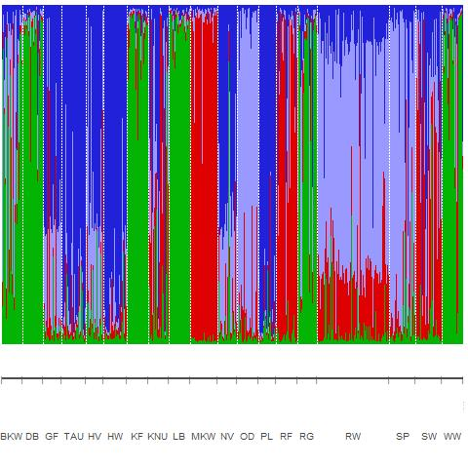

Supplementary Fig. 1: First level STRUCTURE analysis of 19 Hessian red deer AMUs, revealing four main clusters (Cluster 1: BKW, DB, KF, LB, RG, WW; Custer 2: GF, HV, NV, SP, SW; Cluster 3: TAU, HW, PL; Cluster 4: KNU, MKW, OD, RF, RW).

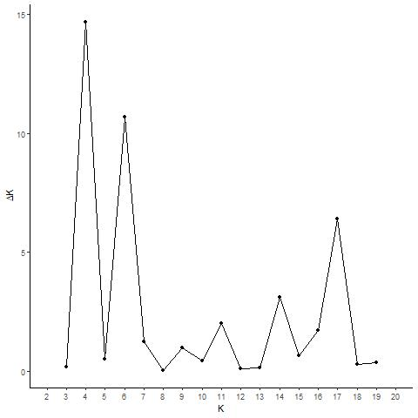
Supplementary Fig. 2: Inferring the number of clusters of the Hessian red deer population from the first level STRUCTURE results using the Evanno method (Evanno et al., 2005).

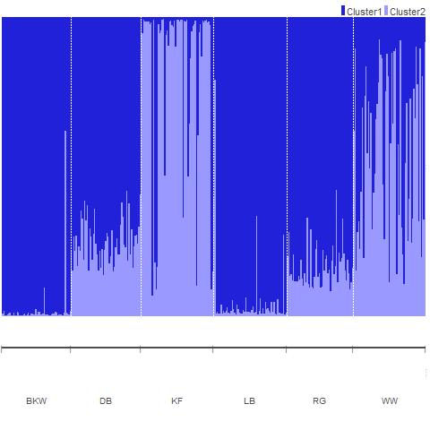
Supplementary Fig. 3: Hierarchical STRUCTURE analysis of Cluster 1 from Fig. 1, revealing two clusters (Cluster 1: BKW, DB, LB, RG; Cluster 2: KF, WW).

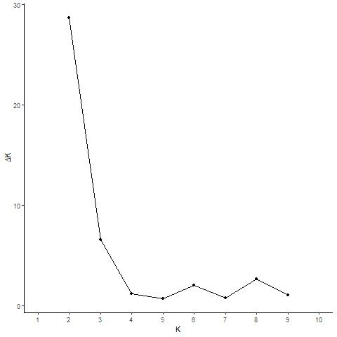
Supplementary Fig. 4: Inferring the number of clusters from the second level STRUCTURE results of Cluster 1 using the Evanno method (Evanno et al., 2005).

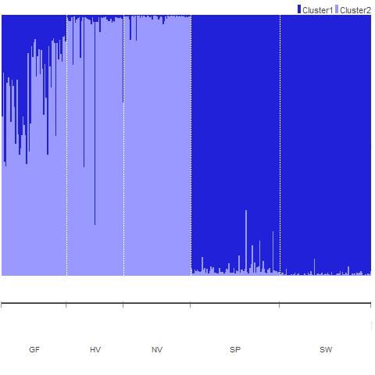
Supplementary Fig. 5: Hierarchical STRUCTURE analysis of Cluster 2 from Fig. 1, revealing two clusters (Cluster 1: SP, SW; Cluster 2: GF, HV, NV).
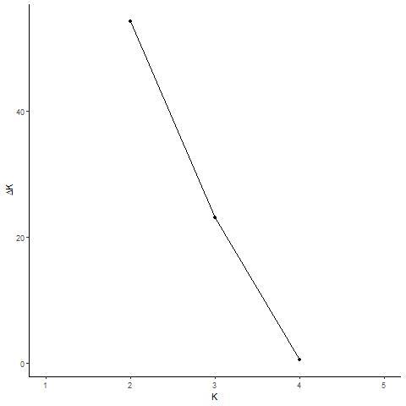
Supplementary Fig. 6: Inferring the number of clusters from the second level STRUCTURE results of Cluster 2 using the Evanno method (Evanno et al., 2005).

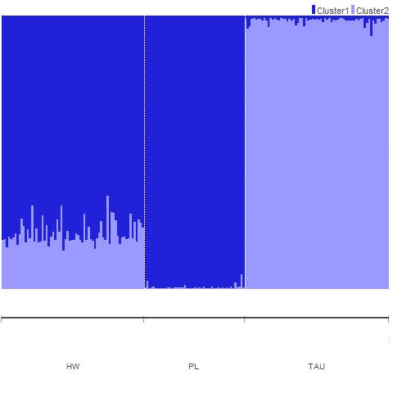
Supplementary Fig. 7: Hierarchical STRUCTURE analysis of Cluster 3 from Fig. 1, revealing two clusters (Cluster 1: HW, PL; Cluster 2: TAU).
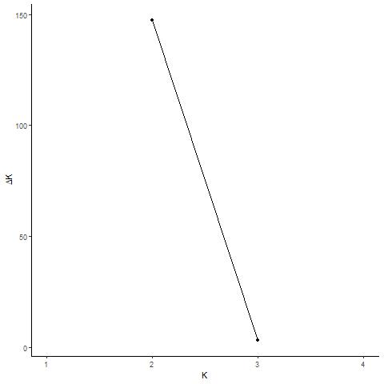
Supplementary Fig. 8: Inferring the number of clusters from the second level STRUCTURE results of Cluster 3 using the Evanno method (Evanno et al., 2005).

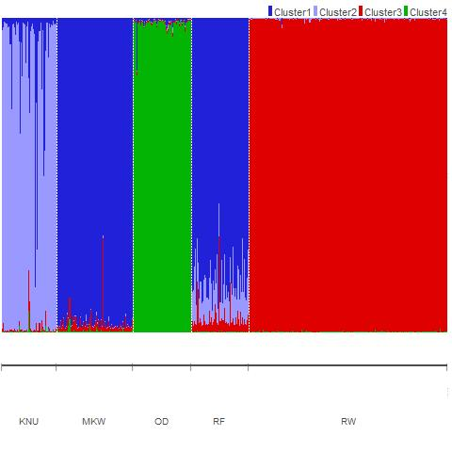
Supplementary Fig. 9: Hierarchical STRUCTURE analysis of Cluster 4 from Fig. 1, revealing four clusters (Cluster 1: MKW, RF; Cluster 2: KNU; Cluster 3: RW; Cluster 4: OD).
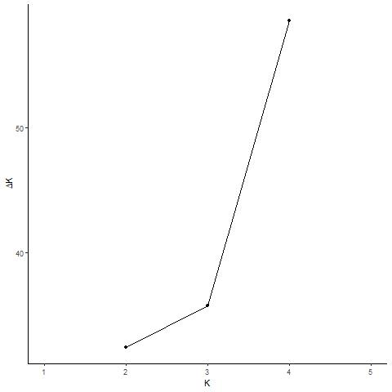
Supplementary Fig. 10: Inferring the number of clusters from the second level STRUCTURE results of Cluster 4 using the Evanno method (Evanno et al., 2005).

Supplementary References
Bishop MD, Kappes SM, Keele JW, Stone RT, Sunden SL, Hawkins GA, Toldo SS, Fries R, Grosz MD, Yoo J (2001) A genetic linkage map for cattle. Genetics 136:619–639
Evanno G, Regnaut S, Goudet J (2005) Detecting the number of clusters of individuals using the software STRU CTU RE: a simulation study. Mol Ecol 14:2611–2620
Jones KC, Levine KF, Banks JD (2002) Characterization of 11 polymorphic tetranucleotide microsatellites for forensic applications in California elk (Cervus elaphus canadensis). Molec Ecol Notes 2:425–427
Mommens G, Coppieters W, Van de Weghe A, Van Zeveren A, Bouquet Y (1994) Dinucleotide repeat polymorphism at the bovine MM12E6 and MM8D3 loci. Anim Genet25:368
Moore SS, Byrne K, Berger KT, Barendse W, McCarthy F, Womack JE, Hetzel DJS (1994) Characterization of 65 bovine microsatellites. Mamm Genome 5:84–90
Røed KH, Midthjell L (1998) Microsatellites in reindeer, Rangifer tarundus, and their use in other cervids. Molecular Ecology 7: 1773–1776
Steffen P, Eggen A, Dietz AB, Womack JE, Stranzinger G, Fries R (1993) Isolation and mapping of polymorphic microsatellites in cattle. Anim Genet 24:121–124
Thieven U, Harlizius B, Simon D (1995) Dinucleotide repeat polymorphism at the bovine HAUT1 and HAUT14 loci. Anim Genet 26:123
Wilson GA, Strobeck C, Wu L, Coffin JW (1997) Characterization of microsatellite loci in caribou Rangifer tarandus, and their use in other artiodactyls. Mol Ecol 6:697–699

