Supplementary material
Supplementary material 1: Camera traps ID, year of used and the camera traps model used at this location. The models of the camera traps were the following: Bushnell camera traps Trophy cam trail, Reconnyx UltraFire Professional and Browning Strike force HD X
Point ID | Year | Camera traps model |  | Point ID | Year | Camera traps model
1 | 2018 | Bushnell |  | 21 | 2019 | Bushnell
2 | 2018 | Bushnell |  | 22 | 2019 | Bushnell
2 | 2019 | Reconnyx |  | 23 | 2019 | Bushnell
3 | 2018 | Bushnell |  | 24 | 2019 | Bushnell
4 | 2018 | Bushnell |  | 25 | 2019 | Bushnell
4 | 2019 | Bushnell |  | 26 | 2019 | Bushnell
5 | 2018 | Bushnell |  | 27 | 2019 | Bushnell
6 | 2018 | Bushnell |  | 28 | 2019 | Reconnyx
6 | 2019 | Reconnyx |  | 29 | 2019 | Reconnyx
7 | 2018 | Bushnell |  | 30 | 2019 | Bushnell
8 | 2018 | Bushnell |  | 31 | 2019 | Bushnell
8 | 2019 | Bushnell |  | 32 | 2019 | Browning
9 | 2018 | Bushnell |  | 33 | 2018 | Browning
9 | 2019 | Bushnell |  | 34 | 2019 | Browning
10 | 2018 | Bushnell |  | 35 | 2018 | Browning
11 | 2018 | Bushnell |  | 36 | 2019 | Browning
12 | 2018 | Bushnell |  | 37 | 2018 | Browning
12 | 2019 | Bushnell |  | 38 | 2019 | Browning
13 | 2018 | Bushnell
14 | 2018 | Bushnell
15 | 2018 | Bushnell
16 | 2018 | Bushnell and Browning after 26/07/2018
17 | 2018 | Bushnell
18 | 2018 | Bushnell
19 | 2018 | Browning
19 | 2019 | Bushnell
20 | 2019 | Bushnell

Supplementary material 2: Kernel Density Estimation obtained from 252 GPS tracks of hikers and camera traps (grey circle) in Glen Lyon, Scotland. We used a kerned density estimation with a bandwidth of 10m. This illustrates that the hiking activity mostly occurred along the hiking path (high density on the map, in red) in our study area. Thus, the distance from the hiking path is an accurate proxy of the hiking activity in our area.

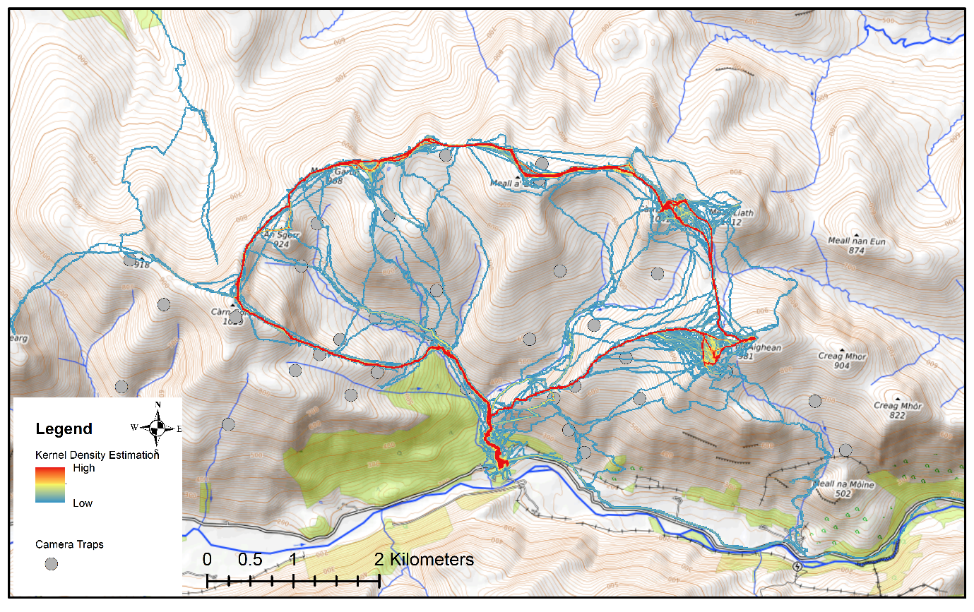

Supplementary material 3: Daily activity patterns (kernel density curves) of red deer (red line) and sheep (blue dotted line) for each camera trap location. The overlap of red deer and sheep activities is shown as the grey shaded area. On the top of each graph, the first line is the camera trap location, the second line represents the number of deer and sheep detected and the third line indicates the coefficient of overlap (Δ₄) and the corresponding 95% confidence interval.
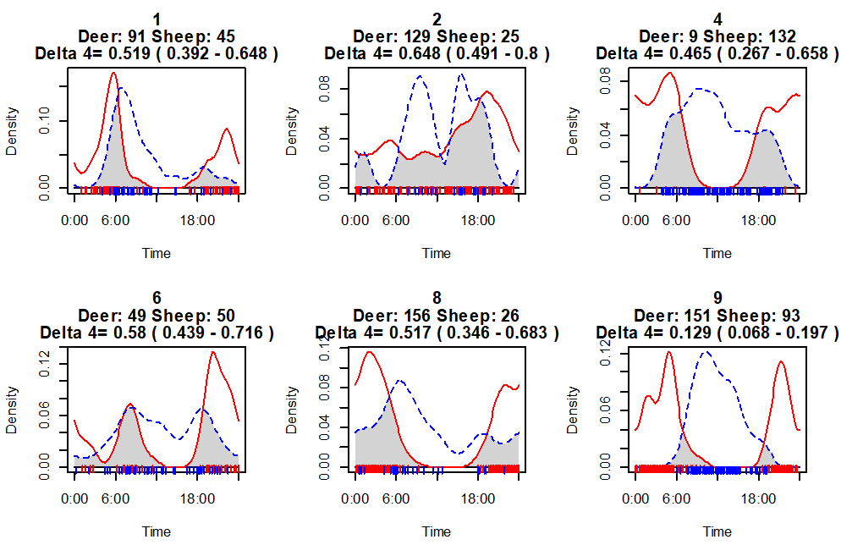
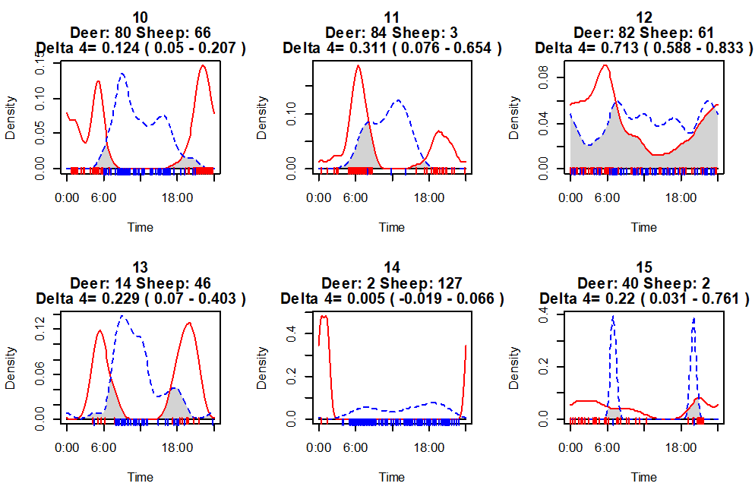

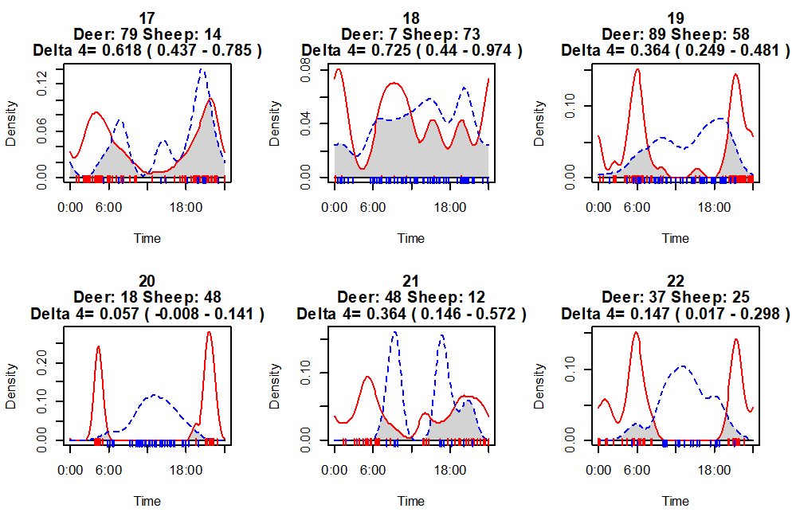
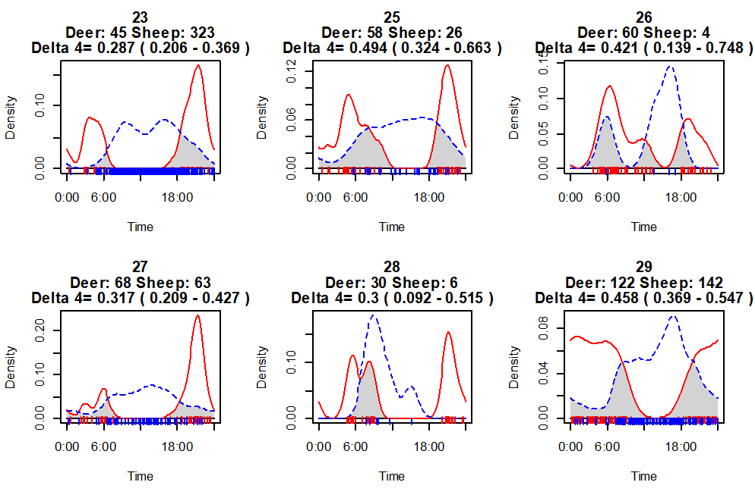

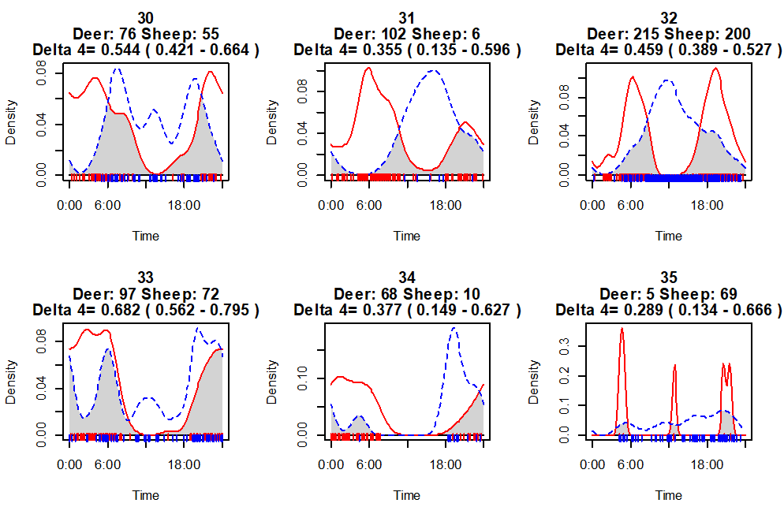
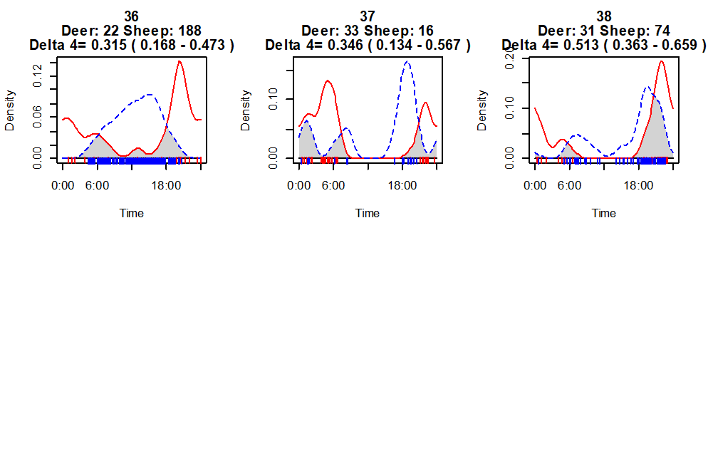

Supplementary material 4: Watson's Two-Sample Test of Homogeneity for each camera trap location between the detection of sheep and deer

Camera trap location | Test statistic | P-value
1 | 1.1563 | < 0.001
2 | 0.2459 | 0.01 < P-value < 0.05
4 | 0.3698 | 0.001 < P-value < 0.01
6 | 0.5845 | < 0.001
8 | 0.7182 | < 0.001
9 | 4.4603 | < 0.001
10 | 2.8675 | < 0.001
11 | 0.1941 | 0.01 < P-value < 0.05
12 | 0.4485 | < 0.001
13 | 0.7023 | < 0.001
14 | 0.1654 | 0.05 < P-value < 0.10
15 | 0.0627 | P-value > 0.10
17 | 0.2121 | 0.01 < P-value < 0.05
18 | 0.0317 | P-value > 0.10
19 | 1.5765 | < 0.001
20 | 1.0794 | < 0.001
21 | 0.2739 | 0.001 < P-value < 0.01
22 | 0.9609 | < 0.001
23 | 2.0539 | < 0.001
25 | 0.7224 | < 0.001
26 | 0.1395 | > 0.10
27 | 1.6388 | < 0.001
28 | 0.2452 | 0.01 < P-value < 0.05
29 | 2.8097 | < 0.001
30 | 0.9578 | < 0.001
31 | 0.3286 | 0.001 < P-value < 0.01
32 | 3.4714 | < 0.001
33 | 0.6143 | < 0.001
34 | 0.3514 | 0.001 < P-value < 0.01
35 | 0.0823 | > 0.10
36 | 1.1105 | < 0.001
37 | 0.4127 | < 0.001
38 | 0.6679 | < 0.001

