Supplementary material

Title: Habitat preferences and similarities of Grey Partridges and Common Pheasants in agricultural landscapes under organic and conventional farming

Journal: European Journal of Wildlife Research

Authors: Eva Maria SCHÖLL, Armin ESCHBERGER-FRIEDL, Stéphanie SCHAI-BRAUN, Alfred FREY-ROOS

Affiliation: University of Natural Resources and Life Sciences, Vienna (BOKU), Department of Integrative Biology and Biodiversity Research, Institute of Wildlife Biology and Game Management, Gregor-Mendel-Strasse 33, 1180 Vienna, Austria

Corresponding author: Eva Maria SCHÖLL (eva.schoell@boku.ac.at)

Table S1 Number and occurrence (presence = 1, absence = 0) of Grey Partridges and Common Pheasants detected within the 29 study squares (each 300 x 300 m) during the first (5th until 23rd March 2018) and second (26th March until 6th April 2018) field trip in spring
 | First field trip |  |  |  | Second field trip |  |  |  | Occurrence
Study square | Date | Grey Partridges  (N) | Common Pheasants  (N) |  | Date | Grey Partridges  (N) | Common Pheasants  (N) |  | Grey Partridge | Common Pheasant
1 | 05.03.2018 | 0 | 0 |  | 28.03.2018 | 0 | 1 |  | 0 | 1
2 | 05.03.2018 | 0 | 1 |  | 28.03.2018 | 1 | 0 |  | 1 | 1
3 | 08.03.2018 | 1 | 1 |  | 29.03.2018 | 0 | 2 |  | 1 | 1
4 | 22.03.2018 | 0 | 1 |  | 29.03.2018 | 0 | 1 |  | 0 | 1
5 | 15.03.2018 | 1 | 1 |  | 26.03.2018 | 0 | 2 |  | 1 | 1
6 | 21.03.2018 | 0 | 1 |  | 02.04.2018 | 0 | 2 |  | 0 | 1
7 | 15.03.2018 | 0 | 2 |  | 26.03.2018 | 0 | 4 |  | 0 | 1
8 | 21.03.2018 | 0 | 2 |  | 02.04.2018 | 0 | 0 |  | 0 | 1
9 | 20.03.2018 | 0 | 0 |  | 28.03.2018 | 0 | 4 |  | 0 | 1
10 | 20.03.2018 | 0 | 1 |  | 28.03.2018 | 0 | 2 |  | 0 | 1
11 | 22.03.2018 | 0 | 0 |  | 30.03.2018 | 0 | 2 |  | 0 | 1
12 | 21.03.2018 | 0 | 1 |  | 03.04.2018 | 0 | 0 |  | 0 | 1
13 | 09.03.2018 | 0 | 0 |  | 04.04.2018 | 0 | 1 |  | 0 | 1
14 | 13.03.2018 | 0 | 3 |  | 30.03.2018 | 0 | 4 |  | 0 | 1
15 | 18.03.2018 | 5 | 0 |  | 06.04.2018 | 1 | 0 |  | 1 | 0
16 | 21.03.2018 | 0 | 0 |  | 03.04.2018 | 0 | 2 |  | 0 | 1
17 | 15.03.2018 | 1 | 3 |  | 29.03.2018 | 0 | 2 |  | 1 | 1
18 | 07.03.2018 | 2 | 1 |  | 06.04.2018 | 0 | 1 |  | 1 | 1
19 | 15.03.2018 | 4 | 1 |  | 29.03.2018 | 3 | 0 |  | 1 | 1
20 | 16.03.2018 | 5 | 1 |  | 05.04.2018 | 2 | 2 |  | 1 | 1
21 | 14.03.2018 | 4 | 2 |  | 04.04.2018 | 1 | 1 |  | 1 | 1
22 | 22.03.2018 | 3 | 1 |  | 04.04.2018 | 1 | 0 |  | 1 | 1
23 | 16.03.2018 | 3 | 1 |  | 05.04.2018 | 1 | 3 |  | 1 | 1
24 | 22.03.2018 | 0 | 1 |  | 04.04.2018 | 0 | 0 |  | 0 | 1
25 | 14.03.2018 | 0 | 0 |  | 04.04.2018 | 0 | 0 |  | 0 | 0
26 | 23.03.2018 | 0 | 0 |  | 06.04.2018 | 0 | 0 |  | 0 | 0
27 | 23.03.2018 | 1 | 0 |  | 06.04.2018 | 1 | 0 |  | 1 | 0
28 | 14.03.2018 | 1 | 2 |  | 27.03.2018 | 1 | 0 |  | 1 | 1
29 | 19.03.2018 | 0 | 0 |  | 27.03.2018 | 0 | 0 |  | 0 | 0

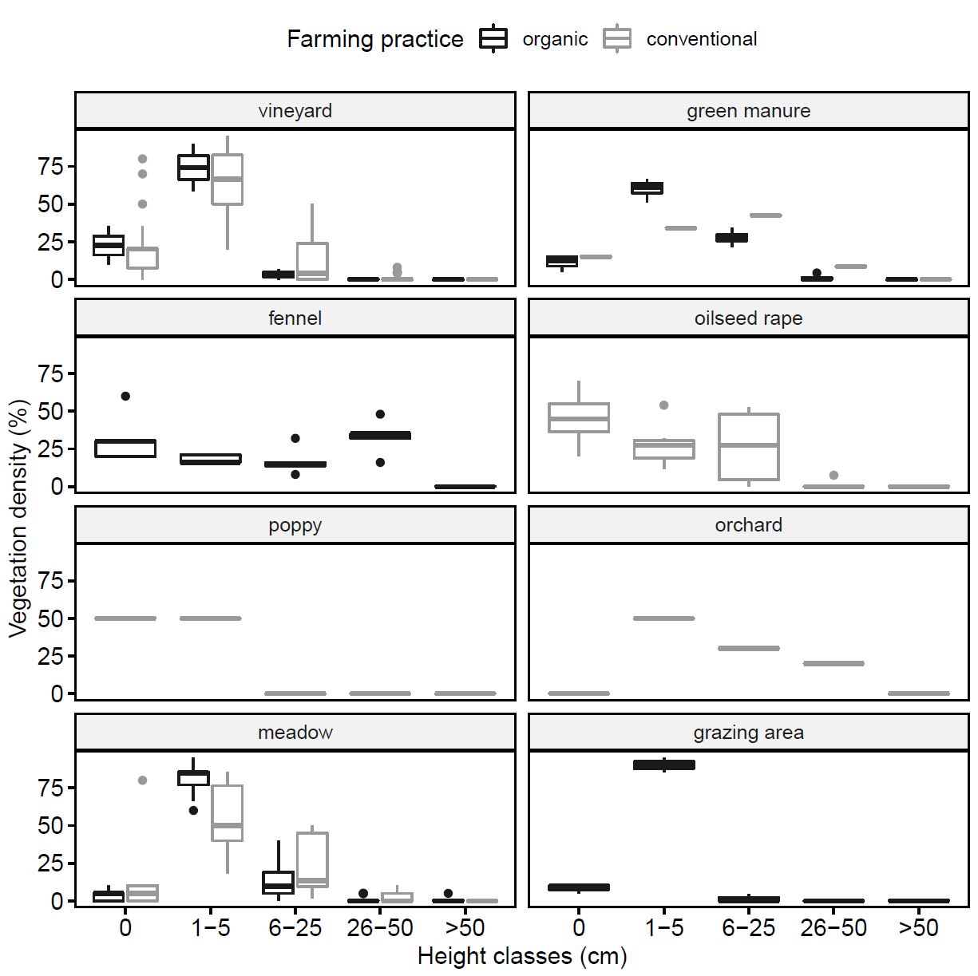
Fig. S1 Ground vegetation density at different height classes in agricultural fields under organic and/or conventional farming

Table S2 Environmental variables contributing to the first four axes of the principal component analysis. The first two axes were used to define the environmental space found across the entire study region (see Broennimann et al. 2012)

Variable | PC 1 | PC 2 | PC 3 | PC 4
Shannon-diversity index | 0.6 | 39.8 | 4.9 | 10.2
without culture.org | 11.1 | 14.2 | 2.6 | 10.5
without culture.con | 19.6 | 0.1 | 13.7 | 5.1
winter cereals.org | 24.7 | 3.4 | 0.0 | 4.9
winter cereals.con | 11.5 | 5.5 | 33.1 | 1.3
lucerne.org | 12.3 | 2.7 | 0.2 | 8.1
lucerne.con | 2.9 | 1.1 | 10.0 | 43.1
fallow land.org | 10.1 | 30.5 | 0.2 | 2.8
fallow land.con | 7.3 | 2.7 | 35.3 | 14.0
Variance explained (%) | 28.5 | 19.7 | 13.2 | 11.5
Eigenvalue | 2.6 | 1.8 | 1.2 | 1.0

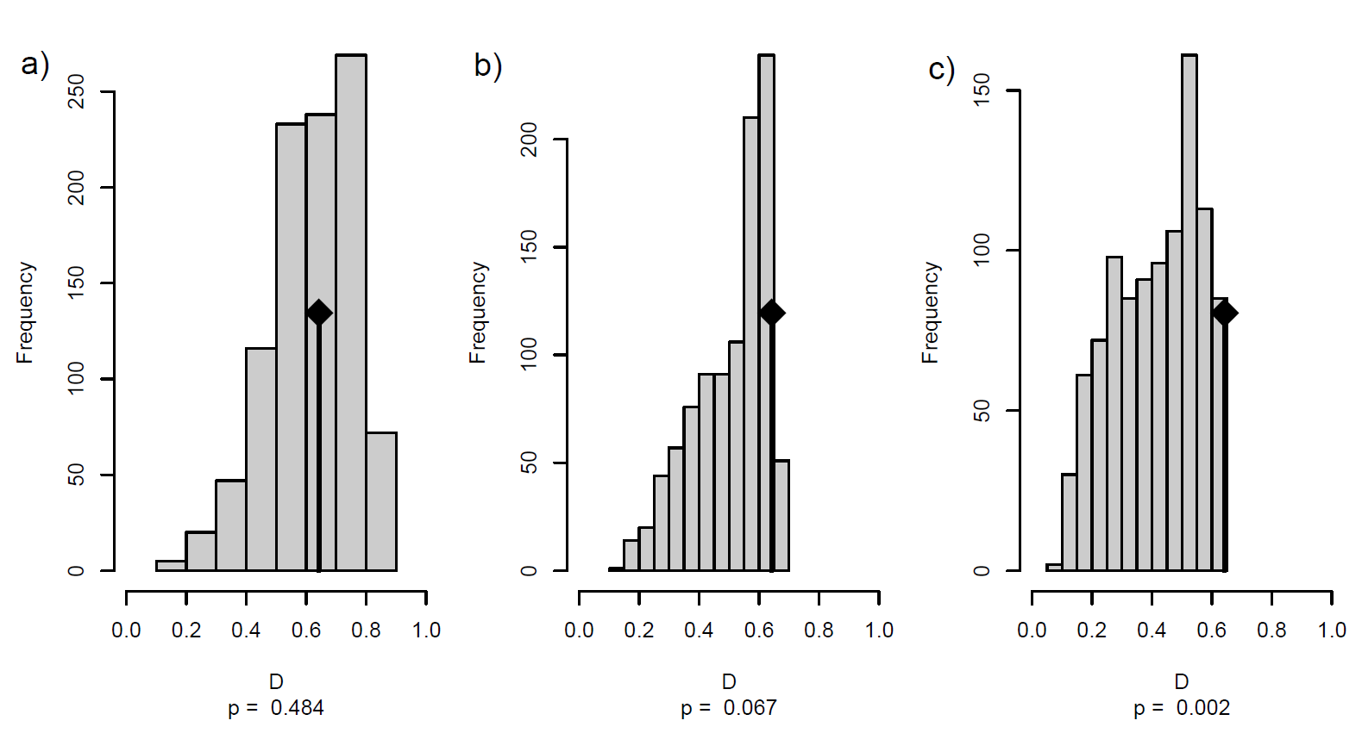
Fig. S2 a) Habitat equivalence test, and b) and c) similarity tests in the environmental space for Grey Partridge and Common Pheasant. Habitat similarity tests are performed in both directions; b) Grey Partridge versus Common Pheasant, c) Common Pheasant versus Grey Partridge. Observed Schoener´s D values are represented with the black diamond. For the analyses, observed D values of the species were compared to the distribution of simulated D values, which were based on 1,000 iterations. A p-value <0.05 was used to evaluate significance of habitat equivalency and similarity (see Broennimann et al. 2012)

Reference
Broennimann O, Fitzpatrick MC, Pearman PB, Petitpierre B, Pellissier L, Yoccoz NG, Thuiller W, Fortin M-J, Randin C, Zimmermann NE, Graham CH, Guisan A (2012) Measuring ecological niche overlap from occurrence and spatial environmental data. Glob Ecol Biogeogr 21:481-497. https://doi.org/10.1111/j.1466-8238.2011.00698.x

