Appendix 1

Table A1. Britford fox tagging events. Number of fixes and distances moved are for the 15 March to 15 June period only. Location data were filtered and determined as active as described in the text. The distances moved were calculated from active fixes only, with daily distances calculated only for days where collars were entirely on a 10 min fix schedule.
fox | sex | date |  | n relocations |  |  | distance moved (10 min, m) |  | distance moved (day, m)
 |  | start | end | total | filtered | active | mean | max | mean | max
B16F01 | F | 16/04/2016 | 22/05/2016 | 2080 | 1834 | 828 | 83 | 411 | 3704 | 4731
B16F02 | Fª | 28/04/2016 | 17/06/2016 | 5640 | 4991 | 2373 | 78 | 469 | 3457 | 5360
B16F03 | Fª | 01/05/2016 | 08/06/2016 | 4710 | 3816 | 2114 | 118 | 638 | 6256 | 9678
B16M01 | M | 16/03/2016 | 25/03/2016 | 1110 | 1078 | 394 | 43 | 445 | 1548 | 3175
B16M02 | M | 20/03/2016 | 16/06/2016^{b} | 6592 | 6383 | 2767 | 107 | 772 | 5113 | 7464
B16M03 | M | 20/03/2016 | 25/05/2016 | 4716 | 4276 | 1744 | 87 | 891 | 3231 | 8151
B16M04 | M | 19/04/2016 | 28/04/2016 | 1109 | 968 | 270 | 88 | 384 | 2586 | 3551
B16M05 | M | 28/04/2016 | 19/06/2016 | 5626 | 4953 | 1955 | 60 | 585 | 2020 | 4756
B16M06 | M | 12/05/2016 | 17/06/2016 | 4983 | 4633 | 2021 | 66 | 499 | 2793 | 4436
B17F01 | F | 07/03/2017 | 04/04/2017 | 2363 | 2279 | 628 | 68 | 405 | 1538 | 2457
B17F02 | F | 14/03/2017 | 15/03/2017 | 10 | 10 | 5 | - | - | - | -
B17F03 | F | 17/03/2017 | 19/05/2017 | 5864 | 4716 | 2564 | 115 | 595 | 6133 | 8604
B17F04 | F | 22/03/2017 | 25/05/2017 | 5918 | 5231 | 2276 | 89 | 869 | 3833 | 5478
B17F05 | Fª | 16/04/2017 | 23/05/2017 | 3957 | 3742 | 1783 | 94 | 614 | 4912 | 9000
B17M01 | M | 15/03/2017 | 17/04/2017 | 3432 | 1590 | 967 | 79 | 513 | 2787 | 4508
B17M02 | M | 22/03/2017 | 07/05/2017 | 4279 | 3857 | 1411 | 52 | 593 | 1816 | 8659
B17M03 | M | 22/03/2017 | 13/05/2017 | 4451 | 4259 | 1815 | 83 | 1058 | 4020 | 11065
B17M04 | M | 01/04/2017 | 16/05/2017 | 4286 | 4172 | 1519 | 85 | 661 | 3229 | 5008
B17M05 | M | 18/04/2017 | 02/06/2017 | 4459 | 4289 | 1733 | 61 | 499 | 2294 | 2964
ªFemale lactating when caught.
^{b}B16M02 data from two collars; no data between 23/03/2016 and 15/04/2016 (1st collar detached).

Table A2. Somerley fox tagging events. Number of fixes and distances moved are for the 15 March to 15 June period only. Location data were filtered and determined as active as described in the text. The distances moved were calculated from active fixes only, with daily distances calculated only for days where collars were entirely on a 10 min fix schedule.
fox | sex | date |  | n fixes |  |  | distance moved (10 min, m) |  | distance moved (day, m)
 |  | start | end | total | filtered | active | mean | max | mean | max
S18F01 | Fª | 26/04/2018 | 22/05/2018 | 3525 | 2321 | 1385 | 132 | 718 | 5679 | 7795
S18F02 | Fª | 01/05/2018 | 07/06/2018^{b} | 5284 | 5048 | 2434 | 130 | 657 | 7096 | 11562
S18M01 | M | 28/02/2018 | 03/05/2018 | 2855 | 2499 | 1569 | 143 | 867 | 7727 | 10435
S18M02 | M | 01/03/2018 | 19/05/2018 | 5114 | 4141 | 2192 | 95 | 590 | 3157 | 5662
S18M03 | M | 02/05/2018 | 01/07/2018 | 5054 | 4823 | 2602 | 155 | 795 | 8608 | 11929
S18M04 | M | 11/05/2018 | 01/07/2018 | 3764 | 3489 | 2112 | 136 | 677 | 6346 | 8357
S19F01 | Fª | 03/04/2019 | 26/06/2019^{c} | 7742 | 5048 | 3308 | 126 | 828 | 6073 | 12024
S19F02 | F | 15/04/2019 | 07/05/2019 | 3262 | 2900 | 1139 | 196 | 1137 | 6908 | 19455
S19F03 | Fª | 19/04/2019 | 08/05/2019 | 2830 | 813 | 685 | 171 | 617 | 5136 | 7820
S19F04 | F | 10/05/2019 | 20/06/2019 | 5291 | 4910 | 2247 | 74 | 711 | 3523 | 5366
S19F05 | Fª | 15/05/2019 | 21/06/2019 | 4573 | 4304 | 2004 | 132 | 701 | 6696 | 12211
S19F06 | Fª | 23/05/2019 | 04/07/2019 | 3420 | 3163 | 1434 | 103 | 576 | 4996 | 9548
S19M01 | M | 12/04/2019 | 15/05/2019 | 4428 | 4233 | 2051 | 131 | 562 | 6649 | 11271
S19M02 | M | 15/04/2019 | 04/07/2019^{d} | 8120 | 7484 | 3530 | 145 | 875 | 6608 | 9445
S19M03 | M | 19/04/2019 | 12/06/2019 | 6552 | 6417 | 3351 | 116 | 654 | 5777 | 9922
S19M04 | M | 15/05/2019 | 14/06/2019 | 4423 | 4091 | 1683 | 144 | 591 | 5761 | 10071
ªFemale lactating when caught.
^{b}S18F02 data from two collars, no data missing as fox recaptured and 2nd collar fitted on 13/05/2018.
^{c}S19F01 data from two collars, no data between 09/05/2019 and 21/05/2019 (1st collar battery failed).
^{d}S19M02 data from two collars, no data missing as fox recaptured and 2nd collar fitted on 22/05/2019.

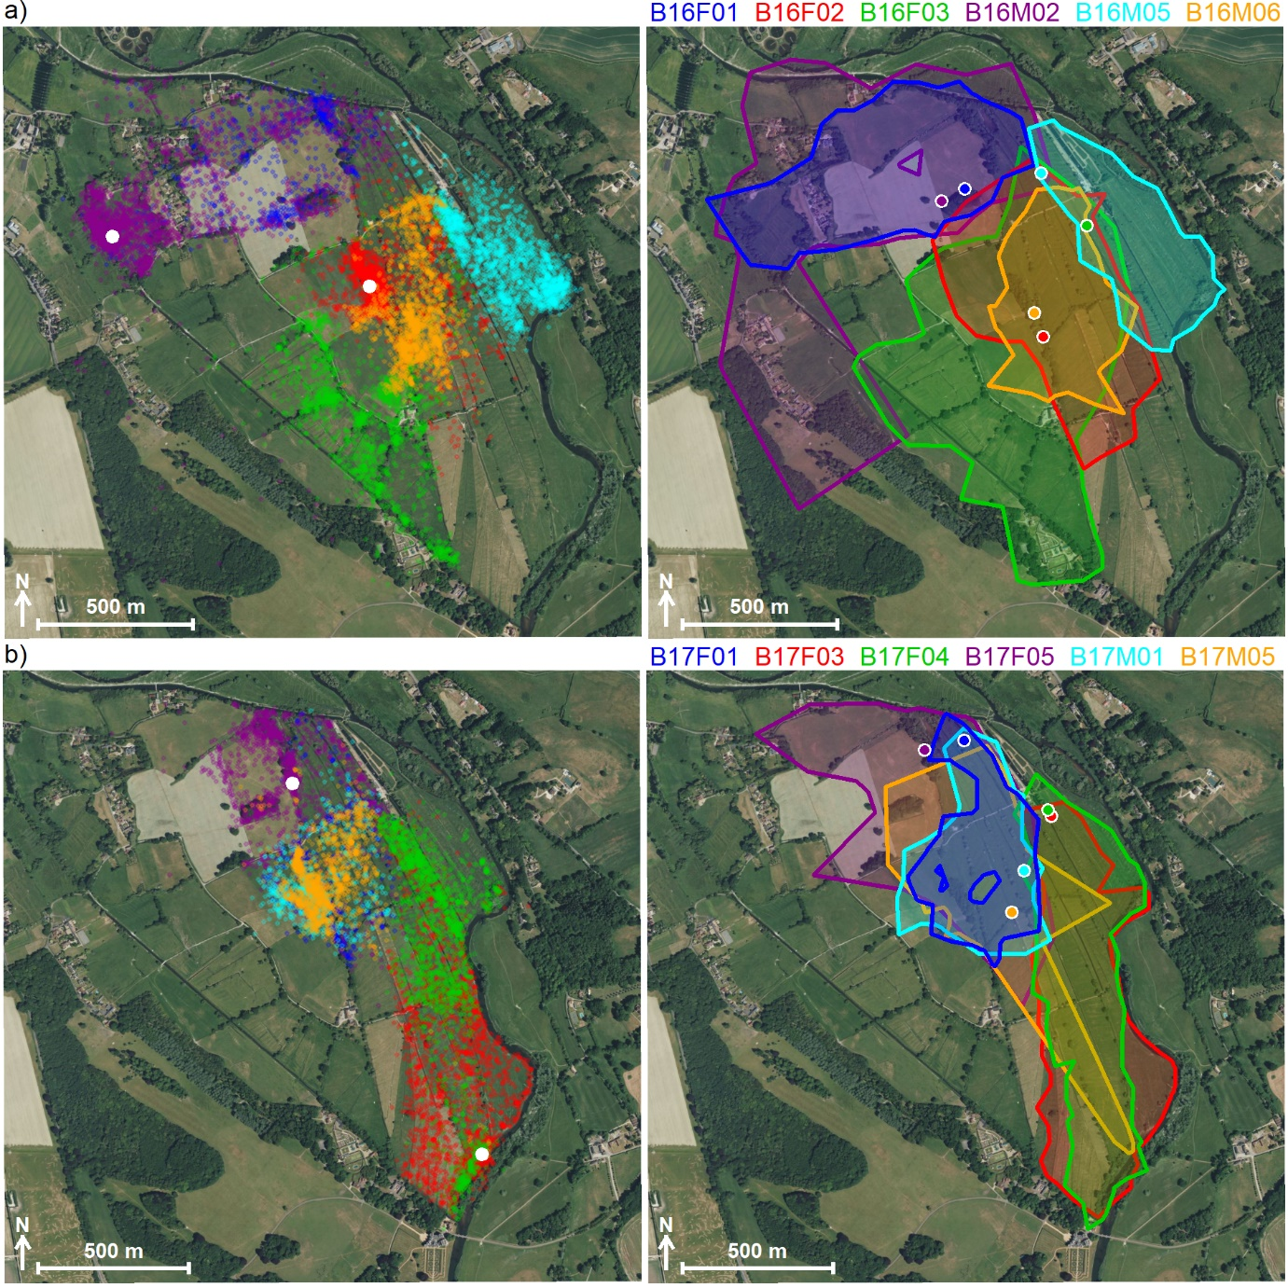
Fig. A1. Britford fox relocations and estimated home ranges in a) 2016 and b) 2017. Relocations (left panels) are shown using transparent colours so denser colour indicates areas with greater use. Known or suspected breeding earth (den) locations are shown by solid white circles. Home ranges (right panels) determined as the 100% isopleth of the utilisation distribution given by Local Convex Hulls. Capture locations for each fox are shown by matching coloured circles with a white outline. Contains Bing imagery (©Microsoft Corporation 2022).
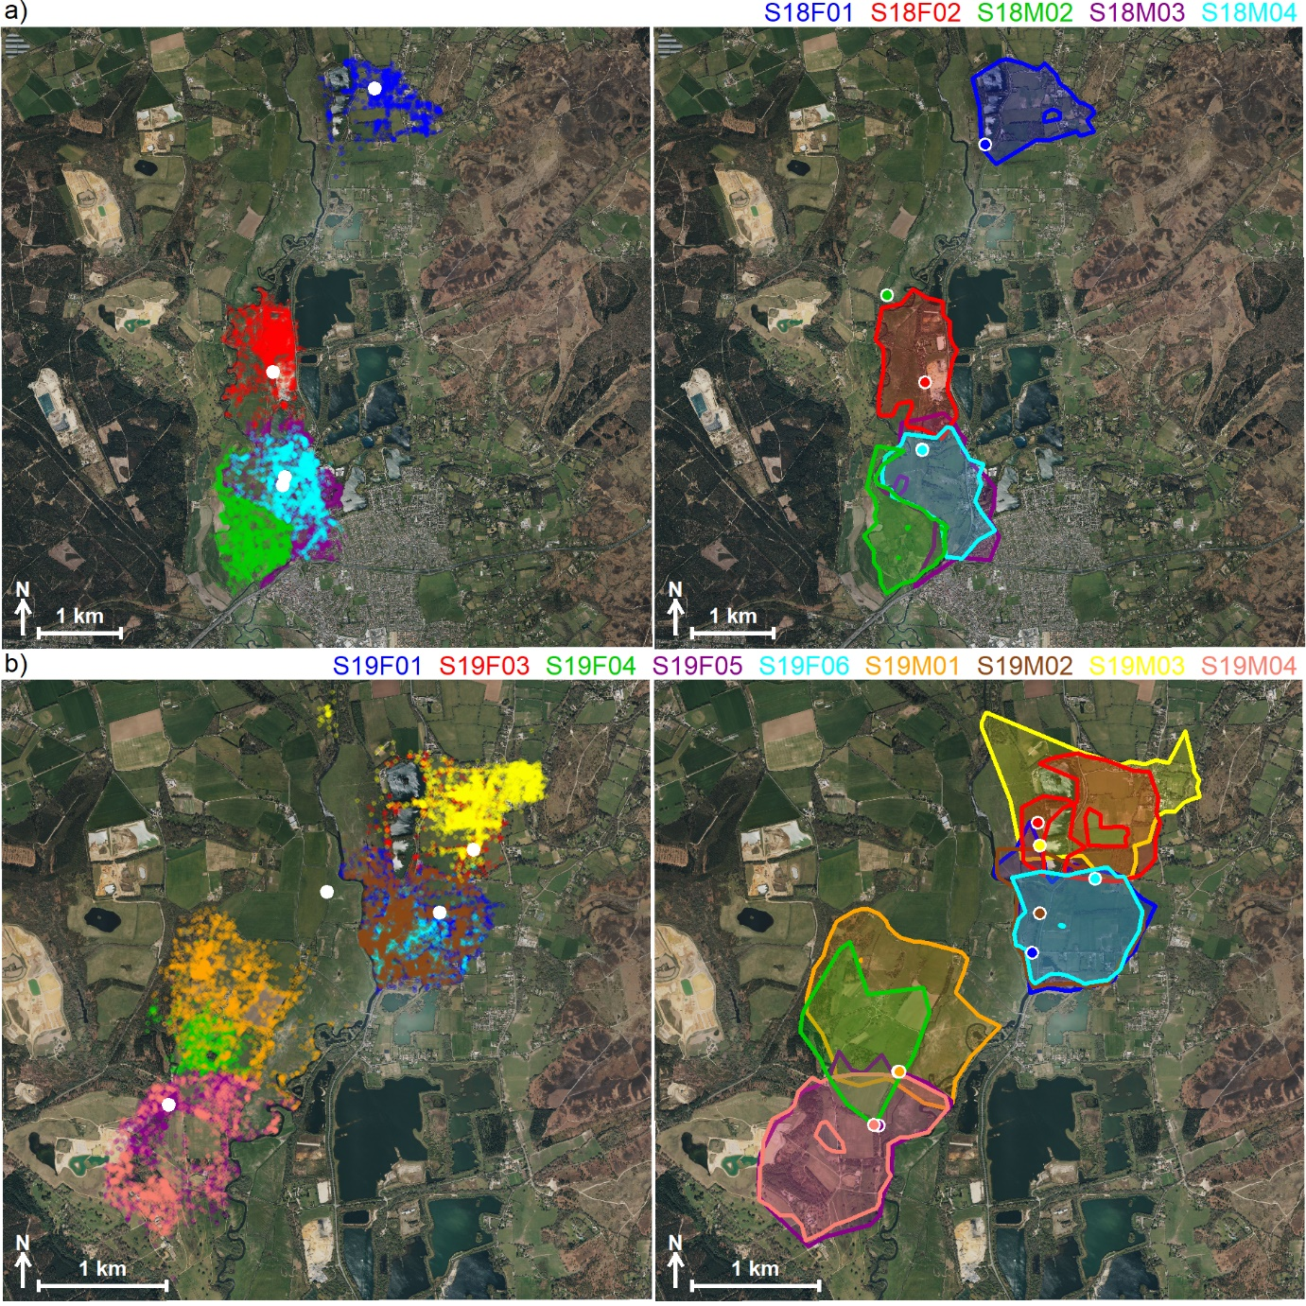
Fig. A2. Somerley fox fix locations and estimated home ranges in a) 2018 and b) 2019. Fixes (left panels) are shown using transparent colours so denser colour indicates areas with greater use. Known or suspected breeding earth (den) locations are shown by solid white circles. Home ranges (right panels) determined as the 100% isopleth of the utilisation distribution given by Local Convex Hulls. Capture locations for each fox are shown by matching coloured circles with a white outline. Contains Bing imagery (©Microsoft Corporation 2022).
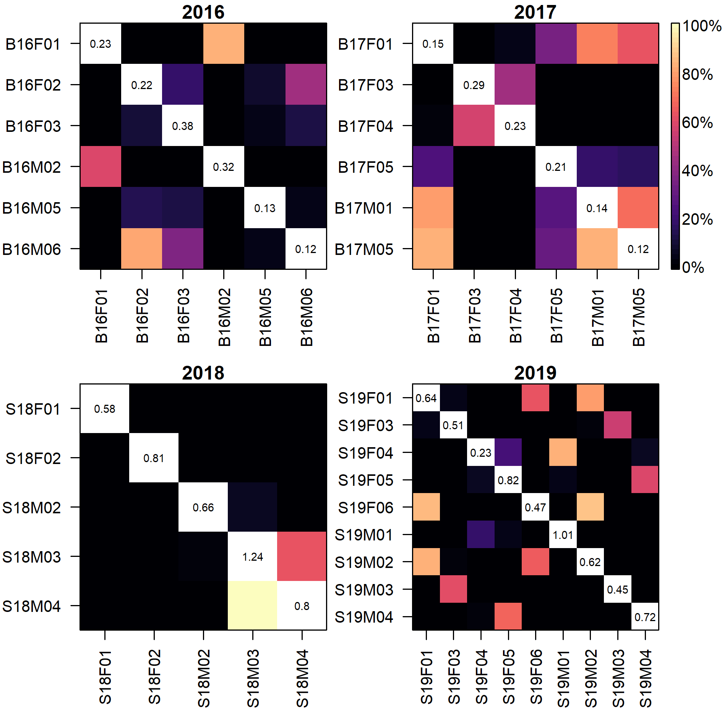
Fig. A3. Home range overlap matrix between resident foxes tagged in each year at Britford (2016-2017) and Somerley (2018-2019). Colour shows the percentage of overlap from black (no overlap) to white (100% overlap), with columns indicating the overlap of those foxes with those in each row. Values on the diagonal show the home range area in km² determined as the 95% isopleth of the utilisation distribution given by Local Convex Hulls.
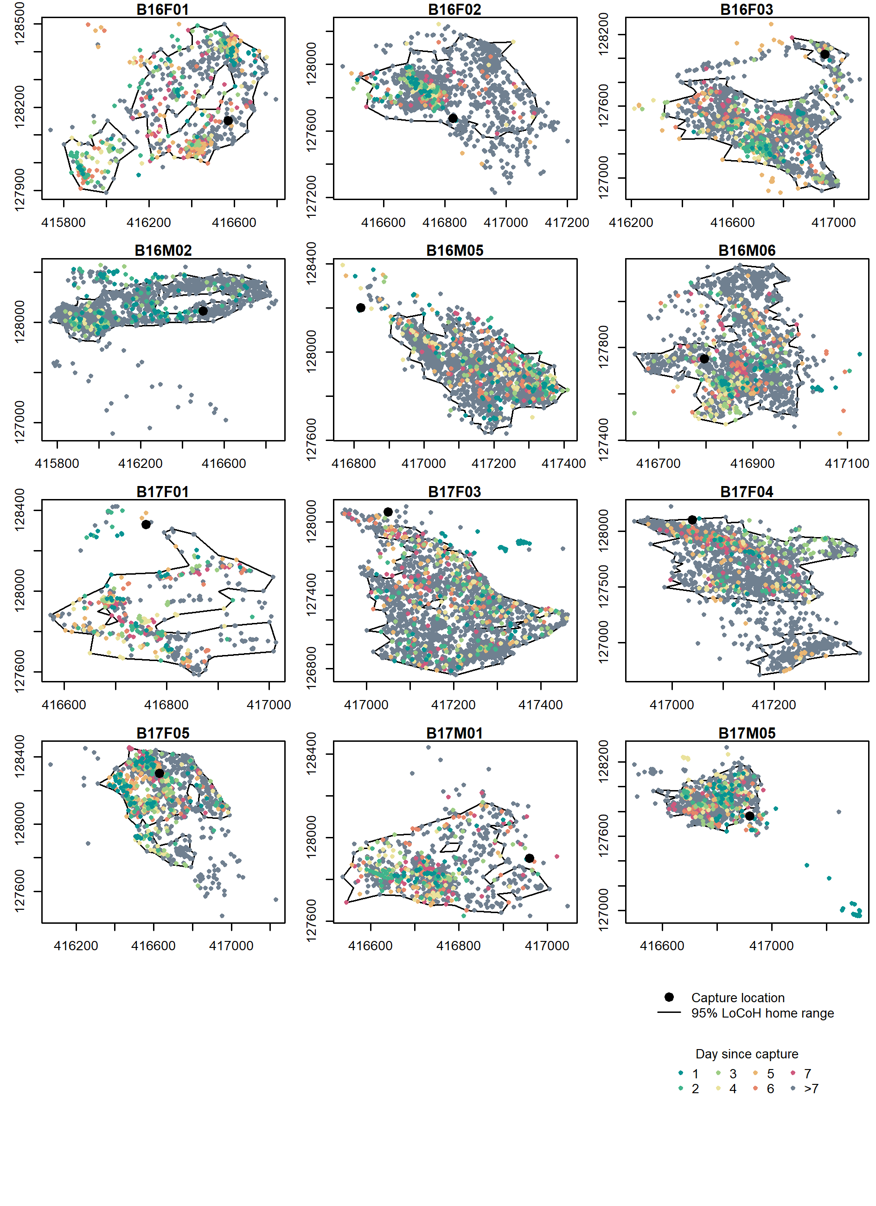
Fig. A4. Locations of resident Britford foxes during the first week following capture (points coloured by day since capture) relative to all fixes (grey points). All fixes shown relative to the estimated home range.
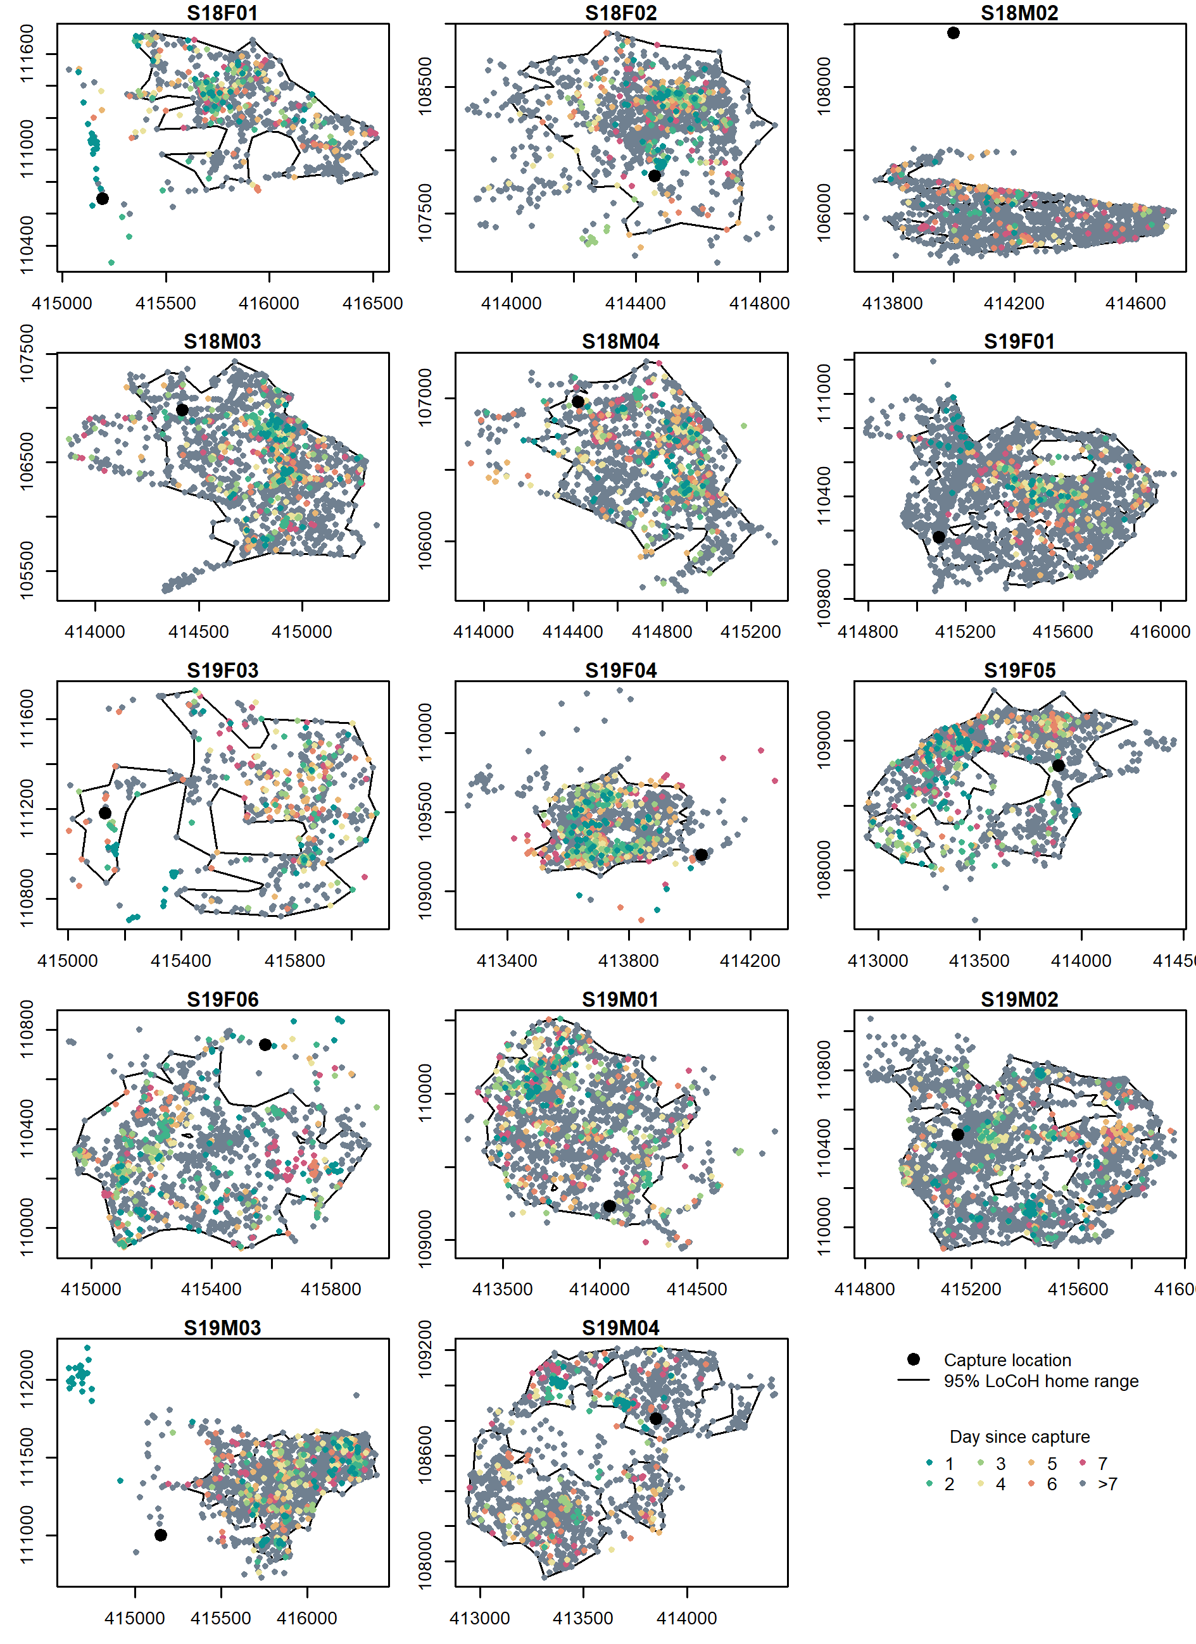
Fig. A5. Relocations of resident Somerley foxes during the first week following capture (points coloured by day since capture) relative to all relocations (grey points). All relocations shown relative to the estimated home range.
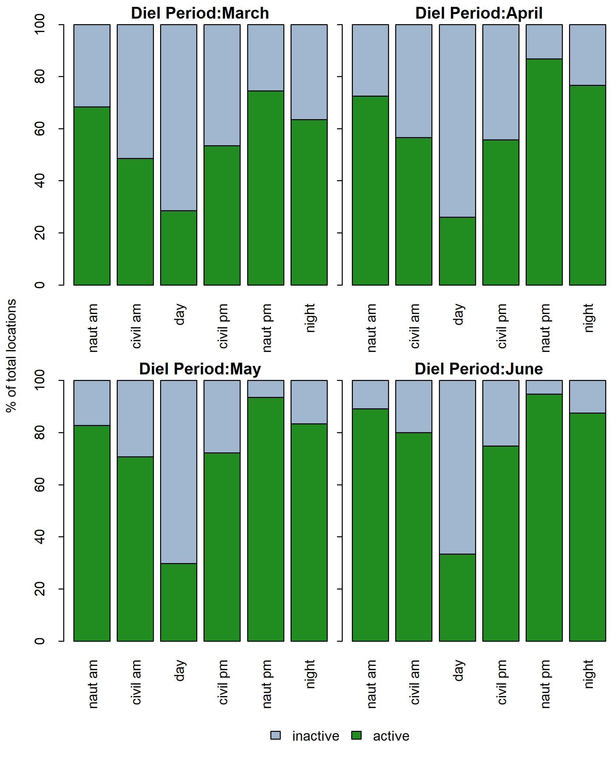
Fig. A6. Interaction between diel period and month in fox activity patterns during the wader nesting period.

