Disentangling low productivity on western capercaillie (Tetrao urogallus) through an artificial nests experiment: martens are the key

Pablo Palencia^{1, 2*} & Patricia Barroso^{2, 3}
- Department of Biology of Organisms and Systems, University of Oviedo, Biodiversity Research Institute (University of Oviedo – CSIC – Principado de Asturias), Mieres, Spain
- University of Turin, Department of Veterinary Sciences, Turin, Italy
- University of Leon, Department of Animal Health, Leon, Spain
*Corresponding author: Universsity of Oviedo, Edificio de Investigación, 5ª planta, c/ Gonzalo Gutiérrez Quirós s/n, E-336000 Mieres, Spain. E-mail. palenciapablo@uniovi.es and palencia.pablo.m@gmail.com
APPENDIX

Appendix S1: effect of time gap in the number of independent detections
Table summarizing the number of events of martens for a range of time gaps, from 1 minute to 240 minutes.

Table 1 S1: Relationship between the time gap to consider independent encounters and the resulting number of encounters.
Time gap (min) | Nº encounters
1 | 155
5 | 151
10 | 150
20 | 150
30 | 148
60 | 148
120 | 147
240 | 145

Appendix S2: description of photogrammetry

The photogrammetry approach describes the relationship between the size of the calibration object in the image (in pixels) and its actual size and distance from the camera; and the relationship between X-Y pixel position in the image and the angular distance from the camera’s principal axis. To use photogrammetry, it is necessary to calibrate each camera deployment, and the camera model. The camera model (here Tetrao by Spromise S308) was calibrated once by taking 15 images of the calibration pole (here a one-meter-length pole with marks at 20 cm intervals) at known distances from the camera (maximum 15 m) and from the centre to the laterals of the field of view. On the field, each camera deployment was calibrated by recording 15 pictures of the calibration pole across the field of view and spaces 1-2 m apart. We finally digitized the images to extract the pixel position of the animals in the open-source tool AnimalTracker (https://github.com/lauraVzarco/animaltracker). To apply CTDS, we recorded the pixel position of animals in all the pictures in which an individual of the target species was recorded. To apply REM, we recorded the pixel position of all the individuals when entering the detection zone, and we also reconstructed the trajectory of those individuals that did not react to the presence of the camera. Pixel positions were later transformed to animal-to-camera distances and angles using the CTtracking package in R (https://github.com/MarcusRowcliffe/CTtracking).

Appendix S3: binomial GLM with environmental and habitat-related predictors
Using the data from the 82 artificial nests deployed, we fitted a binomial GLM to identify the main environmental and habitat-related predictors. Specifically, we included as continuous predictors: the slope, the altitude, the distance to water streams, and, the percentage of scrubland, riparian, deciduous, and evergreen forest in the 10m radii buffer. Land use variables were obtained from the land cover map of the Centro de Investigación Ecológica y Aplicaciones Forestales (CREAF) (CREAF, 2009). We included as factors: the orientation (eight levels), the scrubland coverage (three levels), the resistance to passage (three levels), and whether the nest was monitored with a camera trap or not (two levels). A backward stepwise procedure based on Akaike’s Information Criteria was applied to select the most parsimonious models (Akaike, 1974). The best model included the slope, the altitude, the distance to water streams and the percentage of scrubland in the 10m radius buffer (Table 1). Despite it was not selected in the stepwise procedure, we maintained in the model whether the nest was monitored with a camera trap or not. The percentage of scrubland had a strong positive effect on predation and the slope had a strong negative effect on predation (both significant). The distance to the water stream had a weak positive effect on predation (marginally significant). The R² of this model was 0.13. When doing the model diagnosis of the best model, we observed non-linear tendencies in the altitude, the slope and the percentage of scrubland. We thus tested the quadratic effect of the altitude; and the cubic effect of slope and percentage of scrubland. We only observed a slight reduction (< 3 units) in AIC when including the quadratic effect of altitude. In consequence, we decided to include the linear relationships for simplicity when fitting new models including camera trap-based predictors.

Table 1 S3. Results of the binomial generalized linear model used to evaluate the environmental and habitat-related parameters that determine the probability of nest predation. Bold highlight significant values
 | Estimate ± SE | z-value | p-value
Intercept | -0.55 ± 1.91 | -0.29 | 0.77
Slope | -0.08 ± 0.04 | -2.04 | 0.04
Altitude | 0.001 ± 0.0001 | 1.65 | 0.09
Scrubland percentage | 0.02 ± 0.01 | 2.13 | 0.03
Distance to water streams | 0.003 ± 0.002 | 1.78 | 0.07
Sampling point (without CT) | -0.57 ± 0.62 | -0.93 | 0.35

Akaike, H. (1974). A new look at the statistical model identification. IEEE Transactions on Automatic Control, 19(6), 716–723. https://doi.org/10.1109/TAC.1974.1100705

CREAF, 2009. Mapa de cobertes del sòl de Catalunya [WWW Document]. URL http://www.creaf.uab.es/mcsc/ (accessed 8.3.23).

Appendix S4: examples of predators detecting a nest, but not predating it
Martens, foxes and wild boar were detected in nests available to predation (i.e. not predated before), but not always predated the nest. Particularly, martens were detected in 28 nests, and predated 19 of them (Fig. 1-S4); foxes were detected in 21 nests, and predated 9 of them; and wild boar were detected in 26 nests, and predated 3 of them (Fig. 2-S4).
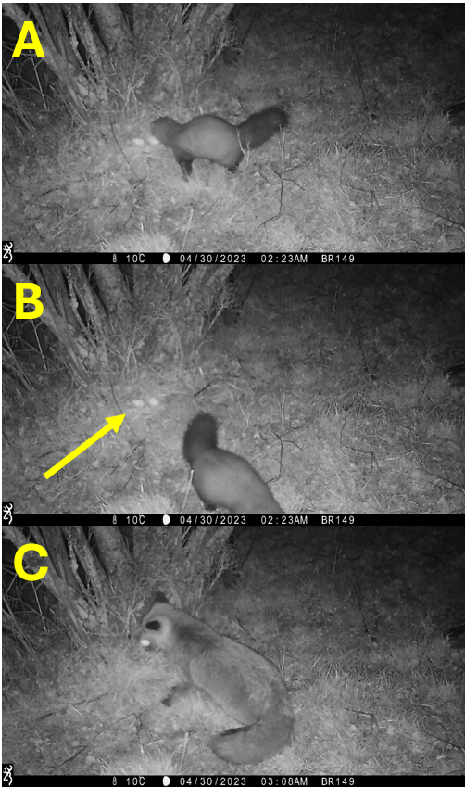
Figure 1 S4. Example of a marten detecting a nest (panel A) but not predating it (panel B). Thirty-five minutes later a red fox predated the nest (panel C).

Wild boar was detected in 43 nests. In 26 of them, wild boar was detected before the nest was predated, frequently reacting to the eggs, but without consuming them.
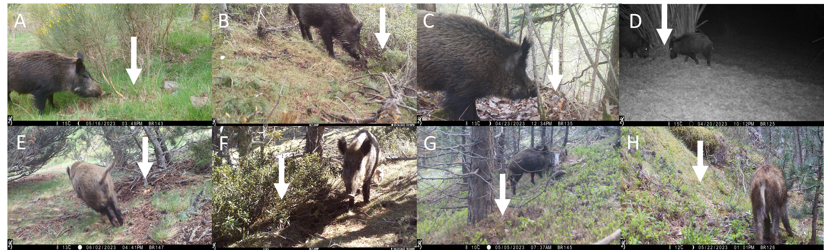
Figure 2 S4. Pictures from eight different artificial nests in which wild boar was detected reacting to the nest (upper panels, A-D), and in the vicinity of the nest (bottom panels, E-H). None of these nests were preyed by wild boar. White arrow indicates the location of the nest.

Appendix S5: binomial GLMs to explore the effect of nests density and deployment period in predation
We created buffers of 25, 100 and 500m radius around each nest, and subsequently counted the number of nests around each nest for each range of distance. Then, we fitted a binomial GLM including the number of nests predictor:

Model: Predation ~ number of nests (25m buffer):

 | Estimate ± SE | z-value | p-value
Intercept | -15.44 ± 1696.7 | -0.009 | 0.993
N nests | 16.00 ± 1696.73 | 0.009 | 0.992

Model: Predation ~ number of nests (100m buffer):

 | Estimate ± SE | z-value | p-value
Intercept | -0.12 ± 0.61 | -0.20 | 0.84
N nests | 0.56 ± 0.45 | 1.24 | 0.21

Model: Predation ~ number of nests (500m buffer):

 | Estimate ± SE | z-value | p-value
Intercept | -0. 24 ± 0.56 | -0.42 | 0.67
N nests | 0.12 ± 0.07 | 1.60 | 0.11

Regarding the deployment period, nests were deployed in two weeks. The first half of the nests were all deployed by March 30th; the second half of the nests were all deployed by May 3rd. We have now provided more results about that in the manuscript.

Model: Predation ~ deployment period:

 | Estimate ± SE | z-value | p-value
Intercept | -0.67 ± 0.29 | 2.29 | 0.022
Period (second) | -0.17 ± 0. 48 | 0.36 | 0.719

Appendix S6: random encounter model (REM) and camera-trap distance sampling (CTDS) parameters
Table 1 S6. Estimated random encounter model (REM) parameter values for each species, where y, is the number of independent events; t, is the survey effort; v, is the average distance travelled by an individual during a day (day range); r, is the radius of detection; and Ɵ, is the angle of detection.
Species | Parameter |  |  |  |  |  | Population density
 | y (enc) | t (cam·day) | v (km·day⁻¹) | r (km) | Ɵ (rad) | Mean (ind·km⁻²) |  | Log-normal 95% CI (lower, upper)
Red fox | 192 | 1992 | 9.13 | 0.0039 | 0.50 | 3.37 |  | 1.79 – 6.35
Wild boar | 317 | 1992 | 6.24 | 0.0042 | 0.76 | 6.95 |  | 4.79 – 10.07

Table 2 S6. Camera trap distance sampling parameters estimated for the best model selected to estimate martens (pine and stone martens) population density. N is the number of encounters; K is the number of sampling points, w is the truncation distance, T is the sampling effort, $\hat{t}$ is the snapshot moment, Ɵ is the angle of detection, $\hat{P}$ is the probability of detection, and $\hat{A}$ is the activity level.
 |  | Estimate
Parameter | n (enc) | 492
Parameter | K (n CTs) | 27
Parameter | w (m) | 9
Parameter | T (s) | 391010229
Parameter | $\hat{t}$ (s) | 0.43
Parameter | Ɵ (rad) | 0.30
Parameter | $$\hat{P}$$ | 0.59
Parameter | $$\hat{A}$$ | 0.39
Population density | Mean (ind·km⁻²) | 0.49
Population density | Log-normal 95% CI (lower, upper) | 0.26 – 0.82

