Broad geographic variation in age- and sex-dependent origin of harvested Eurasian wigeon (Mareca penelope) revealed by stable-hydrogen (δ²H) isotope analyses of feathers
Sari Holopainen*ª, Antti Piironen*^{a,b}, Jackson W. Kusack^{c}, Keith A. Hobson^{c,d}, Matthew B. Ellis^{e,f}, Iben Hove Sørensen^{e,g}, Heather Warrender^{f} & Toni Laaksonenª
ª Department of Biology, University of Turku, FI-20014 Turku, Finland
^{b} University of Saskatchewan, 112 Science Place, Saskatoon, SK, Canada, S7N 5E2.
^{c} Department of Biology, Western University, 1151 Richmond St., London, ON, Canada, N6A 5B7.
^{d} Environment and Climate Change Canada, 11 Innovation Blvd., Saskatoon, SK, Canada.S7N 3H5.
^{e} Waterfowlers’ Network, Molsvej 34, DK-8410 Rønde, Denmark.
^{f} British Association for Shooting & Conservation, Marford Mill, Rossett, Wrexham, UK. LL12 0HL.
^{g} Department of Ecoscience, Aarhus University, DK-8000 Aarhus C, Denmark.

* Corresponding authors: Holopainen and Piironen contributed equally to this work.

Direct all correspondence to: Sari Holopainen sari.holopainen@utu.fi

Supplement material

Supplementary Appendix A1 Wing collection and origin
Most of the Eurasian wigeons (Mareca penelope) wings we collected belonged to birds shot in September-October, while the start of season had a lower peak too (Fig. A1).
To further study the differences in the origin of harvest bag along the season, we divided harvest season into four 20 days periods (the last section been 26 days). With this framing, we had wing samples as follows for the four periods: 91, 140, 89 and 34, from start to end, respectively. For 29 wigeons harvest days were not indicated and were thus left out from the analyses. The number of samples for adult birds declined in the course of the season and no adult females were shot in the last period, while the numbers for juveniles were more evenly distributed (Table A1).
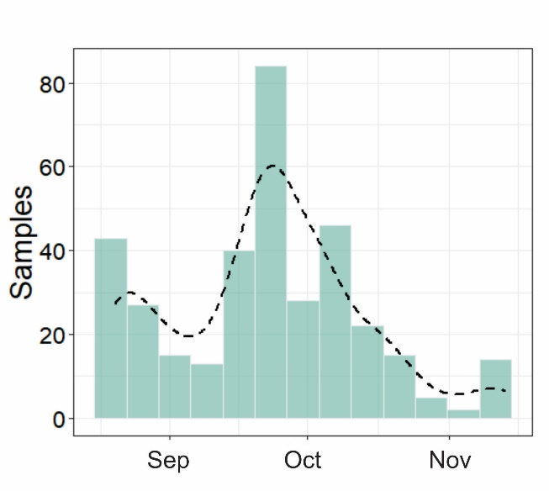
Fig. A1 The number of wings collected weekly during the hunting season starting from 20 Aug onwards.

Table A1 Number of wings collected during the harvest season presented age- and sex-specifically (Ad = adult, Juv = juvenile).
Period of the season | Ad females | Ad males | Juv females | Juv males
20 Aug to 8 Sep | 10 | 21 | 35 | 25
9 Sep to 28 Sep | 27 | 32 | 28 | 53
29 Sep to 18 Oct | 12 | 6 | 35 | 36
19 Oct to 13 Nov | 0 | 3 | 17 | 14

With this same four-period analysis, the δ ²H_{f} values of flight feathers were equally higher in the beginning of the season in juvenile females and males, while the values dropped after the first 20 days (Fig. A2). With adults, however, we found a significant difference between males and females during the first period (Fig. A2). Females had higher values than males in the beginning of the season, while the values equalized in the course of the season. No adult females were however shot in the last period of the season. These results of the putative origin indicate that we can recognise two stages within the harvest season: birds harvested during the early season may differ from the birds harvested after mid-September.
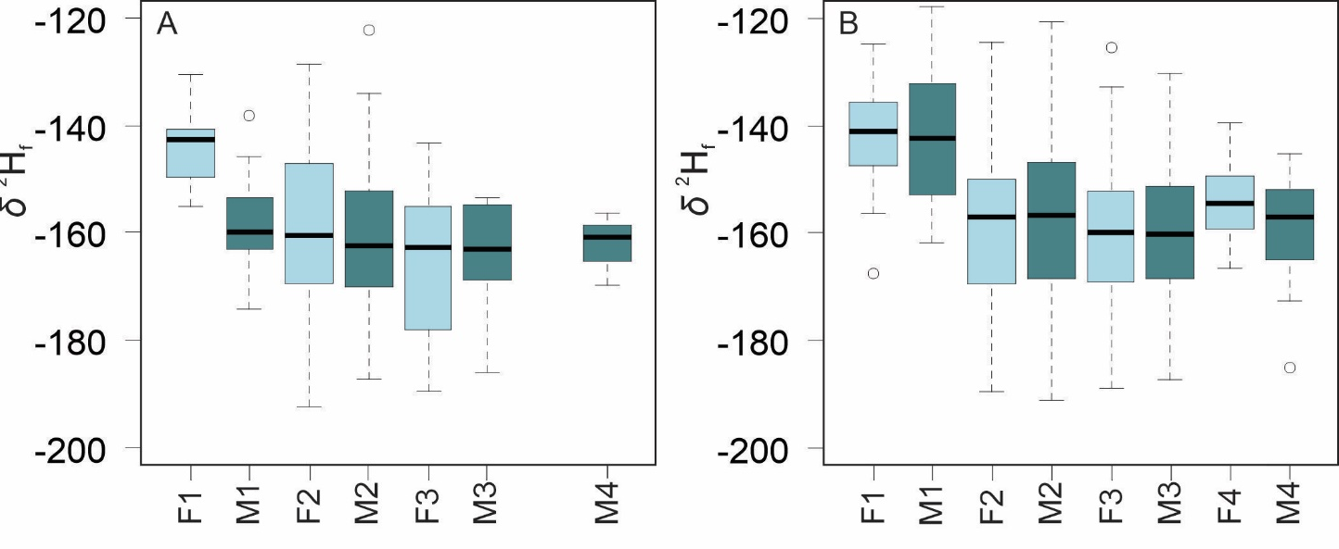
Fig. A2 Data for the relationship between putative origin (δ ²H_{f} values of flight feathers) for wigeons harvested in Finland during autumn 2021 for A) adult and B) juvenile wigeon females (F) and males (M) in the course of the harvest season; 1: 20 Aug to 8 Sep, 2: 9 Sep to 28 Sep 28, 3: 29 Sep to 18 Oct, 4: 19 Oct to 13 Nov. Box plots show the median, interquartile range and whiskers indicate the range. Circles indicate outliers.
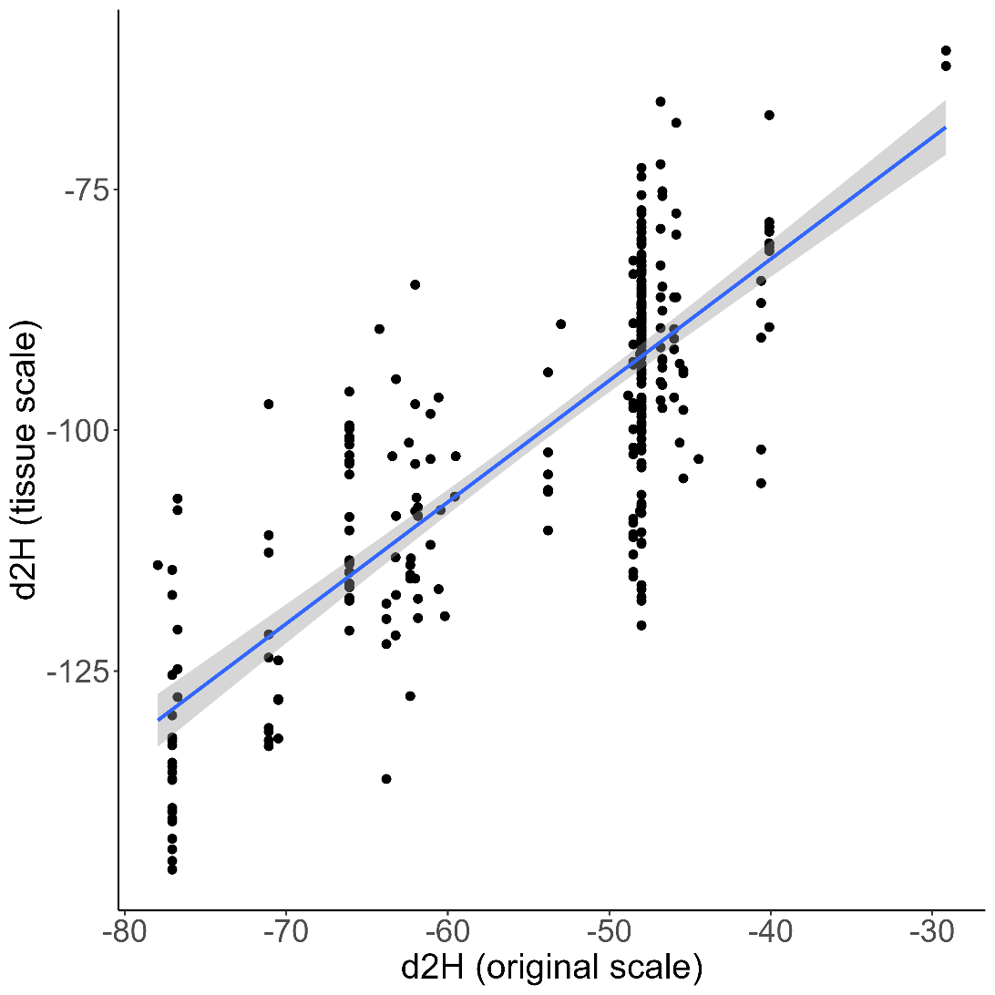
Fig. A3 The estimated relationship between growing-season average δ²H of precipitation and predicted values of δ²H_{f} of wigeon wings.
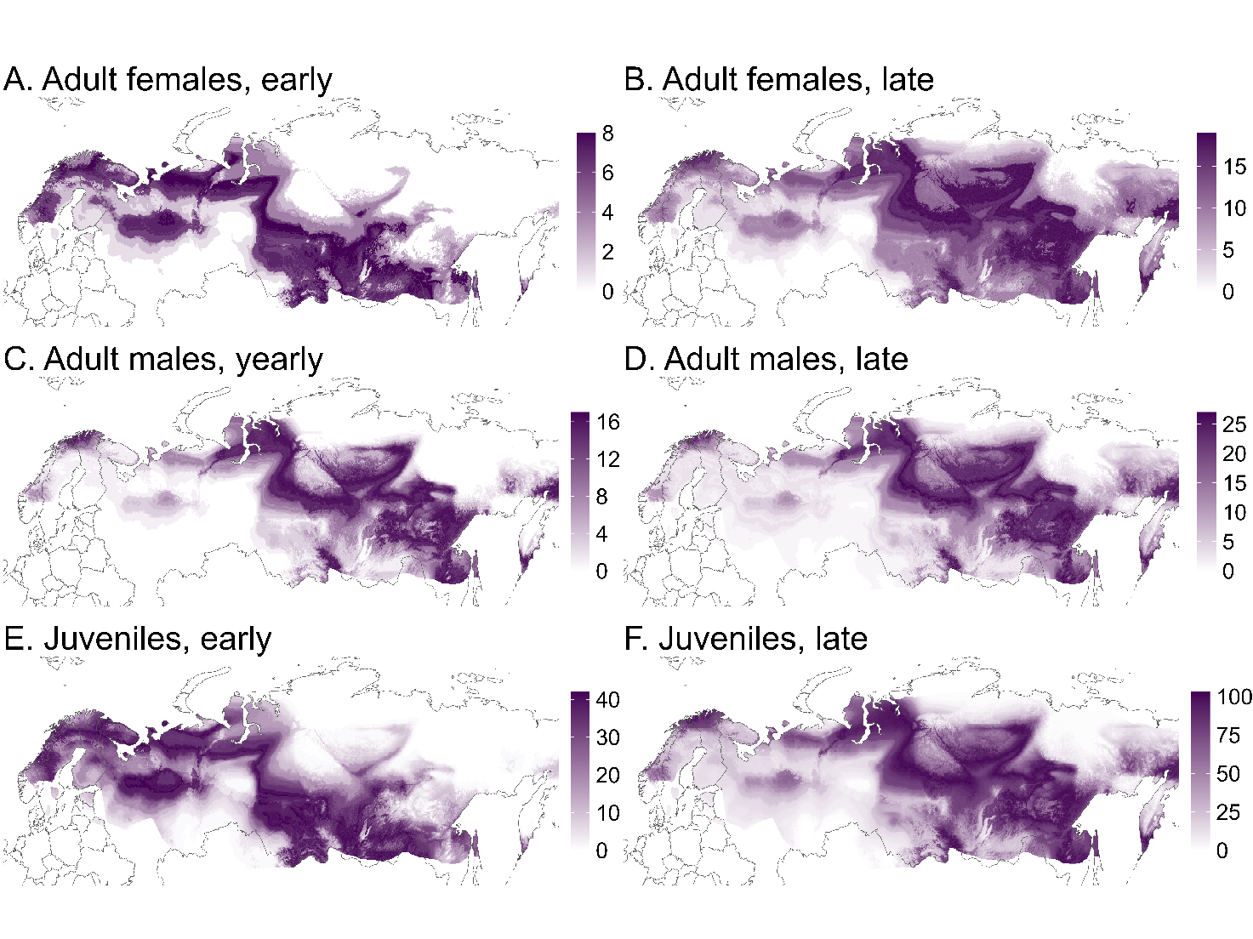
Fig. A4 Geographic distribution of assigned sites of origin for adult female (A-B), adult male (C-D) and juvenile (E-F) wigeons harvested in Finland in 2021. The content of the figure is otherwise similar to Fig. 4, but the assignment of origins is done without using prior information from satellite tracked and ringed birds, meaning that the possible origins cover the entire breeding range of wigeons in Eurasia. Left and right panels show the putative origin for birds harvested in early (20 Aug – 8 Sep) and late (9 Sep – 13 Nov) hunting season respectively. Sample sizes in each subplot are A (n = 10), B (n = 39), C (n = 21), D (n = 41), E (n = 60) and F (n = 183). The darker the colour purple, the more individuals assigned to that pixel, under at 2:1 odds ratio.

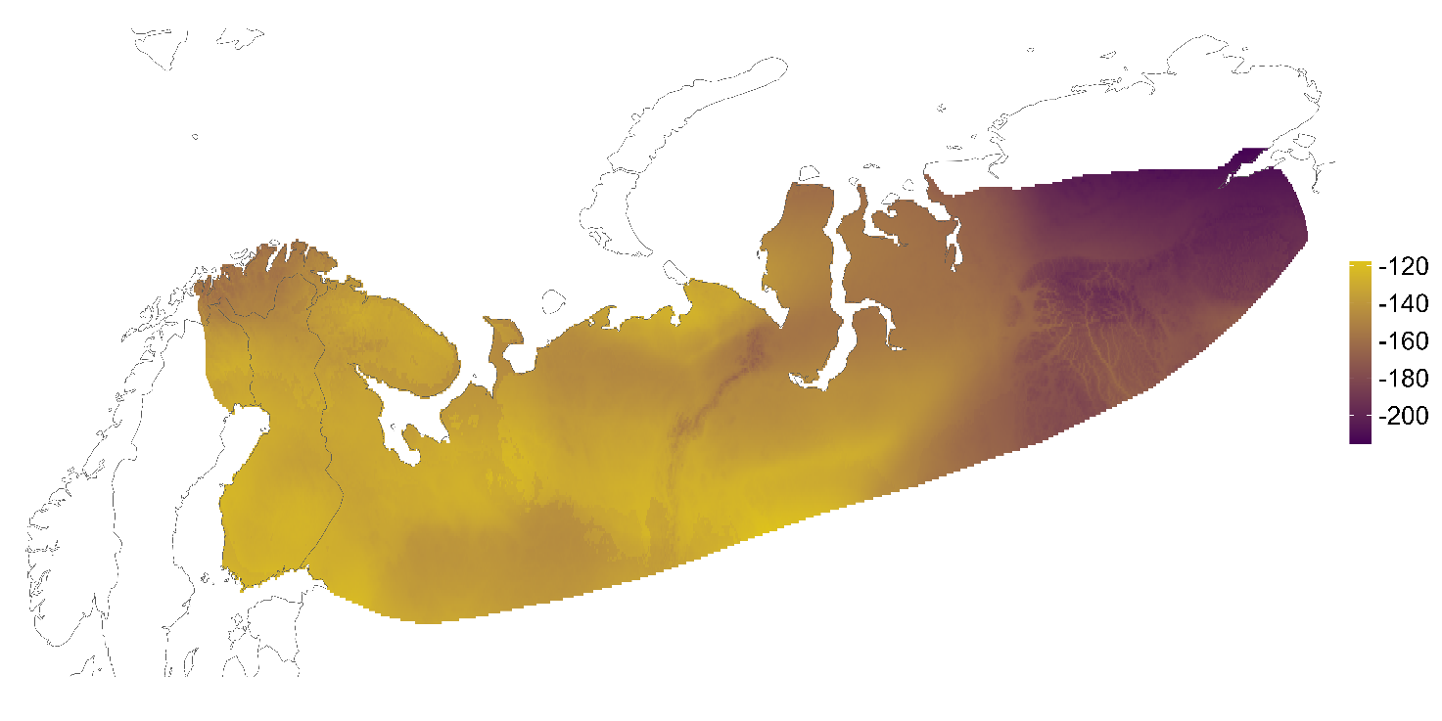
Fig. A5 Calibrated δ²H_{f} isoscape masked and clipped to only represent the region of expected origin. The region is delineated using satellite tracking data and ring recoveries (see the text for details).

Table A2 Raw data for the putative origin (δ ²H_{f} values of flight feathers) for wigeons harvested in Finland during autumn 2021.

SampleID | Age | Sex | VSMOW
1 | juv | male | -143.0
2 | juv | male | -140.0
3 | juv | male | -165.9
4 | juv | male | -154.3
5 | juv | male | -166.3
6 | juv | male | -160.0
7 | ad | female | -146.2
8 | juv | female | -138.8
9 | juv | male | -152.2
10 | juv | female | -165.6
11 | juv | female | -154.3
12 | juv | male | -183.5
13 | juv | male | -162.2
14 | juv | female | -161.6
15 | ad | male | -169.5
16 | juv | male | -148.4
17 | ad | male | -136.9
18 | ad | female | -140.8
19 | ad | female | -142.9
20 | ad | male | -174.0
21 | juv | female | -124.3
22 | juv | male | -168.5
23 | juv | male | -147.7
24 | juv | male | -155.8
25 | juv | male | -163.5
26 | ad | female | -167.7
27 | ad | male | -175.6
28 | ad | female | -162.3
29 | ad | male | -152.9
30 | juv | male | -120.7
31 | juv | male | -123.0
32 | ad | male | -151.5
33 | ad | male | -169.0
34 | ad | male | -143.9
35 | juv | male | -158.1
36 | juv | female | -164.9
37 | ad | male | -161.9
38 | ad | female | -175.7
39 | ad | female | -151.2
40 | ad | male | -134.0
41 | ad | female | -132.0
42 | ad | male | -151.0
43 | ad | female | -159.6
44 | juv | male | -125.9
45 | ad | female | -155.4
46 | ad | male | -153.5
47 | ad | male | -122.2
48 | ad | female | -162.6
49 | ad | female | -128.7
50 | ad | female | -147.7
51 | ad | male | -164.0
52 | ad | female | -177.2
53 | ad | male | -160.9
54 | juv | female | -164.7
55 | juv | female | -174.7
56 | juv | female | -189.0
57 | juv | female | -159.4
58 | juv | female | -161.2
59 | juv | male | -130.0
60 | juv | female | -172.3
61 | juv | female | -145.9
62 | juv | female | -183.0
63 | juv | male | -169.5
64 | ad | male | -164.7
65 | juv | female | -173.6
66 | ad | female | -173.7
67 | juv | male | -160.1
68 | ad | female | -179.8
69 | juv | male | -166.3
70 | ad | female | -176.2
71 | ad | female | -161.8
72 | juv | female | -132.8
73 | juv | male | -163.5
74 | juv | male | -169.8
75 | ad | male | -186.2
76 | ad | female | -189.7
77 | ad | female | -154.7
78 | juv | female | -169.2
79 | juv | female | -134.4
80 | ad | male | -153.5
81 | juv | male | -167.7
82 | ad | female | -188.0
83 | juv | female | -143.7
84 | juv | female | -183.4
85 | juv | male | -167.4
86 | ad | female | -155.3
87 | ad | female | -192.5
88 | juv | male | -178.1
89 | juv | female | -169.7
90 | ad | male | -154.9
91 | juv | male | -178.3
92 | juv | male | -167.1
93 | juv | male | -187.2
94 | juv | female | -152.6
95 | juv | female | -177.0
96 | ad | male | -161.2
97 | juv | male | -149.0
98 | juv | female | -157.8
99 | juv | male | -140.7
100 | juv | female | -156.9
101 | juv | male | -164.9
102 | juv | female | -161.4
103 | juv | female | -149.2
104 | juv | female | -164.5
105 | juv | female | -152.3
106 | juv | male | -147.8
107 | juv | male | -145.3
108 | juv | male | -172.8
109 | juv | female | -156.5
110 | juv | male | -163.8
111 | juv | female | -149.0
112 | juv | male | -156.1
113 | juv | female | -136.0
114 | juv | male | -152.0
115 | juv | male | -139.0
116 | juv | female | -161.2
117 | juv | female | -158.6
118 | juv | male | -169.7
119 | juv | female | -169.0
120 | ad | male | -147.5
121 | juv | male | -177.2
122 | juv | male | -139.4
123 | juv | male | -163.8
124 | juv | female | -154.3
125 | juv | female | -150.3
126 | juv | male | -141.2
127 | juv | male | -153.4
128 | ad | male | -178.2
129 | ad | female | -171.2
130 | juv | male | -178.1
131 | juv | male | -169.5
132 | ad | female | -145.1
133 | juv | female | -152.1
134 | ad | male | -168.7
135 | juv | female | -142.5
136 | ad | female | -161.3
137 | ad | female | -169.2
138 | juv | female | -156.7
139 | juv | female | -149.4
140 | juv | male | -128.7
141 | ad | female | -169.8
142 | ad | female | -153.0
143 | ad | female | -159.4
144 | ad | male | -170.7
145 | ad | male | -169.8
146 | juv | male | -185.2
147 | juv | male | -158.0
148 | juv | female | -149.3
149 | juv | female | -136.5
150 | juv | female | -158.3
151 | juv | female | -125.1
152 | ad | male | -160.0
153 | ad | female | -140.8
154 | ad | female | -148.1
155 | ad | male | -162.8
156 | ad | male | -152.7
157 | ad | male | -166.1
158 | juv | male | -162.1
159 | juv | female | -164.1
160 | juv | male | -191.1
161 | juv | male | -123.7
162 | juv | male | -144.0
163 | juv | male | -171.7
164 | juv | female | -158.7
165 | juv | female | -170.6
166 | juv | male | -157.5
167 | juv | male | -152.3
168 | juv | male | -152.8
169 | juv | male | -146.9
170 | juv | female | -172.7
171 | ad | male | -148.3
172 | juv | female | -163.5
173 | juv | male | -149.0
174 | juv | female | -182.7
175 | juv | female | -156.5
176 | juv | male | -146.5
177 | juv | male | -169.6
178 | juv | male | -162.3
179 | juv | male | -145.4
180 | juv | female | -157.3
181 | juv | female | -158.1
182 | juv | female | -168.4
183 | ad | female | -143.1
184 | juv | male | -151.7
185 | juv | male | -161.8
186 | juv | male | -159.7
187 | juv | female | -156.1
188 | juv | male | -172.1
190 | ad | female | -161.4
191 | ad | female | -162.9
192 | ad | female | -142.6
193 | juv | male | -146.5
194 | juv | female | -148.0
195 | juv | female | -134.1
196 | juv | female | -137.9
197 | juv | male | -132.1
198 | juv | female | -148.8
199 | juv | male | -155.0
200 | juv | male | -144.5
201 | juv | female | -138.7
202 | juv | female | -156.5
203 | juv | male | -143.4
204 | juv | female | -142.4
205 | juv | female | -137.7
206 | juv | female | -142.6
207 | juv | female | -140.5
208 | juv | female | -144.0
209 | juv | male | -135.1
210 | juv | male | -131.9
211 | juv | female | -139.2
212 | juv | female | -141.8
213 | juv | male | -158.6
214 | juv | female | -144.3
215 | juv | male | -134.2
216 | juv | female | -143.1
217 | juv | female | -155.0
218 | juv | male | -156.2
219 | juv | female | -159.7
220 | juv | female | -125.3
221 | ad | male | -160.7
222 | ad | male | -156.5
223 | juv | male | -156.0
224 | juv | female | -139.5
225 | juv | male | -152.0
226 | ad | male | -166.6
227 | juv | female | -169.4
228 | juv | male | -127.4
229 | juv | male | -129.8
230 | juv | male | -129.4
231 | juv | female | -124.6
232 | juv | male | -144.3
233 | juv | male | -124.1
234 | juv | female | -129.2
235 | ad | male | -177.4
236 | juv | female | -152.0
237 | juv | male | -169.0
238 | juv | female | -144.4
239 | juv | male | -142.6
240 | ad | female | -165.5
241 | juv | female | -156.6
242 | juv | male | -168.8
243 | juv | male | -172.7
244 | juv | male | -168.2
245 | ad | male | -145.8
246 | juv | female | -151.6
247 | ad | male | -147.0
248 | ad | male | -138.3
249 | ad | female | -155.2
250 | juv | male | -154.2
251 | ad | female | -154.0
252 | juv | female | -149.2
253 | ad | male | -157.8
254 | juv | female | -161.6
255 | juv | male | -147.7
256 | juv | male | -179.2
257 | juv | female | -176.2
258 | juv | female | -160.2
259 | juv | female | -141.1
260 | juv | female | -150.9
261 | ad | male | -173.5
262 | juv | female | -169.7
263 | juv | male | -163.3
264 | juv | male | -150.2
265 | ad | male | -154.6
266 | juv | female | -170.6
267 | ad | male | -165.4
268 | juv | male | -165.1
269 | juv | male | -116.2
270 | juv | male | -157.1
271 | juv | male | -153.6
272 | juv | male | -163.7
273 | juv | male | -159.3
274 | ad | male | -157.1
275 | juv | male | -134.2
276 | ad | female | -146.5
277 | ad | male | -168.7
278 | juv | male | -148.4
279 | juv | male | -153.1
280 | juv | male | -154.4
281 | ad | female | -168.9
282 | juv | female | -150.1
283 | ad | male | -172.5
284 | juv | male | -136.9
285 | juv | male | -124.4
286 | juv | male | -154.7
287 | juv | male | -143.3
288 | ad | male | -164.1
289 | juv | male | -167.9
290 | juv | male | -152.3
291 | ad | female | -130.5
292 | juv | female | -140.3
293 | juv | female | -167.7
294 | juv | male | -142.9
295 | juv | male | -135.1
296 | ad | male | -153.5
297 | ad | male | -171.2
298 | ad | male | -164.2
299 | juv | male | -155.9
300 | ad | male | -181.2
301 | juv | male | -175.8
302 | ad | male | -162.1
303 | juv | male | -162.7
304 | ad | female | -140.6
305 | juv | male | -156.7
306 | ad | male | -153.2
307 | ad | male | -167.1
308 | ad | male | -163.0
309 | ad | male | -174.1
310 | ad | male | -168.5
311 | ad | male | -155.0
312 | ad | male | -157.9
313 | ad | male | -151.1
314 | juv | female | -125.1
315 | juv | male | -157.0
316 | juv | female | -148.7
317 | juv | female | -149.3
318 | ad | male | -173.8
319 | ad | male | -165.6
320 | ad | male | -187.5
321 | juv | male | -153.7
322 | juv | male | -145.5
323 | juv | female | -166.4
324 | juv | female | -210.6
325 | juv | male | -153.2
326 | juv | male | -167.2
327 | juv | female | -176.1
328 | juv | female | -171.2
329 | ad | female | -173.9
330 | juv | male | -150.7
331 | juv | female | -155.7
332 | juv | male | -167.5
333 | juv | male | -154.5
334 | juv | male | -175.3
335 | juv | female | -131.7
336 | ad | female | -136.2
337 | juv | female | -143.3
338 | juv | male | -117.7
339 | juv | female | -144.3
340 | juv | male | -152.9
341 | juv | female | -149.5
342 | ad | female | -142.6
343 | juv | male | -149.2
344 | juv | male | -139.2
345 | juv | female | -166.6
346 | juv | male | -164.2
347 | juv | male | -150.5
348 | juv | male | -148.2
349 | ad | female | -184.6
350 | juv | female | -149.9
351 | juv | female | -150.1
352 | juv | male | -133.8
353 | juv | male | -139.7
354 | juv | female | -135.3
355 | juv | female | -129.0
356 | juv | female | -135.1
357 | juv | female | -138.3
358 | juv | female | -147.0
359 | juv | male | -134.5
360 | juv | male | -171.1
361 | juv | female | -154.6
362 | juv | male | -172.2
363 | juv | female | -189.6
364 | juv | male | -150.8
365 | ad | female | -136.8
366 | ad | male | -154.9
367 | ad | female | -141.4
368 | ad | male | -161.5
369 | juv | male | -163.9
370 | juv | female | -140.6
371 | juv | male | -151.4
372 | ad | female | -152.5
373 | juv | male | -156.6
374 | juv | male | -172.8
375 | juv | female | -150.2
376 | ad | male | -155.3
377 | ad | male | -161.3
378 | ad | male | -159.8
379 | ad | male | -165.4
380 | ad | female | -149.8
381 | juv | female | -139.9
382 | ad | male | -162.9
383 | juv | male | -141.9
384 | ad | male | -162.8

