Hunting bag statistics of wild mammals in Portugal (1989-2022): on the need to improve data report and compilation

Supplementary information
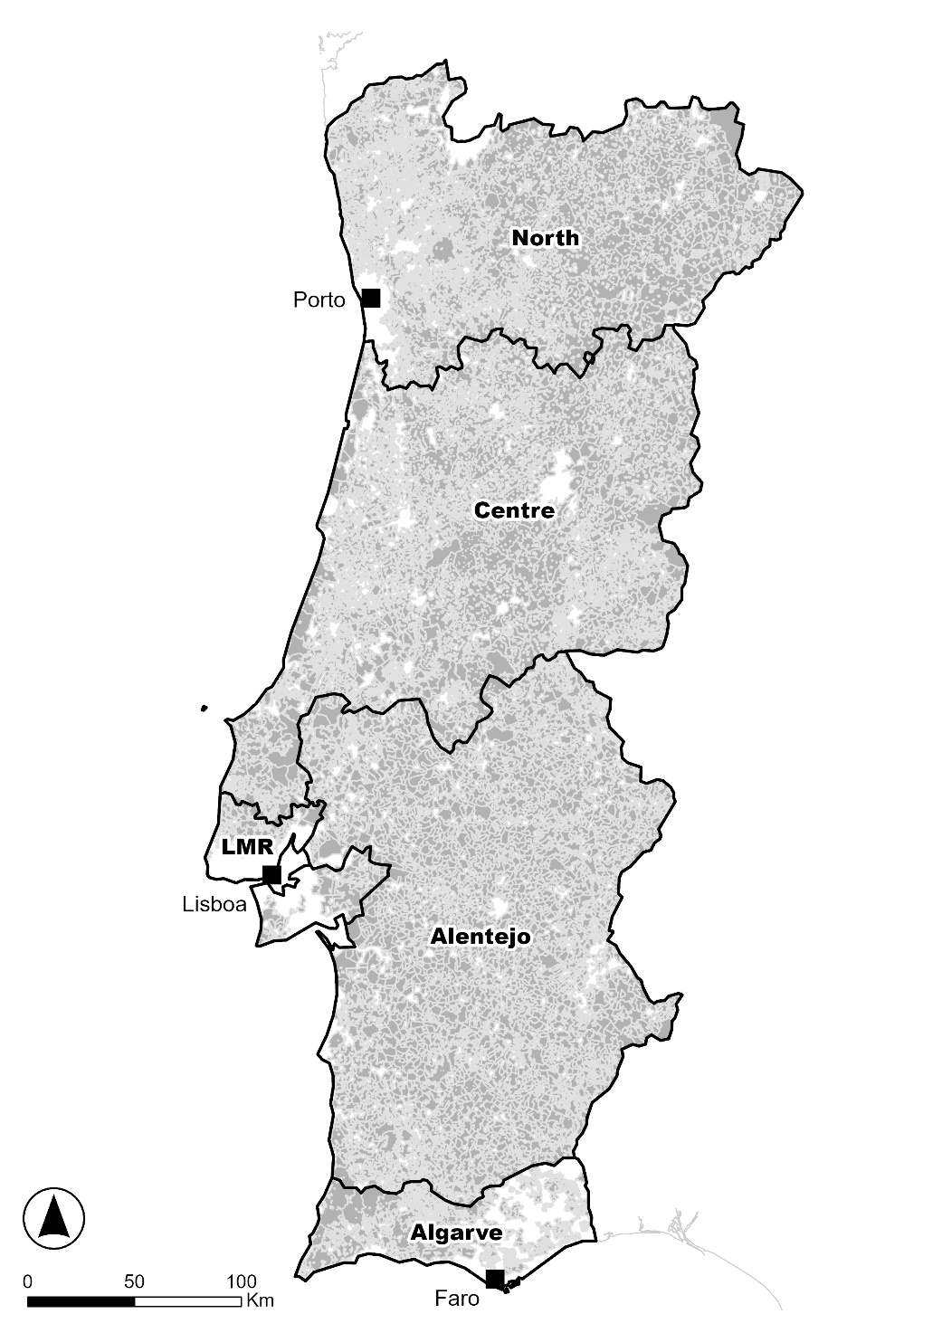

Figure S1 – Mainland Portugal with mention to the main regions (NUTSII from the French version Nomenclature des Unités Territoriales Statistiques). *LMR - Lisbon Metropolitan Region.
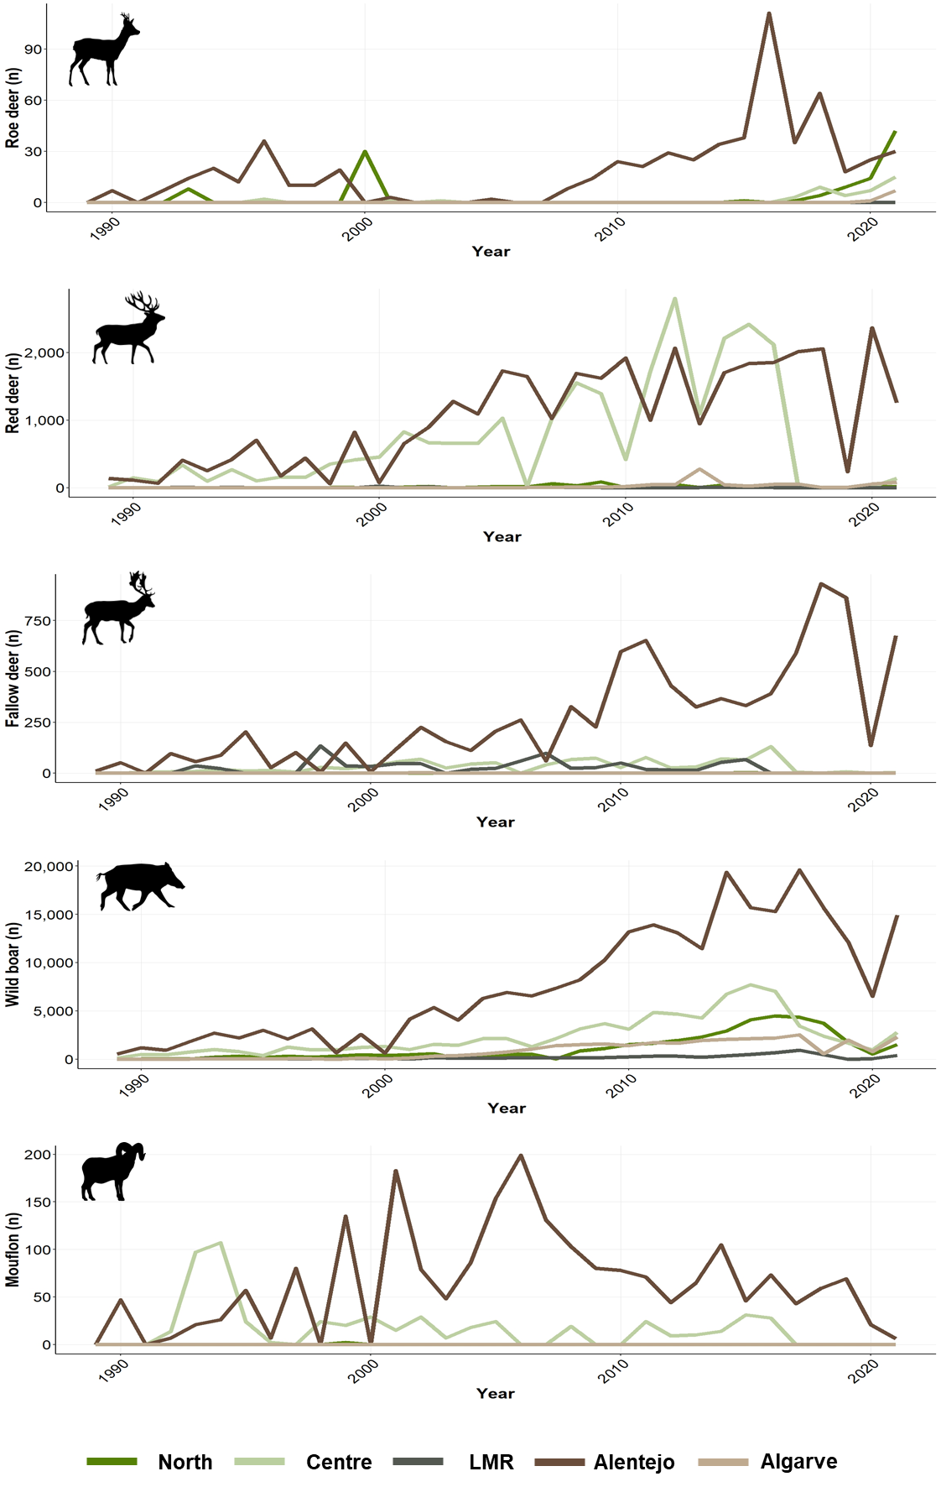

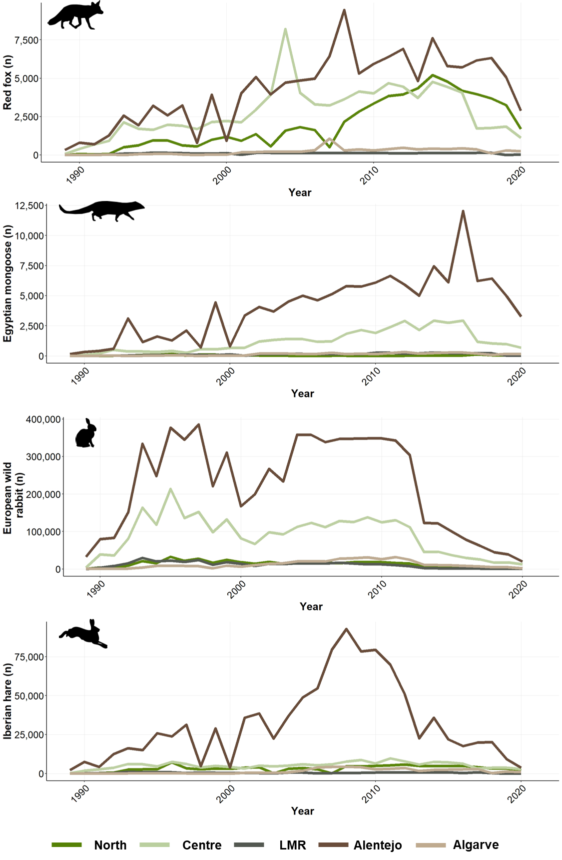

Figure S2 – Temporal trends per region (North, Centre, LMR – Lisbon Metropolitan Region, Alentejo, Algarve) in the number of wild ungulates (roe deer, red deer, fallow deer, wild boar, mouflon), wild carnivores (red fox, Egyptian mongoose) and lagomorphs (European wild rabbit and Iberian hare) legally harvested and reported between 1989 and 2022.

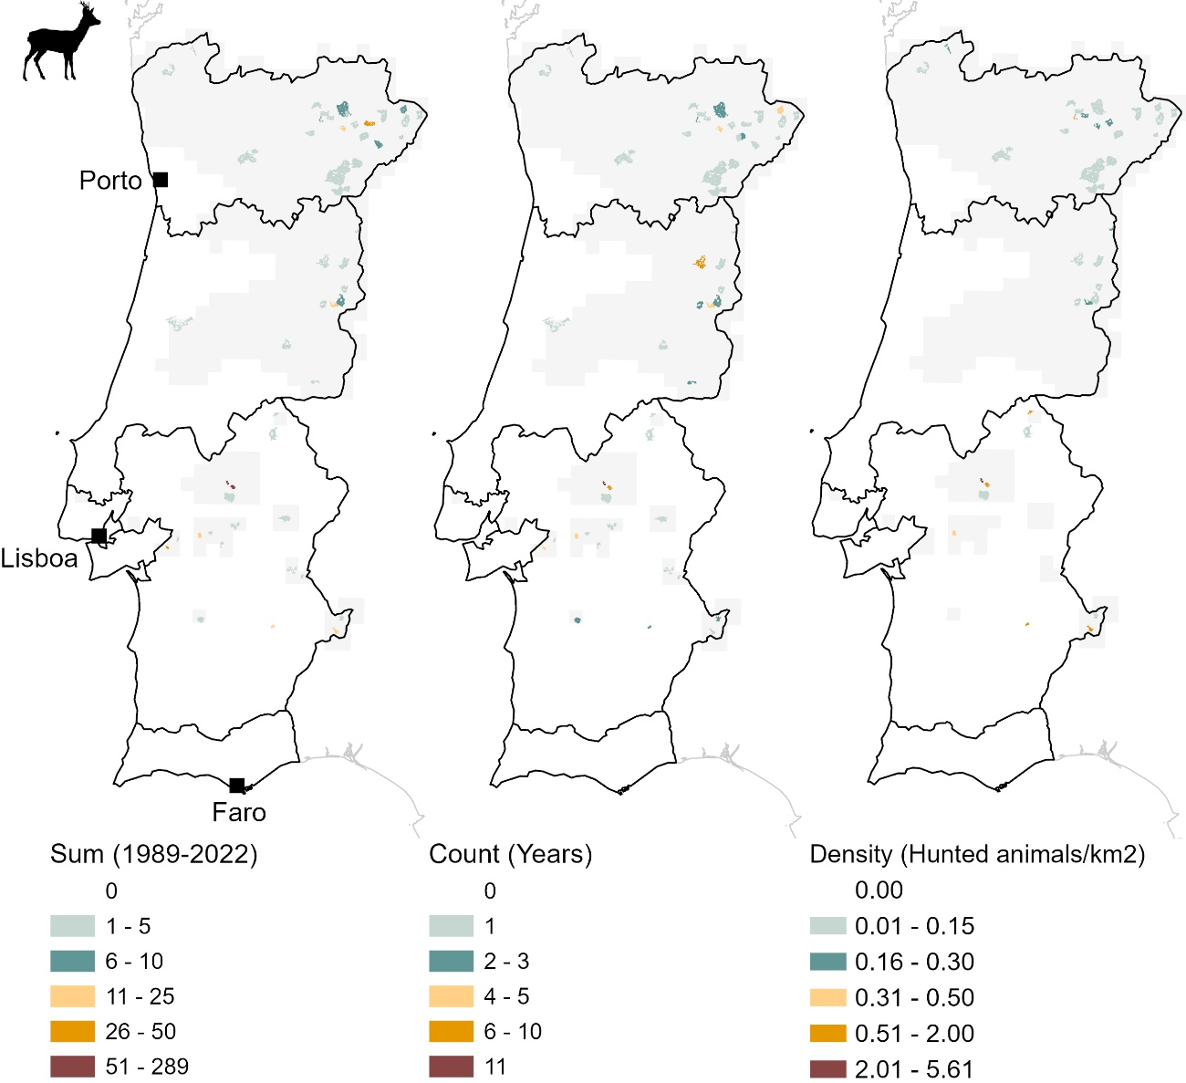
Figure S3 – Hunting bag statistics at hunting ground level (Roe deer Capreolus capreolus). Total number of animals harvested between 1989 and 2022 (left), number of years for which data are available (centre) and the average density of harvested animals between 2012/2013 and 2021/2022 (10 years, right). The ten-year time window for the average density of hunted animals does not cover the entire period of analysis (1989-2022), so some hunting areas are not depicted probably due to poor data reporting. Light grey depicts roe deer distribution at national scale (Fonseca et al., 2019; Torres et al., 2023a).

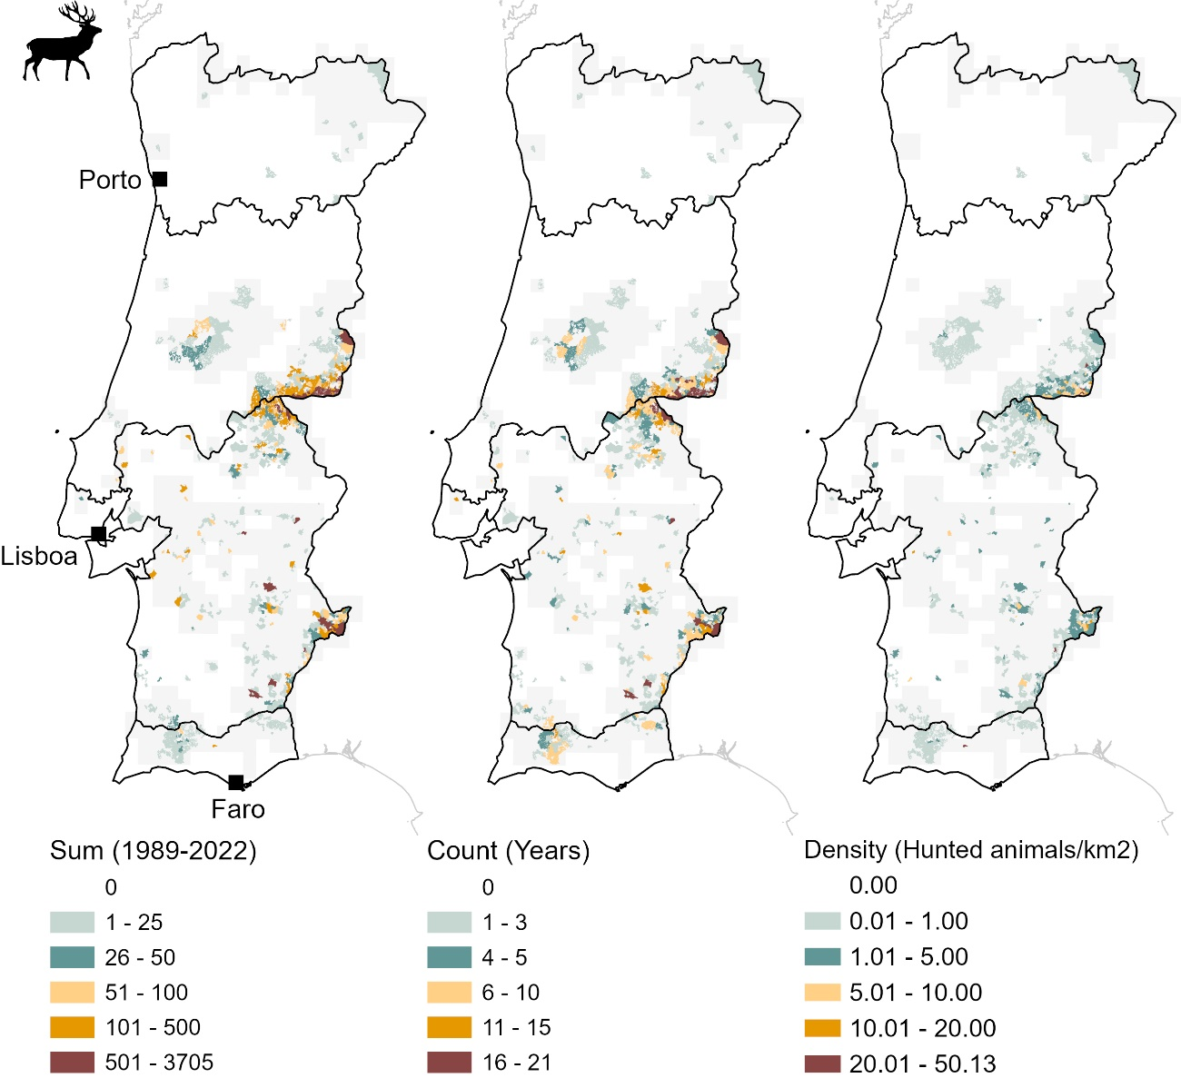
Figure S4 – Hunting bag statistics at hunting ground level (red deer Cervus elaphus). Total number of animals harvested between 1989 and 2022 (left), number of years for which data are available (centre) and the average density of harvested animals between 2012/2013 and 2021/2022 (10 years, right). The ten-year time window for the average density of hunted animals does not cover the entire period of analysis (1989-2022), so some hunting areas are not depicted probably due to poor data reporting. Light grey depicts red deer distribution at national scale (Fonseca et al., 2019; Carvalho et al., 2023a).

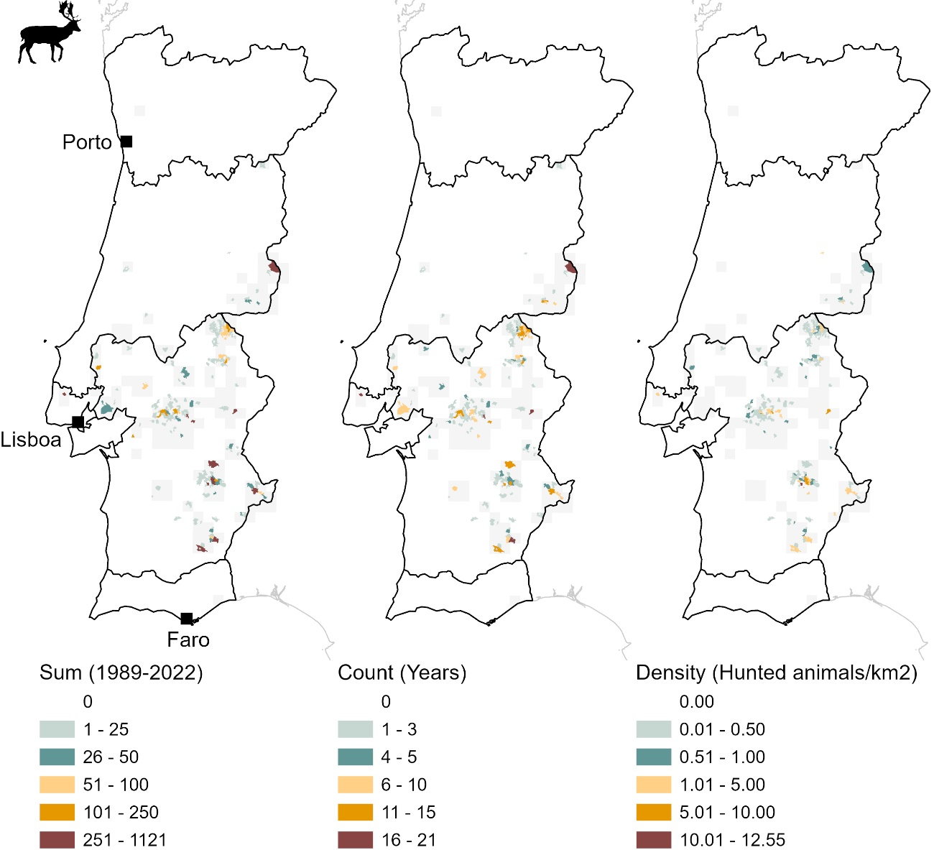
Figure S5 – Hunting bag statistics at hunting ground level (fallow deer Dama dama). Total number of animals harvested between 1989 and 2022 (left), number of years for which data are available (centre) and the average density of harvested animals between 2012/2013 and 2021/2022 (10 years, right). The ten-year time window for the average density of hunted animals does not cover the entire period of analysis (1989-2022), so some hunting areas are not depicted probably due to poor data reporting. Light grey depicts fallow deer distribution at national scale (Fonseca et al., 2019; Carvalho et al., 2023b).

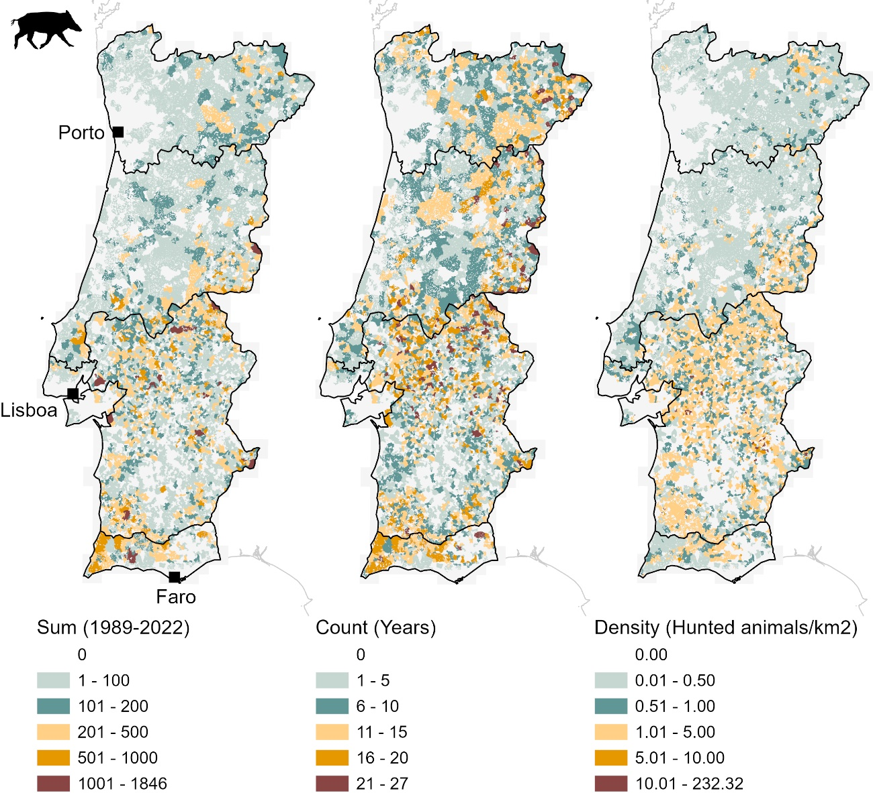
Figure S6 – Hunting bag statistics at hunting ground level (wild boar Sus scrofa). Total number of animals harvested between 1989 and 2022 (left), number of years for which data are available (centre) and the average density of harvested animals between 2012/2013 and 2021/2022 (10 years, right). The ten-year time window for the average density of hunted animals does not cover the entire period of analysis (1989-2022), so some hunting areas are not depicted probably due to poor data reporting. Light grey depicts wild boar distribution at national scale (Fonseca et al., 2019; Fonseca et al., 2023).

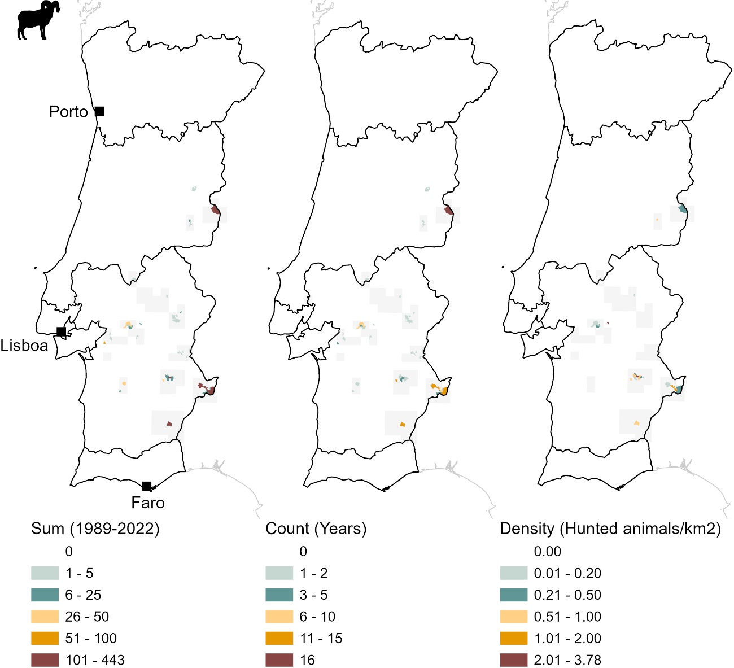
Figure S7 – Hunting bag statistics at hunting ground level (mouflon Ovis aries). Total number of animals harvested between 1989 and 2022 (left), number of years for which data are available (centre) and the average density of harvested animals between 2012/2013 and 2021/2022 (10 years, right). The ten-year time window for the average density of hunted animals does not cover the entire period of analysis (1989-2022), so some hunting areas are not depicted probably due to poor data reporting. Light grey depicts mouflon distribution at national scale (Fonseca et al., 2019; Torres et al., 2023b).

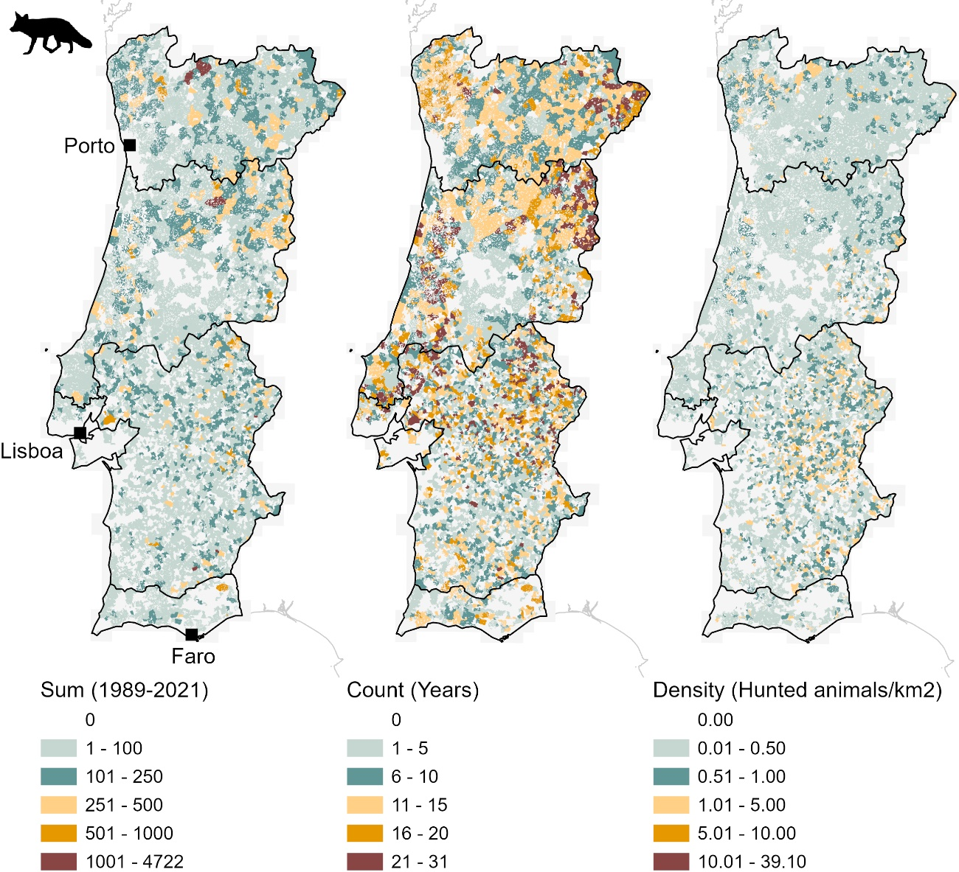
Figure S8 – Hunting bag statistics at hunting ground level (red fox Vulpes vulpes). Total number of animals harvested between 1989 and 2022 (left), number of years for which data are available (centre) and the average density of harvested animals between 2012/2013 and 2021/2022 (10 years, right). The ten-year time window for the average density of hunted animals does not cover the entire period of analysis (1989-2022), so some hunting areas are not depicted probably due to poor data reporting. Light grey depicts red fox distribution at national scale (Álvares et al., 2019; Negrões et al., 2023).

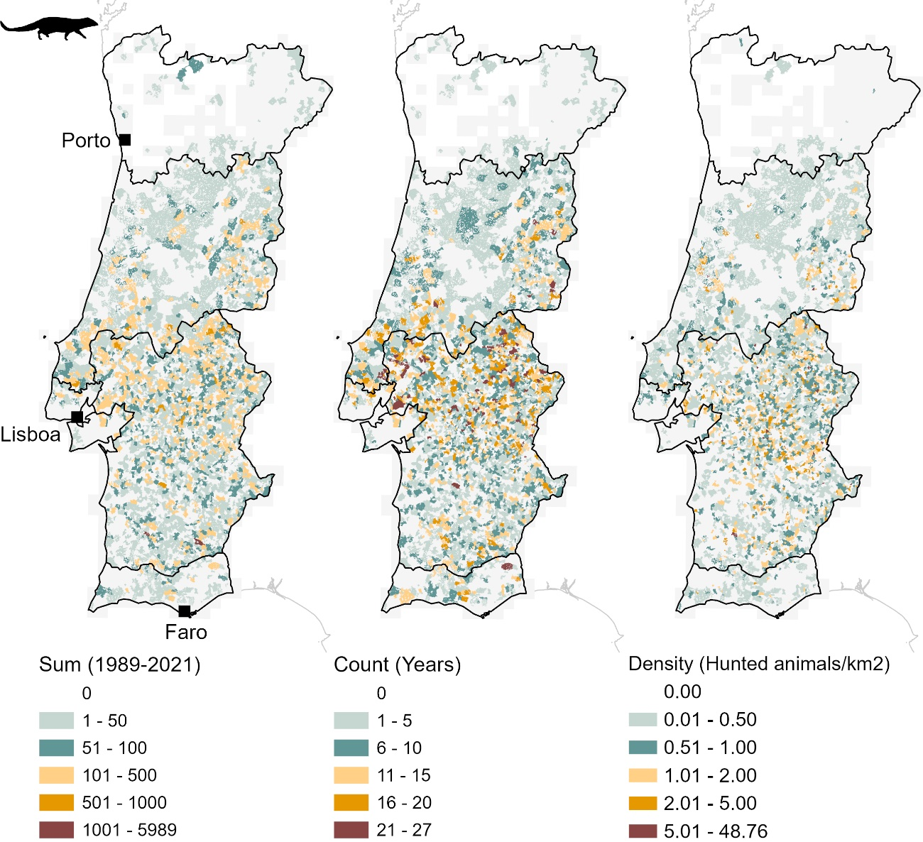
Figure S9 – Hunting bag statistics at hunting ground level (Egyptian mongoose Herpestes ichneumon). Total number of animals harvested between 1989 and 2022 (left), number of years for which data are available (centre) and the average density of harvested animals between 2012/2013 and 2021/2022 (10 years, right). The ten-year time window for the average density of hunted animals does not cover the entire period of analysis (1989-2022), so some hunting areas are not depicted probably due to poor data reporting. Light grey depicts Egyptian mongoose distribution at national scale (Álvares et al., 2019; Bandeira & Rosalino, 2023).

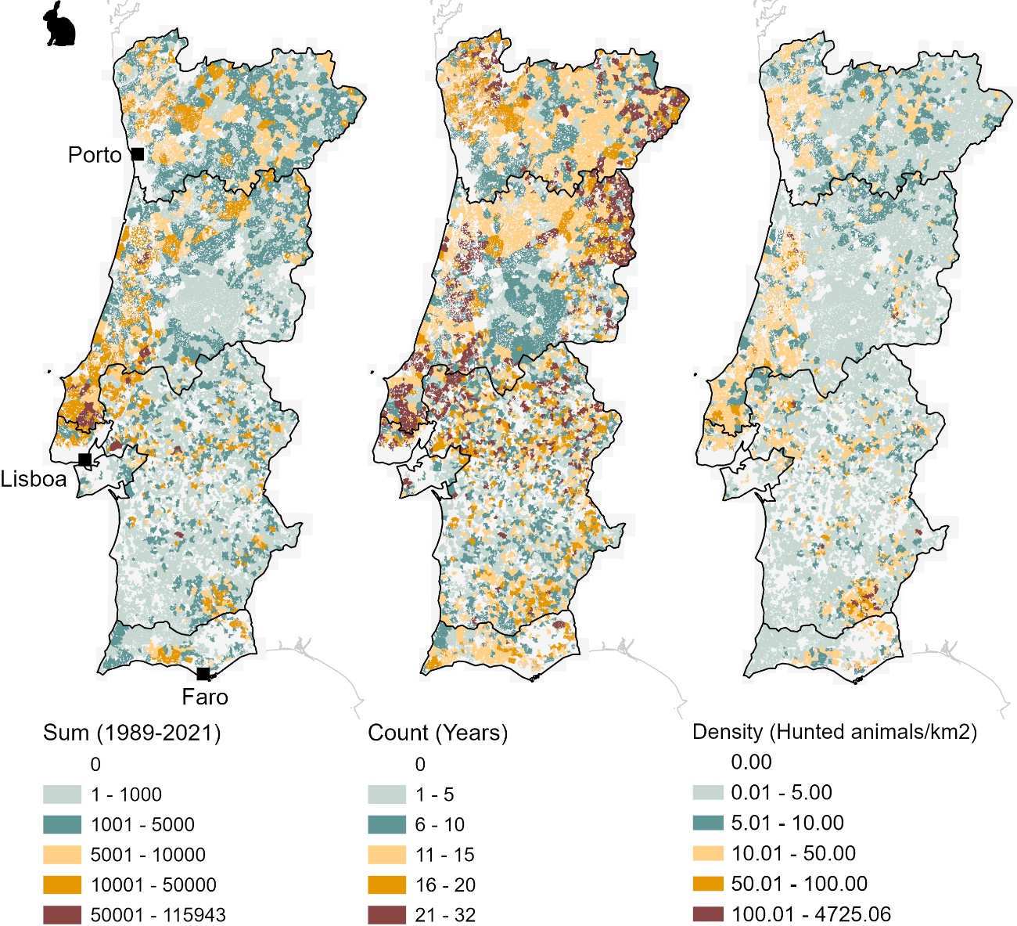
Figure S10 – Hunting bag statistics at hunting ground level (European wild rabbit Oryctolagus cuniculus). Total number of animals harvested between 1989 and 2022 (left), number of years for which data are available (centre) and the average density of harvested animals between 2012/2013 and 2021/2022 (10 years, right). The ten-year time window for the average density of hunted animals does not cover the entire period of analysis (1989-2022), so some hunting areas are not depicted probably due to poor data reporting. Light grey depicts European wild rabbit distribution at national scale (Ferreira et al., 2019; Mira et al., 2023a).

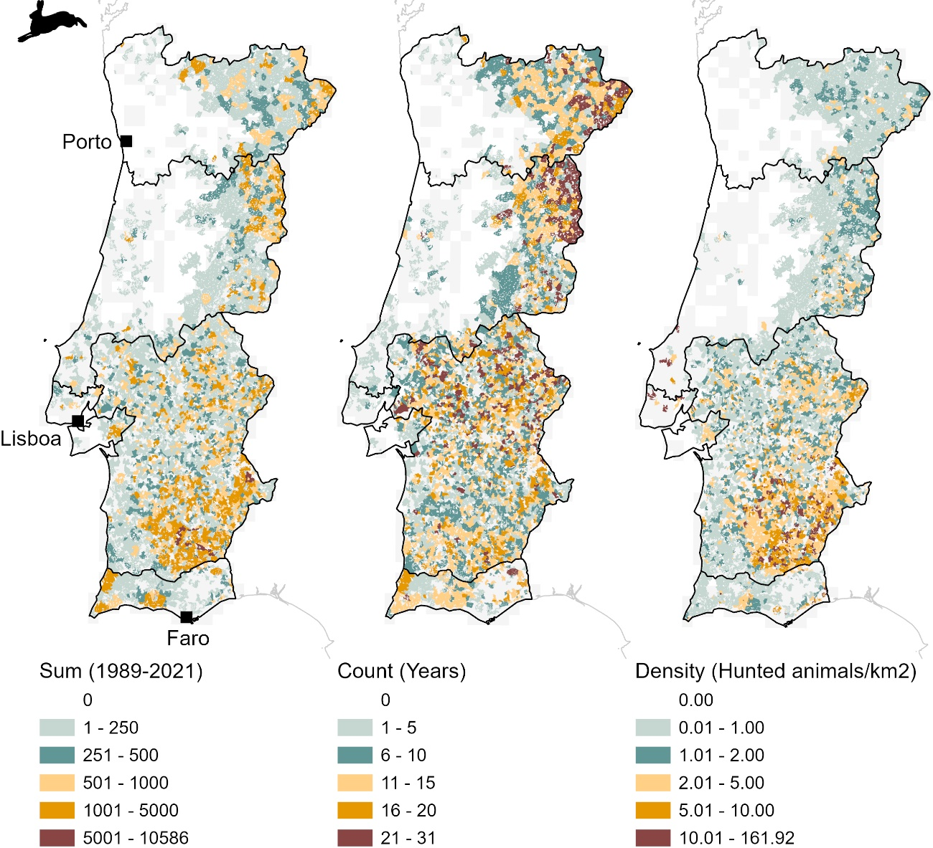
Figure S11 – Hunting bag statistics at hunting ground level (Iberian hare Lepus granatensis). Total number of animals harvested between 1989 and 2022 (left), number of years for which data are available (centre) and the average density of harvested animals between 2012/2013 and 2021/2022 (10 years, right). The ten-year time window for the average density of hunted animals does not cover the entire period of analysis (1989-2022), so some hunting areas are not depicted probably due to poor data reporting. Light grey depicts Iberian hare distribution at national scale (Ferreira et al., 2019; Mira et al., 2023b).

Table S1 – Number of wild ungulates (roe deer, red deer, fallow deer, wild boar, mouflon), wild carnivores (red fox, Egyptian mongoose) and lagomorphs (European wild rabbit and Iberian hare) legally harvested and reported between 1989 and 2022 in mainland Portugal.
Year | Roe deer (Capreolus capreolus) | Red deer (Cervus elaphus) | Fallow deer (Dama dama) | Wild boar (Sus scrofa) | Mouflon (Ovis aries) | Red fox (Vulpes vulpes) | Egyptian mongoose (Herpestes ichneumon) | European wild rabbit (Oryctolagus cuniculus) | Iberian hare (Lepus granatensis)
1989/1990 | 0 | 151 | 9 | 931 | 0 | 633 | 340 | 51,891 | 4,086
1990/1991 | 7 | 260 | 51 | 2,484 | 47 | 2,021 | 1,056 | 214,233 | 14,030
1991/1992 | 0 | 157 | 4 | 2,276 | 0 | 2,089 | 1,012 | 245,360 | 10,781
1992/1993 | 7 | 347 | 103 | 3,884 | 21 | 3,717 | 1,594 | 411,133 | 24,608
1993/1994 | 22 | 751 | 99 | 6,317 | 118 | 8,758 | 4,414 | 880,896 | 39,478
1994/1995 | 20 | 692 | 128 | 5,324 | 133 | 7,228 | 2,596 | 644,256 | 37,718
1995/1996 | 12 | 1,032 | 248 | 7,703 | 81 | 8,968 | 3,132 | 1,025,382 | 54,471
1996/1997 | 38 | 605 | 97 | 7,114 | 9 | 9,158 | 3,119 | 859,421 | 58,178
1997/1998 | 10 | 592 | 105 | 6,271 | 80 | 8,773 | 3,935 | 934,338 | 60,497
1998/1999 | 10 | 409 | 166 | 2,857 | 24 | 4,463 | 1,818 | 551,265 | 15,421
1999/2000 | 19 | 1240 | 206 | 6,512 | 157 | 9,560 | 6,499 | 751,951 | 55,429
2000/2001 | 30 | 551 | 72 | 3,617 | 29 | 5,812 | 2,196 | 461,774 | 16,064
2001/2002 | 4 | 1481 | 217 | 8,669 | 198 | 10,415 | 5,981 | 440,506 | 58,262
2002/2003 | 0 | 1596 | 341 | 11,576 | 108 | 13,020 | 7,630 | 572,776 | 64,616
2003/2004 | 1 | 1934 | 180 | 8,809 | 55 | 11,335 | 7,290 | 519,695 | 40,061
2004/2005 | 0 | 1756 | 174 | 12,872 | 104 | 17,947 | 8,129 | 695,548 | 63,264
2005/2006 | 2 | 2774 | 281 | 14,323 | 178 | 14,277 | 14,992 | 705,152 | 81,803
2006/2007 | 0 | 1680 | 321 | 12,548 | 199 | 16,903 | 7,983 | 668,530 | 89,032
2007/2008 | 0 | 2108 | 198 | 13,869 | 131 | 14,195 | 8,828 | 758,049 | 115,057
2008/2009 | 8 | 3289 | 416 | 16,826 | 122 | 18,240 | 9,597 | 791,950 | 132,825
2009/2010 | 14 | 3109 | 328 | 20,102 | 80 | 15,002 | 9,767 | 858,837 | 113,239
2010/2011 | 24 | 2361 | 674 | 23,043 | 78 | 16,031 | 9,822 | 876,929 | 109,833
2011/2012 | 21 | 4951 | 747 | 25,608 | 95 | 17,483 | 10,784 | 896,038 | 99,460
2012/2013 | 29 | 2810 | 470 | 24,082 | 53 | 17,437 | 10,279 | 781,757 | 76,309
2013/2014 | 25 | 2323 | 368 | 22,233 | 75 | 14,656 | 8,208 | 340,144 | 38,429
2014/2015 | 34 | 3998 | 490 | 33,560 | 119 | 19,316 | 11,701 | 335,361 | 54,348
2015/2016 | 39 | 4299 | 464 | 31,790 | 77 | 16,460 | 9,906 | 285,262 | 39,043
2016/2017 | 111 | 4035 | 521 | 30,916 | 101 | 14,971 | 15,704 | 229,736 | 33,266
2017/2018 | 39 | 2085 | 596 | 32,126 | 43 | 12,653 | 8,103 | 177,646 | 31,535
2018/2019 | 77 | 2063 | 931 | 23,014 | 59 | 12,081 | 7,835 | 126,183 | 28,036
2019/2020 | 31 | 2452 | 869 | 18,003 | 69 | 10,690 | 6,274 | 112,713 | 18,150
2020/2021 | 47 | 250 | 136 | 8,909 | 21 | 6,110 | 4,308 | 70,356 | 9,930
2021/2022 | 94 | 1488 | 678 | 22,414 | 6 | NA | NA | NA | NA

Table S2 – Model parameters per region (North, Centre, LMR, Alentejo, Algarve) for the total number of animals harvested between 1989 and 2022.
Region | Coefficients | Roe deer (Capreolus capreolus) | Red deer (Cervus elaphus) | Fallow deer (Dama dama) | Wild boar (Sus scrofa) | Mouflon (Ovis aries) | Red fox (Vulpes vulpes) | Egyptian mongoose (Herpestes ichneumon) | European wild rabbit (Oryctolagus cuniculus) | Iberian hare (Lepus granatensis)
North | β | 0.28 | 0.72 | 0.004 | 53.70 | -0.004 | 54.35 | 0.40 | 26.19 | 91.97
North | SE | 0.16 | 0.42 | 0.01 | 71.82 | 0.01 | 112.21 | 1.57 | 1103.60 | 50.92
North | t | 1.73 | 1.72 | 0.66 | 0.75 | -0.62 | 0.48 | 0.25 | 0.02 | 1.81
North | p | < 0.10 | < 0.10 | 0.51 | 0.46 | 0.54 | 0.63 | 0.80 | 0.98 | < 0.10
Centre | β | 0.47 | 30.92 | 0.83 | 135.95 | -0.63 | 56.69 | 21.65 | 271.10 | 81.42
Centre | SE | 0.39 | 13.64 | 0.82 | 27.68 | 0.77 | 85.86 | 81.14 | 6697.0 | 288.4
Centre | t | 1.21 | 2.26 | 1.01 | 4.91 | -0.82 | 0.66 | 0.26 | 0.04 | 0.28
Centre | p | 0.23 | <0.05 | 0.32 | < 0.001 | 0.42 | 0.51 | 0.79 | 0.97 | 0.78
LMR | β | - | -0.07 | -0.06 | 13.86 | - | 1.25 | 3.27 | 19.52 | -1.33
LMR | SE | - | 0.07 | 0.79 | 5.98 | - | 2.12 | 4.52 | 899.40 | 11.54
LMR | t | - | -0.89 | .0.07 | 2.32 | - | 0.59 | 0.72 | 0.02 | -0.11
LMR | p | - | 0.38 | 0.94 | < 0.05 | - | 0.56 | 0.48 | 0.98 | 0.91
Alentejo | β | 1.21 | 58.23 | 20.23 | 518.10 | 0.95 | 169.60 | 224.0 | -407.50 | 49.65
Alentejo | SE | 0.50 | 7.43 | 3.56 | 95.39 | 1.30 | 45.43 | 34.82 | 13956.0 | 2684.0
Alentejo | t | 2.42 | 7.84 | 5.69 | 5.43 | 0.73 | 3.73 | 6.43 | -0.03 | 0.02
Alentejo | p | < 0.05 | < 0.001 | < 0.001 | < 0.001 | 0.47 | < 0.001 | < 0.001 | 0.98 | 0.99
Algarve | β | 0.22 | 2.41 | -0.003 | 77.10 | - | 13.65 | 7.16 | 62.19 | 35.28
Algarve | SE | 0.19 | 1.01 | 0.01 | 11.39 | - | 4.63 | 2.67 | 767.40 | 106.94
Algarve | t | 1.16 | 2.38 | -0.31 | 6.77 | - | 2.95 | 2.69 | 0.08 | 0.33
Algarve | p | 0.26 | < 0.02 | 0.76 | < 0.001 | - | < 0.05 | 0.01 | 0.94 | 0.74

Table S3 – Average annual growth rate per quinquennium for the nine wild mammal species legally hunted in mainland Portugal.
Group | Species | 1989-1990/1993-1994 | 1994-1995/1998-1999 | 1999-2000/2003-2004 | 2004-2005/2008-2009 | 2009-2010/2013-2014 | 2014-2015/2018-2019
Ungulates | Roe deer | 57% | 19% | -10% | -100% | 32% | 54%
Ungulates | Red deer | 68% | -7% | 69% | 18% | 4% | 5%
Ungulates | Fallow deer | 124% | 26% | 34% | 29% | 7% | 22%
Ungulates | Wild boar | 73% | -9% | 47% | 15% | 6% | 4%
Ungulates | Mouflon | 181% | 121% | 192% | 26% | -4% | 7%
Carnivores | Red fox | 109% | -9% | 33% | 14% | -4% | -2%
Carnivores | Egyptian mongoose | 110% | -10% | 77% | 14% | -3% | 7%
Lagomorphs | European wild rabbit | 127% | -3% | 3% | 10% | -11% | -17%
Lagomorphs | Iberian hare | 102% | -5% | 85% | 28% | -20% | -4%

REFERENCES
Álvares F, Ferreira CC, Márcia Barbosa A, Rosalino LM, Pedroso NM & Bencatel J (2019) Carnívoros. In: Bencatel, J., Sabino-Marques, H., Álvares, F., Moura, A.E. & Barbosa, A.M. (eds.), Atlas de Mamíferos de Portugal, 2ª edição, pp. 116-149. Universidade de Évora, Portugal.

Bandeira V & Rosalino LM (2023) Herpestes ichneumon sacarrabos. In: Mathias ML (coord.), Fonseca C, Rodrigues L, Grilo C et al (eds.): Livro Vermelho dos Mamíferos de Portugal Continental. FCiências.ID, ICNF, Lisboa.

Carvalho J, Queirós J, Bugalho M, Cortez P & Santos J (2023a) Cervus elaphus veado. In: Mathias ML (coord.), Fonseca C, Rodrigues L et al (eds.): Livro Vermelho dos Mamíferos de Portugal Continental. FCiências.ID, ICNF, Lisboa.

Carvalho J & Torres RT (2023b) Dama dama gamo. In: Mathias ML (coord.), Fonseca C, Rodrigues L et al (eds.): Livro Vermelho dos Mamíferos de Portugal Continental. FCiências.ID, ICNF, Lisboa.

Ferreira, CC, Alves PC, Lourenço R & Bencatel J (2019) Lagomorfos. In: Bencatel, J., Sabino-Marques, H., Álvares, F., Moura, A.E. & Barbosa, A.M. (eds.), Atlas de Mamíferos de Portugal, 2ª edição, pp. 116-149. Universidade de Évora, Portugal.

Fonseca C, Carvalho J, Santos JPV, Torres RT & Bencatel J (2019) Artiodáctilos. In: Bencatel, J., Sabino-Marques, H., Álvares, F., Moura, A.E. & Barbosa, A.M. (eds.), Atlas de Mamíferos de Portugal, 2ª edição, pp. 116-149. Universidade de Évora, Portugal.

Fonseca C, Santos P, Torres RT, Silva C & Monzón A (2023) Sus scrofa javali. In: Mathias ML (coord.), Fonseca C, Rodrigues L et al (eds.): Livro Vermelho dos Mamíferos de Portugal Continental. FCiências.ID, ICNF, Lisboa.

Mira A, Santos AE & Alves PC (2023a) Oryctolagus cuniculus coelho-ibérico. In: Mathias ML (coord.), Fonseca C, Rodrigues L, Grilo C et al (eds.): Livro Vermelho dos Mamíferos de Portugal Continental. FCiências.ID, ICNF, Lisboa.

Mira A, Santos AM & Alves PC (2023b) Lepus granatensis lebre-ibérica. In: Mathias ML (coord.), Fonseca C, Rodrigues L, Grilo C et al (eds.): Livro Vermelho dos Mamíferos de Portugal Continental. FCiências.ID, ICNF, Lisboa.

Negrões N, Álvares F & Petrucci-Fonseca F (2023) Vulpes vulpes raposa. In: Mathias ML (coord.), Fonseca C, Rodrigues L et al (eds.): Livro Vermelho dos Mamíferos de Portugal Continental. FCiências.ID, ICNF, Lisboa.

Torres RT, Santos J, Álvares F, Cortez JP & Monzón A (2023a) Capreolus capreolus corço. In: Mathias ML (coord.), Fonseca C, Rodrigues L et al (eds.): Livro Vermelho dos Mamíferos de Portugal Continental. FCiências.ID, ICNF, Lisboa.

Torres RT & Carvalho J (2023b) Ovis aries muflão. In: Mathias ML (coord.), Fonseca C, Rodrigues L et al (eds.): Livro Vermelho dos Mamíferos de Portugal Continental. FCiências.ID, ICNF, Lisboa.

