Title:

Variation in activity patterns of Japanese serow (Capricornis crispus) across different temporal scales.
Journal name:
Mammalian Biology
Authors and Affiliation:
Kushaal Selvarajah^{1*}, Seung-Yun Baek¹, Hayato Takada², Dongmin Kim^{3,4}, Yusaku Yamada¹, Shinsuke Koike⁵
¹United Graduate School of Agricultural Science, Tokyo University of Agriculture and Technology, Fuchu, Tokyo 183-8509, Japan
²Wildlife Management Center, Tokyo University of Agriculture and Technology, Fuchu, Tokyo 183-8509, Japan
³Department of Ecology, Evolution, and Behavior, University of Minnesota, St. Paul, Minnesota, USA
⁴Department of Organismic and Evolutionary Biology, Harvard University, Cambridge, Massachusetts, USA
⁵Institute of Global Innovation Research, Tokyo University of Agriculture and Technology, Fuchu, Tokyo 183-8509, Japan

*Corresponding author: kushaalconservation@gmail.com
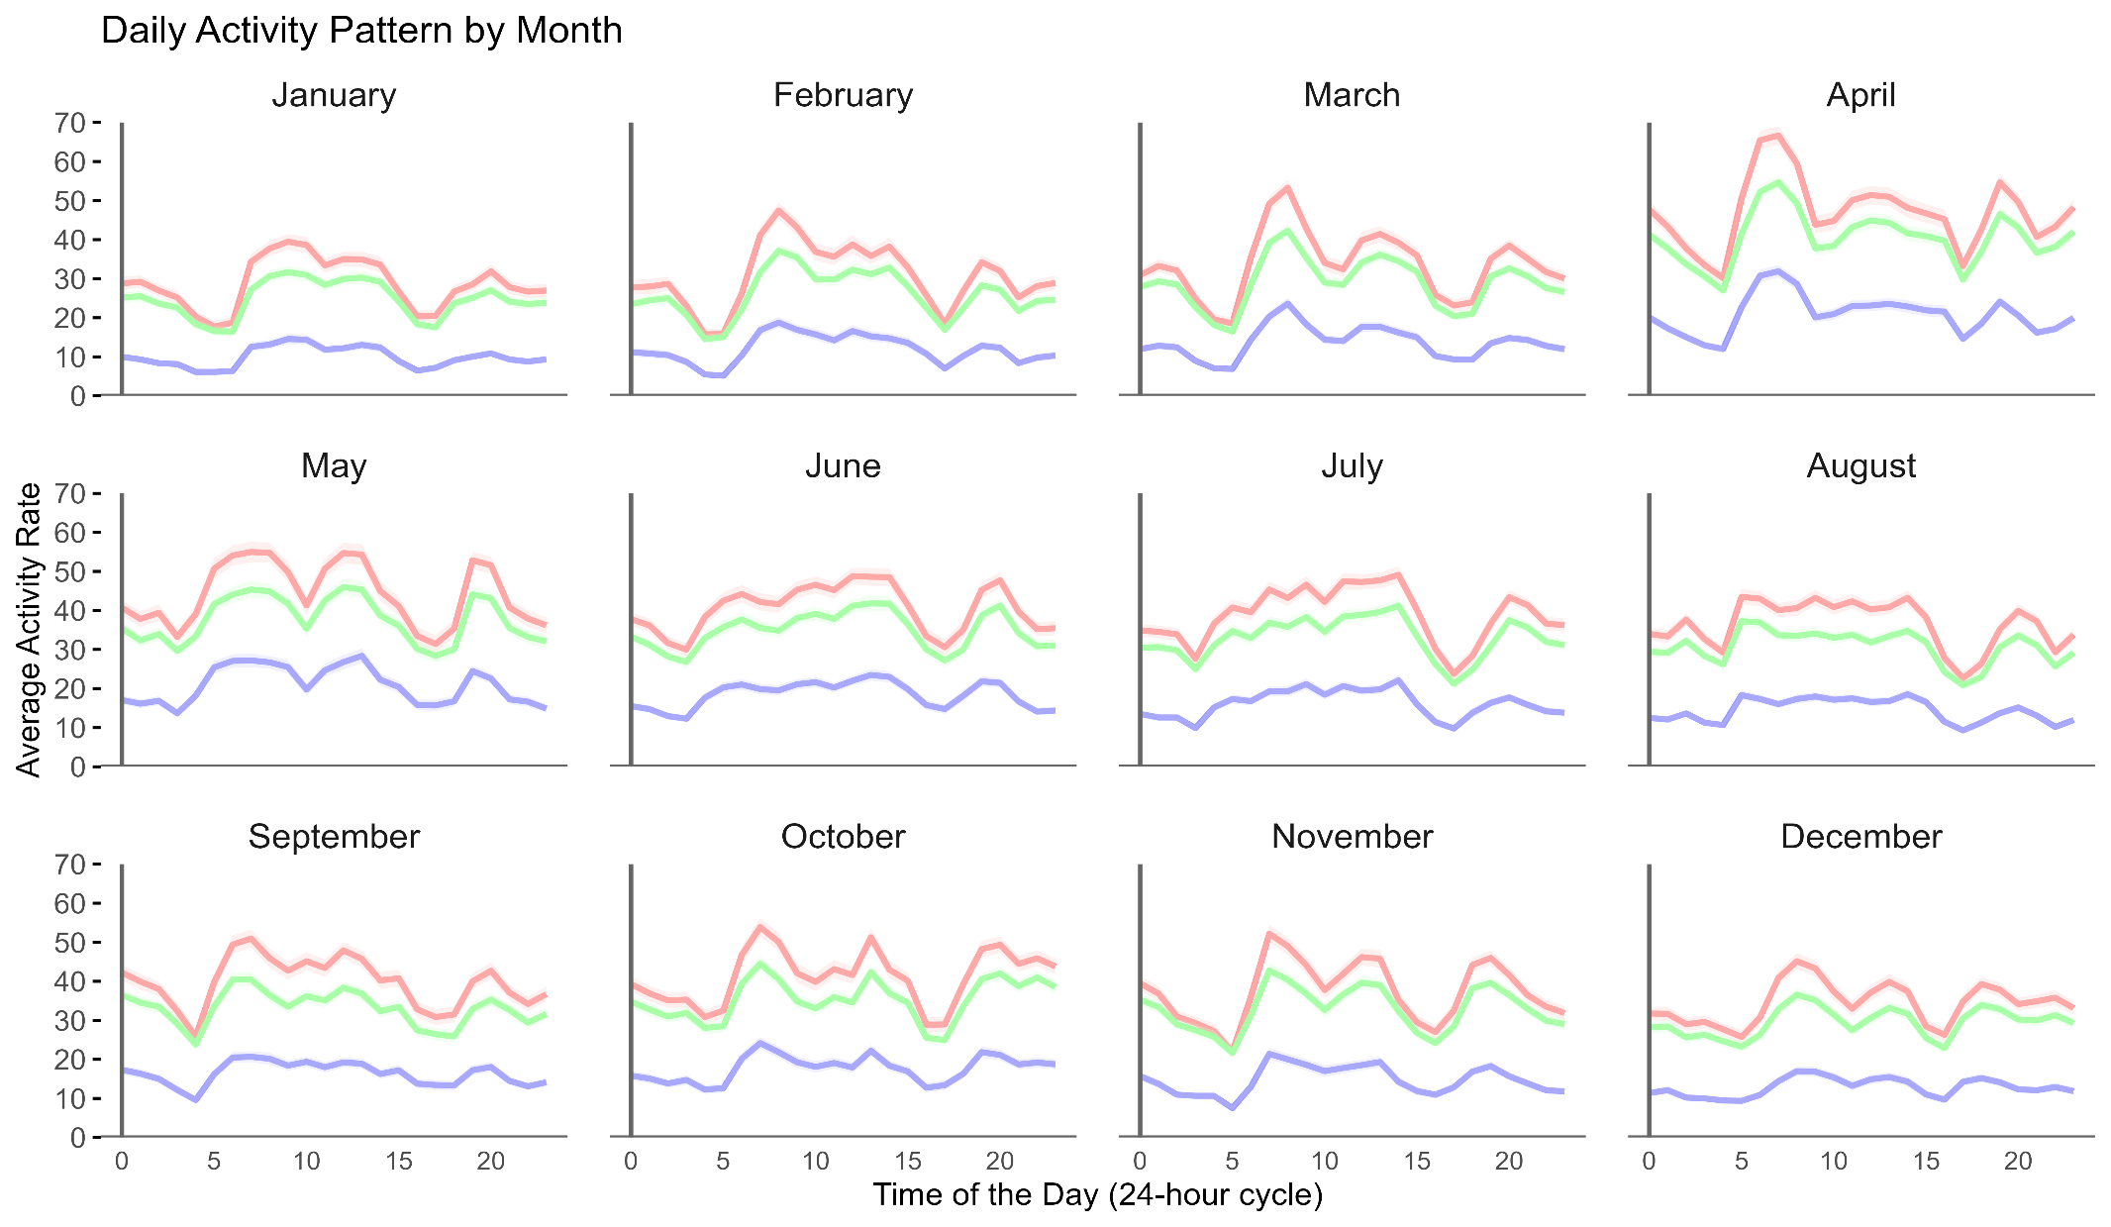
Supplement 1 Average activity rate of all individuals analysed each month and hourly per day (24 hours) based on the values obtained from counts at every 5-minute interval across data collection periods. Using values derived from individual axis (Red; X-axis, Blue: Y-axis and Green: Z-axis) to calculate the average values per hour projected in each month. The shaded bandwidth on all three axis represents 95% confidence interval
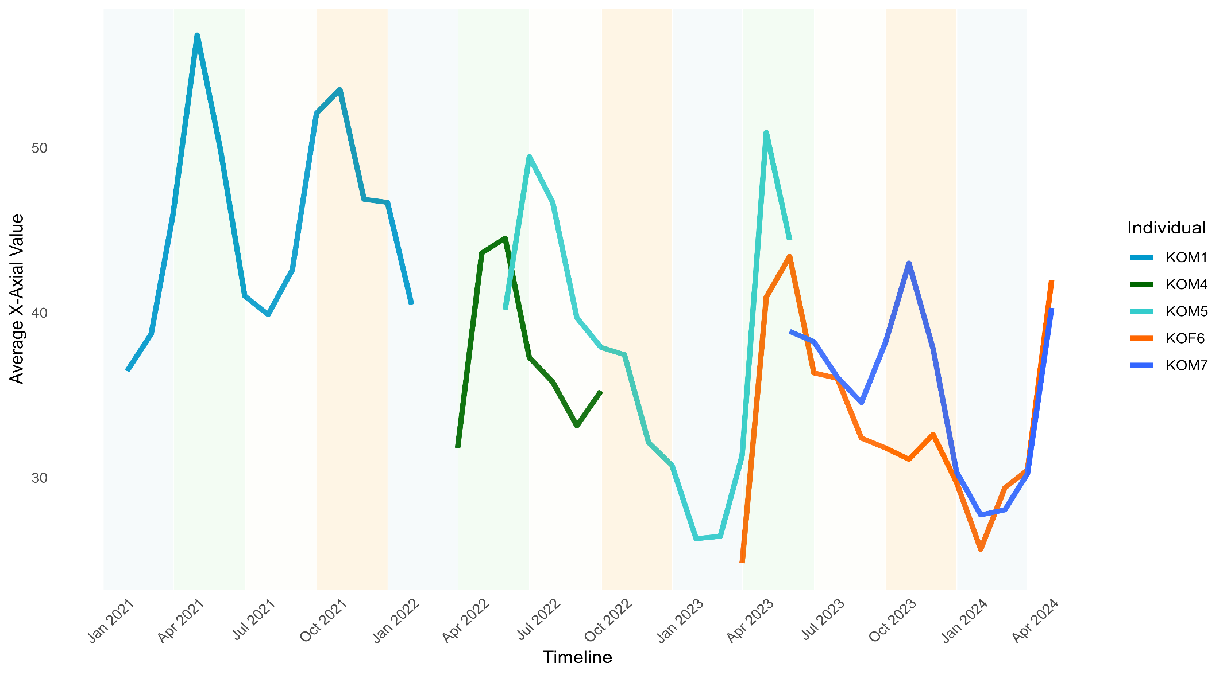
Supplement 2 Average value of the X-axis on the accelerometer based on each individual plotted on a time series following the data collection periods. The four seasons are coloured in accordance with previous study in this area (Maeda et al. 2024): spring (green), March–May; summer (yellow), June–August; autumn (orange), September–November; and winter (purple), December–February

