Supplementary material
Tables
Table S1 Quantification of pellets and optical fields analyses per locality. LC: locality codes. Northeastern localities are indicated in green, whereas southwestern localities are in brown.
LC | Localities | Pellets | Optical fields
1 | Mancha Ruana | 60 | 180
2 | Montaña Blanca | 43 | 129
3 | Valle | 57 | 171
4 | Cañada Blanca | 59 | 177
5 | Chafarí | 59 | 177
6 | Montaña Negra | 56 | 168
7 | Ucanca | 60 | 178
8 | Izaña | 60 | 180
9 | Maja | 60 | 179
10 | Fasnia | 60 | 179
11 | El Portillo | 60 | 180
12 | La Fortaleza | 56 | 168
13 | Chiqueros | 60 | 180
14 | Guancheros | 60 | 180
 | Total | 810 | 2426

Table S2 Plant taxa from Teide National Park included in the microhistological reference collection. Data sourced from the Biodiversity Data Bank of the Canary Islands (BDBCI).
Family | Plant species
Apiaceae | Pimpinella cumbrae Link
Asteraceae | Andryala pinnatifida Aiton
Asteraceae | Argyranthemum tenerifae Humphries
Asteraceae | Carlina xeranthemoides L.f.
Asteraceae | Cheirolophus teydis C. Sm. & G. López
Asteraceae | Erigeron calderae A. Hansen
Asteraceae | Rhaponticum canariense DC.
Asteraceae | Tolpis webbii Sch. Bip. ex Webb & Berthel.
Boraginaceae | Echium auberianum Webb & Berthel.
Boraginaceae | Echium wildpretii Hook. f.
Brassicaceae | Descurainia bourgeauana (E. Fourn.) O. E. Schulz
Brassicaceae | Erysimum scoparium (Brouss. ex Willd.) Wettst.
Campanulaceae | Wahlenbergia lobelioides (L. f.) Link
Caryophyllaceae | Silene nocteolens Webb & Berthel.
Dipsacaceae | Pterocephalus lasiospermus Link ex Buch
Fabaceae | Adenocarpus viscosus (Willd.) Webb & Berthel.
Fabaceae | Chamaecytisus proliferus (L. f.) Link
Fabaceae | Lotus campylocladus Webb & Berthel.
Fabaceae | Spartocytisus supranubius (L. f.) Christ ex G. Kunkel
Lamiaceae | Sideritis eriocephala Marrero Rodr. ex Negrín & P. Pérez
Lamiaceae | Micromeria sp.
Lamiaceae | Nepeta teydea Webb & Berthel.
Pinaceae | Pinus canariensis C. Sm. & DC.
Plantaginaceae | Plantago webbii Barnéoud
Poaceae | Arrhenatherum calderae A.Hansen
Poaceae | Bromus madritensis L.
Scrophulariaceae | Scrophularia glabrata Aiton
Violaceae | Viola cheiranthifolia Humb. & Bonpl.

Table S3 Abundance (%OF) of rabbit dietary components identified in pellets analysed from each locality. Northeastern localities are indicated in green and southwestern ones in brown. The number of plant species consumed at each locality and their Levin’s index are provided. Abbreviations: LC: locality codes; S.sp: Spartocytisus supranubius; P.la: Pterocephalus lasiospermus; D.bo: Descurainia bourgeauana; A.vi: Adenocarpus viscosus; A.ca: Arrhenatherum calderae; E.sc: Erysimum scoparium; M.sp: Micromeria sp.; B.sp: Bromus sp.; A.pi: Andryala pinnatifida; A.te: Argyranthemum tenerifae; C.xe: Carlina xeranthemoides.

LC | Localities | S.sp | P.la | D.bo | A.vi | A.ca | E.sc | M.sp | B.sp | A.pi | A.te | C.xe | Species number | Levin index
1 | Mancha Ruana | 95.18 | 2.04 | 2.36 | 0.11 | 0.21 |  | 0.11 |  |  |  |  | 6 | 0.02
2 | Montaña Blanca | 32.08 | 16.60 | 39.49 | 3.00 |  | 5.63 | 3.19 |  |  |  |  | 6 | 0.49
3 | El Valle | 87.13 | 0.73 | 6.90 | 1.05 | 2.62 | 0.73 |  |  | 0.73 |  |  | 7 | 0.05
4 | Cañada Blanca | 35.03 | 19.35 | 39.27 | 5.85 | 0.25 | 0.12 | 0.06 | 0.06 |  |  |  | 8 | 0.31
5 | Chafarí | 58.82 | 6.80 |  | 8.33 | 24.51 |  |  | 1.13 | 0.32 | 0.08 |  | 7 | 0.23
6 | Montaña Negra | 47.02 | 20.45 | 0.15 | 12.45 | 15.47 | 3.92 |  | 0.45 | 0.08 |  |  | 8 | 0.33
7 | Ucanca | 47.90 | 39.22 | 0.64 | 5.48 | 1.28 | 2.14 | 1.00 | 2.35 |  |  |  | 8 | 0.23
8 | Izaña | 35.90 | 18.85 | 33.16 | 10.96 |  | 0.20 | 0.80 | 0.07 | 0.07 |  |  | 8 | 0.36
9 | Maja | 35.67 | 12.10 | 47.77 | 4.01 |  |  | 0.08 | 0.31 | 0.08 |  |  | 7 | 0.28
10 | Fasnia | 32.36 | 25.57 | 25.80 | 12.07 | 2.76 |  | 0.06 | 0.17 | 1.15 |  |  | 8 | 0.42
11 | El Portillo | 23.45 | 37.24 | 19.68 | 17.94 | 0.93 | 0.49 | 0.27 |  |  |  |  | 7 | 0.46
12 | La Fortaleza | 36.44 | 34.66 | 2.81 | 11.05 | 0.14 | 8.99 | 4.87 | 0.07 | 0.07 |  | 0.82 | 10 | 0.29
13 | Chiqueros | 26.30 | 28.97 | 30.54 | 6.09 | 6.41 | 0.27 | 0.38 | 0.92 | 0.05 |  |  | 9 | 0.37
14 | Guancheros | 32.36 | 30.20 | 19.00 | 7.61 | 2.91 | 7.30 |  | 0.31 | 0.25 | 0.06 |  | 9 | 0.39

Table S4 Levin’s index for rabbits in Teide National Park per time period in 2017.
Time period | Levin Index
December-February | 0.29
February-April | 0.24
April-June | 0.29
June-August | 0.36
August-October | 0.28
October-December | 0.29

Table S5 Number of plant species present in each pellet (dietary diversity) per locality. Northeastern localities are indicated in green and southwestern localities in brown. Abbreviations: LC: locality codes.
 |  | Nº plant species in faecal pellets
LC | Localities | 1 | 2 | 3 | 4 | 5 | 6 | Total
1 | Mancha Ruana | 158 | 17 | 4 | 1 | 0 | 0 | 180
2 | Montaña Blanca | 5 | 29 | 58 | 29 | 8 | 0 | 129
3 | El Valle | 100 | 59 | 10 | 2 | 0 | 0 | 171
4 | Cañada Blanca | 1 | 35 | 97 | 43 | 1 | 0 | 177
5 | Chafarí | 25 | 76 | 60 | 15 | 1 | 0 | 177
6 | Montaña Negra | 10 | 36 | 70 | 45 | 7 | 0 | 168
7 | Ucanca | 5 | 101 | 47 | 17 | 5 | 3 | 178
8 | Izaña | 6 | 63 | 67 | 40 | 3 | 1 | 180
9 | Maja | 4 | 86 | 75 | 13 | 1 | 0 | 179
10 | Fasnia | 1 | 17 | 88 | 60 | 13 | 0 | 179
11 | El Portillo | 0 | 13 | 67 | 95 | 5 | 0 | 180
12 | La Fortaleza | 2 | 29 | 79 | 41 | 15 | 6 | 172
13 | Chiqueros | 0 | 6 | 73 | 78 | 20 | 3 | 180
14 | Guancheros | 0 | 12 | 86 | 69 | 11 | 2 | 180

Table S6 Selection of rabbit diet items consumed at each locality based on the Savage Index. Northeastern localities are indicated in green and southwestern localities in brown. Abbreviations: LC: locality codes; S.sp: Spartocytisus supranubius; P.la: Pterocephalus lasiospermus; D.bo: Descurainia bourgeauana; A.vi: Adenocarpus viscosus; P.spp: Poaceae spp.; E.sc: Erysimum scoparium; A.te: Argyranthemum tenerifae; C.xe: Carlina xeranthemoides; NS: no selection; S+: positive selection; S−: negative selection.
LC | Localities | S. sp | P. la | D.bo | A.vi | P.spp | E.sc | A.te | C.xe
1 | Mancha Ruana | NS | NS | S+ | NS | NS
2 | Montaña Blanca | NS | S+ | S+ |  | NS | NS | S-
3 | El Valle | S+ | NS | S- | S- | S+ | NS | S-
4 | Cañada Blanca | S- | S- | S+ | NS | NS | NS
5 | Chafarí | S+ | NS |  | S- | NS |  | NS
6 | Montaña Negra | NS | S- | NS | S+ | S+ | S+
7 | Ucanca | S- | S+ | NS | S+ | NS | NS
8 | Izaña | S- | S+ | NS | S+ | NS | NS
9 | Maja | NS | S- | S+ | S+ | NS
10 | Fasnia | NS | S- | S+ | S+ | S+ |  |  | NS
11 | El Portillo | S- | NS | S+ | S+ | NS | NS
12 | La Fortaleza | S- | S+ | NS | S- | NS | S+ |  | NS
13 | Chiqueros | S- | S+ | S+ | S+ | S+ | NS
14 | Guancheros | S- | NS | NS | S+ | S+ | S+ | NS

Table S7 Rabbit density (rabbits/ha) per locality and time period in 2017. Density data were obtained from Teide National Park estimates (MITECO 2017). Abbreviations: LC: locality codes; Dec: December; Feb: February; Apr: April; Jun: June; Aug: August; Oct; October; Dec: December.

LC | Localities | Dec-Feb | Feb-Apr | Apr-Jun | Jun-Aug | Aug-Oct | Oct-Dec | Mean
1 | Mancha Ruana | 2.5 | 3.0 | 3.4 | 2.9 | 1.7 | 2.8 | 2.72
2 | Montaña Blanca | 0.2 | 0.1 | 0.3 | 0.3 | 0.1 | 0.1 | 0.18
3 | El Valle | 2.3 | 1.6 | 1.7 | 1 | 1.4 | 1.2 | 1.53
4 | Cañada Blanca | 2.4 | 3.8 | 3.2 | 3.7 | 2.5 | 3.8 | 3.23
5 | Chafarí | 1.0 | 1.2 | 0.7 | 1.7 | 1.1 | 1.3 | 1.17
6 | Montaña Negra | 1.0 | 1.2 | 1.1 | 0.7 | 1.6 | 1.2 | 1.13
7 | Ucanca | 1.3 | 1.1 | 2.6 | 3.1 | 1.5 | 0.2 | 1.63
8 | Izaña | 3.2 | 3.9 | 2.9 | 2.2 | 3.0 | 2.1 | 2.88
9 | Maja | 1.0 | 0.7 | 1.8 | 0.8 | 2.5 | 1.8 | 1.43
10 | Fasnia | 1.9 | 1.6 | 0.7 | 1.3 | 2.3 | 1.6 | 1.57
11 | El Portillo | 3.5 | 2.4 | 3.2 | 1.0 | 2.3 | 2.1 | 2.42
12 | La Fortaleza | 0.8 | 0.6 | 1.4 | 1.1 | 2.9 | 0.1 | 1.15
13 | Chiqueros | 1.2 | 1.3 | 1.2 | 0.9 | 1.9 | 0.5 | 1.17
14 | Guancheros | 2.1 | 1.7 | 2.6 | 1.1 | 1.8 | 2 | 1.88
 | Mean | 1.74 | 1.73 | 1.91 | 1.56 | 1.90 | 1.49

Figures
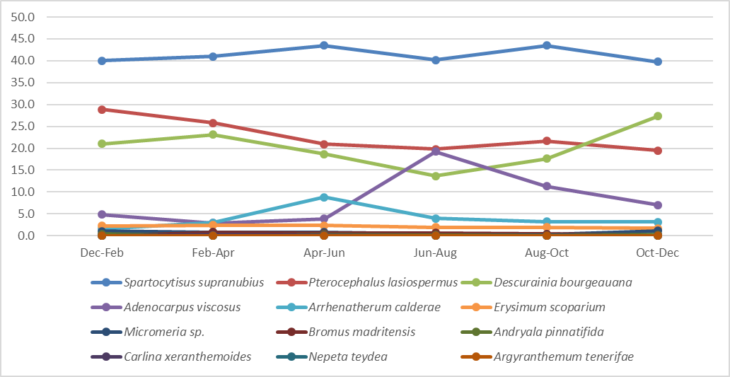

Figure S1 Abundance (%OF) of rabbit diet items detected in pellets defecated during the different time periods in all sampled localities in Teide National Park. % OF: percentage of optical fields in which each plant item appeared after analysing pellet content. The y-axis shows the abundance (%OF) of each plant identified in the pellets studied, and the x-axis shows the time periods to which each pellet collection corresponds.

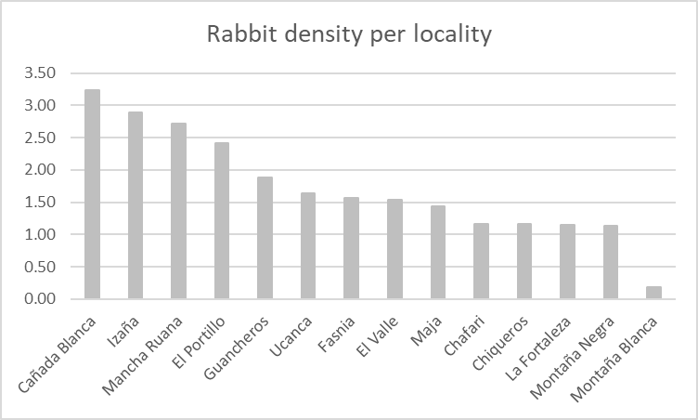
Figure S2 Rabbit density (rabbits/ha) per locality in 2017. Data were obtained from Teide National Park estimates (MITECO 2017). The y-axis shows rabbit density, and the x-axis shows the localities.

