Supporting information to the paper
More Than Movement Routes: The Role of Biocorridors for Feeding, Shelter, and Niche Partitioning of Wild Ungulates

Markéta Divišová, Josef Suchomel, Denisa Dvořáková, Jan Šipoš

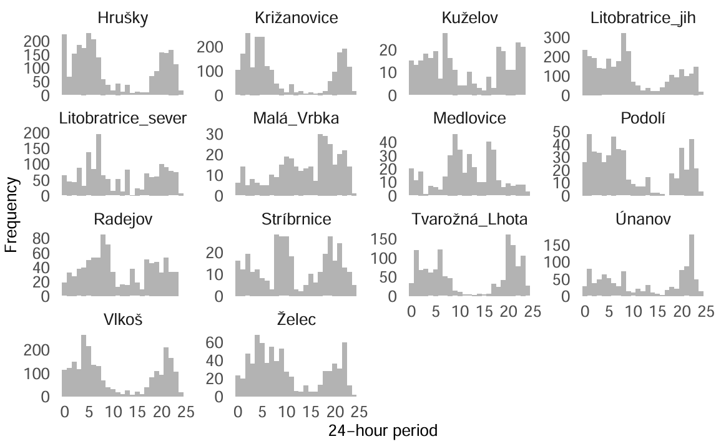
Figure S1. Daily frequency of roe deer (Capreolus capreolus) detections across all monitored sites.
Histogram shows the distribution of camera trap records over a 24-hour period for each study locality. The x-axis represents the time of day (in hours), while the y-axis indicates the relative frequency of detections.

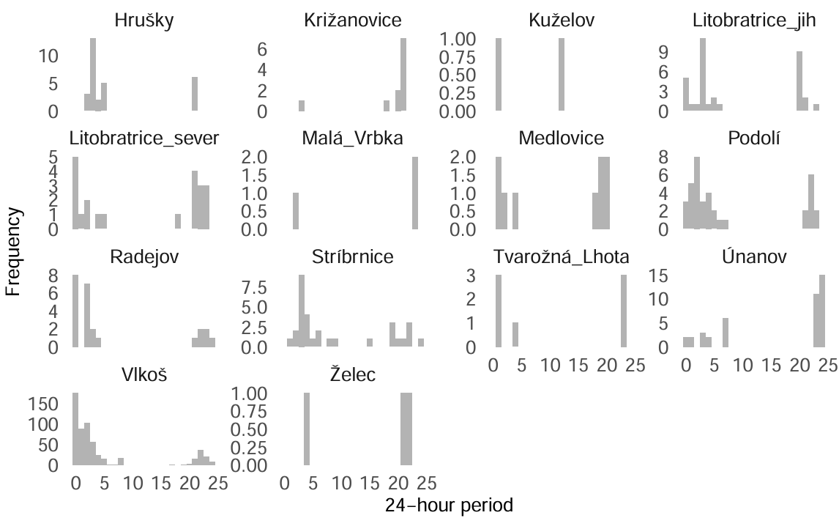
Figure S2. Daily frequency of wild boar (Sus scrofa) detections across all monitored sites.
Histogram shows the distribution of camera trap records over a 24-hour period for each study locality. The x-axis represents the time of day (in hours), while the y-axis indicates the relative frequency of detections.

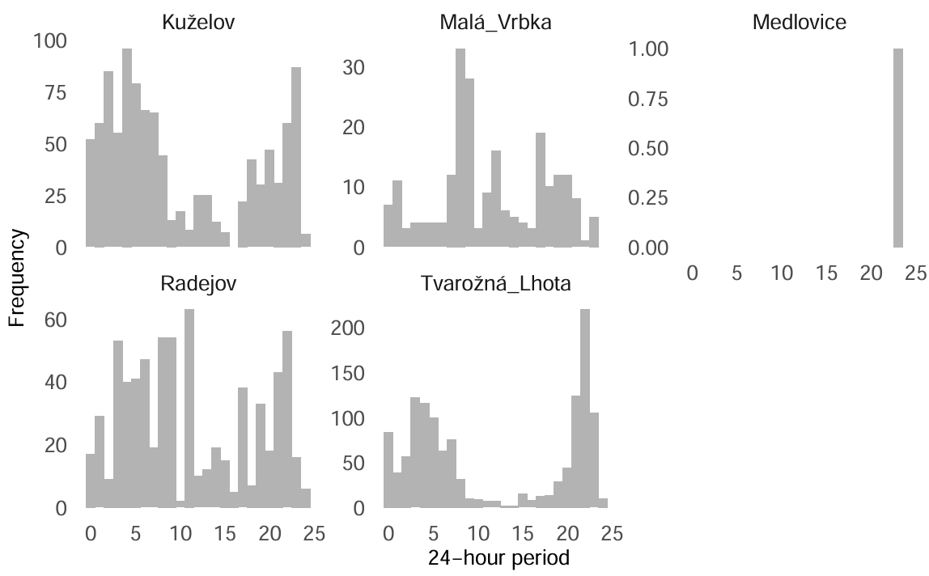
Figure S3. Daily frequency of fallow dear (Dama dama) detections across all monitored sites.
Histogram shows the distribution of camera trap records over a 24-hour period for each study locality. The x-axis represents the time of day (in hours), while the y-axis indicates the relative frequency of detections.

Figure S4. Ordination diagram visualizes how roe deer activity patterns in fallow-deer-free biocorridors correspond to different times of day (dawn, day, dusk, night), highlighting potential temporal preferences in the absence of interspecific competition. In the partial canonical correspondence analysis (pCCA), time intervals were used as dependent variables, behavioural activities were treated as an explanatory variable and years, moths and biocoridor ID were used as covariables. The significance of the ordination axes was tested using a restricted Monte Carlo permutation test, in which randomization was constrained within each biocorridor while preserving temporal autocorrelation of individual records through separate cyclic shifts within each locality.
Figure S5. Ordination diagram visualizes the relationship between roe deer (Capreolus capreolus) behavior in biocorridors with the presence of fallow deer (Dama dama) and the distribution of day phases (dawn, day, dusk, night). In the partial canonical correspondence analysis (pCCA), time intervals were used as dependent variables, behavioural activities were treated as an explanatory variable and years, moths and biocoridor ID were used as covariables. The significance of the ordination axes was tested using a restricted Monte Carlo permutation test, in which randomization was constrained within each biocorridor while preserving temporal autocorrelation of individual records through separate cyclic shifts within each locality.

Figure S6. Ordination diagram illustrating the relationship between fallow deer (Dama dama) behavior and the distribution of day phases (dawn, day, dusk, night). In the partial canonical correspondence analysis (pCCA), time intervals were used as dependent variables, behavioural activities were treated as an explanatory variable and years, moths and biocoridor ID were used as covariables. The significance of the ordination axes was tested using a restricted Monte Carlo permutation test, in which randomization was constrained within each biocorridor while preserving temporal autocorrelation of individual records through separate cyclic shifts within each locality.

Table S1: Characteristics of the biocorridors studied. This table summarizes key physical and environmental features of the biocorridors, including their size, vegetation structure, and altitude, which are important for understanding habitat suitability for wildlife species.

ID | corridor name | coordinates | length  (m) | width  (m) | height  (m) | altitude  (m a.s.l.) | abundance of nitrophytes, (relative) | abundance of forest species, (relative)
BK1 | Hrušky | LON 19,954  LAT 48,803 | 1360 | 19-27 | 9,6 | 190 | 42 (71,2 %) | 2 (3,4 %)
BK2 | Křižanovice | LON 17,036  LAT 49,293 | 433 | 11-15 | 9,61 | 265 | 96 (48,3 %) | 24 (10,8 %)
BK3 | Kuželov | LON 17,482  LAT 48,852 | 1600 | 35-50 | 10,13 | 407 | 33 (20,9 %) | 50 (31,65 %)
BK4 | Litobratřice J | LON 16,415  LAT 48,868 | 1440 | 25-27 | 12,6 | 219 | 41 (51,3 %) | 12 (15 %)
BK5 | Litobratřice S | LON 16,411  LAT 48,891 | 1150 | 25-30 | 12 | 227 | 46 (51,1 %) | 16 (17,7 %)
BK6 | Malá Vrbka | LON 17,458  LAT 48,881 | 1100 | 30-50 | 12,22 | 331 | 40 (28,4 %) | 40 (28,4 %)
BK7 | Medlovice | LON 17,282  LAT 49,047 | 530 | 11,5 | 6,49 | 350 | 35 (44,9 %) | 13 (16,7 %)
BK8 | Podolí | LON 16,734  LAT 49,200 | 820 | 10 | 8,86 | 281 | 50 (50,5 %) | 12 (12,1 %)
BK9 | Radějov | LON 17,341  LAT 48,874 | 1225 | 16-20 | 9,09 | 245 | 57 (45,6 %) | 26 (20,8 %)
BK10 | Stříbrnice | LON 17,313  LAT 49,049 | 172 | 15 | 7,84 | 310 | 22 (33,3 %) | 16 (24,3 %)
BK11 | Tvarožná Lhota | LON 17,375  LAT 48,863 | 1300 | 45-57 | 12,24 | 337 | 56 (28,6 %) | 66 (33,7 %)
BK12 | Únanov | LON 16,054  LAT 48,915 | 1470 | 15 | 8,3 | 299 | 41 (48,8 %) | 9 (10,7 %)
BK13 | Vlkoš | LON 17,188  LAT 48,990 | 1830 | 15 | 10,41 | 201 | 69 (53,5 %) | 7 (5,4 %)
BK14 | Želeč | LON 17,089  LAT 49,353 | 1350 | 40-55 | 6,44 | 265 | 60 (35,3 %) | 22 (12,9 %)

Table S2. Summary of camera-trap deployment and performance, including total deployment duration (number of days), number of active days, number of photographs recorded, and days affected by malfunction or inactivity for each camera trap.

Camera trap | Number of days | Active days | Number of photos | Number of malfunction days | Number of inactive days
30 | 233 | 31 | 44 | 18 | 184
31 | 233 | 190 | 1158 | 4 | 39
33 | 233 | 229 | 2820 | 1 | 3
5 | 435 | 249 | 1150 | 165 | 21
2 | 435 | 286 | 949 | 142 | 25
3 | 435 | 248 | 1364 | 125 | 62
4 | 435 | 283 | 1206 | 87 | 65
36 | 110 | 80 | 312 | 8 | 22
37 | 110 | 95 | 1040 | 0 | 15
38 | 110 | 94 | 334 | 13 | 3
26 | 243 | 198 | 1711 | 5 | 40
27 | 243 | 95 | 721 | 73 | 75
28 | 243 | 111 | 579 | 21 | 111
29 | 243 | 100 | 739 | 89 | 54
23 | 242 | 148 | 853 | 32 | 63
24 | 242 | 107 | 681 | 31 | 104
25 | 242 | 101 | 181 | 62 | 79
39 | 110 | 104 | 542 | 0 | 6
40 | 110 | 75 | 318 | 3 | 32
34 | 81 | 75 | 440 | 0 | 6
35 | 81 | 43 | 101 | 0 | 38
6 | 275 | 106 | 99 | 49 | 120
7 | 275 | 212 | 935 | 17 | 46
14 | 269 | 161 | 734 | 54 | 54
18 | 269 | 187 | 712 | 23 | 59
19 | 269 | 202 | 1034 | 15 | 52
1 | 81 | 72 | 484 | 0 | 9
15 | 269 | 240 | 968 | 0 | 29
16 | 269 | 157 | 630 | 43 | 69
17 | 269 | 221 | 1670 | 5 | 43
20 | 241 | 95 | 324 | 23 | 123
21 | 241 | 187 | 931 | 6 | 48
22 | 241 | 212 | 1693 | 0 | 29
10 | 270 | 240 | 1870 | 0 | 30
11 | 270 | 164 | 640 | 51 | 55
12 | 270 | 185 | 487 | 53 | 32
13 | 270 | 227 | 1314 | 12 | 31
8 | 273 | 167 | 687 | 62 | 44
9 | 273 | 79 | 128 | 86 | 108

Table S3. Sensitivity analysis of camera-trap data: number of recorded events and corresponding activity rates for each species and trap, calculated using 15-, 30-, and 60-minute intervals.

 |  | events |  |  |  | rates
trap ID | species | 15 min. | 30 min. | 60 min. | camera days | 15 min. | 30 min. | 60 min.
1 | wild boar | 14 | 9 | 4 | 31 | 45 | 29 | 13
1 | roe deer | 13 | 8 | 4 | 339 | 4 | 2 | 1
2 | wild boar | 0 | 0 | 0 | 8 | 0 | 0 | 0
2 | roe deer | 19 | 12 | 7 | 487 | 4 | 2 | 1
3 | wild boar | 1 | 1 | 1 | 5 | 20 | 20 | 20
3 | roe deer | 14 | 9 | 6 | 885 | 2 | 1 | 1
4 | wild boar | 1 | 1 | 1 | 5 | 20 | 20 | 20
4 | roe deer | 12 | 9 | 4 | 1203 | 1 | 1 | 0
5 | roe deer | 16 | 11 | 7 | 1117 | 1 | 1 | 1
6 | wild boar | 2 | 2 | 2 | 10 | 20 | 20 | 20
6 | roe deer | 6 | 5 | 4 | 32 | 19 | 16 | 13
7 | wild boar | 7 | 5 | 4 | 54 | 13 | 9 | 7
7 | roe deer | 14 | 10 | 7 | 1269 | 1 | 1 | 1
8 | wild boar | 13 | 7 | 3 | 5 | 260 | 140 | 60
8 | roe deer | 17 | 10 | 7 | 952 | 2 | 1 | 1
9 | wild boar | 7 | 5 | 4 | 3 | 233 | 167 | 133
9 | roe deer | 12 | 11 | 6 | 212 | 6 | 5 | 3
10 | wild boar | 14 | 11 | 6 | 147 | 10 | 7 | 4
10 | roe deer | 14 | 12 | 9 | 969 | 1 | 1 | 1
11 | wild boar | 18 | 12 | 7 | 97 | 19 | 12 | 7
11 | roe deer | 19 | 16 | 9 | 1244 | 2 | 1 | 1
12 | wild boar | 9 | 6 | 5 | 9 | 100 | 67 | 56
12 | roe deer | 11 | 8 | 7 | 293 | 4 | 3 | 2
13 | wild boar | 8 | 4 | 4 | 46 | 17 | 9 | 9
13 | roe deer | 10 | 8 | 7 | 559 | 2 | 1 | 1
14 | fallow deer | 7 | 6 | 5 | 228 | 3 | 3 | 2
14 | roe deer | 8 | 7 | 7 | 222 | 4 | 3 | 3
15 | fallow deer | 20 | 15 | 7 | 349 | 6 | 4 | 2
15 | roe deer | 21 | 15 | 8 | 454 | 5 | 3 | 2
16 | fallow deer | 11 | 11 | 8 | 308 | 4 | 4 | 3
16 | wild boar | 3 | 2 | 2 | 3 | 100 | 67 | 67
16 | roe deer | 9 | 9 | 7 | 256 | 4 | 4 | 3
17 | fallow deer | 10 | 8 | 6 | 629 | 2 | 1 | 1
17 | wild boar | 1 | 1 | 1 | 2 | 50 | 50 | 50
17 | roe deer | 11 | 9 | 6 | 999 | 1 | 1 | 1
18 | fallow deer | 12 | 9 | 5 | 183 | 7 | 5 | 3
18 | wild boar | 16 | 11 | 8 | 24 | 67 | 46 | 33
18 | roe deer | 18 | 10 | 7 | 1044 | 2 | 1 | 1
19 | fallow deer | 16 | 12 | 7 | 232 | 7 | 5 | 3
19 | wild boar | 1 | 1 | 1 | 4 | 25 | 25 | 25
19 | roe deer | 14 | 10 | 6 | 388 | 4 | 3 | 2
20 | wild boar | 0 | 0 | 0 | 1 | 0 | 0 | 0
20 | roe deer | 3 | 3 | 3 | 210 | 1 | 1 | 1
21 | wild boar | 2 | 2 | 2 | 6 | 33 | 33 | 33
21 | roe deer | 11 | 10 | 7 | 440 | 3 | 2 | 2
22 | wild boar | 1 | 1 | 1 | 9 | 11 | 11 | 11
22 | roe deer | 7 | 5 | 4 | 199 | 4 | 3 | 2
23 | wild boar | 0 | 0 | 0 | 2 | 0 | 0 | 0
23 | roe deer | 13 | 10 | 7 | 801 | 2 | 1 | 1
24 | roe deer | 7 | 5 | 4 | 455 | 2 | 1 | 1
25 | wild boar | 11 | 9 | 6 | 41 | 27 | 22 | 15
25 | roe deer | 9 | 8 | 6 | 218 | 4 | 4 | 3
26 | wild boar | 5 | 2 | 1 | 10 | 50 | 20 | 10
26 | roe deer | 21 | 13 | 7 | 2950 | 1 | 0 | 0
27 | wild boar | 2 | 2 | 2 | 7 | 29 | 29 | 29
27 | roe deer | 11 | 8 | 6 | 908 | 1 | 1 | 1
28 | wild boar | 1 | 1 | 1 | 1 | 100 | 100 | 100
28 | roe deer | 15 | 10 | 7 | 689 | 2 | 1 | 1
29 | wild boar | 9 | 4 | 2 | 8 | 113 | 50 | 25
29 | roe deer | 17 | 12 | 7 | 1023 | 2 | 1 | 1
30 | roe deer | 6 | 5 | 4 | 43 | 14 | 12 | 9
31 | wild boar | 0 | 0 | 0 | 2 | 0 | 0 | 0
31 | roe deer | 20 | 15 | 8 | 839 | 2 | 2 | 1
33 | wild boar | 7 | 4 | 2 | 13 | 54 | 31 | 15
33 | roe deer | 14 | 10 | 7 | 841 | 2 | 1 | 1
34 | fallow deer | 0 | 0 | 0 | 1 | 0 | 0 | 0
34 | wild boar | 9 | 3 | 3 | 8 | 113 | 38 | 38
34 | roe deer | 19 | 13 | 7 | 337 | 6 | 4 | 2
35 | wild boar | 7 | 4 | 2 | 1 | 700 | 400 | 200
35 | roe deer | 9 | 5 | 3 | 67 | 13 | 7 | 4
36 | fallow deer | 8 | 6 | 5 | 198 | 4 | 3 | 3
36 | wild boar | 0 | 0 | 0 | 1 | 0 | 0 | 0
36 | roe deer | 9 | 8 | 8 | 97 | 9 | 8 | 8
37 | fallow deer | 12 | 9 | 8 | 720 | 2 | 1 | 1
37 | wild boar | 0 | 0 | 0 | 2 | 0 | 0 | 0
37 | roe deer | 11 | 8 | 6 | 73 | 15 | 11 | 8
38 | fallow deer | 9 | 7 | 5 | 79 | 11 | 9 | 6
38 | roe deer | 14 | 8 | 7 | 145 | 10 | 6 | 5
39 | fallow deer | 17 | 8 | 5 | 156 | 11 | 5 | 3
39 | wild boar | 2 | 2 | 2 | 4 | 50 | 50 | 50
39 | roe deer | 18 | 8 | 4 | 119 | 15 | 7 | 3
40 | fallow deer | 9 | 9 | 6 | 76 | 12 | 12 | 8
40 | roe deer | 14 | 8 | 7 | 222 | 6 | 4 | 3

Table S4: Percentage overview of behaviours of selected animal species during the study period, with marginally represented behaviour types under 1% excluded from the analyses (i.e., territoriality, parental care and reproduction).
 | grooming | resting | movement | feeding | territoriality | parental care | reproduction
Capreolus capreolus | 4,5 % | 10,1 % | 60,6 % | 23,9 % | 0,2 % | 0,5 % | 0,1 %
Dama dama | 2,0 % | 16,4 % | 67,5 % | 13,9 % | 0,2 % | 0 % | 0 %
Sus scrofa | 0,3 % | 0,2 % | 61,3 % | 38,2 % | 0 % | 0 % | 0 %

Table S5. Station-level summaries of camera-trap data, showing for each camera month and year: total number of events recorded in 30-minute intervals (event30), total camera-days, number of events per 100 camera-days, and the median and interquartile range (IQR) of events per 30-minute interval.

Trap ID | Year | Month | event30 | Camera days | events/100day | median_event30 | IQR_event30
1 | 2021 | 10 | 11 | 100 | 11 | 1 | 0.25
1 | 2021 | 11 | 221 | 100 | 221 | 1 | 0
1 | 2021 | 12 | 231 | 100 | 231 | 1 | 0
1 | 2022 | 1 | 84 | 100 | 84 | 1 | 2
2 | 2020 | 10 | 0 | 100 | 0 | NA | NA
2 | 2020 | 11 | 6 | 100 | 6 | 1 | 0
2 | 2020 | 12 | 16 | 100 | 16 | 1 | 0
2 | 2021 | 1 | 66 | 100 | 66 | 1 | 1.25
2 | 2021 | 2 | 23 | 200 | 11.5 | 1 | 0
2 | 2021 | 3 | 87 | 200 | 43.5 | 5 | 5
2 | 2021 | 4 | 11 | 200 | 5.5 | 1 | 0
2 | 2021 | 5 | 27 | 300 | 9 | 1 | 0
2 | 2021 | 6 | 30 | 300 | 10 | 4 | 2.25
2 | 2021 | 7 | 29 | 300 | 9.666666667 | 6 | 1
2 | 2021 | 8 | 70 | 400 | 17.5 | 1 | 8.25
2 | 2021 | 9 | 19 | 400 | 4.75 | 1 | 0
2 | 2021 | 10 | 5 | 400 | 1.25 | 1 | 0
2 | 2021 | 11 | 13 | 400 | 3.25 | 1 | 0
2 | 2021 | 12 | 9 | 500 | 1.8 | 1 | 0
3 | 2020 | 11 | 1 | 100 | 1 | 1 | 0
3 | 2020 | 12 | 5 | 100 | 5 | 1 | 0
3 | 2021 | 1 | 1 | 100 | 1 | 1 | 0
3 | 2021 | 2 | 5 | 200 | 2.5 | 1 | 0
3 | 2021 | 3 | 32 | 200 | 16 | 2.5 | 2
3 | 2021 | 4 | 148 | 200 | 74 | 1 | 1
3 | 2021 | 5 | 42 | 300 | 14 | 1 | 0
3 | 2021 | 6 | 14 | 300 | 4.666666667 | 1 | 0
3 | 2021 | 7 | 16 | 300 | 5.333333333 | 1 | 0
3 | 2021 | 8 | 40 | 400 | 10 | 1 | 0
3 | 2021 | 9 | 24 | 400 | 6 | 1 | 0
3 | 2021 | 10 | 18 | 400 | 4.5 | 1 | 0
3 | 2021 | 11 | 19 | 400 | 4.75 | 1 | 0
3 | 2021 | 12 | 25 | 500 | 5 | 1 | 0
3 | 2022 | 1 | 1 | 500 | 0.2 | 1 | 0
4 | 2020 | 11 | 10 | 100 | 10 | 1 | 0
4 | 2020 | 12 | 34 | 100 | 34 | 1 | 0
4 | 2021 | 1 | 29 | 100 | 29 | 1 | 0
4 | 2021 | 2 | 62 | 200 | 31 | 1 | 3
4 | 2021 | 3 | 113 | 200 | 56.5 | 1 | 0.25
4 | 2021 | 4 | 138 | 200 | 69 | 1 | 0
4 | 2021 | 5 | 38 | 300 | 12.66666667 | 1 | 0
4 | 2021 | 6 | 28 | 300 | 9.333333333 | 1 | 0
4 | 2021 | 7 | 14 | 300 | 4.666666667 | 1 | 0
4 | 2021 | 8 | 36 | 400 | 9 | 1 | 0
4 | 2021 | 9 | 20 | 400 | 5 | 1 | 0
4 | 2021 | 10 | 14 | 400 | 3.5 | 1 | 0
4 | 2021 | 11 | 25 | 400 | 6.25 | 1 | 0
4 | 2021 | 12 | 19 | 500 | 3.8 | 1 | 0
4 | 2022 | 1 | 3 | 500 | 0.6 | 1 | 0
5 | 2020 | 11 | 7 | 100 | 7 | 1 | 0
5 | 2020 | 12 | 1 | 100 | 1 | 1 | 0
5 | 2021 | 1 | 3 | 100 | 3 | 1 | 0
5 | 2021 | 3 | 5 | 200 | 2.5 | 1 | 0
5 | 2021 | 4 | 241 | 200 | 120.5 | 1 | 1
5 | 2021 | 5 | 21 | 300 | 7 | 1 | 0
5 | 2021 | 6 | 96 | 300 | 32 | 1 | 1
5 | 2021 | 7 | 56 | 300 | 18.66666667 | 5 | 3.5
5 | 2021 | 8 | 106 | 400 | 26.5 | 1 | 2
5 | 2021 | 9 | 9 | 400 | 2.25 | 1 | 0
5 | 2021 | 10 | 43 | 400 | 10.75 | 2 | 2
5 | 2021 | 11 | 100 | 400 | 25 | 1 | 1
5 | 2021 | 12 | 116 | 500 | 23.2 | 1 | 4.25
5 | 2022 | 1 | 3 | 500 | 0.6 | 3 | 0
6 | 2021 | 6 | 7 | 100 | 7 | 1.5 | 1.25
6 | 2021 | 7 | 6 | 200 | 3 | 1 | 0
6 | 2021 | 9 | 1 | 200 | 0.5 | 1 | 0
6 | 2021 | 10 | 18 | 300 | 6 | 2 | 2
6 | 2021 | 11 | 6 | 300 | 2 | 2 | 1
6 | 2021 | 12 | 1 | 300 | 0.333333333 | 1 | 0
7 | 2021 | 4 | 7 | 100 | 7 | 1 | 0
7 | 2021 | 5 | 2 | 100 | 2 | 1 | 0
7 | 2021 | 6 | 39 | 100 | 39 | 1 | 0
7 | 2021 | 7 | 37 | 200 | 18.5 | 1 | 1.25
7 | 2021 | 8 | 82 | 200 | 41 | 1 | 1
7 | 2021 | 9 | 87 | 200 | 43.5 | 1 | 2
7 | 2021 | 10 | 131 | 300 | 43.66666667 | 1 | 1
7 | 2021 | 11 | 146 | 300 | 48.66666667 | 1 | 0
7 | 2021 | 12 | 277 | 300 | 92.33333333 | 1 | 0
7 | 2022 | 1 | 28 | 300 | 9.333333333 | 1 | 0
8 | 2021 | 4 | 52 | 100 | 52 | 1 | 0
8 | 2021 | 5 | 113 | 100 | 113 | 1 | 1
8 | 2021 | 6 | 62 | 100 | 62 | 1 | 0.5
8 | 2021 | 7 | 88 | 200 | 44 | 3 | 3
8 | 2021 | 8 | 35 | 200 | 17.5 | 1 | 2
8 | 2021 | 9 | 15 | 200 | 7.5 | 1 | 0
8 | 2021 | 10 | 180 | 300 | 60 | 1 | 0
8 | 2021 | 11 | 118 | 300 | 39.33333333 | 1 | 0
8 | 2021 | 12 | 169 | 300 | 56.33333333 | 1 | 0
8 | 2022 | 1 | 4 | 300 | 1.333333333 | 1 | 0.5
9 | 2021 | 4 | 14 | 100 | 14 | 2 | 1.5
9 | 2021 | 5 | 124 | 100 | 124 | 4 | 6
9 | 2021 | 6 | 16 | 100 | 16 | 2.5 | 2.5
9 | 2021 | 7 | 28 | 200 | 14 | 3 | 2
9 | 2021 | 9 | 3 | 200 | 1.5 | 1.5 | 0.5
9 | 2021 | 10 | 60 | 300 | 20 | 1 | 1
9 | 2021 | 11 | 20 | 300 | 6.666666667 | 2 | 1.75
9 | 2021 | 12 | 34 | 300 | 11.33333333 | 1 | 2
10 | 2021 | 4 | 21 | 100 | 21 | 1 | 0
10 | 2021 | 5 | 239 | 100 | 239 | 1 | 0.25
10 | 2021 | 6 | 104 | 100 | 104 | 1 | 2
10 | 2021 | 7 | 252 | 200 | 126 | 1 | 2
10 | 2021 | 8 | 39 | 200 | 19.5 | 1 | 0
10 | 2021 | 9 | 57 | 200 | 28.5 | 1 | 0
10 | 2021 | 10 | 80 | 200 | 40 | 4 | 5
10 | 2021 | 11 | 236 | 300 | 78.66666667 | 1 | 0
10 | 2021 | 12 | 61 | 300 | 20.33333333 | 1 | 0
10 | 2022 | 1 | 4 | 300 | 1.333333333 | 2 | 0
11 | 2021 | 1 | 96 | 300 | 32 | 3 | 3
11 | 2021 | 4 | 3 | 100 | 3 | 1 | 0
11 | 2021 | 5 | 10 | 100 | 10 | 1 | 0
11 | 2021 | 6 | 20 | 100 | 20 | 1 | 1.75
11 | 2021 | 7 | 51 | 200 | 25.5 | 2 | 1
11 | 2021 | 8 | 197 | 200 | 98.5 | 3 | 4.25
11 | 2021 | 9 | 194 | 200 | 97 | 2 | 5
11 | 2021 | 10 | 152 | 200 | 76 | 1 | 0
11 | 2021 | 11 | 116 | 300 | 38.66666667 | 1 | 0
11 | 2021 | 12 | 420 | 300 | 140 | 1 | 4
11 | 2022 | 1 | 100 | 300 | 33.33333333 | 1 | 3.75
12 | 2021 | 4 | 2 | 100 | 2 | 2 | 0
12 | 2021 | 5 | 129 | 100 | 129 | 2 | 3
12 | 2021 | 6 | 48 | 100 | 48 | 1 | 0
12 | 2021 | 7 | 25 | 200 | 12.5 | 1 | 0
12 | 2021 | 8 | 35 | 200 | 17.5 | 1 | 0
12 | 2021 | 9 | 47 | 200 | 23.5 | 1 | 0
12 | 2021 | 10 | 2 | 200 | 1 | 1 | 0
12 | 2021 | 12 | 21 | 300 | 7 | 1 | 0
13 | 2021 | 4 | 69 | 100 | 69 | 1 | 0
13 | 2021 | 5 | 178 | 100 | 178 | 1 | 0
13 | 2021 | 6 | 91 | 100 | 91 | 1 | 1
13 | 2021 | 7 | 65 | 200 | 32.5 | 1 | 0
13 | 2021 | 8 | 78 | 200 | 39 | 1 | 0
13 | 2021 | 9 | 40 | 200 | 20 | 1 | 0.75
13 | 2021 | 10 | 47 | 200 | 23.5 | 1 | 1
13 | 2021 | 11 | 30 | 300 | 10 | 2 | 1.75
13 | 2021 | 12 | 71 | 300 | 23.66666667 | 1 | 2.5
14 | 2021 | 4 | 30 | 100 | 30 | 1 | 0
14 | 2021 | 5 | 96 | 100 | 96 | 1 | 0
14 | 2021 | 6 | 55 | 100 | 55 | 1 | 1
14 | 2021 | 7 | 20 | 200 | 10 | 1 | 0
14 | 2021 | 8 | 64 | 200 | 32 | 1 | 0
14 | 2021 | 9 | 67 | 200 | 33.5 | 2 | 3.25
14 | 2021 | 10 | 18 | 200 | 9 | 3 | 1
14 | 2021 | 11 | 42 | 300 | 14 | 1 | 1.5
14 | 2021 | 12 | 59 | 300 | 19.66666667 | 3 | 3
14 | 2022 | 1 | 9 | 300 | 3 | 2 | 1
15 | 2021 | 4 | 23 | 100 | 23 | 2 | 1.5
15 | 2021 | 5 | 282 | 100 | 282 | 3 | 6
15 | 2021 | 6 | 44 | 100 | 44 | 1 | 0
15 | 2021 | 7 | 123 | 200 | 61.5 | 1 | 1
15 | 2021 | 8 | 198 | 200 | 99 | 3 | 3
15 | 2021 | 9 | 81 | 200 | 40.5 | 2 | 3
15 | 2021 | 10 | 164 | 200 | 82 | 1 | 3
15 | 2021 | 11 | 173 | 300 | 57.66666667 | 1 | 1
15 | 2021 | 12 | 49 | 300 | 16.33333333 | 1.5 | 2
15 | 2022 | 1 | 8 | 300 | 2.666666667 | 1 | 1
16 | 2021 | 4 | 6 | 100 | 6 | 1 | 0
16 | 2021 | 5 | 134 | 100 | 134 | 1 | 1
16 | 2021 | 6 | 37 | 100 | 37 | 1 | 0
16 | 2021 | 7 | 37 | 100 | 37 | 1 | 0
16 | 2021 | 8 | 31 | 200 | 15.5 | 1 | 0
16 | 2021 | 9 | 39 | 200 | 19.5 | 1 | 0
16 | 2021 | 10 | 83 | 200 | 41.5 | 1 | 1
16 | 2021 | 11 | 65 | 300 | 21.66666667 | 1 | 0
16 | 2021 | 12 | 36 | 300 | 12 | 1.5 | 2
16 | 2022 | 1 | 15 | 300 | 5 | 1 | 0.5
17 | 2021 | 4 | 42 | 100 | 42 | 1 | 0
17 | 2021 | 5 | 147 | 100 | 147 | 1 | 0
17 | 2021 | 6 | 154 | 100 | 154 | 1 | 0
17 | 2021 | 7 | 150 | 200 | 75 | 1 | 0
17 | 2021 | 8 | 104 | 200 | 52 | 1 | 0
17 | 2021 | 9 | 75 | 200 | 37.5 | 1 | 0
17 | 2021 | 10 | 179 | 200 | 89.5 | 1 | 0
17 | 2021 | 11 | 140 | 300 | 46.66666667 | 1 | 0
17 | 2021 | 12 | 164 | 300 | 54.66666667 | 1 | 0
17 | 2022 | 1 | 76 | 300 | 25.33333333 | 1 | 1
18 | 2021 | 4 | 15 | 100 | 15 | 2 | 1
18 | 2021 | 5 | 61 | 100 | 61 | 1 | 0
18 | 2021 | 6 | 104 | 100 | 104 | 3 | 5.5
18 | 2021 | 7 | 272 | 200 | 136 | 1 | 3
18 | 2021 | 8 | 43 | 200 | 21.5 | 2 | 2
18 | 2021 | 9 | 66 | 200 | 33 | 1 | 0.75
18 | 2021 | 10 | 100 | 200 | 50 | 1 | 0
18 | 2021 | 11 | 212 | 300 | 70.66666667 | 1 | 0
18 | 2021 | 12 | 197 | 300 | 65.66666667 | 1 | 0
18 | 2022 | 1 | 27 | 300 | 9 | 1 | 0
19 | 2021 | 1 | 0 | 300 | 0 | NA | NA
19 | 2021 | 4 | 38 | 100 | 38 | 1 | 0
19 | 2021 | 5 | 88 | 100 | 88 | 1 | 0
19 | 2021 | 6 | 25 | 100 | 25 | 1 | 1
19 | 2021 | 7 | 150 | 200 | 75 | 1 | 2
19 | 2021 | 8 | 49 | 200 | 24.5 | 1 | 1
19 | 2021 | 9 | 14 | 200 | 7 | 1 | 0.75
19 | 2021 | 10 | 17 | 200 | 8.5 | 1 | 1
19 | 2021 | 11 | 89 | 300 | 29.66666667 | 1 | 0.25
19 | 2021 | 12 | 146 | 300 | 48.66666667 | 1 | 4
19 | 2022 | 1 | 43 | 300 | 14.33333333 | 1 | 0.25
20 | 2021 | 1 | 0 | 300 | 0 | NA | NA
20 | 2021 | 5 | 7 | 100 | 7 | 1 | 0
20 | 2021 | 6 | 15 | 100 | 15 | 1 | 0
20 | 2021 | 7 | 21 | 100 | 21 | 1 | 0
20 | 2021 | 8 | 42 | 200 | 21 | 1 | 0
20 | 2021 | 9 | 23 | 200 | 11.5 | 1 | 0
20 | 2021 | 10 | 2 | 200 | 1 | 1 | 0
20 | 2021 | 11 | 4 | 300 | 1.333333333 | 1 | 0
20 | 2021 | 12 | 13 | 300 | 4.333333333 | 1 | 0
21 | 2021 | 5 | 15 | 100 | 15 | 1 | 0
21 | 2021 | 6 | 61 | 100 | 61 | 1 | 0
21 | 2021 | 7 | 33 | 100 | 33 | 1 | 0
21 | 2021 | 8 | 45 | 200 | 22.5 | 1 | 0
21 | 2021 | 9 | 81 | 200 | 40.5 | 1 | 3
21 | 2021 | 10 | 44 | 200 | 22 | 1 | 0
21 | 2021 | 11 | 35 | 300 | 11.66666667 | 1 | 0
21 | 2021 | 12 | 54 | 300 | 18 | 1 | 0
21 | 2022 | 1 | 10 | 300 | 3.333333333 | 2 | 0
22 | 2021 | 5 | 18 | 100 | 18 | 4.5 | 1
22 | 2021 | 6 | 25 | 100 | 25 | 1 | 0
22 | 2021 | 7 | 11 | 100 | 11 | 1 | 0
22 | 2021 | 8 | 36 | 200 | 18 | 1 | 0
22 | 2021 | 9 | 9 | 200 | 4.5 | 1 | 0
22 | 2021 | 10 | 2 | 200 | 1 | 1 | 0
22 | 2021 | 11 | 8 | 300 | 2.666666667 | 1 | 0
22 | 2021 | 12 | 28 | 300 | 9.333333333 | 1 | 0
22 | 2022 | 1 | 1 | 300 | 0.333333333 | 1 | 0
23 | 2021 | 5 | 114 | 100 | 114 | 1 | 0
23 | 2021 | 6 | 176 | 100 | 176 | 1 | 0
23 | 2021 | 7 | 12 | 100 | 12 | 2 | 1
23 | 2021 | 8 | 23 | 200 | 11.5 | 1 | 0.25
23 | 2021 | 9 | 27 | 200 | 13.5 | 1 | 0
23 | 2021 | 10 | 97 | 200 | 48.5 | 1 | 0
23 | 2021 | 11 | 115 | 300 | 38.33333333 | 1 | 1
23 | 2021 | 12 | 141 | 300 | 47 | 1 | 0
23 | 2022 | 1 | 2 | 300 | 0.666666667 | 1 | 0
24 | 2021 | 5 | 112 | 100 | 112 | 1 | 0
24 | 2021 | 6 | 64 | 100 | 64 | 1 | 0
24 | 2021 | 7 | 21 | 100 | 21 | 1 | 0
24 | 2021 | 8 | 27 | 200 | 13.5 | 1 | 0
24 | 2021 | 9 | 60 | 200 | 30 | 1 | 0
24 | 2021 | 10 | 29 | 200 | 14.5 | 1 | 1
24 | 2021 | 11 | 33 | 200 | 16.5 | 1 | 0.25
24 | 2021 | 12 | 34 | 300 | 11.33333333 | 1 | 0.25
25 | 2021 | 5 | 59 | 100 | 59 | 1 | 1
25 | 2021 | 6 | 25 | 100 | 25 | 1.5 | 2.75
25 | 2021 | 7 | 16 | 100 | 16 | 1 | 2
25 | 2021 | 8 | 51 | 200 | 25.5 | 3 | 2.75
25 | 2021 | 9 | 32 | 200 | 16 | 1 | 2.75
25 | 2021 | 10 | 81 | 200 | 40.5 | 1 | 2
25 | 2021 | 11 | 75 | 200 | 37.5 | 2 | 2
25 | 2021 | 12 | 27 | 300 | 9 | 4 | 1.25
25 | 2022 | 1 | 4 | 300 | 1.333333333 | 1 | 0.5
26 | 2021 | 1 | 132 | 300 | 44 | 1 | 0
26 | 2021 | 5 | 24 | 100 | 24 | 1 | 1
26 | 2021 | 6 | 14 | 100 | 14 | 1 | 1.25
26 | 2021 | 7 | 44 | 100 | 44 | 1 | 0.5
26 | 2021 | 8 | 77 | 200 | 38.5 | 1 | 0.25
26 | 2021 | 9 | 106 | 200 | 53 | 1 | 0
26 | 2021 | 10 | 170 | 200 | 85 | 1 | 0
26 | 2021 | 11 | 270 | 300 | 90 | 1 | 0
26 | 2021 | 12 | 545 | 300 | 181.6666667 | 1 | 0
26 | 2022 | 1 | 64 | 300 | 21.33333333 | 1 | 0
27 | 2021 | 5 | 32 | 100 | 32 | 1 | 0
27 | 2021 | 6 | 68 | 100 | 68 | 1 | 0
27 | 2021 | 7 | 38 | 100 | 38 | 1 | 2.25
27 | 2021 | 8 | 37 | 200 | 18.5 | 1 | 0
27 | 2021 | 9 | 4 | 200 | 2 | 1 | 0
27 | 2021 | 10 | 3 | 200 | 1.5 | 1.5 | 0.5
27 | 2021 | 11 | 53 | 300 | 17.66666667 | 1 | 0
27 | 2021 | 12 | 241 | 300 | 80.33333333 | 1 | 0
27 | 2022 | 1 | 23 | 300 | 7.666666667 | 1 | 0
28 | 2021 | 5 | 26 | 100 | 26 | 1 | 0.25
28 | 2021 | 6 | 24 | 100 | 24 | 1 | 0
28 | 2021 | 7 | 40 | 100 | 40 | 1 | 0
28 | 2021 | 8 | 63 | 200 | 31.5 | 1 | 0
28 | 2021 | 9 | 8 | 200 | 4 | 1 | 0
28 | 2021 | 10 | 49 | 200 | 24.5 | 1 | 0
28 | 2021 | 11 | 97 | 300 | 32.33333333 | 1 | 0.75
28 | 2021 | 12 | 180 | 300 | 60 | 1 | 0
28 | 2022 | 1 | 9 | 300 | 3 | 2 | 1
29 | 2021 | 5 | 151 | 100 | 151 | 1 | 0
29 | 2021 | 7 | 3 | 100 | 3 | 1 | 0
29 | 2021 | 9 | 8 | 200 | 4 | 1 | 1
29 | 2021 | 10 | 104 | 200 | 52 | 1 | 1
29 | 2021 | 11 | 177 | 300 | 59 | 1 | 1
29 | 2021 | 12 | 261 | 300 | 87 | 1 | 0
29 | 2022 | 1 | 6 | 300 | 2 | 2 | 1
30 | 2021 | 5 | 7 | 100 | 7 | 1.5 | 1.25
30 | 2021 | 6 | 10 | 100 | 10 | 2.5 | 1.5
30 | 2021 | 7 | 11 | 100 | 11 | 2 | 2
30 | 2021 | 8 | 1 | 100 | 1 | 1 | 0
30 | 2021 | 10 | 27 | 200 | 13.5 | 3 | 2
30 | 2021 | 11 | 1 | 200 | 0.5 | 1 | 0
30 | 2021 | 12 | 1 | 200 | 0.5 | 1 | 0
30 | 2022 | 1 | 1 | 300 | 0.333333333 | 1 | 0
31 | 2021 | 5 | 3 | 100 | 3 | 1 | 0
31 | 2021 | 6 | 165 | 100 | 165 | 1 | 0
31 | 2021 | 7 | 206 | 100 | 206 | 1 | 2
31 | 2021 | 8 | 67 | 100 | 67 | 1 | 3
31 | 2021 | 9 | 56 | 200 | 28 | 1.5 | 3.75
31 | 2021 | 10 | 67 | 200 | 33.5 | 1 | 0
31 | 2021 | 11 | 174 | 200 | 87 | 1 | 0
31 | 2021 | 12 | 71 | 300 | 23.66666667 | 1 | 0
31 | 2022 | 1 | 36 | 300 | 12 | 1 | 0
33 | 2021 | 5 | 84 | 100 | 84 | 1 | 0
33 | 2021 | 6 | 164 | 100 | 164 | 1 | 0
33 | 2021 | 7 | 127 | 100 | 127 | 1 | 0
33 | 2021 | 8 | 148 | 100 | 148 | 1 | 0
33 | 2021 | 9 | 51 | 200 | 25.5 | 1 | 0
33 | 2021 | 10 | 78 | 200 | 39 | 3 | 4.5
33 | 2021 | 11 | 93 | 200 | 46.5 | 1 | 1
33 | 2021 | 12 | 141 | 300 | 47 | 1 | 1
33 | 2022 | 1 | 13 | 300 | 4.333333333 | 1 | 0.75
34 | 2021 | 10 | 14 | 100 | 14 | 1.5 | 1.25
34 | 2021 | 11 | 219 | 100 | 219 | 1 | 0
34 | 2021 | 12 | 191 | 100 | 191 | 1 | 0
34 | 2022 | 1 | 161 | 100 | 161 | 1 | 2
35 | 2021 | 11 | 27 | 100 | 27 | 2 | 2
35 | 2021 | 12 | 64 | 100 | 64 | 1 | 0
35 | 2022 | 1 | 14 | 100 | 14 | 1 | 1.25
36 | 2021 | 10 | 73 | 100 | 73 | 1 | 1.5
36 | 2021 | 11 | 168 | 100 | 168 | 1 | 1
36 | 2021 | 12 | 124 | 100 | 124 | 1 | 0
36 | 2022 | 1 | 63 | 100 | 63 | 1 | 0
36 | 2022 | 2 | 6 | 200 | 3 | 1 | 0
37 | 2021 | 10 | 45 | 100 | 45 | 1 | 1
37 | 2021 | 11 | 537 | 100 | 537 | 1 | 1
37 | 2021 | 12 | 655 | 100 | 655 | 1 | 0
37 | 2022 | 1 | 30 | 100 | 30 | 1 | 0
37 | 2022 | 2 | 2 | 200 | 1 | 1 | 0
38 | 2021 | 10 | 23 | 100 | 23 | 1 | 0
38 | 2021 | 11 | 113 | 100 | 113 | 1 | 1
38 | 2021 | 12 | 122 | 100 | 122 | 1 | 1
38 | 2022 | 1 | 96 | 100 | 96 | 1 | 1
38 | 2022 | 2 | 40 | 200 | 20 | 3 | 3
39 | 2021 | 10 | 5 | 100 | 5 | 1 | 0.25
39 | 2021 | 11 | 202 | 100 | 202 | 1 | 1
39 | 2021 | 12 | 238 | 100 | 238 | 1 | 2
39 | 2022 | 1 | 57 | 100 | 57 | 2 | 2
39 | 2022 | 2 | 23 | 200 | 11.5 | 2 | 1.5
40 | 2021 | 10 | 16 | 100 | 16 | 1 | 0
40 | 2021 | 11 | 181 | 100 | 181 | 1 | 0
40 | 2021 | 12 | 115 | 100 | 115 | 1 | 0
40 | 2022 | 1 | 99 | 100 | 99 | 1 | 1
40 | 2022 | 2 | 13 | 200 | 6.5 | 1 | 1

Table S6. Estimated incident rate ratios (IRR) and 95% confidence intervals for predictors of animal activity. The table presents results from a generalized linear mixed model assessing the effects of temporal predictors of time activity of roe deer (sin_t and cos_t) and their interactions with presence of fallow deer, including covariates characterizing the spatial configuration of biocorridors on the number of events recorded within 30-minute intervals. For each predictor, the incident rate ratio (IRR) and its 95% confidence interval (CI_low, CI_high) are reported. IRRs were calculated by exponentiating the fixed-effect parameter estimates from the model. An IRR > 1 indicates a positive association with activity, whereas an IRR < 1 indicates a negative association.

Predictors | IRR | CI_low | CI_high
Intercept | 2.330774e-06 | 4.703698e-09 | 0.001154944
Canopy shading potential | 8.493929e+00 | 1.877792e+00 | 38.421094304
Woody vegetation height | 1.030665e+00 | 9.331219e-01 | 1.138404887
Area | 9.999975e-01 | 9.999862e-01 | 1.000008793
Length | 1.000015e+00 | 9.993755e-01 | 1.000655357
Localities withot DamaDama | 2.596549e+00 | 1.719673e+00 | 3.920550465
sin_t | 8.255290e-01 | 7.946132e-01 | 0.857647578
cos_t | 1.261458e+00 | 1.211380e+00 | 1.313605886
Loc. without_DamaDama:sin_t | 9.336679e-01 | 8.723315e-01 | 0.999317137
Loc. without DamaDama:cos_t | 7.761335e-01 | 7.179086e-01 | 0.839080672

Table S7. Estimated incident rate ratios (IRR) and 95% confidence intervals for predictors of animal activity. The table presents results from a generalized linear mixed model assessing the effects of environmental variables, species presence, and temporal predictors on animal activity (response variable measured as the number of events per 30-minute interval). For each predictor, the incident rate ratio (IRR) and its 95% confidence interval (CI_low, CI_high) are reported. IRRs were calculated by exponentiating the fixed-effect parameter estimates from the model. An IRR > 1 indicates a positive association with activity, whereas an IRR < 1 indicates a negative association.

Biocorridor characteristic | IRR | CI_low | CI_high
Intercept | 1.309149e-06 | 1.831640e-10 | 9.357023e-03
Length | 9.993963e-01 | 9.976447e-01 | 1.001151e+00
Canopy shading potential | 9.364376e+00 | 1.082768e+00 | 8.098828e+01
Woody vegetation height | 1.144581e+00 | 9.280370e-01 | 1.411653e+00
Shape (width/length) | 2.075558e+03 | 1.948837e-07 | 2.210519e+13
Forest plant species | 9.526014e-01 | 8.774475e-01 | 1.034192e+00
Area | 1.000021e+00 | 9.999621e-01 | 1.000080e+00
Nitrophilous species | 9.872905e-01 | 8.891902e-01 | 1.096214e+00

