Supplementary Materials

Table S1. Characteristics of the six study areas and the number of sampling points.
ID | Valley | Elevation (m) | Habitat | No. of sampling points
R1200 | Val di Rhêmes | 1200 | Mixed deciduous forest | 39
R1840 | Val di Rhêmes | 1840 | Coniferous forest with alder grove (Alnus spp.) | 40
R1948 | Val di Rhêmes | 1948 | Coniferous forest, shrubland, alpine grassland, alder grove (Alnus spp.) | 22
S1521 | Valsavarenche | 1521 | Mixed deciduous forest | 40
S1868 | Valsavarenche | 1868 | Coniferous forest | 37
S1966 | Valsavarenche | 1966 | Coniferous forest, shrubland, alpine grassland | 39

Table S2. Number of adult animals found in nest boxes and handled, divided by taxa and area. The letter indicates the valley (R, Rhêmes Valley and S, Valsavarenche), and the number is the mean elevation of the sampling points within each area.
Area | M. avellanarius | E. quercinus | G. glis | Apodemus spp. | C. glareolus
R1200 | 12 | 14 | 2 | 0 | 0
R1840 | 8 | 0 | 0 | 0 | 0
R1948 | 55 | 0 | 0 | 0 | 2
S1521 | 10 | 13 | 0 | 1 | 0
S1868 | 5 | 0 | 0 | 2 | 0
S1966 | 36 | 0 | 0 | 1 | 0

Table S3. Number of footprint cards from footprint tunnels identified for each taxon in each study area during the 2022 survey, including indeterminate cases. The letter indicates the valley (R, Rhêmes Valley and S, Valsavarenche), and the number is the mean elevation of the sampling points within each area.
Area | M. avellanarius | E. quercinus | G. glis | Apodemus spp. | Mustela sp. | Indeterminate
R1200 | 115 | 206 | 21 | 8 | 0 | 8
R1840 | 118 | 3 | 0 | 155 | 1 | 2
R1948 | 182 | 0 | 0 | 53 | 0 | 5
S1521 | 87 | 329 | 0 | 44 | 0 | 3
S1868 | 39 | 22 | 0 | 189 | 0 | 6
S1966 | 172 | 0 | 0 | 77 | 0 | 5

Table S4. Model selection for occupancy models based on the AICc value. The table shows, for each model, the number of parameters (K), the corrected AIC value (AICc), the difference in AICc (ΔAICc) from the best model, the relative AICc weight (AICcWt) and the log-likelihood (LL). ψ = occupancy; p = detection.
Models | K | AICc | ΔAICc | AICcWt | LL
Muscardinus avellanarius
Season 1
ψ(~Elevation + Shrub 1m * Shrub cover) p( ~Method + Area) | 12 | 1101.92 | 0.00 | 0.44 | -538.20
ψ(~Elevation + Shrub 1m * Shrub cover + N. garden dormice) p( ~Method + Area) | 13 | 1103.32 | 1.40 | 0.22 | -537.77
ψ(~Elevation + Shrub 1m * Shrub cover + Shrub 2m + N. garden dormice) p( ~Method + Area) | 14 | 1103.54 | 1.61 | 0.20 | -536.73
ψ(~Elevation + Shannon + Shrub 1m * Shrub cover + Shrub 2m + N. garden dormice) p( ~Method + Area) | 15 | 1104.96 | 3.04 | 0.10 | -536.29
ψ(~Elevation + Shrub 1m + Shrub cover) p( ~Method + Area) | 11 | 1107.80 | 5.88 | 0.02 | -542.26
ψ(~Elevation + Shrub 1m + Shrub cover + N. garden dormice) p( ~Method + Area) | 12 | 1108.21 | 6.29 | 0.02 | -541.34
ψ(~1) p( ~Method + Area) | 8 | 1156.21 | 54.28 | 0.00 | -569.76
ψ(~1) p(~1) | 2 | 1510.63 | 408.70 | 0.00 | -753.29
Season 2
ψ(~Elevation + Shrub 1m * Shrub cover + Shrub 2m + N. garden dormice) p( ~Method + Area) | 14 | 991.46 | 0.00 | 0.43 | -480.69
ψ(~Elevation + Shrub 1m * Shrub cover + N. garden dormice) p( ~Method + Area) | 13 | 992.25 | 0.80 | 0.29 | -482.23
ψ(~Elevation + Shannon + Shrub 1m * Shrub cover + Shrub 2m + N. garden dormice) p( ~Method + Area) | 15 | 993.33 | 1.87 | 0.17 | -480.47
ψ(~Elevation + Shrub 1m * Shrub cover) p( ~Method + Area) | 12 | 994.70 | 3.25 | 0.08 | -484.59
ψ(~Elevation + Shrub 1m + Shrub cover + N. garden dormice) p( ~Method + Area) | 12 | 997.17 | 5.72 | 0.02 | -485.82
ψ(~Elevation + Shrub 1m + Shrub cover) p( ~Method + Area) | 11 | 1001.97 | 10.51 | 0.00 | -489.34
ψ(~1) p( ~Method + Area) | 8 | 1056.67 | 65.21 | 0.00 | -519.99
ψ(~1) p(~1) | 2 | 1567.82 | 576.36 | 0.00 | -781.88
Season 3
ψ(~Elevation + Shrub 1m * Shrub cover + N. garden dormice) p( ~Method + Area) | 13 | 431.15 | 0.00 | 0.49 | -201.68
ψ(~Elevation + Shrub 1m * Shrub cover) p( ~Method + Area) | 12 | 433.21 | 2.06 | 0.17 | -203.84
ψ(~Elevation + Shrub 1m + Shrub cover + N. garden dormice) p( ~Method + Area) | 12 | 433.68 | 2.53 | 0.14 | -204.08
ψ(~Elevation + Shrub 1m * Shrub cover + Shrub 2m + N. garden dormice) p( ~Method + Area) | 14 | 434.27 | 3.11 | 0.10 | -202.09
ψ(~Elevation + Shannon + Shrub 1m * Shrub cover + Shrub 2m + N. garden dormice) p( ~Method + Area) | 15 | 435.73 | 4.58 | 0.05 | -201.67
ψ(~Elevation + Shrub 1m + Shrub cover) p( ~Method + Area) | 11 | 435.87 | 4.72 | 0.05 | -206.29
ψ(~1) p( ~Method + Area) | 8 | 459.41 | 28.25 | 0.00 | -221.36
ψ(~1) p(~1) | 2 | 612.93 | 181.78 | 0.00 | -304.44
Eliomys quercinus
Season 1
ψ(~Elevation + N. Ground Dead Trees + N. Standing Dead Trees) p( ~Method) | 6 | 492.60 | 0.00 | 0.37 | -239.72
ψ(~Elevation) p( ~Method) | 4 | 493.45 | 0.85 | 0.24 | -242.46
ψ(~Elevation + N. Standing Dead Trees) p( ~Method) | 5 | 494.59 | 1.98 | 0.14 | -241.88
ψ(~Elevation + N. Ground Dead Trees + N. Standing Dead Trees + Rock) p( ~Method) | 7 | 494.74 | 2.13 | 0.13 | -239.58
ψ(~1) p(~Method) | 3 | 495.27 | 2.67 | 0.10 | -244.48
ψ(~Elevation + Canopy + N. Ground Dead Trees + N. Standing Dead Trees + Rock) p(~Method) | 8 | 497.20 | 4.60 | 0.04 | -239.57
ψ(~1) p(~1) | 2 | 772.64 | 280.03 | 0.00 | -384.24
Season 2
ψ(~Elevation) p( ~Method) | 4 | 405.95 | 0.00 | 0.33 | -198.70
ψ(~Elevation + N. Ground Dead Trees + N. Standing Dead Trees) p( ~Method) | 6 | 406.63 | 0.68 | 0.24 | -196.73
ψ(~Elevation + N. Standing Dead Trees) p( ~Method) | 5 | 406.86 | 0.91 | 0.21 | -198.02
ψ(~1) p(~Method) | 3 | 408.25 | 2.30 | 0.11 | -200.96
ψ(~Elevation + N. Ground Dead Trees + N. Standing Dead Trees + Rock) p( ~Method) | 7 | 409.02 | 3.07 | 0.07 | -196.72
ψ(~Elevation + Canopy + N. Ground Dead Trees + N. Standing Dead Trees + Rock) p(~Method) | 8 | 410.21 | 4.26 | 0.04 | -196.08
ψ(~1) p(~1) | 2 | 929.33 | 523.38 | 0.00 | -462.59
Season 3
ψ(~1) p(~Method) | 3 | 483.77 | 0.00 | 1.00 | -238.73
ψ(~1) p(~1) | 2 | 630.30 | 146.53 | 0.00 | -313.07

Table S5. Parameter estimates from the best occupancy model for the hazel dormouse (Muscardinus avellanarius) and the garden dormouse (Elyomis quercinus) for the three seasons considered, with occupancy (ψ) and detection probability (p) components considered separately (SE = standard error).
Component | Parameter | Estimate | SE | z-value | p-value
M. avellanarius - Season 1
Occupancy (ψ) | Intercept | -0.382 | 0.176 | -2.17 | 0.030
 | Elevation | -0.310 | 0.198 | -1.56 | 0.118
 | Shrub 1m | 0.853 | 0.199 | 4.30 | < 0.001
 | Shrub cover | 0.491 | 0.230 | 2.13 | 0.033
 | Shrub 1m : Shrub cover | 0.574 | 0.216 | 2.66 | 0.008
Detection probability (p) | Intercept | 0.175 | 0.234 | 0.75 | 0.455
 | Method Nest box | -2.881 | 0.198 | -14.57 | < 0.001
 | Area S1521 | -0.023 | 0.314 | -0.07 | 0.941
 | Area R1840 | 0.446 | 0.331 | 1.35 | 0.178
 | Area S1868 | -0.753 | 0.505 | -1.49 | 0.136
 | Area R1948 | 1.705 | 0.310 | 5.50 | < 0.001
 | Area S1966 | 0.384 | 0.284 | 1.36 | 0.175
M. avellanarius - Season 2
Occupancy (ψ) | Intercept | -0.374 | 0.171 | -2.18 | 0.029
 | Elevation | -0.306 | 0.205 | -1.49 | 0.135
 | Shrub 1m | 0.846 | 0.199 | 4.25 | < 0.001
 | Shrub cover | 0.577 | 0.227 | 2.54 | 0.011
 | Shrub 1m : Shrub cover | 0.534 | 0.218 | 2.45 | 0.014
 | N. garden dormice | -0.413 | 0.205 | -2.01 | 0.044
Detection probability (p) | Intercept | 1.158 | 0.261 | 4.43 | < 0.001
 | Method Nest box | -3.655 | 0.214 | -17.04 | < 0.001
 | Area S1521 | -0.815 | 0.346 | -2.36 | 0.018
 | Area R1840 | -0.154 | 0.354 | -0.44 | 0.663
 | Area S1868 | -0.535 | 0.471 | -1.14 | 0.256
 | Area R1948 | 1.181 | 0.339 | 3.49 | < 0.001
 | Area S1966 | 0.326 | 0.315 | 1.03 | 0.301
M. avellanarius - Season 3
Occupancy (ψ) | Intercept | 1.160 | 0.947 | 1.22 | 0.221
 | Elevation | -1.370 | 0.563 | -2.43 | 0.015
 | Shrub 1m | 1.910 | 0.880 | 2.17 | 0.030
 | Shrub cover | 3.740 | 1.489 | 2.51 | 0.012
 | Shrub 1m : Shrub cover | 2.350 | 1.016 | 2.32 | 0.021
 | N. garden dormice | -0.950 | 0.554 | -1.72 | 0.086
Detection probability (p) | Intercept | -0.316 | 0.244 | -1.30 | 0.195
 | Method Nest box | -4.044 | 0.727 | -5.56 | < 0.001
 | Area S1521 | -4.171 | 1.048 | -3.98 | < 0.001
 | Area R1840 | -1.502 | 0.384 | -3.91 | < 0.001
 | Area S1868 | -2.588 | 0.670 | -3.86 | < 0.001
 | Area R1948 | -1.117 | 0.407 | -2.75 | 0.006
 | Area S1966 | -2.869 | 0.593 | -4.84 | < 0.001
E. quercinus - Season 1
Occupancy (ψ) | Intercept | 1.400 | 0.310 | 4.50 | < 0.001
 | Elevation | 0.600 | 0.311 | 1.93 | 0.053
Detection probability (p) | Intercept | 0.566 | 0.131 | 4.31 | < 0.001
 | Method Nest box | -4.379 | 0.432 | -10.13 | < 0.001
E. quercinus - Season 2
Occupancy (ψ) | Intercept | 2.699 | 0.554 | 4.87 | < 0.001
 | Elevation | 0.985 | 0.545 | 1.81 | 0.070
Detection probability (p) | Intercept | 1.740 | 0.158 | 11.0 | < 0.001
 | Method Nest box | -5.200 | 0.358 | -14.5 | < 0.001
E. quercinus - Season 3
Occupancy (ψ) | Estimate | 3.000 | 1.690 | 1.77 | 0.076
Detection probability (p) | Intercept | -0.844 | 0.155 | -5.45 | < 0.001
 | Method Nest box | -3.980 | 0.592 | -6.73 | < 0.001

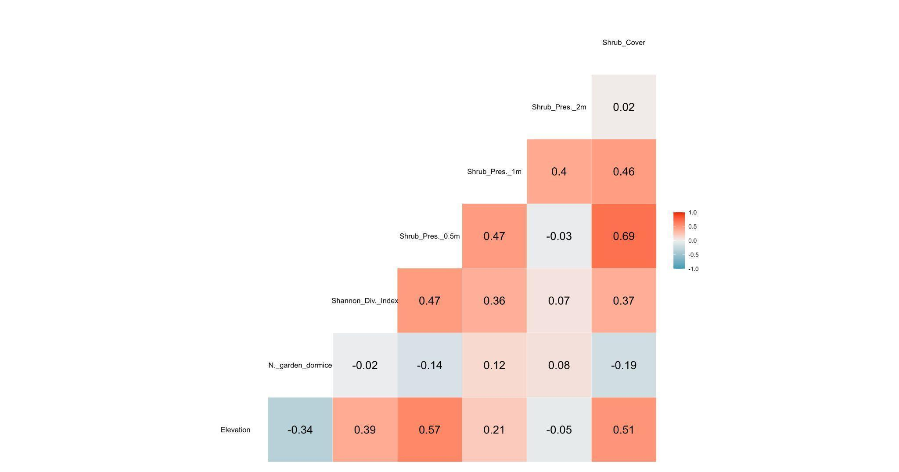
Figure S1. Spearman’s correlation coefficients between environmental variables used for statistical analysis for hazel dormouse (M. avellanarius). Elevation = elevation of each sampling point (m); N. garden dormice = number of garden dormice found in each nest box during each session; Shannon Div. Index = Shannon Diversity Index at each sampling point; Shrub Pres. = presence of shrubs at different heights (0.5, 1, 2 m) at each sampling point; Shrub Cover = percentage shrub cover at each sampling point.

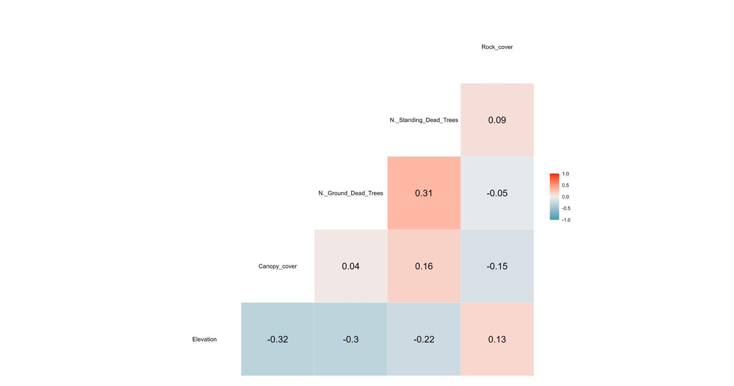
Figure S2. Spearman’s correlation coefficients between environmental variables used for statistical analysis for garden dormouse (E. quercinus). Elevation = elevation of each sampling point (m); Canopy cover (0 to 8) at each sampling point; N. Ground Dead Trees = number of dead trees on the ground at each sampling point; N. Standing Dead Trees = number of standing dead trees at each sampling point; Rock cover = percentage rock cover at each sampling point.

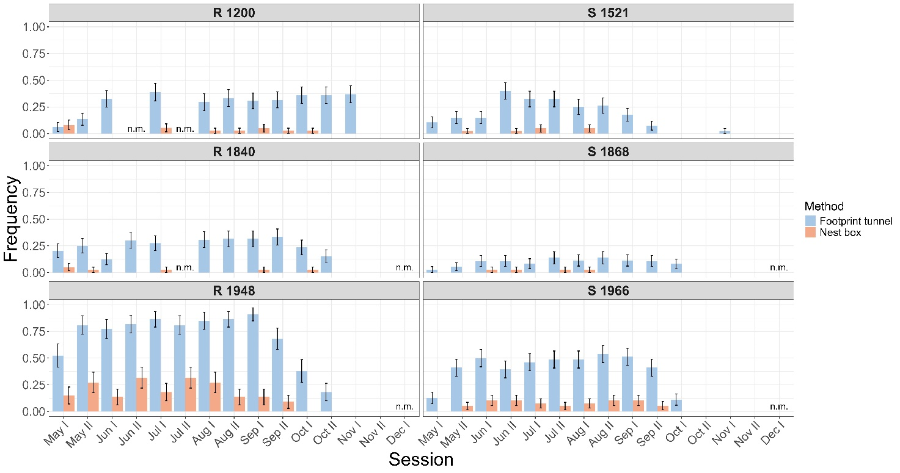
Figure S3. Frequency of occurrence of the hazel dormouse (M. avellanarius) in the six study areas during 2022, divided by the two sampling methods, with the nest box in orange and the footprint tunnel in blue (bars represent ± 1 SE). The letter indicates the area (R, Rhêmes Valley and S, Valsavarenche) and the number, the mean elevation of the sampling points in the area (n.m. = not monitored. When the sampling points monitored during the session were zero or were not a comparable amount with other sessions).

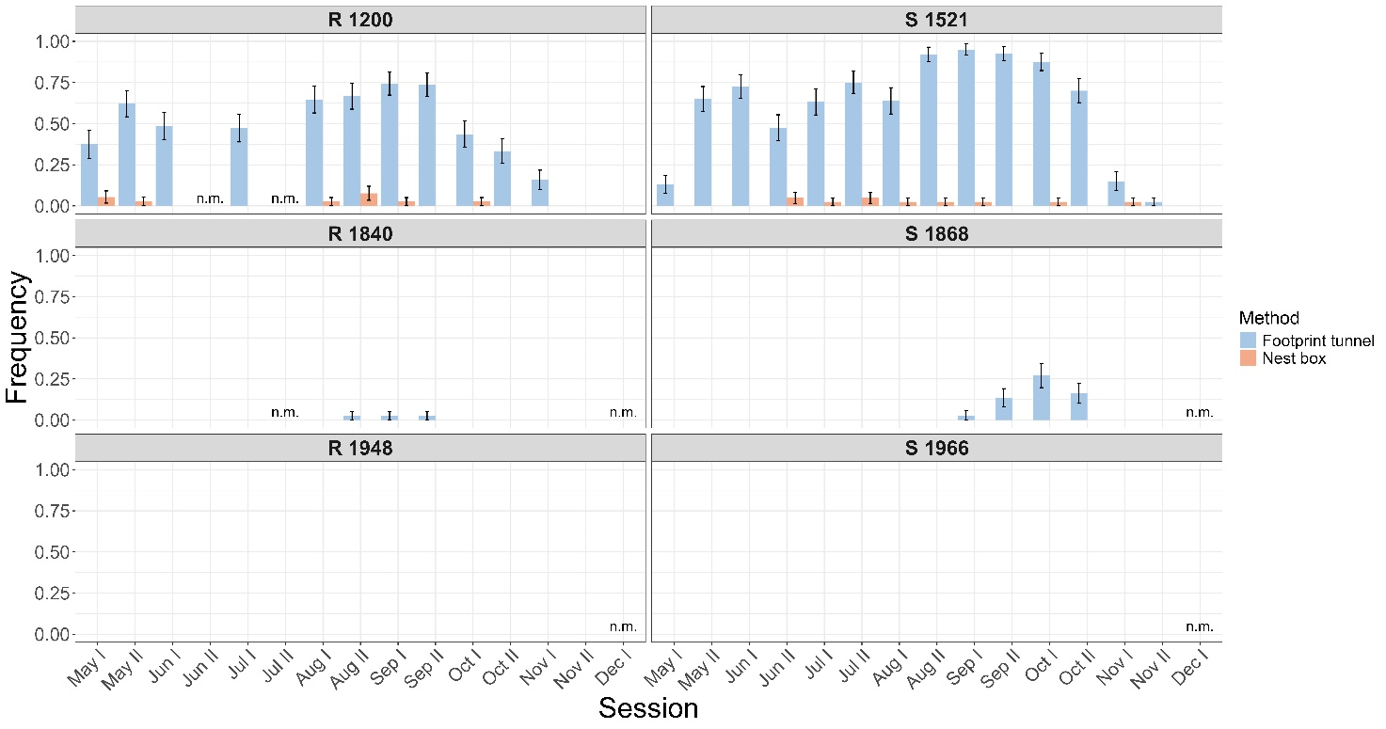
Figure S4. Frequency of occurrence of the garden dormouse (E. quercinus) in the six study areas during 2022, divided by the two sampling methods, with the nest box in orange and the footprint tunnel in blue (bars represent ± 1 SE). The letter indicates the area (R, Rhêmes Valley and S, Valsavarenche) and the number, the mean elevation of the sampling points in the area (n.m. = not monitored. When the sampling points monitored during the session were zero or were not a comparable amount with other sessions).

