Supplementary information to: “The Diet of Free-Ranging Cats in Dutch Open Habitats: A Species-Level Insight”.

Sample collection
Table S1 An overview of the number of collected faecal samples per location, season and year. To allow for comparisons between sampling seasons, we combined the sampling months into (comparable) sampling seasons: winter = December-February, spring = March-May, summer = June-August, autumn = September-November
Number of samples | Location | Season | Year
6 | Island | Winter | 2022 & 2023
31 | Island | Spring | 2021 & 2022 & 2023
11 | Island | Summer | 2021
46 | Island | Autumn | 2020 & 2022 & 2023
94 | Island - total
1 | Mainland | Winter | 2023
14 | Mainland | Spring | 2022 & 2023
32 | Mainland | Summer | 2022
24 | Mainland | Autumn | 2022
71 | Mainland - total
165 | Total

Table S2 The coordinates of the faeces samples collected, from 12 samples the coordinates are not known exactly
island |  |  |  | mainland
 | Long | Lat |  |  | Long | Lat
1 | 6.22 | 53.48 |  | 1 | 4.8 | 51.94
2 | 6.24 | 53.5 |  | 2 | 4.76 | 51.94
3 | 6.24 | 53.49 |  | 3 | 5.7 | 51.9
4 | 6.22 | 53.49 |  | 4 | 4.24 | 51.57
5 | 6.25 | 53.49 |  | 5 | 4.93 | 51.76
6 | 6.15 | 53.47 |  | 6 | 5.31 | 52.21
7 | 6.23 | 53.49 |  | 7 | 4.93 | 51.76
8 | 6.15 | 53.49 |  | 8 | 6.07 | 52.98
9 | 6.26 | 53.49 |  | 9 | 4.22 | 51.59
10 | 6.14 | 53.47 |  | 10 | 5.31 | 52.21
11 | 6.24 | 53.49 |  | 11 | 6.08 | 52.47
12 | 6.2 | 53.48 |  | 12 | 5.31 | 52.21
13 | 6.23 | 53.5 |  | 13 | 5.35 | 52.2
14 | 6.22 | 53.48 |  | 14 | 4.99 | 52.08
15 | 6.15 | 53.49 |  | 15 | 5 | 52.03
16 | 6.24 | 53.49 |  | 16 | 5 | 52.03
17 | 6.24 | 53.49 |  | 17 | 5.31 | 52.21
18 | 6.23 | 53.5 |  | 18 | 4.87 | 52.04
19 | 6.25 | 53.5 |  | 19 | 4.86 | 52.02
20 | 6.26 | 53.49 |  | 20 | 4.93 | 52.03
21 | 6.18 | 53.5 |  | 21 | 4.93 | 52
22 | 6.21 | 53.49 |  | 22 | 5.46 | 52.03
23 | 6.14 | 53.48 |  | 23 | 4.8 | 51.98
24 | 6.14 | 53.48 |  | 24 | 4.93 | 52.03
25 | 6.21 | 53.48 |  | 25 | 4.93 | 51.98
26 | 6.24 | 53.5 |  | 26 | 4.92 | 51.95
27 | 6.21 | 53.48 |  | 27 | 4.93 | 51.76
28 | 6.24 | 53.5 |  | 28 | 5.46 | 52.03
29 | 6.21 | 53.5 |  | 29 | 4.8 | 51.94
30 | 6.2 | 53.48 |  | 30 | 4.85 | 51.98
31 | 6.23 | 53.5 |  | 31 | 5.33 | 52.25
32 | 6.25 | 53.5 |  | 32 | 4.22 | 51.59
33 | 6.15 | 53.49 |  | 33 | 4.93 | 51.76
34 | 6.23 | 53.5 |  | 34 | 5.7 | 51.9
35 | 6.25 | 53.5 |  | 35 | 5.57 | 52.15
36 | 6.26 | 53.49 |  | 36 | 6.07 | 52.98
37 | 6.24 | 53.49 |  | 37 | 5.39 | 52.22
38 | 6.26 | 53.49 |  | 38 | 5.33 | 52.25
39 | 6.25 | 53.49 |  | 39 | 4.8 | 51.99
40 | 6.15 | 53.49 |  | 40 | 5.79 | 51.48
41 | 6.21 | 53.48 |  | 41 | 5.79 | 51.48
42 | 6.25 | 53.49 |  | 42 | 4.93 | 51.76
43 | 6.2 | 53.5 |  | 43 | 4.93 | 52
44 | 6.14 | 53.49 |  | 44 | 4.22 | 51.59
45 | 6.18 | 53.5 |  | 45 | 4.8 | 51.94
46 | 6.26 | 53.49 |  | 46 | 4.22 | 51.59
47 | 6.15 | 53.49 |  | 47 | 4.93 | 52.03
48 | 6.14 | 53.47 |  | 48 | 6.08 | 52.47
49 | 6.23 | 53.48 |  | 49 | 5.33 | 52.25
50 | 6.26 | 53.5 |  | 50 | 4.86 | 52.02
51 | 6.15 | 53.49 |  | 51 | 4.8 | 51.94
52 | 6.15 | 53.49 |  | 52 | 4.84 | 51.98
53 | 6.16 | 53.5 |  | 53 | 5.34 | 52.2
54 | 6.2 | 53.49 |  | 54 | 5 | 52.05
55 | 6.24 | 53.49 |  | 55 | 5.79 | 51.48
56 | 6.26 | 53.49 |  | 56 | 4.85 | 51.98
57 | 6.25 | 53.49 |  | 57 | 5.34 | 52.2
58 | 6.2 | 53.49 |  | 58 | 5 | 52.05
59 | 6.26 | 53.5 |  | 59 | 5.79 | 51.48
60 | 6.2 | 53.5 |  | 60 | 4.24 | 51.57
61 | 6.21 | 53.5 |  | 61 | 5.79 | 51.48
62 | 6.26 | 53.5 |  | 62 | 4.93 | 51.76
63 | 6.25 | 53.49 |  | 63 | 6.08 | 52.47
64 | 6.24 | 53.49 |  | 64 | 4.93 | 52.03
65 | 6.22 | 53.49 |  | 65 | 4.83 | 52.13
66 | 6.24 | 53.49 |  | 66 | 4.8 | 51.98
67 | 6.25 | 53.49 |  | 67 | 4.93 | 52.03
68 | 6.25 | 53.49 |  | 68 | 6.51 | 53.29
69 | 6.25 | 53.49 |  | 69 | 6.52 | 53.29
70 | 6.21 | 53.49 |  | 70 | 6.52 | 53.29
71 | 6.24 | 53.49
72 | 6.26 | 53.5
73 | 6.24 | 53.49
74 | 6.25 | 53.49
75 | 6.21 | 53.49
76 | 6.2 | 53.5
77 | 6.25 | 53.49
78 | 6.25 | 53.49
79 | 6.25 | 53.49
80 | 6.21 | 53.49
81 | 6.21 | 53.49
82 | 6.25 | 53.49
83 | 6.25 | 53.49

Taxonomic assignments

Search parameters BLAST
Search parameters (also default settings for BLAST+ 2.14):
- max e-value = 10 (the lower the number of expected (e) hits of similar quality the more likely the hit is real)
- word size = 28 bp (minimal match region)
- gap cost = linear.
The best hits were saved in a query-centric alignment.

Reference databases
BOLD is the primary reference database for COI sequences, containing official DNA barcode sequences as well as sequences mined from GenBank and private datasets. Genbank (the NCBI nucleotide database) has over 2.5 million COI sequences (Ratnasingham and Hebert 2007; Benson et al. 2009; Porter and Hajibabaei 2020). Much of BOLD’s public data is also deposited in GenBank. However, GenBank is more extensive overall (e.g. contains more data about bacteria), while BOLD applies stricter controls to taxonomic assignments, especially at the species level. However, neither BOLD nor GenBank is entirely complete, and each database provides complementary taxonomic coverage (e.g. Curry et al. 2018). Therefore, combining both databases improves sequence and taxonomic coverage.

Summarizing ESVs
- Top hits (identified to species level) with one deviating assignment from a different family or genus that account for less than 10% of all hits were removed, as they were considered to be errors in the reference database.
- Non-Dutch species that do not occur in our sampling locations and could not plausibly be part of a cats’ diet, were removed, based on the Dutch Species Register (including species with status code 0 - to be defined). This register provides a comprehensive and up-to-date overview of Dutch biodiversity, based on expert-validated data across various taxonomic groups. A custom taxon matcher tool (https://github.com/naturalis/galaxy-tool-taxonmatcher) was used to compare all names obtained to taxa recorded in the Dutch Species Register (Beentjes et al. 2019). Non-native Dutch species that could plausibly occur in cat food (e.g. pig Sus scrofa, turkey Meleagris gallopavo, horse Equus caballus, or cow Bos taurus) were retained for further analysis
- Each ESV that had a different assignment in BOLD compared to GenBank was manually checked. GenBank was assumed to be more comprehensive, so if GenBank did not assign the ESV to Chordata, those ESVs were removed. If only GenBank had assigned a taxon name to an ESV, that assignment was accepted, unless it referred to a non-Dutch taxon (which occasionally happened for LCA-assigned ESVs). In such cases, the ESV was either removed or updated to reflect the correct LCA for Dutch taxa. If GenBank assigned a taxon name at a lower taxonomic level than BOLD, the GenBank assignment was used. If BOLD provided a more detailed identification, the lowest common ancestor (LCA) with the GenBank assignment was chosen. If both databases provided hits at species level, the species-level name of GenBank was accepted when it made ecological sense to do so, e.g. occurring in the sampling locations. Only for Felis silvestris and Felis catus assignment, Felis catus was always chosen over Felis silvestris (because we know for sure none of our samples are from Felis silvestris). It was never the case that BOLD had an assignment at species level and GenBank did not.
- Based on the grade calculated with the formula 0.5*coverage + 0.25*identity + 0.25*ifelse(e-value < 0.01, 100, 0), taxonomic assignments were only deemed reliable up to a specific taxonomic level, see Table S3.
Table S3 Overview grades for each taxonomic assignment
Grade | Taxonomic assignment
97-100 | Genus level assignment reliable
93-96.9 | Family level assignment reliable, set genus to NA
80-92.9 | Order level assignment reliable, set genus and family to NA
70-79.9 | Class level assignment reliable, set genus, family, order to NA
<69.9 | Phylum level assignment reliable, set genus, family, order, class to NA

Overview reads negative controls, mock samples and faecal samples
Table S4 The number of reads per taxa found in the negative extraction controls and negative PCR controls, for both labperiods (2022 and 2023). *Total target reads are all reads without Felidae, Felis, Felis catus, Hominidae and Homo sapiens. **Total reads mock samples are all reads from Passeriformes, Estrildidae, Lonchura, Taeniopygia, Taeniopygia guttata, Mus and Mus musculus
 | DNA Extraction |  |  | PCR
 | 2022 (n=2) | 2023 (n=6) |  | 2022 (n=1) | 2023 (n=5)
Apodemus | 0 | 14 |  | 0 | 0
Bos taurus | 0 |  | 0 | 0 |  | 1
Carnivora | 0 | 35 |  | 0 | 11
Chordata | 0 | 1 |  | 0 | 0
Cricetidae | 0 | 2 |  | 0 | 1
Crocidura russula | 0 | 3 |  | 0 | 1
Estrildidae | 38 | 0 |  | 0 | 0
Felidae | 2 | 5 |  | 0 | 0
Felis | 0 | 0 |  | 0 | 1
Felis catus | 39194 | 1211 |  | 0 | 589
Gallus gallus | 0 | 8 |  | 0 | 0
Hominidae | 0 | 0 |  | 0 | 5
Homo sapiens | 301 | 259 |  | 0 | 155
Lepus europaeus | 0 | 1 |  | 0 | 5
Lonchura | 358 | 3 |  | 0 | 0
Mammalia | 0 | 10 |  | 0 | 1
Meleagris gallopavo | 0 | 4 |  | 0 | 2
Microtus | 0 | 3 |  | 0 | 1
Microtus arvalis | 1 | 8 |  | 0 | 4
Mus | 23 | 4 |  | 0 | 0
Mus musculus | 14180 | 779 |  | 3 | 7
Passeriformes | 14 | 0 |  | 0 | 0
Pluvialis apricaria | 0 | 0 |  | 0 | 3
Rattus norvegicus | 0 | 0 |  | 0 | 1
Regulus regulus | 2 | 0 |  | 0 | 0
Taeniopygia | 139 | 3 |  | 1 | 1
Taeniopygia guttata | 11182 | 336 |  | 12 | 3
Tetraodontidae | 0 | 2 |  | 0 | 0
Total | 65434 | 2691 |  | 16 | 792
Total target reads* | 25937 | 1216 |  | 16 | 42
Total reads mock samples** | 25934 | 1125 |  | 16 | 11

Table S5 Overview total number of reads per sample before and after correction for negative controls and Shannon Diversity. In bold the samples that had a final readcount of 0, due to no target reads found, correction with negative controls or correction for low number of reads (<2) tested with Shannon Diversity (indicated with *)
 | sample |  | raw readcount | readcount nc correction | readcount mock samples | final readcount
1 | F0513_22_22 | 5578 |  | 5575 | 0 | 5575
2 | F0109_22_22 | 5119 |  | 5118 | 0 | 5118
3 | F1213_23_23 | 3097 |  | 3056 | 0 | 3056
4 | F1215_23_23 | 2858 |  | 2813 | 0 | 2813
5 | F1406_22_22 | 2778 |  | 2777 | 0 | 2777
6 | F1413_23_23 | 1081 |  | 1066 | 0 | 1066
7 | F1313_22_22 | 1061 |  | 1058 | 0 | 1058
8 | F0622_22_22 | 1059 |  | 1058 | 0 | 1058
9 | F1313_23_23 | 1011 |  | 996 | 0 | 996
10 | F0117_22_22 | 991 |  | 990 | 0 | 990
11 | F0401_23_23 | 848 |  | 834 | 0 | 834
12 | F1417_23_23 | 998 |  | 835 | 36 | 827
13 | F1513_23_23 | 806 |  | 787 | 0 | 787
14 | F1216_23_23 | 794 |  | 749 | 0 | 749
15 | F0605_23_23 | 766 |  | 746 | 0 | 746
16 | F1220_22_22 | 744 |  | 741 | 0 | 741
17 | F0501_23_23 | 705 |  | 697 | 0 | 697
18 | F0205_23_23 | 666 |  | 646 | 0 | 646
19 | F0303_22_22 | 652 |  | 609 | 32 | 590
20 | F0909_22_22 | 567 |  | 566 | 0 | 566
21 | F0507_23_23 | 539 |  | 518 | 0 | 518
22 | F0210_23_23 | 509 |  | 491 | 0 | 491
23 | F1219_23_23 | 522 |  | 455 | 36 | 423
24 | F0806_23_23 | 394 |  | 394 | 0 | 394
25 | F1014_23_23 | 372 |  | 345 | 0 | 345
26 | F0918_23_23 | 365 |  | 334 | 36 | 331
27 | F1118_23_23 | 380 |  | 333 | 36 | 312
28 | F0710_23_23 | 266 |  | 265 | 0 | 265
29 | F0810_23_23 | 256 |  | 255 | 0 | 255
30 | F1315_23_23 | 231 |  | 215 | 0 | 215
31 | F1305_22_22 | 202 |  | 201 | 0 | 201
32 | F1214_23_23 | 218 |  | 182 | 0 | 182
33 | F1613_23_23 | 203 |  | 177 | 0 | 177
34 | F0412_23_23 | 188 |  | 171 | 0 | 171
35 | F1518_23_23 | 240 |  | 156 | 36 | 155
36 | F0206_23_23 | 169 |  | 151 | 0 | 151
37 | F0611_23_23 | 152 |  | 147 | 0 | 147
38 | F0917_23_23 | 153 |  | 136 | 0 | 136
39 | F0705_23_23 | 120 |  | 111 | 0 | 111
40 | F0505_22_22 | 112 |  | 110 | 0 | 110
41 | F0301_23_23 | 105 |  | 96 | 0 | 96
42 | F0812_23_23 | 97 |  | 83 | 0 | 83
43 | F1002_22_22 | 84 |  | 83 | 0 | 83
44 | F1617_23_23 | 109 |  | 84 | 36 | 80
45 | F1318_23_23 | 107 |  | 85 | 36 | 78
46 | F1414_23_23 | 93 |  | 74 | 0 | 74
47 | F1321_22_22 | 68 |  | 67 | 0 | 67
48 | F0207_23_23 | 77 |  | 66 | 0 | 66
49 | F0106_23_23 | 67 |  | 66 | 0 | 66
50 | F0408_23_23 | 83 |  | 61 | 0 | 61
51 | F1514_23_23 | 76 |  | 61 | 0 | 61
52 | F1217_23_23 | 83 |  | 58 | 0 | 58
53 | F0412_22_22 | 56 |  | 54 | 0 | 54
54 | F1114_23_23 | 75 |  | 53 | 0 | 53
55 | F0102_23_23 | 53 |  | 53 | 0 | 53
56 | F1111_22_22 | 68 |  | 51 | 32 | 51
57 | F0901_22_22 | 44 |  | 44 | 0 | 44
58 | F0809_23_23 | 46 |  | 43 | 0 | 43
59 | F1314_23_23 | 55 |  | 42 | 0 | 42
60 | F0411_23_23 | 50 |  | 40 | 0 | 40
61 | F0505_23_23 | 47 |  | 40 | 0 | 40
62 | F0210_22_22 | 40 |  | 40 | 0 | 40
63 | F0607_23_23 | 50 |  | 37 | 0 | 37
64 | F0208_23_23 | 52 |  | 35 | 0 | 35
65 | F1016_23_23 | 50 |  | 34 | 0 | 34
66 | F0201_23_23 | 37 |  | 28 | 0 | 28
67 | F0101_22_22 | 27 |  | 26 | 0 | 26
68 | F0105_23_23 | 28 |  | 24 | 0 | 24
69 | F0510_23_23 | 33 |  | 23 | 0 | 23
70 | F1117_23_23 | 37 |  | 22 | 0 | 22
71 | F0509_23_23 | 25 |  | 22 | 0 | 22
72 | F1415_23_23 | 30 |  | 20 | 0 | 20
73 | F0502_23_23 | 24 |  | 18 | 0 | 18
74 | F1615_23_23 | 42 |  | 16 | 0 | 16
75 | F1113_23_23 | 38 |  | 15 | 0 | 15
76 | F1015_23_23 | 29 |  | 14 | 0 | 14
77 | F0602_23_23 | 26 |  | 13 | 0 | 13
78 | F0202_23_23 | 23 |  | 12 | 0 | 12
79 | F0211_23_23 | 27 |  | 11 | 0 | 11
80 | F0606_23_23 | 23 |  | 11 | 0 | 11
81 | F0706_23_23 | 22 |  | 11 | 0 | 11
82 | F0407_23_23 | 13 |  | 10 | 0 | 10
83 | F0917_22_22 | 10 |  | 10 | 0 | 10
84 | F0404_23_23 | 24 |  | 9 | 0 | 9
85 | F1420_23_23 | 20 |  | 9 | 0 | 9
86 | F1010_22_22 | 10 |  | 9 | 0 | 9
87 | F1013_23_23 | 33 |  | 8 | 0 | 8
88 | F0609_23_23 | 16 |  | 8 | 0 | 8
89 | F0302_23_23 | 10 |  | 8 | 0 | 8
90 | F0218_22_22 | 9 |  | 8 | 0 | 8
91 | F1018_23_23 | 42 |  | 8 | 36 | 7
92 | F1116_23_23 | 32 |  | 7 | 0 | 7
93 | F1115_23_23 | 30 |  | 7 | 0 | 7
94 | F0203_23_23 | 12 |  | 7 | 0 | 7
95 | F0804_23_23 | 9 |  | 7 | 0 | 7
96 | F0101_23_23 | 23 |  | 6 | 0 | 6
97 | F1614_23_23 | 20 |  | 6 | 0 | 6
98 | F1616_23_23 | 15 |  | 6 | 0 | 6
99 | F1316_23_23 | 11 |  | 6 | 0 | 6
100 | F0309_23_23 | 9 |  | 6 | 0 | 6
101 | F0707_22_22 | 20 |  | 5 | 32 | 5
102 | F1017_23_23 | 14 |  | 5 | 0 | 5
103 | F0209_23_23 | 10 |  | 5 | 0 | 5
104 | F1515_23_23 | 9 |  | 5 | 0 | 5
105 | F0702_23_23 | 8 |  | 5 | 0 | 5
106 | F0811_23_23 | 8 |  | 5 | 0 | 5
107 | F0308_23_23 | 6 |  | 5 | 0 | 5
108 | F0601_23_23 | 13 |  | 4 | 0 | 4
109 | F0406_23_23 | 12 |  | 4 | 0 | 4
110 | F0712_23_23 | 12 |  | 4 | 0 | 4
111 | F1520_23_23 | 11 |  | 4 | 0 | 4
112 | F0506_23_23 | 9 |  | 4 | 0 | 4
113 | F0508_23_23 | 9 |  | 4 | 0 | 4
114 | F0103_23_23 | 4 |  | 4 | 0 | 4
115 | F1619_23_22 | 37 |  | 4 | 32 | 3
116 | F1517_23_23 | 15 |  | 4 | 36 | 3
117 | F0410_23_23 | 11 |  | 3 | 0 | 3
118 | F0801_23_23 | 10 |  | 3 | 0 | 3
119 | F0802_23_23 | 9 |  | 3 | 0 | 3
120 | F0805_23_23 | 5 |  | 3 | 0 | 3
121 | F0110_23_23 | 3 |  | 3 | 0 | 3
122 | F0808_23_23 | 3 |  | 3 | 0 | 3
123 | F0920_23_22 | 87 |  | 2 | 32 | 2
124 | F0915_23_23 | 12 |  | 2 | 0 | 2
125 | F0204_23_23 | 7 |  | 2 | 0 | 2
126 | F0503_23_23 | 5 |  | 2 | 0 | 2
127 | F0603_23_23 | 5 |  | 2 | 0 | 2
128 | F0803_23_23 | 4 |  | 2 | 0 | 2
129 | F0303_23_23 | 3 |  | 2 | 0 | 2
130 | F0305_23_23 | 3 |  | 2 | 0 | 2
131 | F1418_23_23 | 22 |  | 1 | 36 | 1*
132 | F1516_23_23 | 8 |  | 1 | 0 | 1*
133 | F0403_23_23 | 7 |  | 1 | 0 | 1*
134 | F0504_23_23 | 7 |  | 1 | 0 | 1*
135 | F0212_23_23 | 5 |  | 1 | 0 | 1*
136 | F0709_23_23 | 3 |  | 1 | 0 | 1*
137 | F0104_23_23 | 2 |  | 1 | 0 | 1*
138 | F0109_23_23 | 2 |  | 1 | 0 | 1*
139 | F0112_23_23 | 2 |  | 1 | 0 | 1*
140 | F0311_23_23 | 2 |  | 1 | 0 | 1*
141 | F0304_23_23 | 1 |  | 1 | 0 | 1*
142 | F0306_23_23 | 1 |  | 1 | 0 | 1*
143 | F0606_22_22 | 1 |  | 1 | 0 | 1*
144 | F0707_23_23 | 1 |  | 1 | 0 | 1*
145 | F0708_23_23 | 1 |  | 1 | 0 | 1*
146 | F0711_23_23 | 1 |  | 1 | 0 | 1*
147 | F0807_23_23 | 1 |  | 1 | 0 | 1*
148 | F1414_22_22 | 1 |  | 1 | 0 | 1*
149 | F0610_23_23 | 6 |  | 0 | 0 | 0
150 | F0703_23_23 | 5 |  | 0 | 0 | 0
151 | F0914_23_23 | 5 |  | 0 | 0 | 0
152 | F0307_23_23 | 4 |  | 0 | 0 | 0
153 | F0409_23_23 | 4 |  | 0 | 0 | 0
154 | F0604_23_23 | 3 |  | 0 | 0 | 0
155 | F0701_23_23 | 3 |  | 0 | 0 | 0
156 | F0111_23_23 | 2 |  | 0 | 0 | 0
157 | F0107_23_23 | 1 |  | 0 | 0 | 0
158 | F0108_23_23 | 1 |  | 0 | 0 | 0
159 | F0310_23_23 | 1 |  | 0 | 0 | 0
160 | F0312_23_23 | 1 |  | 0 | 0 | 0
161 | F0511_23_23 | 1 |  | 0 | 0 | 0
162 | F0512_23_23 | 1 |  | 0 | 0 | 0
163 | F0202_22_22 | 0 |  | 0 | 0 | 0
164 | F1018_22_22 | 0 |  | 0 | 0 | 0

Table S6 The corrected number of total reads per taxa found in the mock samples. *Total target reads without reads of mock sample species (Passeriformes, Estrildidae, Lonchura, Taeniopygia, Taeniopygia guttata, Mus and Mus musculus)
Taxon | Total number of reads
Taeniopygia guttata | 2165
Mus musculus | 2134
Taeniopygia | 2102
Lonchura | 468
Estrildidae | 527
Mus | 209
Crocidura russula | 32
Passeriformes | 32
Apodemus | 22
Felis catus | 4
Carnivora | 8
Microtus | 8
Rodentia | 4
Chordata | 2
Felidae | 1
Sus scrofa | 2
Bovidae | 1
Cricetidae | 1
Crocidura | 1
Felis | 1
Muridae | 1
Sturnus | 1
Total number of reads | 7726
Total number of target reads* | 84

Shannon Diversity
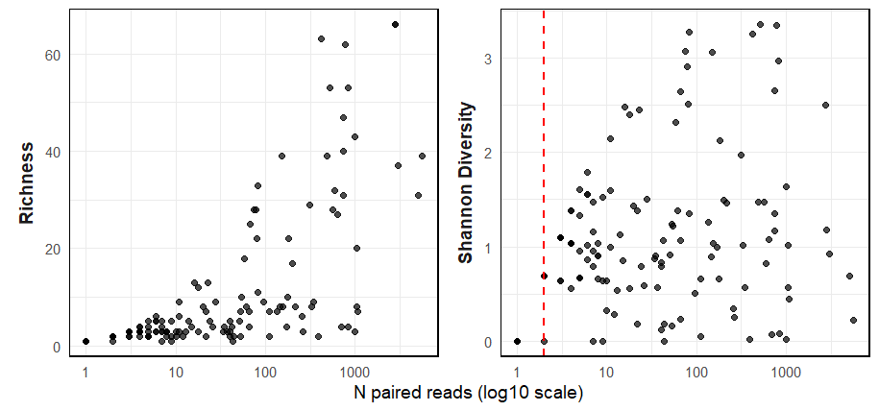Fig. S1 Diversity versus sequencing depth, the total number of target reads per sample. (a): Richness: number of target ESVs detected per sample. (b): Shannon Diversity. The red dotted line indicates the cut-off as below this number of reads samples showed a significantly lower diversity
a
b

Statistical anlaysis - AIC
Table S7 Model comparison for the GLM explaining the cat food presence. Models with and without the interaction between sampling location and season were compared using Akaike’s Information Criterion (AIC), Bayesian Information Criterion (BIC), log-likelihood (logLik), deviance, and likelihood-ratio tests (Chisq)
 | Df | AIC | BIC | logLik | deviance | Chisq | Df | Pr(>Chisq)
catfood_present ~ loc * season | 8 | 167.27 | 190.21 | -75.63 | 151.27
catfood_present ~ loc + season | 5 | 169.54 | 183.88 | -79.77 | 159.54 | 8.27 | 3.00 | 0.04072

Table S8 Model comparison for the GLM explaining the proportion of birds. Models with and without the interaction between sampling location and season were compared using Akaike’s Information Criterion (AIC), Bayesian Information Criterion (BIC), log-likelihood (logLik), deviance, and likelihood-ratio tests (Chisq)
 | Df | AIC | BIC | logLik | deviance | Chisq | Df | Pr(>Chisq)
prop_aves ~ loc + season + catfood | 9 | 164.95 | 190.62 | -73.48 | 146.95
prop_aves ~ loc * season + catfood | 12 | 164.14 | 198.37 | -70.07 | 140.14 | 6.81 | 3.00 | 0.07819

All taxa found in cats’ diet
Table S9 All taxa found in cats’ diet, with corresponding colours to Fig. 2, categorized by catfood, amphibians, birds, rodents, eulipotyphla and lagomorphs. Their relative read abundance (RRA) is shown per sampling location and season. Taxa in bold is found more than 0.01 RRA (1%) per sampling location or season, in red is found on the Dutch Red List (van Norren, Dekker & Limpens, 2020)
 |  | order | family | genus | species | English name | RRA island | RRA mainland | RRA winter |  |  | RRA spring |  | RRA summer |  | RRA autumn
 | catfood | Galliformes | Phasianidae | Gallus | Gallus gallus | Chicken | 0.0235513 | 0.0228051 | 0 |  |  | 0.040119 |  | 0.017178 |  | 0.018018
 | catfood | Tetraodontiformes | Tetraodontidae | no identification | Tetraodontida | Pufferfish | 0.0001492 | 0.0002848 | 0 |  |  | 0 |  | 0 |  | 0.000473
 | catfood | Galliformes | Phasianidae | Meleagris | Meleagris gallopavo | Turkey | 0.0041152 | 0.0371252 | 0 |  |  | 0.046095 |  | 0.013967 |  | 0
 | catfood | Cypriniformes | Cyprinidae | Scardinius | Scardinius erythrophthalmus | Common Rudd | 0.0004165 | 0 | 0 |  |  | 0 |  | 0 |  | 0.000613
 | catfood | Gadiformes | Gadidae | Trisopterus | Trisopterus esmarkii | Norway pout | 0 | 0.0006583 | 0 |  |  | 0.000872 |  | 0 |  | 0
 | catfood | Artiodactyla | Bovidae | no identification | Bovidae | Bovids | 0.0003756 | 0.0120594 | 0 |  |  | 0.000704 |  | 4.19E-05 |  | 0.010799
 | catfood | Artiodactyla | Bovidae | Bos | Bos taurus | Domestic Cattle | 0.0160791 | 0.1205808 | 0.041667 |  |  | 0.046393 |  | 0.084375 |  | 0.046261
 | catfood | Artiodactyla | Suidae | Sus | Sus scrofa | Domestic Pig | 0.0022385 | 0.0666673 | 0.065476 |  |  | 0.02027 |  | 0.061012 |  | 0.006414
 | catfood | Perissodactyla | no identification | no identification | Perissodactyla | Odd-toed Ungulates | 0.0010203 | 0 | 0 |  |  | 0.001686 |  | 0 |  | 0.000368
 | catfood | Perissodactyla | Equidae | no identification | Equidae | Horses | 0.0058391 | 0.0014515 | 0.000483 |  |  | 0.011431 |  | 0 |  | 0.00215
 |  | Anura | Ranidae | Rana | Rana temporaria | Common frog | 0 | 0.0505102 | 0 |  |  | 0 |  | 0.077344 |  | 0
 | birds | Passeriformes | no identification | no identification | Passeriformes | Passerines | 0.0015432 | 0 | 0 |  |  | 0 |  | 0 |  | 0.002273
 | birds | Passeriformes | Regulidae | Regulus | Regulus regulus | Goldcrest | 0.0140022 | 0 | 0 |  |  | 0 |  | 0 |  | 0.020621
 | birds | Passeriformes | Prunellidae | Prunella | Prunella modularis | Dunnock | 0.0010778 | 0 | 0 |  |  | 0 |  | 0.002232 |  | 0.000289
 | birds | Passeriformes | Motacillidae | no identification | Motacillidae | Pipits & Wagtails | 0.0002975 | 0 | 0 |  |  | 0 |  | 0 |  | 0.000438
 | birds | Passeriformes | Motacillidae | Anthus | Anthus pratensis | Meadow Pipit | 0.0066311 | 0 | 0 |  |  | 0.000282 |  | 0.010417 |  | 0.003516
 | birds | Passeriformes | Muscicapidae | Erithacus | Erithacus rubecula | European Robin | 0.0102017 | 0 | 0 |  |  | 0 |  | 0 |  | 0.015024
 | birds | Passeriformes | Passeridae | Passer | Passer | True Sparrows | 0 | 0.0014458 | 0 |  |  | 0 |  | 0.001267 |  | 0.000551
 | birds | Passeriformes | Fringillidae | no identification | Fringillidae | Finches | 3.741E-05 | 0 | 0 |  |  | 0 |  | 0 |  | 5.51E-05
 | birds | Passeriformes | Turdidae | Turdus | Turdus iliacus | Redwing | 0.001286 | 0 | 0 |  |  | 0 |  | 0 |  | 0.001894
 | birds | Passeriformes | Turdidae | Turdus | Turdus philomelos | Song Thrush | 0.0010643 | 0 | 0 |  |  | 0 |  | 0 |  | 0.001567
 | birds | Passeriformes | Sturnidae | Sturnus | Sturnus vulgaris | Common Starling | 0.0148148 | 0 | 0.041667 |  |  | 0.012162 |  | 0.015625 |  | 0
 | birds | Passeriformes | Estrildidae | no identification | Estrildidae | Estrildid Finches | 3.957E-05 | 0 | 0 |  |  | 0 |  | 0 |  | 5.83E-05
 | birds | Passeriformes | Estrildidae | Lonchura | Lonchura | Munias & Mannikins | 0.000823 | 0 | 0 |  |  | 0 |  | 0.002083 |  | 0
 | birds | Passeriformes | Estrildidae | Taeniopygia | Taeniopygia | Zebra Finches | 0.0019746 | 0.0010593 | 0.02381 |  |  | 0.000356 |  | 0 |  | 0.001015
 | birds | Passeriformes | Corvidae | no identification | Corvidae | Crows | 0.0005612 | 0 | 0 |  |  | 0 |  | 0 |  | 0.000826
 | birds | Anseriformes | Anatidae | Branta | Branta | Black Geese | 0.0066248 | 0 | 0 |  |  | 0.005494 |  | 0 |  | 0.006061
 | birds | Anseriformes | Anatidae | Spatula | Spatula clypeata | Northern Shoveler | 0.0117845 | 0.0007658 | 0 |  |  | 0.001014 |  | 0 |  | 0.017355
 | birds | Charadriiformes | Laridae | Larus | Larus | Gulls | 0.0126543 | 0.001455 | 0 |  |  | 0.016116 |  | 0.015625 |  | 0
 | birds | Galliformes | Phasianidae | Phasianus | Phasianus colchicus | Common Pheasant | 0.0423325 | 0.0438776 | 0 |  |  | 0.084679 |  | 0.04256 |  | 0.019707
 | birds | Falconiformes | Falconidae | no identification | Falconidae | Falcons & Caracaras | 0.0002975 | 0 | 0 |  |  | 0 |  | 0 |  | 0.000438
 | rodents | no identification | no identification | no identification | Mammalia | Mammals | 0.0932921 | 0.1533963 | 0.089786 |  |  | 0.07016 |  | 0.091941 |  | 0.16357
 | rodents | Rodentia | no identification | no identification | Rodentia | Rodents | 0.0024784 | 0 | 0.002415 |  |  | 0.002883 |  | 0 |  | 0.001447
 | rodents | Rodentia | Muridae | no identification | Muridae | Murids | 0.0010849 | 0 | 0 |  |  | 0.00123 |  | 0 |  | 0.00077
 | rodents | Rodentia | Muridae | Apodemus | Apodemus | Field Mice | 0.0004049 | 0 | 0.000483 |  |  | 0.000323 |  | 2.22E-05 |  | 0.000313
 | rodents | Rodentia | Muridae | Apodemus | Apodemus sp. | Field Mice | 0.1331975 | 0.0159687 | 0.303535 |  |  | 0.090404 |  | 0.015045 |  | 0.107707
 | rodents | Rodentia | Muridae | Apodemus | Apodemus sylvaticus | Wood Mouse | 0.0003233 | 0 | 0 |  |  | 0.000136 |  | 0 |  | 0.000385
 | rodents | Rodentia | Muridae | Rattus | Rattus | Rats | 0.0004838 | 0 | 0 |  |  | 0.000408 |  | 0 |  | 0.000438
 | rodents | Rodentia | Muridae | Rattus | Rattus norvegicus | Brown Rat | 0.0199929 | 0.0038028 | 0 |  |  | 0.026672 |  | 0 |  | 0.014889
 | rodents | Rodentia | Muridae | Mus | Mus musculus | House Mouse | 0.0201279 | 0.0132717 | 0.025893 |  |  | 0.008193 |  | 0.036458 |  | 0.011919
 | rodents | Rodentia | Muridae | Micromys | Micromys minutus | Eurasian Harvest Mouse | 0.0006859 | 0.0694705 | 0.125 |  |  | 6.86E-05 |  | 0.057607 |  | 0.015702
 | rodents | Rodentia | Cricetidae | no identification | Cricetidae | Voles | 0.0216123 | 0.0466408 | 0.027525 |  |  | 0.056619 |  | 0.027964 |  | 0.01602
 | rodents | Rodentia | Cricetidae | Microtus | Microtus | Meadow Voles | 0.153546 | 0.1330247 | 0.167551 |  |  | 0.234768 |  | 0.16484 |  | 0.072524
 | rodents | Rodentia | Cricetidae | Microtus | Microtus arvalis | Common Vole | 0.1222148 | 0.0106393 | 0.060417 |  |  | 0.060486 |  | 0.045337 |  | 0.115808
 | eulipotyphla | Eulipotyphla | Soricidae | no identification | Soricidae | Shrews | 0.0025905 | 0 | 0 |  |  | 0 |  | 0.003472 |  | 0.001795
 | eulipotyphla | Eulipotyphla | Soricidae | Crocidura | Crocidura | White-toothed Shrews | 0.0044147 | 0.0003851 | 0 |  |  | 0.006127 |  | 0.000373 |  | 0.002506
 | eulipotyphla | Eulipotyphla | Soricidae | Crocidura | Crocidura russula | Greater White-toothed Shrew | 0.1524356 | 0.0126155 | 0.02381 |  |  | 0.048537 |  | 0.062192 |  | 0.164302
 | eulipotyphla | Eulipotyphla | Soricidae | Sorex | Sorex minutus | Eurasian Pygmy Shrew | 0 | 0.022449 | 0 |  |  | 0 |  | 0 |  | 0.02
 | eulipotyphla | Eulipotyphla | Soricidae | Sorex | Sorex coronatus | Crowned Shrew | 0.0002721 | 0.0317759 | 0 |  |  | 0.013957 |  | 0.033032 |  | 0.000103
 | eulipotyphla | Eulipotyphla | Talpidae | Talpa | Talpa europaea | European Mole | 0 | 0.0060024 | 0 |  |  | 0 |  | 0.009191 |  | 0
 |  | Lagomorpha | Leporidae | Lepus | Lepus | True Hares | 0.0029834 | 0 | 0 |  |  | 0.00102 |  | 0.002083 |  | 0.002496
 |  | Lagomorpha | Leporidae | Lepus | Lepus europaeus | European Hare | 0.05121 | 0.0504237 | 0 |  |  | 0.069361 |  | 0.061979 |  | 0.03762
 |  | Lagomorpha | Leporidae | Oryctolagus | Oryctolagus cuniculus | European Rabbit | 0.0002888 | 0.0010204 | 0 |  |  | 0.000363 |  | 0.001874 |  | 0
 |  | no identification | no identification | no identification | Chordata | Chordates | 0.0345273 | 0.0683673 | 0.000483 |  |  | 0.020612 |  | 0.042862 |  | 0.072902

Statistical analysis – rarefaction
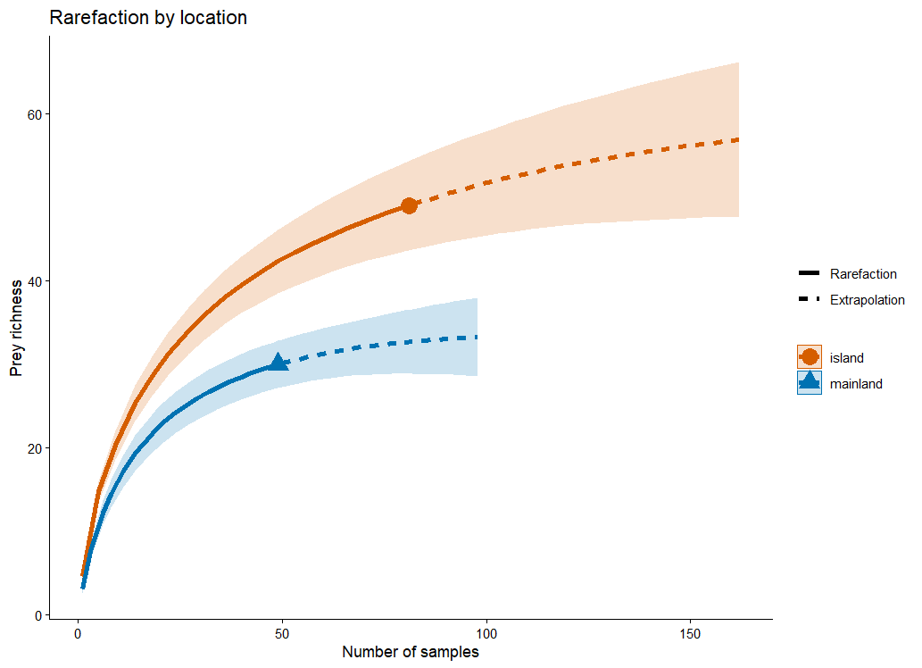
Fig. S2 Rarefaction curves for the number of samples across sampling locations. Solid lines represent interpolated rarefaction curves; dashed lines indicate extrapolation beyond the observed sample size. Each colour corresponds to a distinct sampling location (see legend). The lines illustrate the relationship between sampling effort and prey richness detected, allowing comparison across locations with unequal sample sizes.

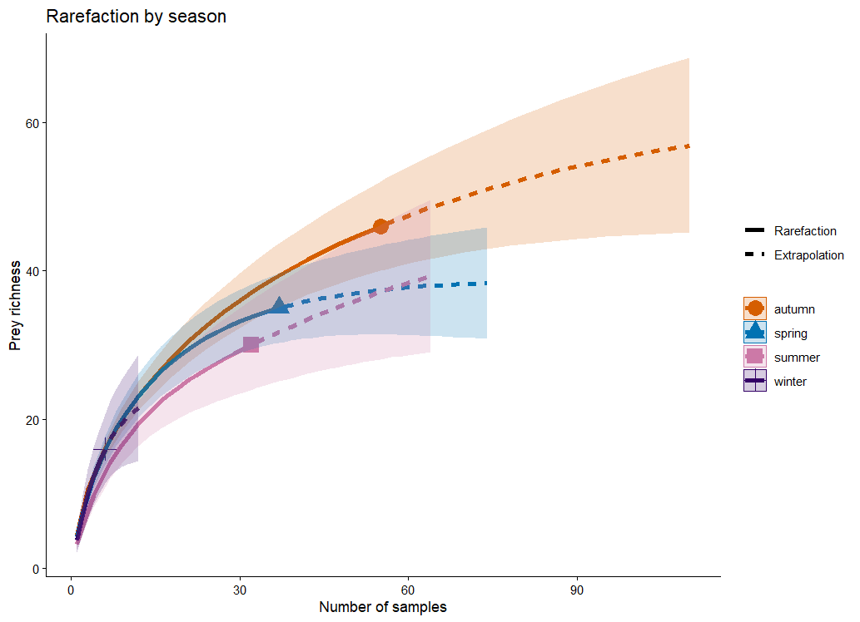
Fig. S3 Rarefaction curves for the number of samples across sampling seasons. Solid lines represent interpolated rarefaction curves; dashed lines indicate extrapolation beyond the observed sample size. Each colour corresponds to a distinct sampling season (see legend). The lines illustrate the relationship between sampling effort and prey richness detected, allowing comparison across seasons with unequal sample sizes.

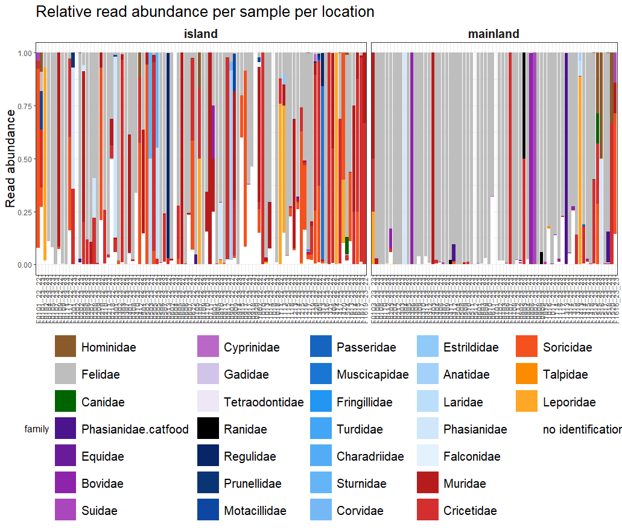
Results relative read abundance all samples
Fig. S4 The relative read abundance per sample divided into samples collected on the island and the mainland, with in grey the relative read abundance of the host (Felis catus), in brown the relative read abundance of human DNA, in white no identification and the rest of the colours showing the target species

Mock samples test
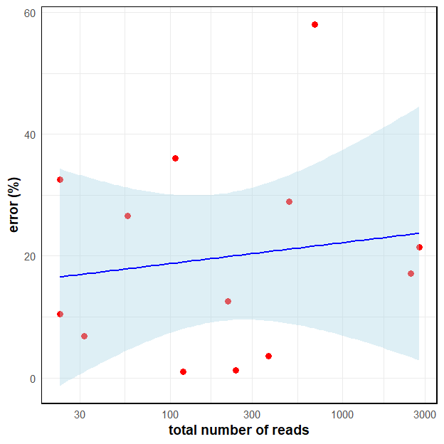Fig. S5 The absolute error between the observed and expected ratio of mouse versus the total number of reads from the mock samples. The absolute error in the mock samples was independent of total read count (F(1,11) = 0.092, β = 0.0016, R² = 0.008, p = 0.77)

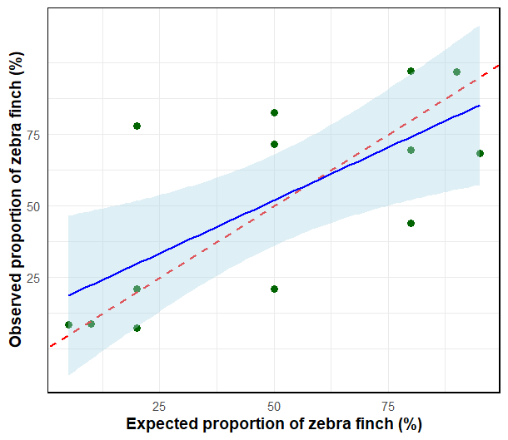
Fig. S6 Relationship between the expected and observed proportions of house mouse in mock DNA samples. Mock samples were prepared with varying proportions of house mouse (Mus musculus) and zebra finch (Taeniopygia guttata) tissue by wet weight. The observed proportion of house mouse reads obtained from DNA metabarcoding is plotted against the expected proportion of house mouse based on tissue mass. Points represent individual mock samples. The dotted red line indicates the 1:1 line (x = y), and the blue line represents the fitted linear model showing the significant positive relationship between observed and expected proportions (F(_{1,11}) = 10.2, β = 0.74, R² = 0.48, p < 0.01)

Relative read abundance on class level
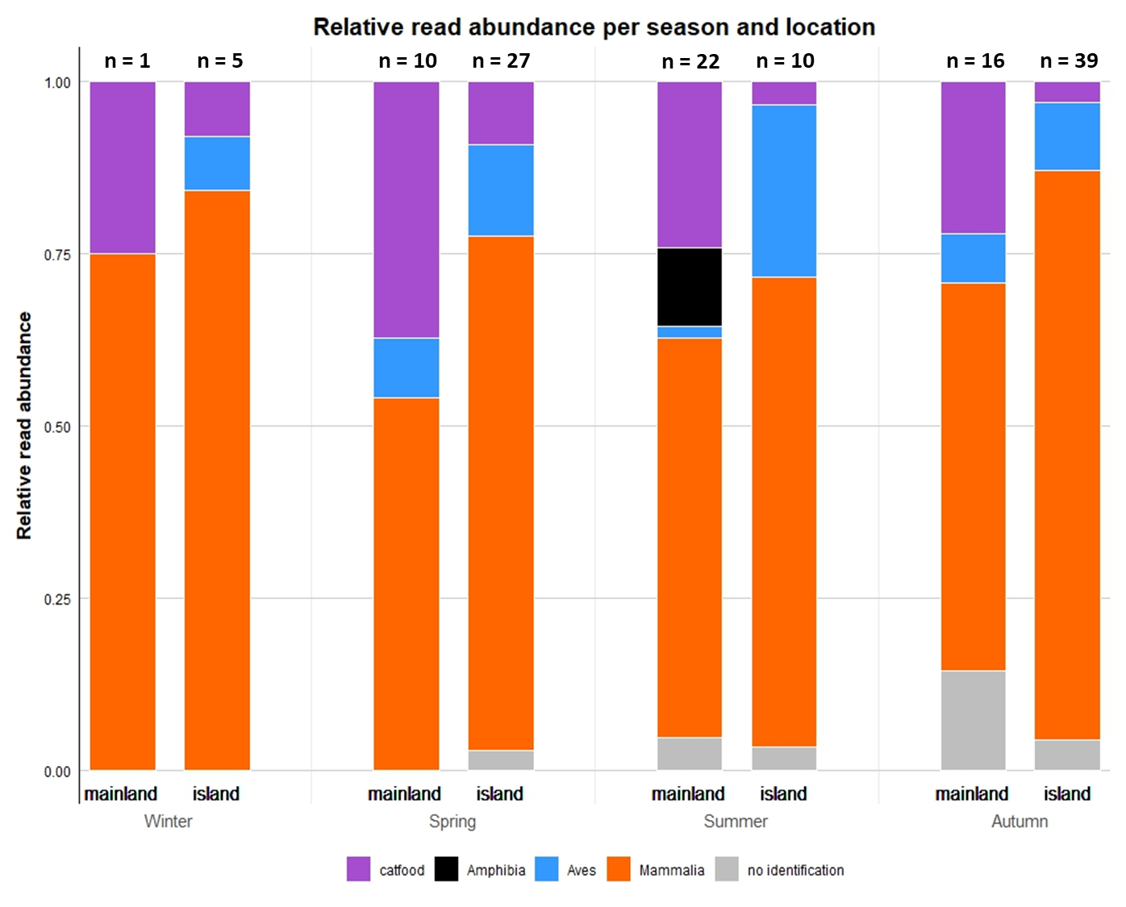
Fig. S7 The relative read abundance of cat food, amphibians (Amphibia), birds (Aves) and mammals (Mammalia) per sampling location (mainland and island) and season (winter, spring, summer, autumn). The sample sizes per sampling location per season are indicated on top

Statistical analysis – sensitivity results
Table S10 Results of the sensitivity analysis on cat food presence showing the distribution of p-values across resampling iterations for two variables (location, loc:season). Median p-values, 95% ranges, and the proportion of iterations yielding p < 0.05 are reported
 | Median p | 95% range | Prop p < 0.05
location | 0.009 | 0.00056 - 0.08 | 0.94
loc:season | 0.11 | 0.0025 - 0.6 | 0.29

Table S11 Results of the sensitivity analysis on community composition showing the distribution of p-values across resampling iterations for sampling location. Median p-values, 95% ranges, and the proportion of iterations yielding p < 0.05 are reported
 | Median p | 95% range | Prop p < 0.05
location | 0.001 | 0.001 – 0.002 | 1

Table S12 Results of the sensitivity analysis on community composition showing the distribution of p-values across resampling iterations for sampling season. Median p-values, 95% ranges, and the proportion of iterations yielding p < 0.05 are reported
 | Median p | 95% range | Prop p < 0.05
season | 0.006 | 0.001 – 0.07 | 0.96

Table S13 Results of the sensitivity analysis on community composition showing the distribution of p-values across resampling iterations for location ×season. Median p-values, 95% ranges, and the proportion of iterations yielding p < 0.05 are reported
 | Median p | 95% range | Prop p < 0.05
location:season | 0.196 | 0.008 - 0.79 | 0.16

Statistical analysis – GLM results
Table S14 Generalized linear model (GLM) results for cat food presence. The table reports model estimates (log scale), standard deviations (SD), z-values, and associated p-values for the effects of sampling location (mainland vs. reference) and sampling season (relative to the reference season)
Predictors | Estimate | SD | z-value | Pr(>|z|)
Intercept | -0.5065 | 0.3600 | -1.407 | 0.15945
locmainland | 1.2823 | 0.4287 | 2.991 | 0.00278
seasonsummer | -0.9406 | 0.5579 | -1.686 | 0.09183
seasonautumn | -0.7263 | 0.4612 | -1.575 | 0.11528
seasonwinter | 1.0310 | 0.9478 | 1.088 | 0.27666
Table S15 Likelihood-ratio tests for fixed effects in the GLM explaining the cat food presence. For each predictor, Chi-square statistics (Chisq), degrees of freedom (Df), and p-values are reported
LR | Chisq | Df | Pr(>Chisq)
location | 9.5073 | 1 | 0.002047
season | 6.6498 | 3 | 0.083938

Table S16 Generalized linear model (GLM) results for the proportion of birds. The table reports model estimates (log scale), standard deviations (SD), z-values, and associated p-values for the effects of sampling location (mainland vs. reference), sampling season (relative to the reference season) and cat food
Predictors | Estimate |  | SD | z-value | Pr(>|z|)
(Intercept) | -0.5181 | 0.3034 |  | -1.708 | 0.0877
locmainland | -0.2508 | 0.3216 |  | -0.780 | 0.4355
seasonsummer | -0.3807 | 0.4143 |  | -0.919 | 0.3581
seasonautumn | -0.2563 | 0.3065 |  | -0.836 | 0.4031
seasonwinter | -0.1027 | 0.6663 |  | -0.154 | 0.8775
catfood | -0.1462 | 0.2956 |  | -0.495 | 0.6208
Table S17 Likelihood-ratio tests for fixed effects in the GLM explaining the proportion of birds.
For each predictor Chi-square statistics (Chisq), degrees of freedom (Df), and p-values are reported
LR | Chisq | Df | Pr(>Chisq)
location | 0.6082 | 1 | 0.4355
season | 1.0866 | 3 | 0.7803
catfood | 0.2447 | 1 | 0.6208

Statistical analysis - PERMANOVA results
Table S18 Overall PERMANOVA (adonis) testing the effect of sampling location on community composition. The table reports degrees of freedom (Df), sums of squares (SumOfSqs), proportion of variance explained (R²), pseudo-F statistic, and permutation-based p-values
 | Df | SumOfSqs | R2 | F | Pr(>F)
location | 1 | 2.244 | 0.04691 | 6.1523 | 1e-04
Residual | 125 | 45.594 | 0.95309
Total | 126 | 47.838 | 1.00000

Table S19 Overall PERMANOVA (adonis) testing the effect of sampling season on community composition. The table reports degrees of freedom (Df), sums of squares (SumOfSqs), proportion of variance explained (R²), pseudo-F statistic, and permutation-based p-values
 | Df | SumOfSqs | R2 | F | Pr(>F)
season | 1 | 2.264 | 0.04732 | 2.0365 | 0.0013
Residual | 123 | 45.574 | 0.95268
Total | 126 | 47.838 | 1.00000

Table S20 Pairwise PERMANOVA (adonis) results comparing seasonal community composition. For each seasonal contrast, the table reports degrees of freedom (Df), sum of squares (SumOfSqs), proportion of variance explained (R²), pseudo-F statistic, and permutation-based p-values
autumn-summer
 | Df | SumOfSqs | R2 | F | Pr(>F)
Model | 1 | 1.1462 | 0.03645 | 3.1023 | 0.004
Residual | 82 | 30.296 | 0.96355
Total | 83 | 31.4422 | 1
autumn-spring
 | Df | SumOfSqs | R2 | F | Pr(>F)
Model | 1 | 1.294 | 0.03803 | 3.5188 | 0.001
Residual | 89 | 32.738 | 0.96197
Total | 90 | 34.033 | 1
autumn-winter
 | Df | SumOfSqs | R2 | F | Pr(>F)
Model | 1 | 0.3872 | 0.0177 | 1.0451 | 0.38
Residual | 58 | 21.4918 | 0.9823
Total | 59 | 21.879 | 1
summer-spring
 | Df | SumOfSqs | R2 | F | Pr(>F)
Model | 1 | 0.3905 | 0.01596 | 1.0541 | 0.386
Residual | 65 | 24.0825 | 0.98404
Total | 66 | 24.473 | 1
summer-winter
 | Df | SumOfSqs | R2 | F | Pr(>F)
Model | 1 | 0.2574 | 0.01966 | 0.6819 | 0.785
Residual | 34 | 12.8358 | 0.98034
Total | 35 | 13.0932 | 1
spring-winter
 | Df | SumOfSqs | R2 | F | Pr(>F)
Model | 1 | 0.3431 | 0.02196 | 0.9207 | 0.493
Residual | 41 | 15.2782 | 0.97804
Total | 42 | 15.6213 | 1

Table S21 Overall PERMANOVA (adonis) testing the effect of sampling location × season on community composition. The table reports degrees of freedom (Df), sums of squares (SumOfSqs), proportion of variance explained (R²), pseudo-F statistic, and permutation-based p-values for the seasonal factor
 | Df | SumOfSqs | R2 | F | Pr(>F)
location:season | 1 | 1.60 | 0.03344 | 1.5134 | 0.0327
Residual | 123 | 41.929 | 0.87649
Total | 126 | 47.838 | 1.00000

Statistical analysis - SIMPER results
Table S22 Results of the simper analysis by the two sampling locations that were compared. ‘average’ gives the average contribution of a species to the overall dissimilarity; SD is the standard deviation of the contribution. ‘ratio’ gives the ratio between average and SD. ‘ava’ and ‘avb’ give the average abundance of each sampling location in the comparison. ‘cumsum’ indicates the cumulative contribution of each species (%) to the dissimilarity between the two sampling locations
Contrast: island-mainland
 | average | sd | ratio | ava | avb | cumsum | p
Microtus | 0.09752 | 0.08942 | 1.0906 | 0.2674 | 0.22227 | 0.111 | 0.421
Mammalia | 0.08768 | 0.11523 | 0.7609 | 0.1402 | 0.20673 | 0.211 | 0.077
Crocidura russula | 0.06864 | 0.10673 | 0.6431 | 0.2142 | 0.02549 | 0.29 | 0.87
Microtus arvalis | 0.06508 | 0.09036 | 0.7202 | 0.2032 | 0.03009 | 0.364 | 0.793
Apodemus sp. | 0.06154 | 0.10692 | 0.5756 | 0.1806 | 0.02837 | 0.434 | 0.949
Bos taurus | 0.05944 | 0.0971 | 0.6122 | 0.0328 | 0.17542 | 0.502 | 0.002
Chordata | 0.05306 | 0.07415 | 0.7156 | 0.0859 | 0.12374 | 0.562 | 0.102
Cricetidae | 0.042 | 0.05969 | 0.7037 | 0.0735 | 0.09316 | 0.61 | 0.113
Lepus europaeus | 0.04139 | 0.0958 | 0.432 | 0.0723 | 0.0629 | 0.657 | 0.518
Phasianus colchicus | 0.03952 | 0.08282 | 0.4772 | 0.0619 | 0.07359 | 0.702 | 0.325
Sus scrofa | 0.03355 | 0.07701 | 0.4357 | 0.0073 | 0.10127 | 0.741 | 0.001
Micromys minutus | 0.02831 | 0.08253 | 0.343 | 0.003 | 0.08557 | 0.773 | 0.006
Mus musculus | 0.02108 | 0.05208 | 0.4047 | 0.0437 | 0.03074 | 0.797 | 0.662
Meleagris gallopavo | 0.01906 | 0.06605 | 0.2886 | 0.0073 | 0.05292 | 0.819 | 0.042
Gallus gallus | 0.01777 | 0.07003 | 0.2538 | 0.0247 | 0.03114 | 0.839 | 0.432
Sorex coronatus | 0.01611 | 0.0542 | 0.2973 | 0.0026 | 0.04996 | 0.857 | 0.018
Rana temporaria | 0.01227 | 0.06072 | 0.202 | 0 | 0.0353 | 0.871 | 0.148
Rattus norvegicus | 0.011 | 0.04733 | 0.2323 | 0.0245 | 0.01222 | 0.884 | 0.622
Sorex minutus | 0.01016 | 0.04915 | 0.2066 | 0 | 0.03087 | 0.895 | 0.14
Equidae | 0.00829 | 0.02367 | 0.3502 | 0.0211 | 0.00902 | 0.905 | 0.814
Bovidae | 0.00754 | 0.0351 | 0.2147 | 0.0038 | 0.02101 | 0.913 | 0.165
Crocidura | 0.00666 | 0.01944 | 0.3423 | 0.021 | 0.00286 | 0.921 | 0.95
Regulus regulus | 0.00634 | 0.04206 | 0.1506 | 0.0185 | 0 | 0.928 | 0.693
Larus | 0.00471 | 0.02875 | 0.164 | 0.0092 | 0.00556 | 0.934 | 0.409
Sturnus vulgaris | 0.00471 | 0.02977 | 0.1582 | 0.0148 | 0 | 0.939 | 0.638
Anthus pratensis | 0.00452 | 0.02394 | 0.1887 | 0.0155 | 0 | 0.944 | 0.871
Branta | 0.00442 | 0.02633 | 0.1678 | 0.014 | 0 | 0.949 | 0.771
Erithacus rubecula | 0.00389 | 0.03235 | 0.1202 | 0.0124 | 0 | 0.954 | 0.646
Rodentia | 0.00368 | 0.01478 | 0.2492 | 0.0126 | 0 | 0.958 | 0.958
Taeniopygia | 0.00366 | 0.01422 | 0.2572 | 0.008 | 0.00612 | 0.962 | 0.539
Talpa europaea | 0.00347 | 0.02394 | 0.1449 | 0 | 0.0113 | 0.966 | 0.35
Lepus | 0.0033 | 0.01697 | 0.1944 | 0.0104 | 0 | 0.97 | 0.773
Soricidae | 0.00309 | 0.01615 | 0.1914 | 0.01 | 0 | 0.973 | 0.861
Oryctolagus cuniculus | 0.00239 | 0.0104 | 0.2298 | 0.0037 | 0.00466 | 0.976 | 0.353
Passer | 0.00234 | 0.01133 | 0.2068 | 0 | 0.00782 | 0.979 | 0.148
Muridae | 0.00225 | 0.00964 | 0.2334 | 0.0079 | 0 | 0.981 | 0.948
Perissodactyla | 0.00173 | 0.00813 | 0.2123 | 0.0067 | 0 | 0.983 | 0.929
Prunella modularis | 0.00162 | 0.01023 | 0.1586 | 0.0053 | 0 | 0.985 | 0.796
Passeriformes | 0.0014 | 0.01241 | 0.1128 | 0.0045 | 0 | 0.987 | 0.406
Apodemus | 0.00135 | 0.00525 | 0.2576 | 0.0048 | 0 | 0.988 | 0.931
Spatula clypeata | 0.00129 | 0.00894 | 0.1448 | 0 | 0.00404 | 0.99 | 0.385
Tetraodontidae | 0.00115 | 0.00627 | 0.1837 | 0.0014 | 0.00246 | 0.991 | 0.379
Trisopterus esmarkii | 0.00108 | 0.00747 | 0.145 | 0 | 0.00374 | 0.992 | 0.365
Rattus | 0.00105 | 0.00654 | 0.1604 | 0.0035 | 0 | 0.993 | 0.63
Apodemus sylvaticus | 0.00102 | 0.00459 | 0.222 | 0.0037 | 0 | 0.995 | 0.867
Lonchura | 0.001 | 0.00886 | 0.1128 | 0.0033 | 0 | 0.996 | 0.386
Turdus iliacus | 0.00099 | 0.00794 | 0.1247 | 0.0044 | 0 | 0.997 | 0.615
Turdus philomelos | 0.00082 | 0.00722 | 0.113 | 0.0037 | 0 | 0.998 | 0.396
Scardinius erythrophthalmus | 0.00059 | 0.00523 | 0.113 | 0.0023 | 0 | 0.998 | 0.415
Motacillidae | 0.0005 | 0.00441 | 0.113 | 0.002 | 0 | 0.999 | 0.407
Falconidae | 0.0005 | 0.00441 | 0.113 | 0.002 | 0 | 1 | 0.407
Fringillidae | 0.00019 | 0.00166 | 0.1129 | 0.0007 | 0 | 1 | 0.409
Estrildidae | 0.00018 | 0.00163 | 0.113 | 0.0007 | 0 | 1 | 0.401
Overall dissimilarity | 0.8768987

Table S23 Results of the simper analysis by the sampling seasons that were compared. ‘average’ gives the average contribution of a species to the overall dissimilarity; SD is the standard deviation of the contribution. ‘ratio’ gives the ratio between average and SD. ‘ava’ and ‘avb’ give the average abundance of each sampling season in the comparison. ‘cumsum’ indicates the cumulative contribution of each species (%) to the dissimilarity between two months
Contrast: autumn-summer
 | average | sd | ratio | ava | avb | cumsum | p
Microtus | 0.09538 | 0.08152 | 1.1701 | 0.14755 | 0.31108 | 0.11 | 0.681
Mammalia | 0.09171 | 0.11648 | 0.7874 | 0.21909 | 0.14478 | 0.216 | 0.175
Crocidura russula | 0.08305 | 0.11344 | 0.7321 | 0.22694 | 0.0945 | 0.312 | 0.106
Microtus arvalis | 0.06907 | 0.0941 | 0.734 | 0.19098 | 0.07687 | 0.392 | 0.433
Chordata | 0.05852 | 0.08012 | 0.7303 | 0.14456 | 0.08125 | 0.46 | 0.08
Bos taurus | 0.05502 | 0.09015 | 0.6103 | 0.07427 | 0.13295 | 0.524 | 0.217
Apodemus sp. | 0.0536 | 0.09326 | 0.5747 | 0.15541 | 0.03648 | 0.586 | 0.889
Lepus europaeus | 0.04124 | 0.09633 | 0.4282 | 0.05664 | 0.07854 | 0.633 | 0.558
Sus scrofa | 0.03206 | 0.07582 | 0.4229 | 0.01953 | 0.08788 | 0.67 | 0.168
Micromys minutus | 0.03152 | 0.08491 | 0.3712 | 0.01721 | 0.08324 | 0.707 | 0.075
Cricetidae | 0.03062 | 0.05072 | 0.6038 | 0.05552 | 0.06444 | 0.742 | 0.968
Phasianus colchicus | 0.02978 | 0.07256 | 0.4104 | 0.0348 | 0.06698 | 0.777 | 0.872
Mus musculus | 0.02695 | 0.06537 | 0.4123 | 0.03141 | 0.06007 | 0.808 | 0.16
Rana temporaria | 0.01985 | 0.07685 | 0.2583 | 0 | 0.05648 | 0.831 | 0.03
Sorex coronatus | 0.01752 | 0.05517 | 0.3176 | 0.00139 | 0.05637 | 0.851 | 0.157
Gallus gallus | 0.01399 | 0.06297 | 0.2222 | 0.01843 | 0.02471 | 0.867 | 0.694
Meleagris gallopavo | 0.00963 | 0.03673 | 0.2623 | 0 | 0.03098 | 0.879 | 0.804
Sorex minutus | 0.0092 | 0.04712 | 0.1953 | 0.02744 | 0 | 0.889 | 0.352
Regulus regulus | 0.00913 | 0.04975 | 0.1835 | 0.02709 | 0 | 0.9 | 0.416
Anthus pratensis | 0.00831 | 0.03447 | 0.2411 | 0.01009 | 0.01925 | 0.909 | 0.155
Rattus norvegicus | 0.00668 | 0.03133 | 0.2132 | 0.02489 | 0 | 0.917 | 0.849
Bovidae | 0.00647 | 0.03348 | 0.1932 | 0.0197 | 0.00122 | 0.925 | 0.49
Crocidura | 0.00629 | 0.01306 | 0.4818 | 0.01916 | 0.00493 | 0.932 | 0.709
Soricidae | 0.00588 | 0.02254 | 0.2609 | 0.0084 | 0.01111 | 0.939 | 0.093
Erithacus rubecula | 0.00561 | 0.03843 | 0.1461 | 0.01809 | 0 | 0.945 | 0.422
Talpa europaea | 0.0056 | 0.03042 | 0.1842 | 0 | 0.01808 | 0.952 | 0.121
Lepus | 0.00449 | 0.01977 | 0.2272 | 0.00686 | 0.00861 | 0.957 | 0.435
Equidae | 0.00382 | 0.01162 | 0.3291 | 0.01429 | 0 | 0.961 | 0.978
Branta | 0.00361 | 0.02633 | 0.1369 | 0.01069 | 0 | 0.965 | 0.692
Prunella modularis | 0.00351 | 0.01546 | 0.2267 | 0.00283 | 0.00891 | 0.97 | 0.093
Oryctolagus cuniculus | 0.00321 | 0.01298 | 0.2469 | 0 | 0.01078 | 0.973 | 0.171
Passer | 0.00294 | 0.01279 | 0.2296 | 0.00322 | 0.00671 | 0.977 | 0.107
Lonchura | 0.00258 | 0.01398 | 0.1843 | 0 | 0.00861 | 0.98 | 0.145
Rodentia | 0.00225 | 0.01159 | 0.1938 | 0.00769 | 0 | 0.982 | 0.916
Passeriformes | 0.00202 | 0.01476 | 0.137 | 0.00655 | 0 | 0.985 | 0.406
Taeniopygia | 0.00174 | 0.0082 | 0.2116 | 0.00661 | 0 | 0.987 | 0.896
Muridae | 0.00163 | 0.00827 | 0.1975 | 0.00567 | 0 | 0.988 | 0.841
Turdus iliacus | 0.00144 | 0.00948 | 0.1514 | 0.00645 | 0 | 0.99 | 0.411
Tetraodontidae | 0.0013 | 0.00667 | 0.1956 | 0.00422 | 0 | 0.992 | 0.324
Turdus philomelos | 0.00118 | 0.00862 | 0.1372 | 0.00544 | 0 | 0.993 | 0.407
Apodemus sylvaticus | 0.00089 | 0.00463 | 0.1923 | 0.00359 | 0 | 0.994 | 0.748
Perissodactyla | 0.00086 | 0.00451 | 0.1906 | 0.00345 | 0 | 0.995 | 0.891
Scardinius erythrophthalmus | 0.00085 | 0.00623 | 0.1371 | 0.0034 | 0 | 0.996 | 0.384
Apodemus | 0.00079 | 0.00406 | 0.194 | 0.00243 | 0.00089 | 0.997 | 0.926
Motacillidae | 0.00072 | 0.00525 | 0.1371 | 0.00287 | 0 | 0.998 | 0.403
Rattus | 0.00072 | 0.00525 | 0.1371 | 0.00287 | 0 | 0.999 | 0.809
Falconidae | 0.00072 | 0.00525 | 0.1371 | 0.00287 | 0 | 0.999 | 0.403
Fringillidae | 0.00027 | 0.00198 | 0.1371 | 0.00102 | 0 | 1 | 0.416
Estrildidae | 0.00027 | 0.00195 | 0.1371 | 0.00105 | 0 | 1 | 0.394
Spatula clypeata | 0 | 0 | NaN | 0 | 0 | 1 | NA
Larus | 0 | 0 | NaN | 0 | 0 | 1 | NA
Sturnus vulgaris | 0 | 0 | NaN | 0 | 0 | 1 | NA
Trisopterus esmarkii | 0 | 0 | NaN | 0 | 0 | 1 | NA
Overall dissimilarity | 0.8645163
Contrast: autumn-spring
species | average | sd | ratio | ava | avb | cumsum | p
Microtus | 0.10591 | 0.09727 | 1.0889 | 0.14755 | 0.3494 | 0.123 | 0.023
Mammalia | 0.08387 | 0.11738 | 0.7145 | 0.21909 | 0.1037 | 0.22 | 0.52
Crocidura russula | 0.07786 | 0.11104 | 0.7012 | 0.22694 | 0.0724 | 0.311 | 0.207
Microtus arvalis | 0.07257 | 0.09027 | 0.8039 | 0.19098 | 0.1156 | 0.395 | 0.208
Apodemus sp. | 0.07008 | 0.1098 | 0.6383 | 0.15541 | 0.1145 | 0.477 | 0.292
Chordata | 0.05159 | 0.06893 | 0.7484 | 0.14456 | 0.0656 | 0.536 | 0.46
Phasianus colchicus | 0.04665 | 0.09043 | 0.5159 | 0.0348 | 0.1225 | 0.591 | 0.103
Cricetidae | 0.04584 | 0.05978 | 0.7669 | 0.05552 | 0.1306 | 0.644 | 0.065
Lepus europaeus | 0.04353 | 0.09367 | 0.4648 | 0.05664 | 0.0896 | 0.695 | 0.42
Bos taurus | 0.04135 | 0.08726 | 0.4739 | 0.07427 | 0.0679 | 0.743 | 0.844
Gallus gallus | 0.02128 | 0.07966 | 0.2671 | 0.01843 | 0.0462 | 0.767 | 0.328
Meleagris gallopavo | 0.0191 | 0.0711 | 0.2686 | 0 | 0.0591 | 0.789 | 0.23
Rattus norvegicus | 0.01701 | 0.06189 | 0.2749 | 0.02489 | 0.0319 | 0.809 | 0.114
Mus musculus | 0.0155 | 0.039 | 0.3975 | 0.03141 | 0.0253 | 0.827 | 0.921
Sus scrofa | 0.01388 | 0.05266 | 0.2637 | 0.01953 | 0.0234 | 0.843 | 0.973
Equidae | 0.01314 | 0.0309 | 0.4253 | 0.01429 | 0.0345 | 0.859 | 0.01
Crocidura | 0.00955 | 0.0248 | 0.3851 | 0.01916 | 0.0165 | 0.87 | 0.098
Sorex minutus | 0.00915 | 0.04698 | 0.1947 | 0.02744 | 0 | 0.88 | 0.422
Regulus regulus | 0.00907 | 0.04962 | 0.1829 | 0.02709 | 0 | 0.891 | 0.519
Larus | 0.00855 | 0.03979 | 0.2149 | 0 | 0.0268 | 0.901 | 0.056
Bovidae | 0.0077 | 0.03384 | 0.2275 | 0.0197 | 0.0057 | 0.91 | 0.39
Sorex coronatus | 0.00769 | 0.03868 | 0.1988 | 0.00139 | 0.0226 | 0.919 | 0.879
Branta | 0.00743 | 0.03257 | 0.2282 | 0.01069 | 0.0142 | 0.927 | 0.198
Micromys minutus | 0.00581 | 0.03886 | 0.1495 | 0.01721 | 0.0014 | 0.934 | 0.991
Sturnus vulgaris | 0.00575 | 0.03479 | 0.1653 | 0 | 0.0181 | 0.941 | 0.574
Erithacus rubecula | 0.00558 | 0.03831 | 0.1457 | 0.01809 | 0 | 0.947 | 0.498
Rodentia | 0.00544 | 0.01822 | 0.2985 | 0.00769 | 0.0125 | 0.954 | 0.232
Lepus | 0.00383 | 0.01817 | 0.2106 | 0.00686 | 0.0053 | 0.958 | 0.566
Muridae | 0.00381 | 0.01221 | 0.3125 | 0.00567 | 0.0086 | 0.962 | 0.077
Anthus pratensis | 0.00346 | 0.01596 | 0.2166 | 0.01009 | 0.0028 | 0.966 | 0.807
Perissodactyla | 0.00314 | 0.01098 | 0.2864 | 0.00345 | 0.0094 | 0.97 | 0.06
Taeniopygia | 0.00298 | 0.00913 | 0.3264 | 0.00661 | 0.0051 | 0.974 | 0.726
Soricidae | 0.00243 | 0.01245 | 0.1948 | 0.0084 | 0 | 0.976 | 0.829
Passeriformes | 0.00201 | 0.01471 | 0.1366 | 0.00655 | 0 | 0.979 | 0.49
Apodemus | 0.00187 | 0.00628 | 0.298 | 0.00243 | 0.0046 | 0.981 | 0.348
Rattus | 0.00183 | 0.00853 | 0.2145 | 0.00287 | 0.0033 | 0.983 | 0.178
Spatula clypeata | 0.0017 | 0.01027 | 0.1652 | 0 | 0.0052 | 0.985 | 0.18
Apodemus sylvaticus | 0.00168 | 0.00562 | 0.2983 | 0.00359 | 0.0026 | 0.987 | 0.152
Turdus iliacus | 0.00143 | 0.00944 | 0.1511 | 0.00645 | 0 | 0.989 | 0.518
Trisopterus esmarkii | 0.00142 | 0.00857 | 0.1655 | 0 | 0.0049 | 0.99 | 0.186
Oryctolagus cuniculus | 0.00141 | 0.00506 | 0.279 | 0 | 0.0052 | 0.992 | 0.822
Tetraodontidae | 0.0013 | 0.00665 | 0.195 | 0.00422 | 0 | 0.993 | 0.426
Turdus philomelos | 0.00118 | 0.00859 | 0.137 | 0.00544 | 0 | 0.995 | 0.52
Passer | 0.001 | 0.00728 | 0.1366 | 0.00322 | 0 | 0.996 | 0.853
Scardinius erythrophthalmus | 0.00085 | 0.00621 | 0.1369 | 0.0034 | 0 | 0.997 | 0.551
Prunella modularis | 0.00079 | 0.00463 | 0.1703 | 0.00283 | 0 | 0.998 | 0.859
Motacillidae | 0.00072 | 0.00523 | 0.1369 | 0.00287 | 0 | 0.999 | 0.545
Falconidae | 0.00072 | 0.00523 | 0.1369 | 0.00287 | 0 | 0.999 | 0.545
Fringillidae | 0.00027 | 0.00197 | 0.1368 | 0.00102 | 0 | 1 | 0.521
Estrildidae | 0.00027 | 0.00194 | 0.1368 | 0.00105 | 0 | 1 | 0.511
Rana temporaria | 0 | 0 | NaN | 0 | 0 | 1 | NA
Talpa europaea | 0 | 0 | NaN | 0 | 0 | 1 | NA
Lonchura | 0 | 0 | NaN | 0 | 0 | 1 | NA
Overall dissimilarity | 0.8609648

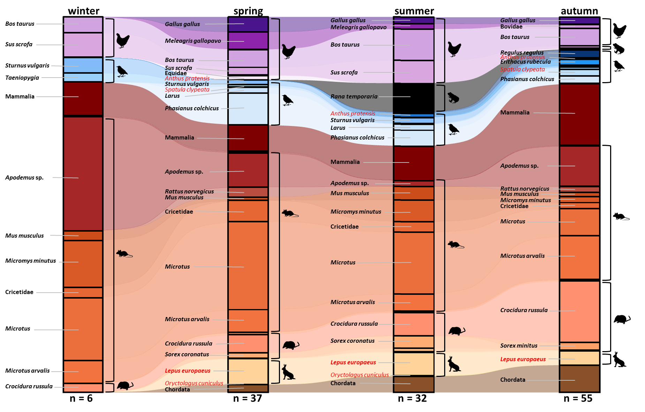
Flow graph taxa along the seasons
Fig. S8 The taxonomic groups detected in the diet of cats, during the different sampling seasons. Taxa mentioned by name and shown in bold contribute more than 1% to the diet. Taxa shown in red are listed on the Dutch Red List (for details see Table S9)

Comparison with other studies using DNA metabarcoding
Table S24 An overview of studies using DNA metabarcoding to investigate the diet of cats
Paper | Where | What | When | Sample size | Results | Primers
Galão et al. (2025) | Madeira island | Free-ranging cats | July-November 2021 | 58 faecal samples | 18 prey taxa, 13 to species level | 12SV5F/12VS5R primers
Plimpton et al. (2021) | New-York City | Feral cats living in Trap-Neuter-Return colonies | July-November 2019 | 134 faecal samples | 16 prey taxa, 0 to species level | 12SV5F/12VS5R primers
Forin-Wiart et al. (2018) | North-eastern France | Free-ranging cats | June, July, November, December 2011, March 2012 | 326 faecal samples | 29 prey taxa, 25 to species level | KiCqStartTM, L15411F, H15546R-PGM, L15411F-MiSeq
This study | The Netherlands (mainland & island) | Free-ranging cats | Year-round 2020-2023 | 164 faecal samples | 54 prey taxa, 28 to species level | mlCOIintF and jgHCO2198 primers

