Clausen & Madsen. The importance of timing in goose grazing effects on winter wheat yield
Supplementary Material 1.

Figure S1. Outline of the experimental setup used for simulating goose grazing, showing a triplet with the three different treatments “winter and spring removal”, “winter removal” and “control” (no removal).
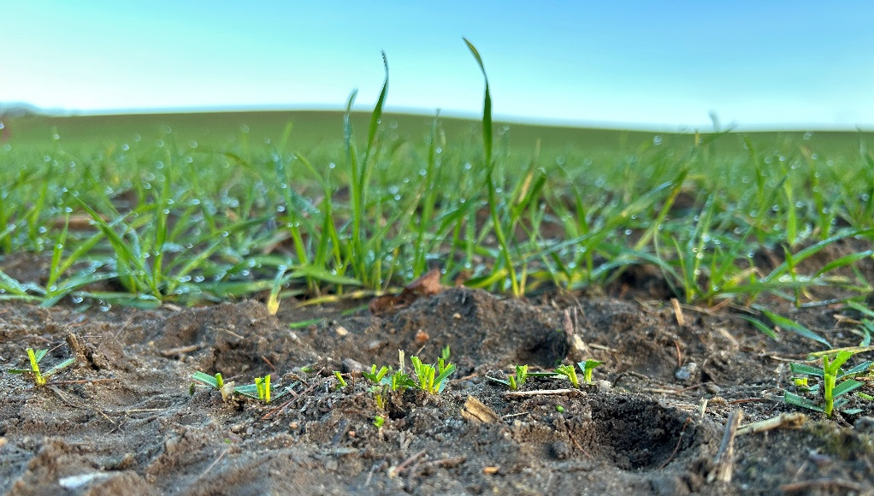
Figure S2. Example of a cut crop (foreground) and control (background) during the first biomass removal in December.

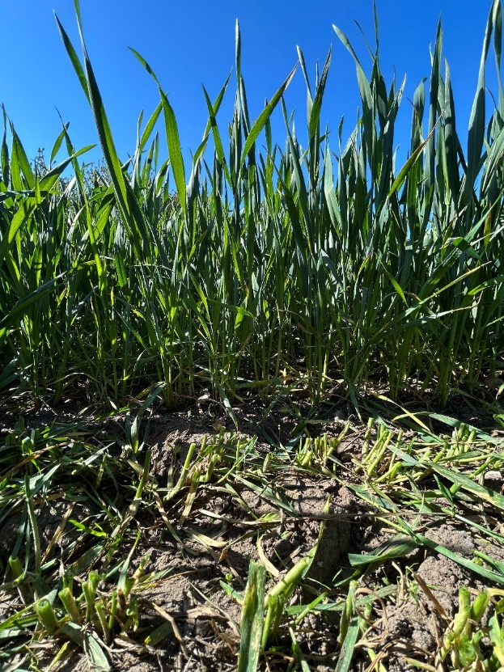
Figure S3. Example of a cut crop (foreground) and control (background) during the second biomass removal in May.

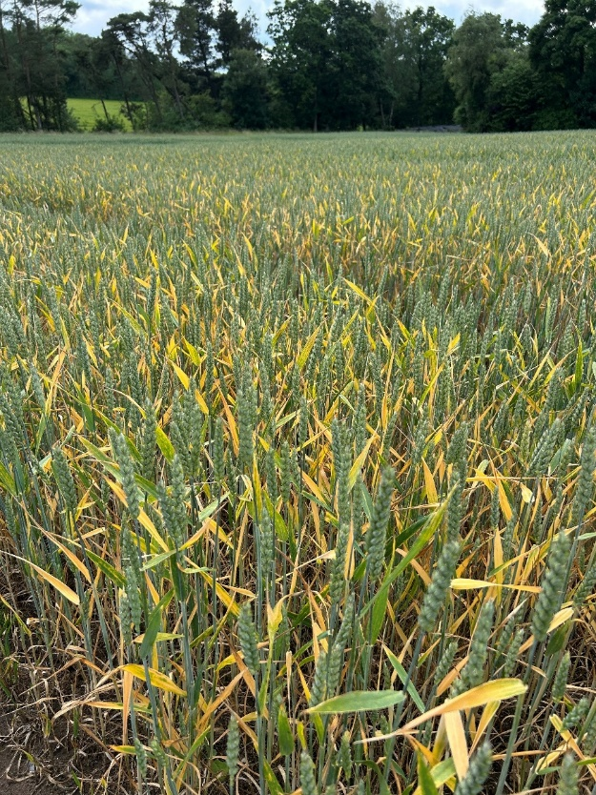
Figure S4. Photo of field H in early June after a very dry period when water stress was obvious.

