Supplementary Materials

Figure S1. Principal Component Analysis of the total amounts of supplemental feeding provided at each year and site.

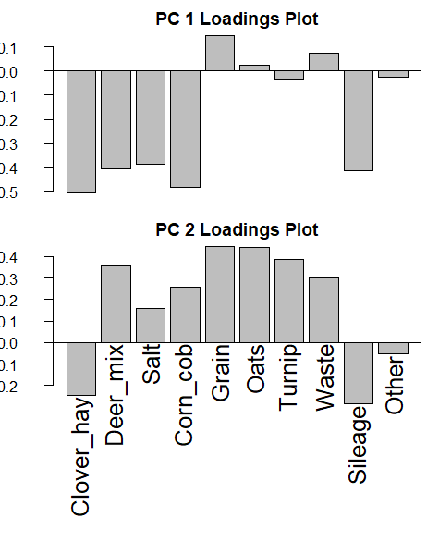

Figure S2. Axis loadings for each variable of Principal Component Analysis of the total amounts of supplemental feeding provided at each year and site.

Figure S3. Principal Component Analysis of the amounts of supplemental feeding provided at each year and site during summer.

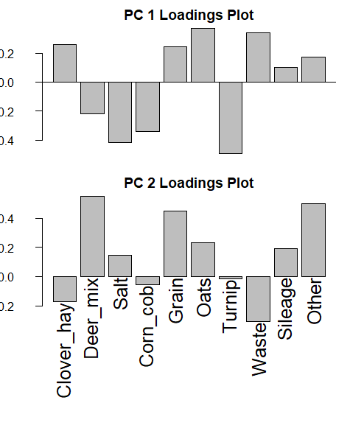
Figure S4. Axis loadings for each variable of Principal Component Analysis of the total amounts of supplemental feeding provided at each year and site during summer.

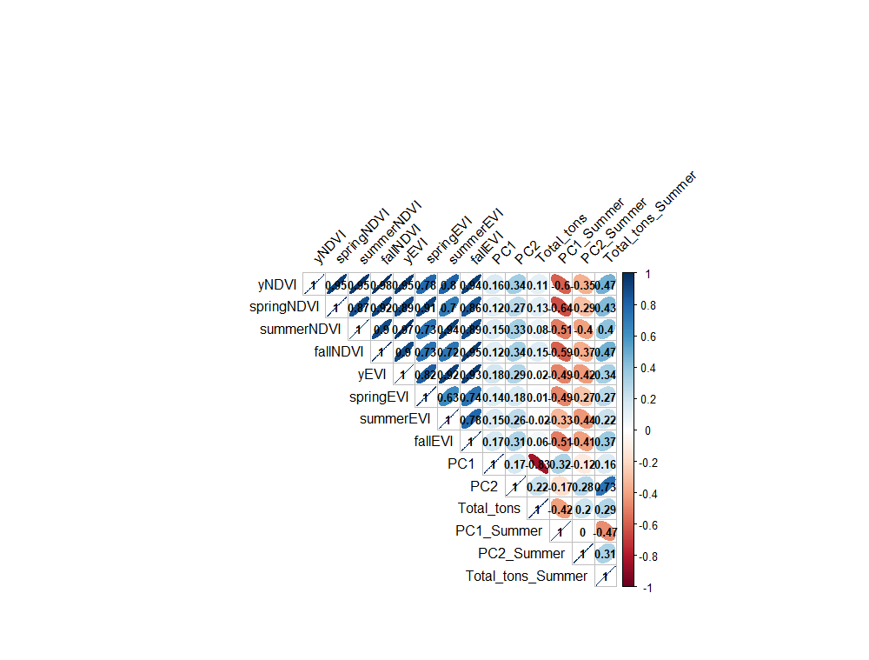

Figure S5. Correlation among independent variables.

Figure S6. Supplementary feeding

Figure S7. Vegetation

Variable | F-value | P-val
yNDVI | 8.275 | 2.25e-07 ***
SummerEVI | 12.84 | 1.38e-10 ***
SpringEVI | 3.5 | 0.00276 **
Supplemental PC1 | 12.1 | 9.9e-10 ***
Supplemental PC2 | 14.04 | 7.03e-11 ***
Summer Supplemental PC1 | 12.31 | 7.37e-10 ***
Summer Supplemental PC2 | 12.09 | 1.01e-09 ***
Total feed | 6.62 | 6.77e-06 ***
Summer feed | 20.55 | 20.55 3.5e-14 ***

Table S1. Results of ANOVA analyses assessing the variation in the values of the predictor covariables among sites.

