Supporting Information for
Unravelling driving conditions of rock and ice avalanches and resulting cascading processes in High Mountain Asia
Yan Zhong¹, Simon Allen^{1,2}, Dongfeng Li³, Christophe Corona^{1,4}, Guoxiong Zheng⁵, Qiao Liu⁶, Markus Stoffel^{1,7, 8}
¹ Climate Change Impacts and Risks in the Anthropocene (C-CIA), Institute for Environmental Sciences, University of Geneva, Switzerland
² Department of Geography, University of Zurich, Switzerland
³ College of Environmental Sciences and Engineering, Peking University, China
⁴ Université Clermont Auvergne, CNRS, Université de Limoges, France
⁵ School of Earth and Environmental Sciences, Lanzhou University, China
⁶ Institute of Mountain Hazards and Environment, Chinese Academy of Sciences, China
⁷ Department of Earth Sciences, University of Geneva, Switzerland
⁸ Department F.-A. Forel for Environmental and Aquatic Sciences, University of Geneva, Switzerland
Corresponding author: Yan Zhong (yan.zhong@etu.unige.ch)

Contents of this file

Figure S1 ~ S4
Table S1 ~ S4

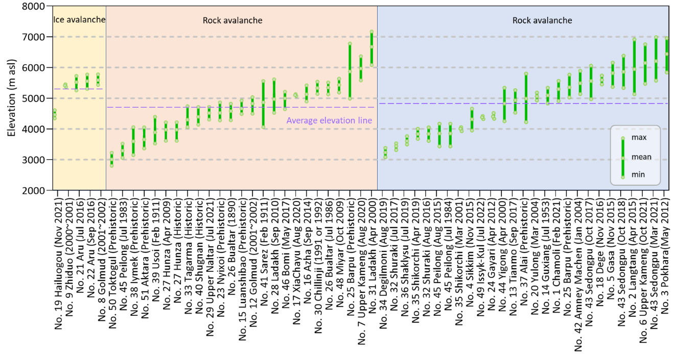

Figure S1. Maximum, mean, and minimum elevations of all digitized RIA starting zones. Purple dashed lines represent the average elevation of all starting zones for ice avalanche, rock avalanche, and rock-ice avalanche, respectively.

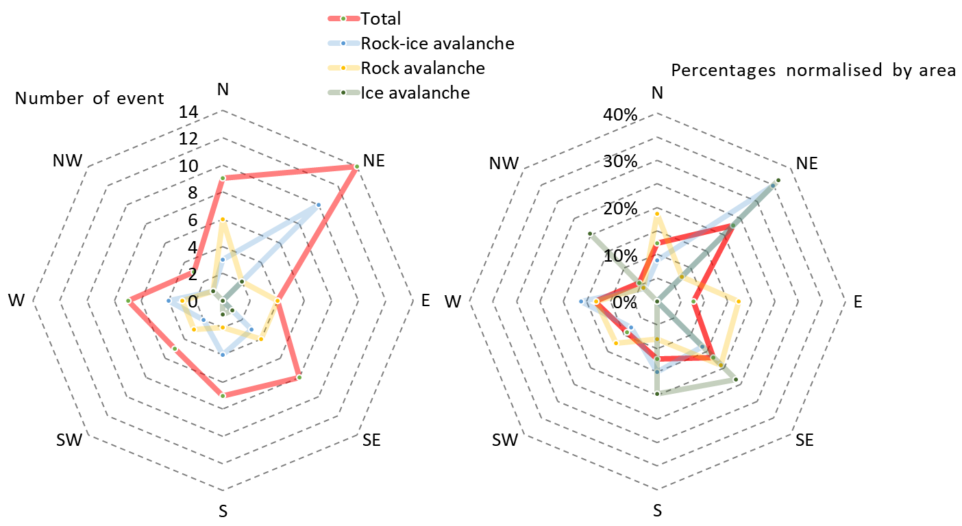 Figure S2. Distribution of aspect, plotted by numbers of event and percentages normalised by area of each aspect in HMA, respectively.
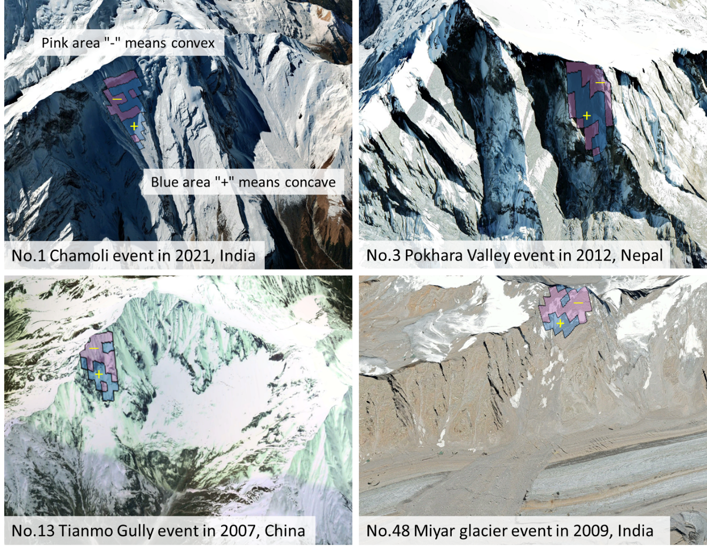 Figure S3. Some illustrative examples of result of profile curvature base on Google Earth images.

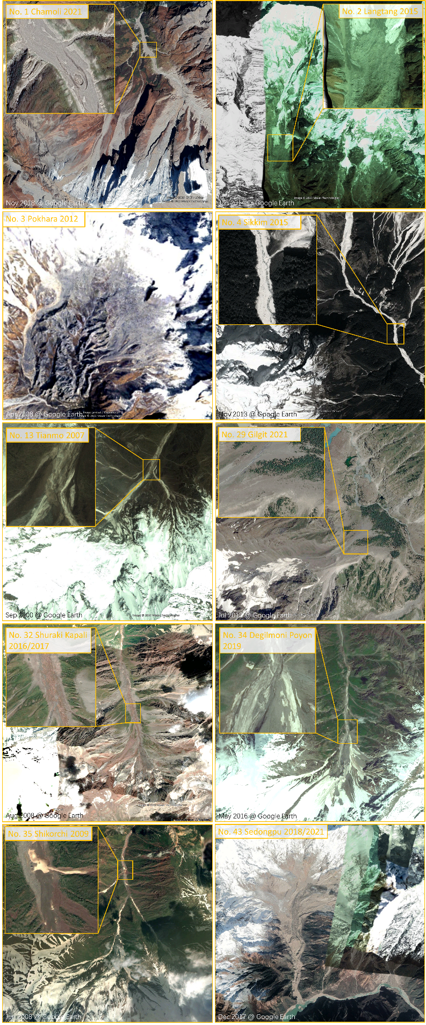
Figure S4. Some examples of sediment conditions for RIA events.

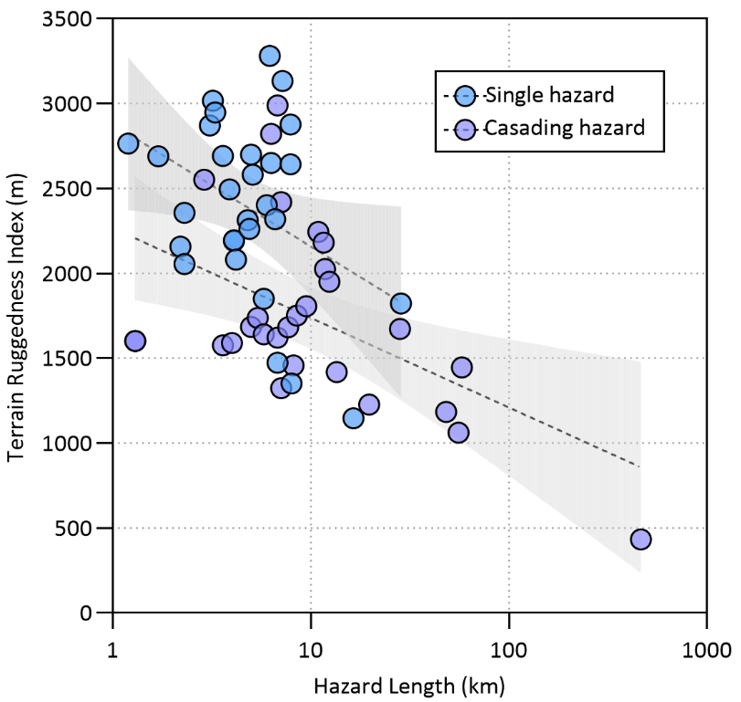
Figure S5. Terrain Ruggedness Index (TRI) for the hazard traces of all events plotted by hazard length. The dotted lines shows the fit of single hazards and cascading hazards. Grey shading indicates the 95% confidence interval of the fitted lines.

Table S1. Collinearity analysis result of RIA contribution factors

Variable | VIF | 1/VIF
Mean Elevation | 3.54 | 0.282224
Permafrost | 3.21 | 0.311605
Temperature | 2.71 | 0.368992
Initial hazard types | 2.04 | 0.49019
Mean Slope | 2 | 0.501019
Seismicity | 1.75 | 0.571671
Lithology | 1.68 | 0.595281
Aspect | 1.57 | 0.638557
Anomaly Precipitation to the 1981-2010 reference period | 1.32 | 0.755456
Profile Curvature | 1.17 | 0.851368
Precipitation for 1 month prior to occurrence (mm) | 1.17 | 0.855184
Mean VIF | 2.01

Table S2. Interaction effects of stepwise GLM regression analysis of RIA contribution factors

Area of starting zone | Coefficient | std. err. | z | P>|z| | [95% conf. | interval]
c.lithology#c.seismicity#c.anomaly#c.permafrost | 0.351741 | 0.117519 | 2.99 | 0.003** | 0.1214075 | 0.5820739
c.precipitation#c.anomaly#c.permafrost | 0.08629 | 0.024677 | 3.5 | 0*** | 0.1346584 | 0.0379246
c.seismicity#c.anomaly#c.permafrost | -1.62291 | 0.525518 | -3.09 | 0.002** | -2.6529201 | -0.592089
precipitation | 0.16223 | 0.052609 | 3.08 | 0.002** | 0.2647271 | 0.0597426
c.lithology#c.precipitation | 0.042887 | 0.013296 | 3.23 | 0.001** | 0.0168282 | 0.0689457
c.seismicity#c.precipitation | 0.061539 | 0.021011 | 2.93 | 0.003** | 0.0203583 | 0.1027196
c.lithology#c.seismicity#c.precipitation | 0.01689 | 0.005286 | 3.2 | 0.001** | 0.0275209 | 0.0062593
anomaly | 1.28254 | 0.371342 | 3.45 | 0.001** | 2.010357 | 0.5547244
c.lithology#c.anomaly | 0.318202 | 0.090946 | 3.5 | 0*** | 0.1399516 | 0.4964518
c.seismicity#c.anomaly | 0.415823 | 0.138415 | 3 | 0.003** | 0.1445357 | 0.6871112
c.lithology#c.seismicity#c.anomaly | -0.09839 | 0.033731 | -2.92 | 0.004** | -0.1644993 | -0.0322772
c.lithology#c.seismicity#c.precipitation#c.anomaly#c.permafrost | -0.00516 | 0.001908 | -2.7 | 0.007** | -0.0088975 | -0.00142
c.anomaly#c.permafrost | 5.464861 | 1.5216 | 3.59 | 0*** | 2.48258 | 8.447142
c.seismicity#c.precipitation#c.permafrost | 0.001699 | 0.000424 | 4.01 | 0*** | 0.0008688 | 0.0025298
c.lithology#c.seismicity#c.precipitation#c.anomaly | -0.00052 | 0.000116 | -4.49 | 0*** | -0.0007442 | -0.0002922
permafrost | 3.254482 | 1.163687 | 2.8 | 0.005** | 1.1648087 | 5.344447
c.seismicity#c.precipitation#c.anomaly#c.permafrost | 0.024828 | 0.008275 | 3 | 0.003** | 0.0086087 | 0.0410469
c.lithology#c.precipitation#c.anomaly | -1.18089 | 0.331776 | -3.55 | 0*** | -1.831146 | -0.5306426
c.lithology#c.seismicity#c.permafrost | -0.23459 | 0.064656 | -3.63 | 0*** | -0.3613116 | -0.1076642
c.anomaly#c.permafrost | 0.01826 | 0.006558 | 3.23 | 0.001** | 0.0071719 | 0.0293487
c.lithology#c.precipitation#c.permafrost | -0.04705 | 0.013357 | -3.52 | 0*** | -0.0666882 | -0.0280497
c.seismicity#c.anomaly#c.permafrost | -0.04161 | 0.013357 | -3.12 | 0.002** | -0.0677757 | -0.0154397
c.lithology#c.seismicity#c.precipitation#c.permafrost | 0.023506 | 0.005222 | 4.5 | 0*** | 0.0132712 | 0.0337416
_cons | -0.03544 | 0.496867 | -0.07 | 0.943 | -1.009279 | 0.9384082
p = 0.9906 ≥ 0.05, removed c.precipitation#c.anomaly
p = 0.8987 ≥ 0.05, removed c.lithology#c.permafrost
p = 0.8830 ≥ 0.05, removed c.precipitation#c.permafrost

p = 0.3415 ≥ 0.05, removed seismicity
p = 0.6222 ≥ 0.05, removed lithology
p = 0.5152 ≥ 0.05, removed c.lithology#c.seismicity
p = 0.1984 ≥ 0.05, removed c.seismicity#c.permafrost
p = 0.1823 ≥ 0.05, removed c.lithology#c.precipitation#c.anomaly
Standard errors in parentheses; * p < 0.10, ** p < 0.05, *** p < 0.01

Table S3. Collinearity analysis result of RIA contribution factors

Variable | VIF | 1/VIF
Glacier area | 5.53 | 0.180718
Glacier length | 5.52 | 0.181109
Stream flow | 3.17 | 0.31511
Stream order | 3.03 | 0.330396
ΔH | 1.95 | 0.51239
L_{real} | 1.95 | 0.51412
Glacier slope | 1.5 | 0.664713
Slope | 1.48 | 0.674079
Terrain Ruggedness Index | 1.16 | 0.865559
Mean VIF | 2.81

Table S4. Stepwise GLM regression analysis of RIA cascading processes contribution factors

Occurrence of cascading process | Coefficient | std. err. | z | P>|z| | [95% conf. | interval]
Stream flow | 1.29024 | 0.5862886 | 2.20 | 0.028** | 0.1411352 | 2.439344
ΔH | 1.222412 | 0.5827572 | 2.10 | 0.036** | 0.080229 | 2.364595
Terrain Ruggedness Index | -0.606805 | 0.3137 | -1.93 | 0.053* | -1.221646 | 0.0080358
_cons | -2.765026 | 2.50028 | -1.11 | 0.269 | -7.665484 | 2.135432

p = 0.8165 ≥ 0.05, removed real length
p = 0.7761 ≥ 0.05, removed glacier length
p = 0.7661 ≥ 0.05, removed stream order
p = 0.6161 ≥ 0.05, removed glacier slope
p = 0.3681 ≥ 0.05, removed slope
p = 0.2985 ≥ 0.05, removed glacier area
Standard errors in parentheses; * p < 0.10, ** p < 0.05, *** p < 0.01

