Supplement of
Rainfall-induced landslides and debris flow in Chieng So commune, Son La Province,
Vietnam
Tran Trung Hieu^{1,2,3*}, Łukasz Pawlik², Pham Van Tien³, Nguyen Cong Quan³

¹ International Environmental Doctoral School, University of Silesia in Katowice, Sosnowiec, Poland
² Institute of Earth Sciences, University of Silesia in Katowice, Sosnowiec, Poland
³ Institute of Earth Sciences, Vietnam Academy of Science and Technology, Hanoi, Vietnam

* Corresponding author address: trunghieu95ctb@gmail.com/ hieu.tran@us.edu.pl
ORCID: https://orcid.org/0009-0003-2542-2496

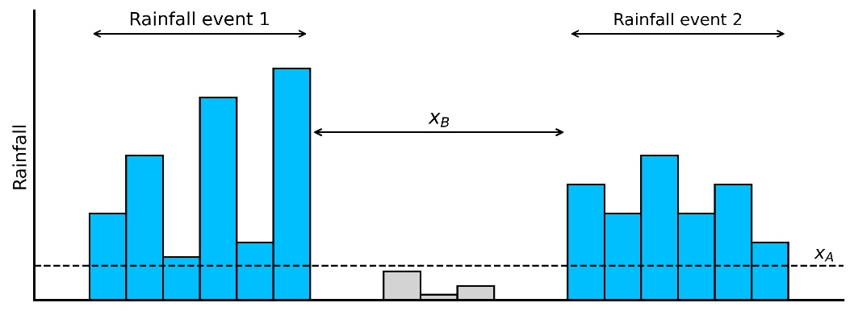
Fig. S1 Schematic illustration of rainfall event identification based on two parameters: a minimum rainfall threshold $(x_{A})$ and the minimum time interval between two consecutive rainfall events ${(x}_{B})$. ​
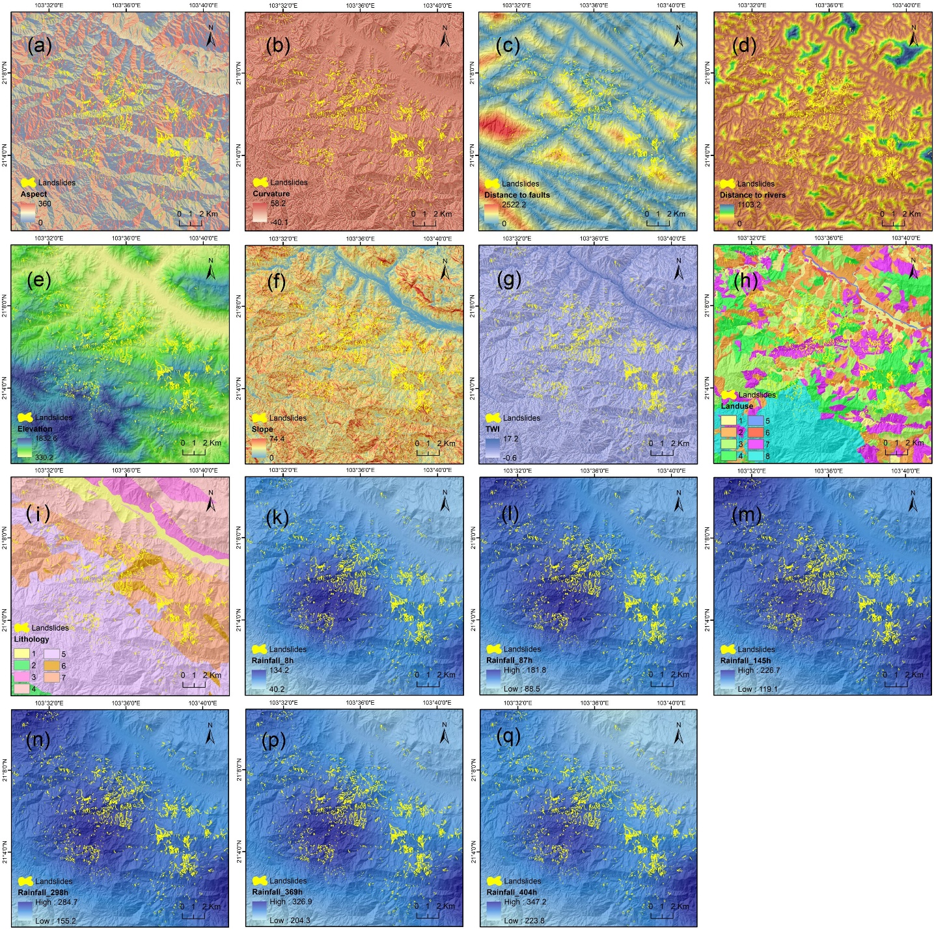
Fig. S2 (a) Aspect, (b) Curvature, (c) Distance to faults, (d) Distance to rivers, (e) Elevation, (f) Slope, (g) TWI, (h) Landuse, (i) Lithology, (k) 8-h Antecedent rainfall, (l) 87-h Antecedent rainfall, (m) 145-h Antecedent rainfall, (n) 298-h Antecedent rainfall, (p) 369-h Antecedent rainfall and (q) 404-h Antecedent rainfall. Lithology: (1) Quaternary sediment, (2) Suoi Bang formation, (3) Huoid Hao formation, (4) Nam Ty formation, (5) Dong Trau formation, (6) Phase 2 Song Ma complex, (7) Phase 1 Song Ma complex. Land use: (1) rice terraces, (2) annual cropland, (3) production forest land, (4) protection forest land, (5) water (streams, ponds), (6) built-up area, (7) bare rock, (8) special-use forest land.
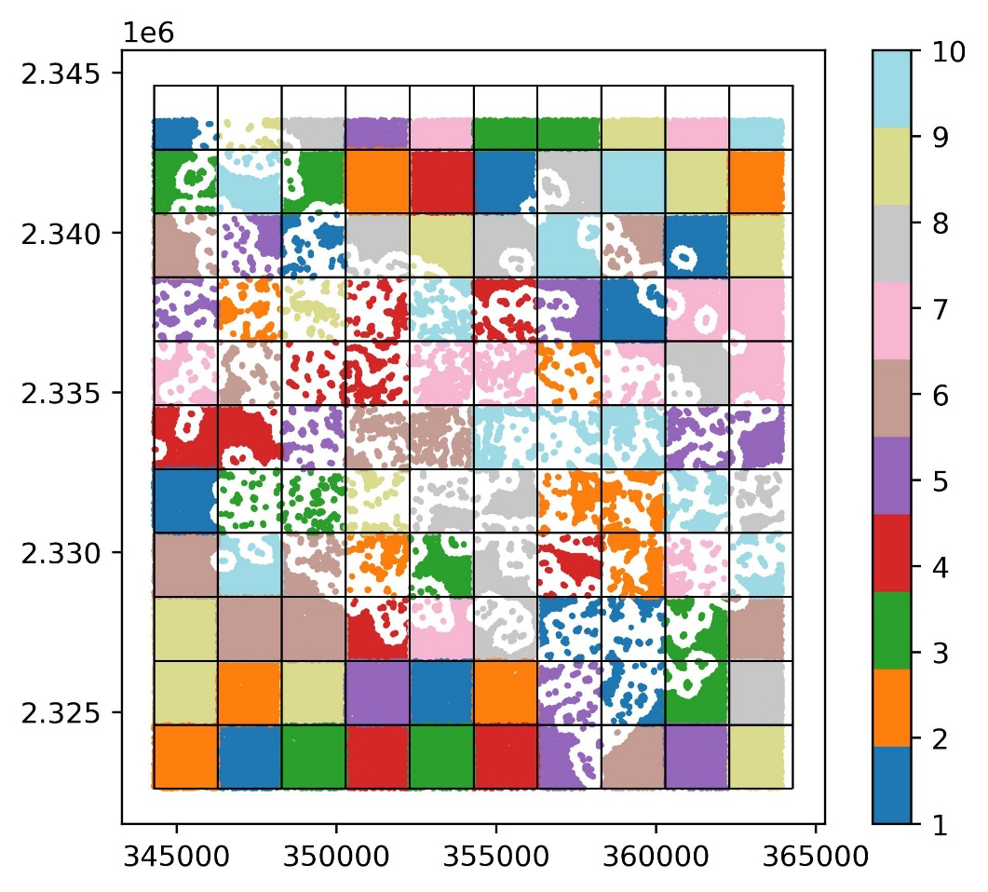
Fig. S3 Spatial blocks with a block size of 2,000 m and randomly assigned 10-fold cross-validation partitions. White areas indicate a 400-meter buffer separating landslide areas.

