Table 1S. Quality assessment of the included studies
Study ID | Uozumi 2024 | Song 2024 | Scheppach 2024 | Goto 2024 | Abe 2020 | Akimoto 2022 | Goto 2019 | Higuchi 2023 | Kantsevoy 2013
1. Was the study question or objective clearly stated? | YES | YES | YES | YES | YES | YES | YES | YES | YES
2. Were eligibility/selection criteria for the study population prespecified and clearly described? | YES | YES | YES | YES | YES | YES | YES | YES | YES
3. Were the participants in the study representative of those who would be eligible for the test/service/intervention in the general or clinical population of interest? | YES | YES | YES | YES | YES | YES | YES | YES | YES
4. Were all eligible participants that met the prespecified entry criteria enrolled? | YES | YES | NO | NO | YES | YES | NO | NO | YES
5. Was the sample size sufficiently large to provide confidence in the findings? | NO | YES | NO | YES | NO | YES | YES | YES | NO
6. Was the test/service/intervention clearly described and delivered consistently across the study population? | YES | YES | YES | YES | YES | YES | NO | YES | YES
7. Were the outcome measures prespecified, clearly defined, valid, reliable, and assessed consistently across all study participants? | YES | YES | YES | YES | YES | YES | YES | YES | YES
8. Were the people assessing the outcomes blinded to the participants' exposures/interventions? | NO | NO | NO | NO | NO | NO | NO | NO | NO
9. Was the loss to follow-up after baseline 20% or less? Were those lost to follow-up accounted for in the analysis? | NO | NO | NO | NO | NO | NO | NO | NO | NO
10. Did the statistical methods examine changes in outcome measures from before to after the intervention? Were statistical tests done that provided p values for the pre-to-post changes? | NO | YES | NO | NO | NO | NO | NO | YES | NO
11. Were outcome measures of interest taken multiple times before the intervention and multiple times after the intervention (i.e., did they use an interrupted time-series design)? | NA | NA | NA | NA | NA | NA | NA | NA | NA
12. If the intervention was conducted at a group level (e.g., a whole hospital, a community, etc.) did the statistical analysis take into account the use of individual-level data to determine effects at the group level? | NO | NO | NO | NO | NO | NO | NO | NO | NO
Quality Rating (Good, Fair, or Poor) | FAIR | FAIR | FAIR | FAIR | FAIR | FAIR | FAIR | FAIR | FAIR

[S1] Subgroup analysis (suturing time)
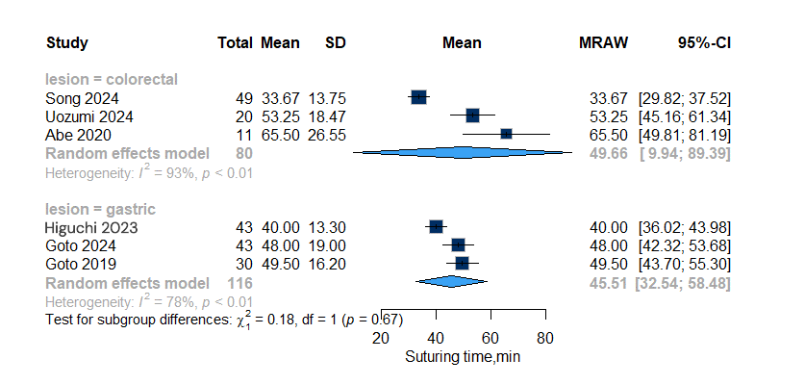

[S2] Subgroup analysis (Closure rate)
[A] Complete Closure rate
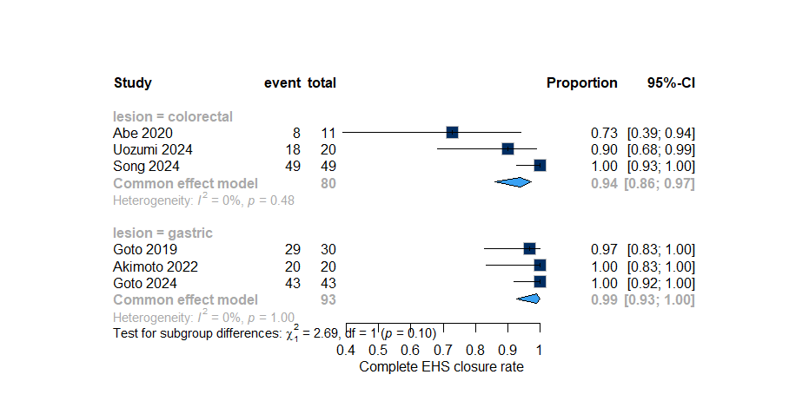

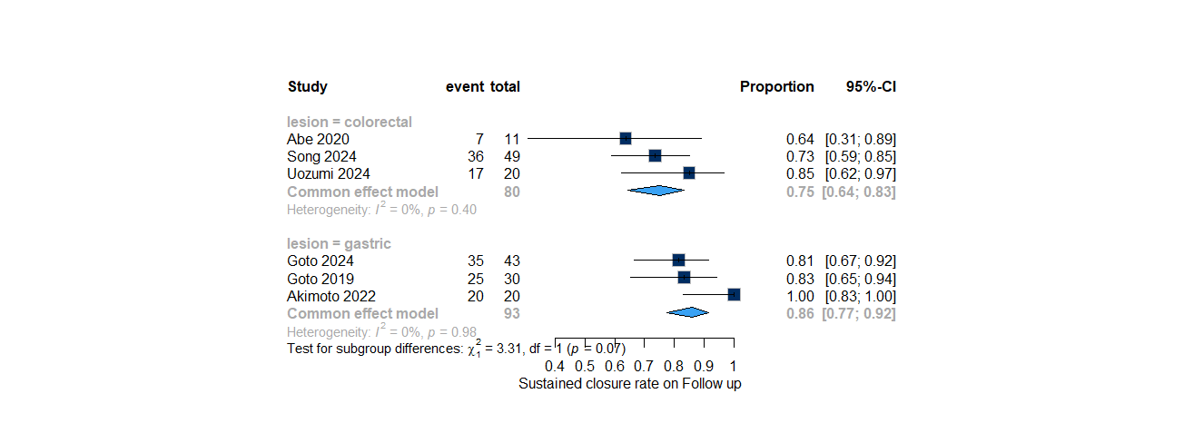
[B] Sustained closure rate

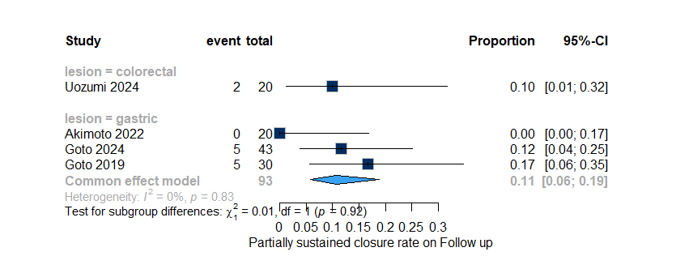
[c] Partially Sustained closure rate

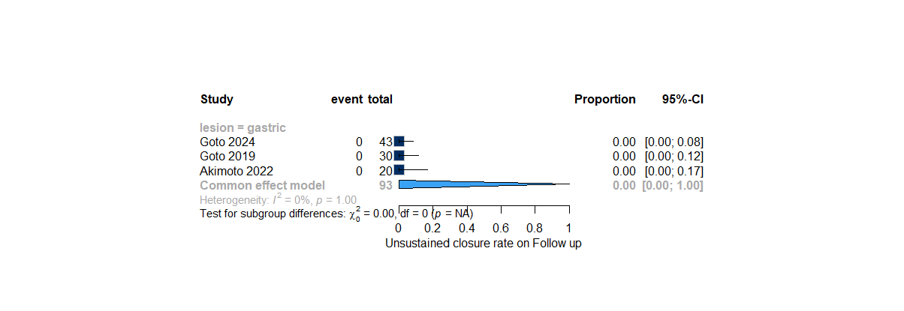
[D] Unsustained closure rate

[S3] Subgroup analysis (Number of stitches)
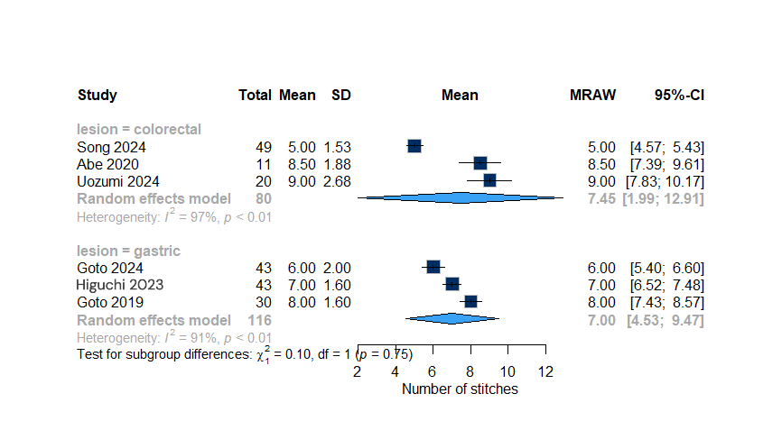

[S4] Subgroup analysis (Time per stitch)
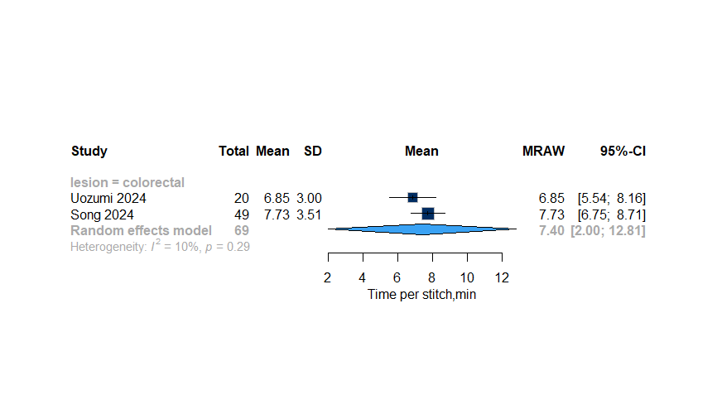

[S5] Procedure time
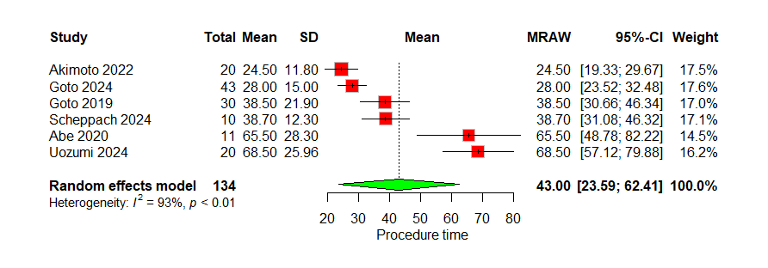
[A]

[B] Sensitivity analysis by omitting (Uozumi 2024)
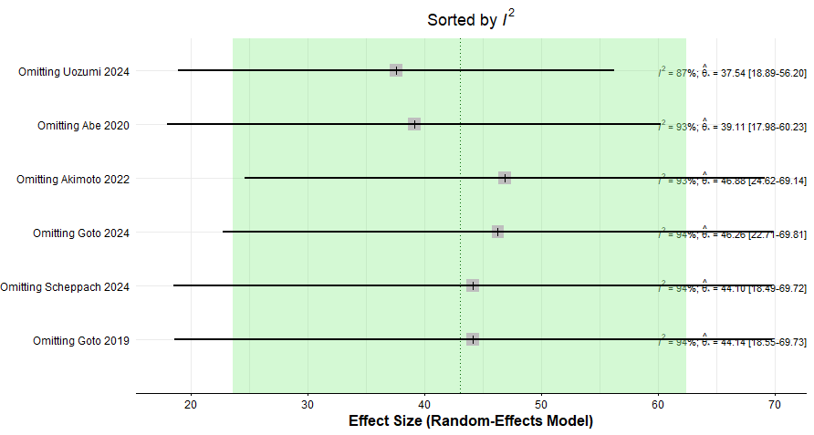

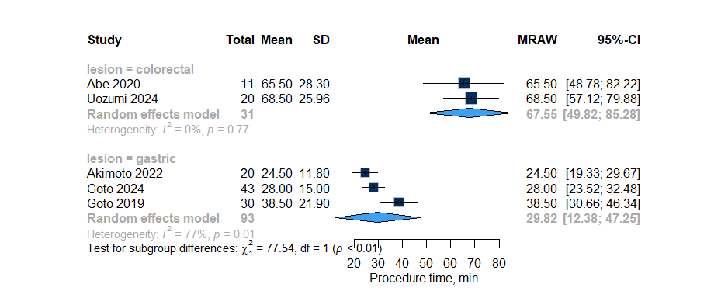
[C] Subgroup analysis (Procedure time)

[S6] Hospitalization
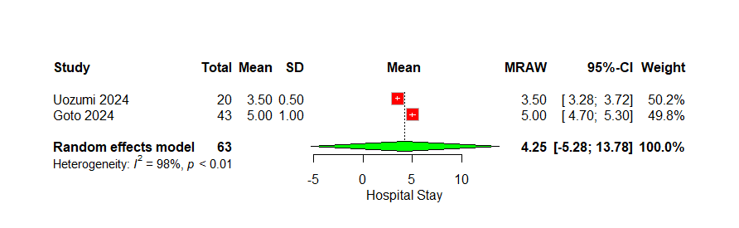

[S7] Intra-operative Bleeding
[A]
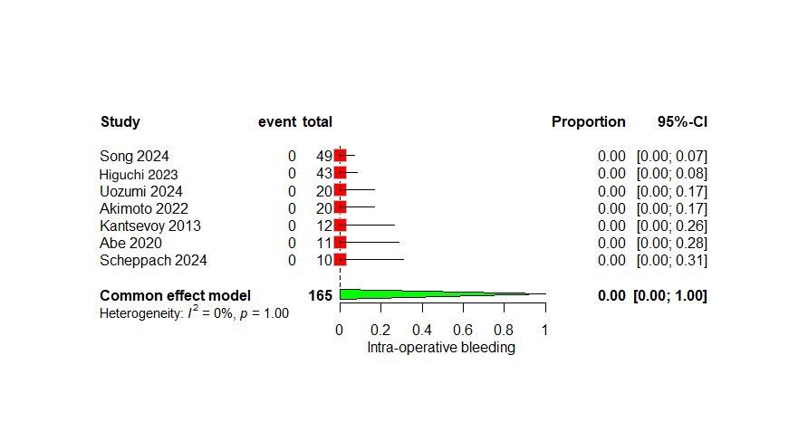
[B] Subgroup analysis (Intra-operative Bleeding)
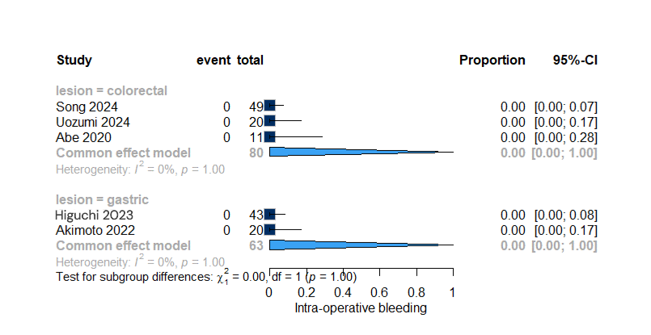

[S8] Subgroup analysis (Postoperative Bleeding)

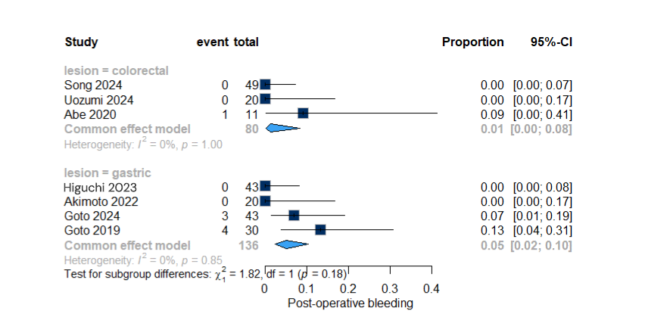

[S8] Intra-operative Perforation
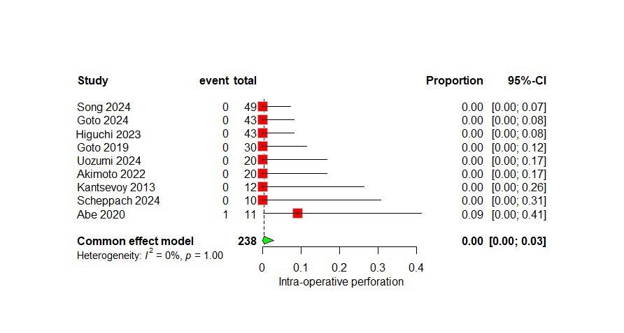

[S9] Subgroup analysis (Intra-operative perforation)
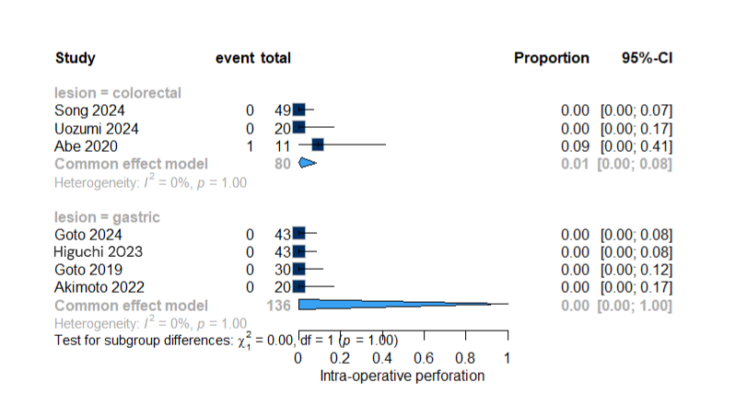
[S10] Postoperative Perforation
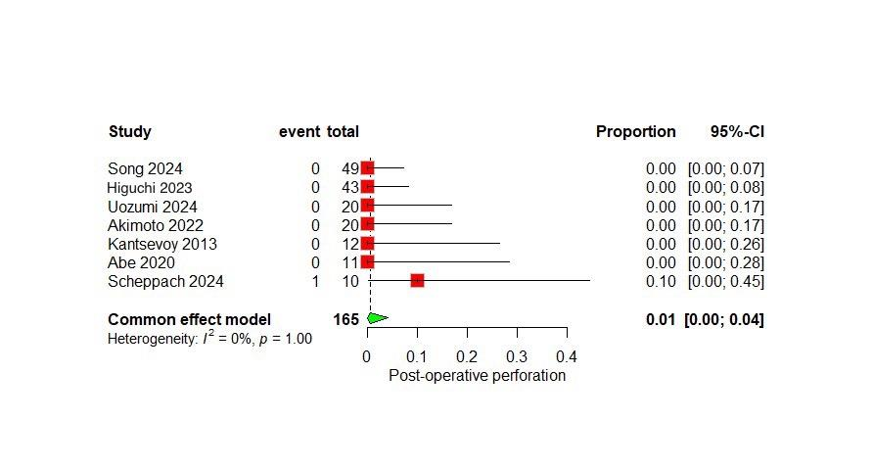

[S11] Subgroup analysis (Postoperative perforation)
