Online Resource
Online Resource 1. Bland–Altman plots for pericentral and peripheral retinal thickness measurements.

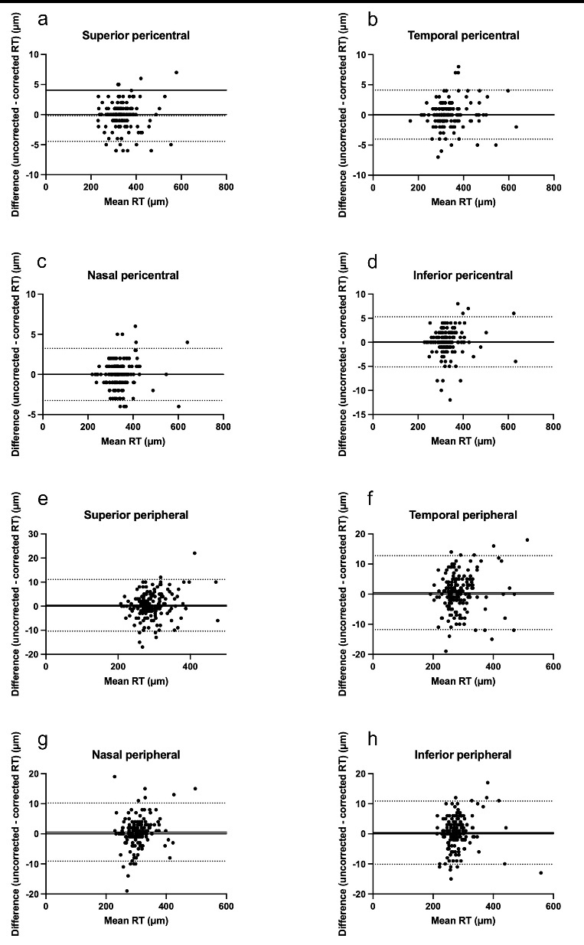

Bland–Altman plots showing the agreement between corrected and uncorrected retinal thickness measurements in the Early Treatment Diabetic Retinopathy Study grid. The pericentral sectors are shown in panels (a–d): (a) superior, (b) temporal, (c) nasal, and (d) inferior. The peripheral sectors are shown in panels (e–h): (e) superior, (f) temporal, (g) nasal, and (h) inferior. The x-axis represents the mean of the corrected and uncorrected measurements, and the y-axis represents the difference between the two measurements (corrected − uncorrected). The solid line indicates the mean difference, and the dashed lines indicate the 95% limits of agreement.
Online Resource 2. Linear regression analysis between axial length and the difference in retinal thickness measurements
 |  | β (μm/mm) | 95% CI | P
Fovea |  | 2.14 | 1.92 to 2.35 | <0.0001
Pericentral | Superior | -0.48 | -0.75 to -0.21 | <0.001
 | Temporal | -0.14 | -0.40 to 0.13 | 0.32
 | Nasal | -0.04 | -0.25 to 0.18 | 0.72
 | Inferior | -0.72 | -1.05 to -0.40 | <0.0001
Peripheral | Superior | -4.03 | -4.37 to -3.69 | <0.0001
 | Temporal | -4.66 | -5.04 to -4.29 | <0.0001
 | Nasal | -3.30 | -3.69 to -2.92 | <0.0001
 | Inferior | -3.85 | -4.21 to -3.50 | <0.0001
The measurement difference was defined as the retinal thickness obtained without AL correction minus that obtained with AL correction. Linear regression analysis was performed with AL as the independent variable and the measurement difference as the dependent variable. β represents the slope of the regression line, indicating the change in measurement difference (μm) per 1-mm increase in AL.
AL, axial length; CI, confidence interval.

Online Resource 3. Relationship between axial length and the difference in retinal thickness measurements in the pericentral and peripheral sectors.

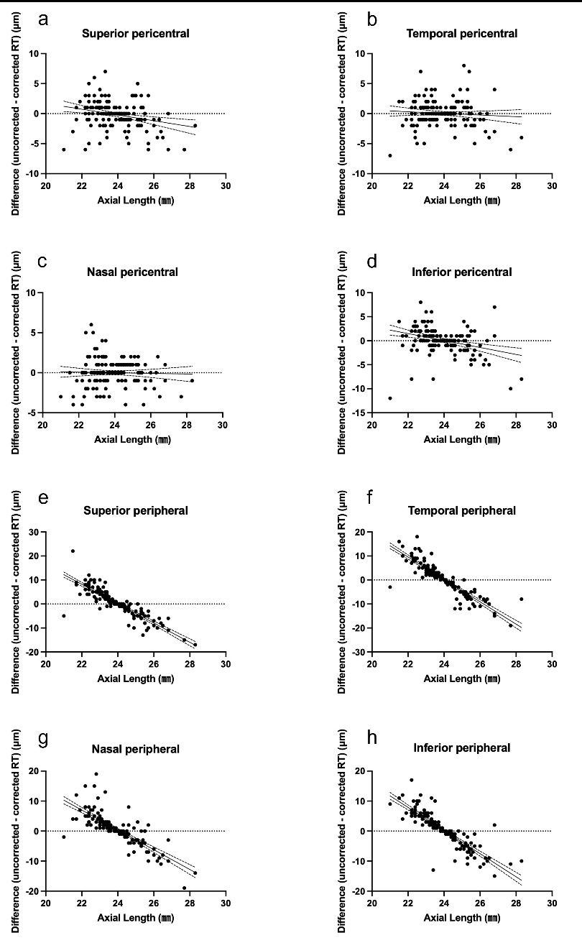

Scatter plots showing the relationship between axial length and the difference between uncorrected and corrected retinal thickness measurements (uncorrected − corrected) for the ETDRS sectors: (a) temporal inner, (b) superior inner, (c) nasal inner, (d) inferior inner, (e) temporal outer, (f) superior outer, (g) nasal outer, and (h) inferior outer.
The solid lines represent the linear regression lines for each sector. Significant associations between axial length and the measurement difference were observed in the superior inner, inferior inner, and all peripheral sectors, whereas no significant association was detected in the temporal inner and nasal inner sectors.

Online Resource 4. GEE analysis of factors associated with CST difference
Variable | β | 95% CI | P
axial length (per 1-mm increase) | 2.128 | 1.905 to 2.351 | <0.001
Lens status (phakic vs. pseudophakic) | 0.105 | -0.447 to 0.657 | 0.71
Vitreoretinal surgery history (present vs. absent) | -0.068 | -1.079 to 0.943 | 0.89
A generalized estimating equation (GEE) analysis examining the association of axial length, lens status, and vitreoretinal surgery history with central subfield thickness (CST) difference. CST difference was defined as uncorrected CST minus corrected CST. Axial length was entered as a continuous variable (per 1-mm increase). Lens status was coded as phakic vs. pseudophakic, and vitreoretinal surgery history as present vs. absent (reference categories: pseudophakic and absence of surgery). A GEE with a normal distribution and identity link was used.

Online Resource 5. GEE analysis restricted to eyes without prior vitreoretinal surgery
Variable | β | 95% CI | P
Axial length (per 1-mm increase) | 2.335 | 2.104 to 2.566 | <0.001
Lens status (phakic vs. pseudophakic) | 0.104 | -0.439 to 0.646 | 0.70
ERM (present vs. absent) | 0.613 | -0.124 to 1.350 | 0.10
A generalized estimating equation (GEE) analysis restricted to eyes without prior vitreoretinal surgery to evaluate the potential influence of epiretinal membrane (ERM) on central subfield thickness (CST) difference. CST difference was defined as uncorrected CST minus corrected CST. Axial length was entered as a continuous variable (per 1-mm increase). Lens status was coded as phakic vs. pseudophakic, and epiretinal membrane as present vs. absent (reference categories: pseudophakic and absence of ERM). A GEE with a normal distribution and identity link was used.

