Supplementary material for

Circulating exosome-derived miR-191-5p is a novel therapeutic biomarker for radiotherapy in esophageal squamous cell carcinoma patients.
Huan Wang¹², Yasunori Matsumoto¹, Abula Maiyulan¹, Takeshi Toyozumi¹, Ryota Otsuka¹, Nobufumi Sekino¹, Koichiro Okada¹, Tadashi Shiraishi¹, Toshiki Kamata1 and Hisahiro Matsubara¹
1. Department of Frontier Surgery, Chiba University, Chiba, Japan.
2. Department of Thoracic Surgery, Cancer Hospital of China Medical University, Liaoning Cancer Hospital & Institute, Shenyang, China.

Supplementary figure

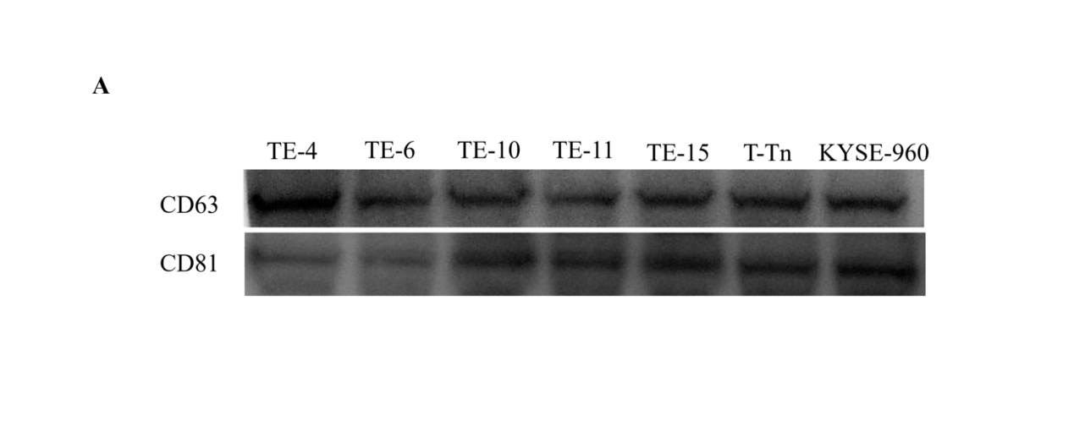
Figure S1. A. Exosome markers(CD63, CD81) were used to identify exosomes.

Figure S2. qRT-PCR of miR-191-5p expression in TE11 and KYSE-960 transfected miR-191-5p or negative control, and parental cells. The cell lines TE11 and KYSE-960 were seeded into 6-well plates (2.5×10⁵ cells per well), and after 24 h, cells were transfected with miR-191 mimic or negative control mimic using LipofectamineTM RNAi-MAX.

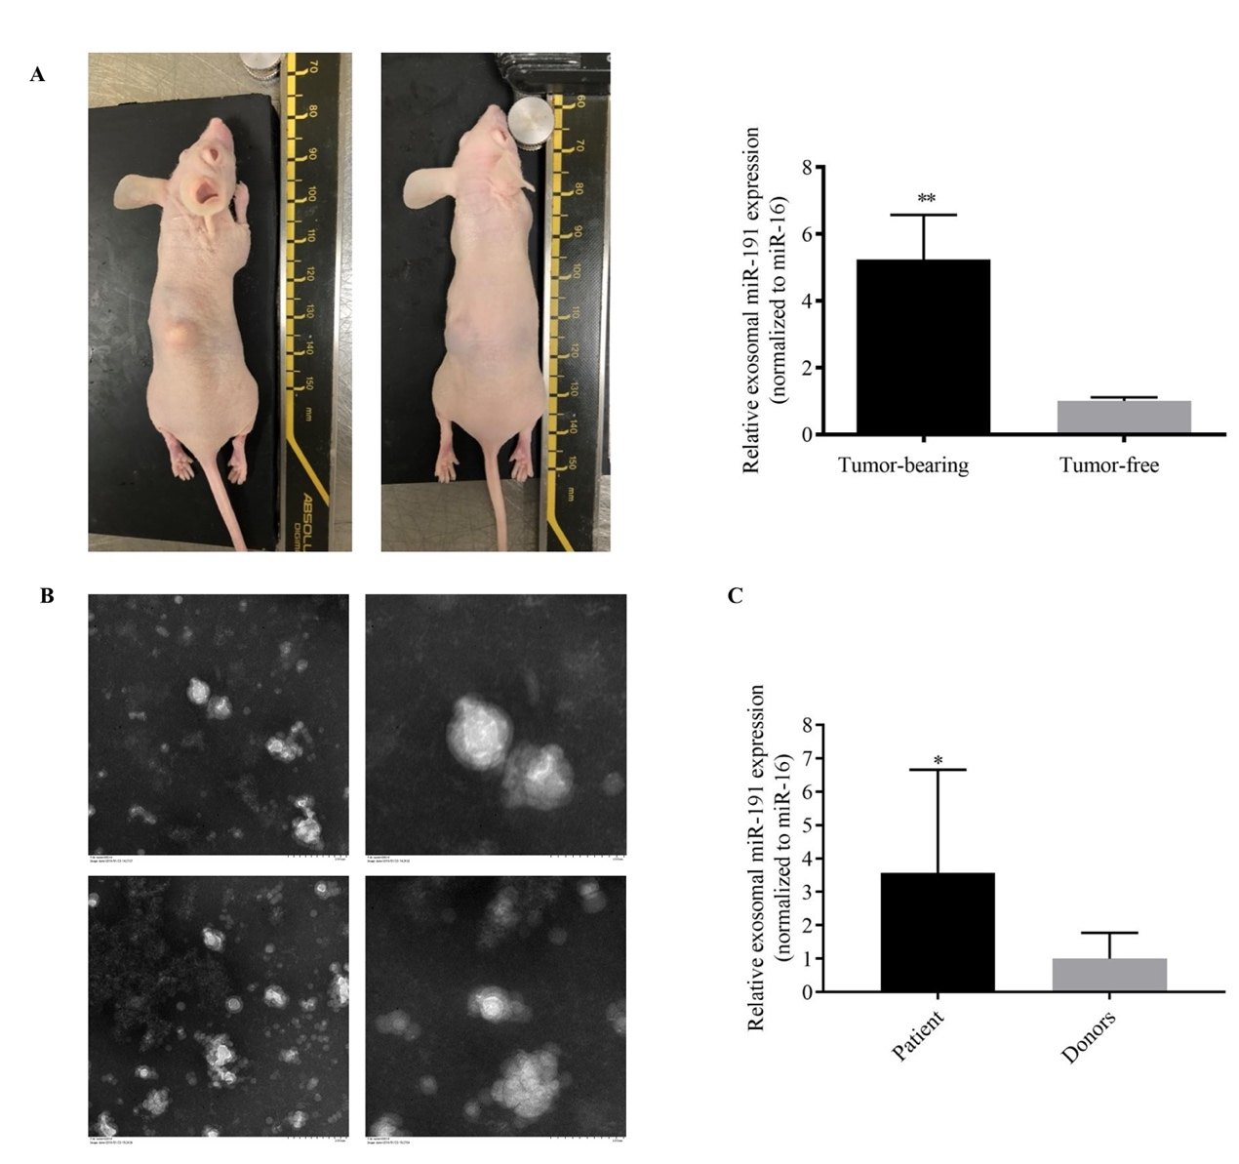
Figure S3. miR-191 was upregulated in the tumor-derived exosomes in vivo. A. The expression of exosomal miR-191-5p was significantly higher in the tumor-bearing group than in the tumor-free group. B. An electron microscope image of exosome isolated from the plasma of an esophageal cancer patient. Note the presence of exosomes ranging in size from 30-100 nm. C. The overexpression of miR-191 in exosomes isolated from the plasma of ESCC patients. The miR-191 expression was analyzed by qRT-PCR and normalized to the miR-16 expression. * p=0.0481 and **P < 0.01.

Figure S4. exosomal miR-191-5p and histological Grade by CRT followed by esophagectomy.
miR-191-5p High（n=29）and miR-191-5p Low(n=30)

