Living alone is related to depressive symptoms during the COVID-19 pandemic
Journal of Public Health

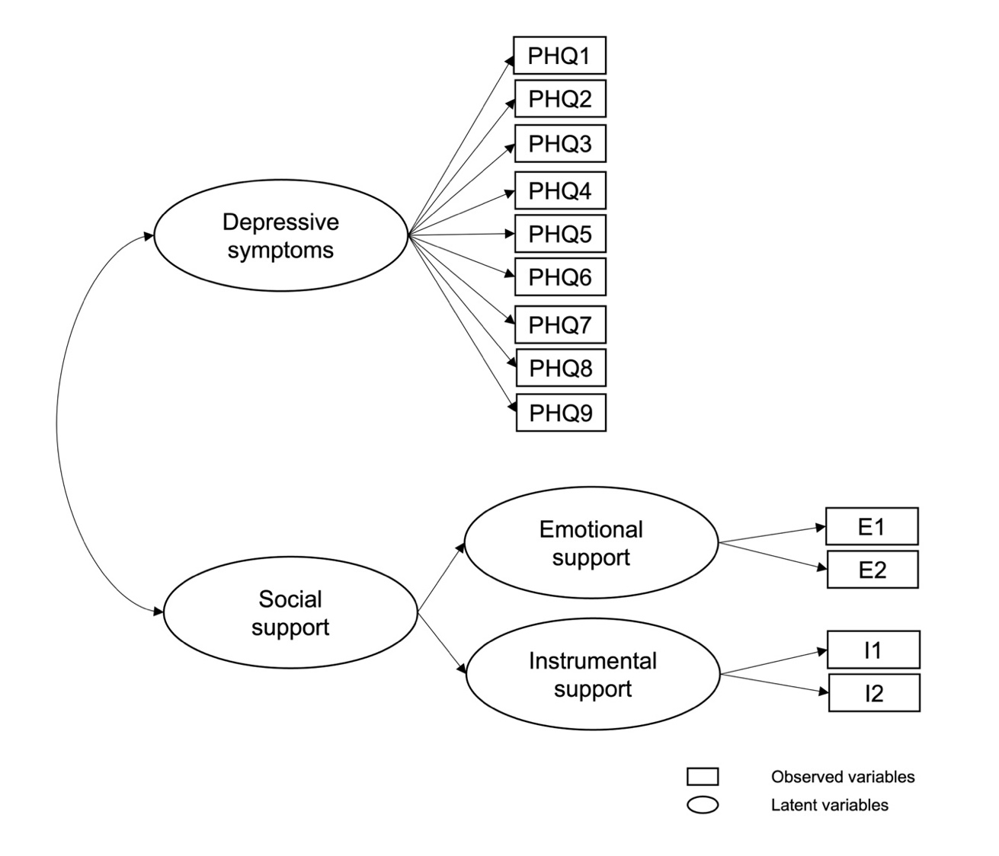
Online Resource 2 Measurement model 2
In measurement model 2, depressive symptoms were estimated as a first-order, one-factor model, where all nine items loaded directly onto the latent factor depression. Social support was estimated as a two-factor, second-order model that consisted of a factor called emotional support and a factor called instrumental support, that loaded onto a second-order factor called social support. PHQ1 – PHQ9 = Items 1-9 of the PHQ-9, E1 = Item 1 emotional support, E2 = Item 2 emotional support, I1 = Item 1 instrumental support, I2 = Item 2 instrumental support.

