Supplementary material 1: Ethics
Country | Ethical board
Hungary | Human Research Ethics Board at Apáczai Csere János Faculty, Széchenyi István University (Győr, Hungary), SZE-AK-2018/001
Israel | Faculty of Social Welfare & Health Sciences #403/18 The University of Haifa, Israel
Spain | The study was approved by the Andalusian Biomedical Research Committee (regional health administration)
Ireland | Ethical approval for the study from the Health Services Executive Research Ethics Committee in Merlin Park, Galway, Ireland.
England | Health Research Authority, London – Bloomsbury Research Ethics Committee – REC Reference 18/LO/1339
*Researchers from the remaining five countries did not require ethical approval for this specific project

Supplementary material 2: Interview schedule
Welcome, thank you for coming. Introduce yourself.
Give some background to the project and use time for getting the interviewee to feel comfortable.
I’ll be asking you to talk about your experiences with [child’s name] and how you got services and support for him. We really want to learn about your experiences and compare them with the experiences of parents in other countries. There are no right or wrong answers. The interview will take about an hour. Of course, the interview will be confidential. For purposes of analyses I will need to audio-record the interview. Would this be ok with you?
Start by briefly introducing the research aims

Topic Question Probes
Making sense of language impairment and how the parent describes it
Can you tell me about [child]?
- Prompt can you tell me about your child’s language problem?

How would other people notice that your child has a language problem or disorder?

What kinds of strategies do you use to communicate with your child?
- How do you manage?
  - “I wonder if you can tell me more about this and how it affected you”.
  - “Tell me about a time when this happened”.
  - “Could you give me another example?”
  - “Tell me about a time when you found a strategy useful”
  - “Could you give me another example about when you used a specific strategy?”
Impact on the family
Can you describe the impact that having a child with a language disorder has had on your family? (prompts mother, father, siblings, grandparents, extended family)
- Getting help
  - Can you tell me about how you got help for your child?
  - What were the barriers to accessing help?
  - What helped you to access help?
How has the help been useful?
- What is the most important thing that you would suggest to another parent with a child with the same problem?
  - “if you were to point to one single thing only”
Closure and verifying common understanding
- In summary, my understanding is that xxx (summarise the key points from the interview because you want to check that you have understood the informant’s intended meaning).
- Is there anything else that you would like to tell me about what [child’s name]?
Thank you!

Debriefing: after the interview and after the audio-recorder has been switched off, the interviewer should take some time to debrief with the interviewee and to help her come out of the interview mode. Also comments about how the questions and the interview may have seemed clear and the questions appropriate are also relevant, since this is a pilot project.
Supplementary material 3: Interview detail
Country | Length interview in minutes | Location | Were field notes taken?
Croatia | 55 | Participants’ home | yes
Denmark | 73 | University clinic | no
Hungary | 53 | Participants’ home | yes
Iceland | 60 | Centre for Language Development and Literacy | yes
Ireland | 44 | University | yes
Israel | 77 | University clinic | no
Netherlands | 45 | Participants’ home | yes
Norway | 50 | Participants’ home | no
Spain | 35 | Participants’ home | no

Supplemental Material S4. Examples of visual materials developed in identifying patterns of meanings, themes and sub-themes across the data sets.
. Process 1

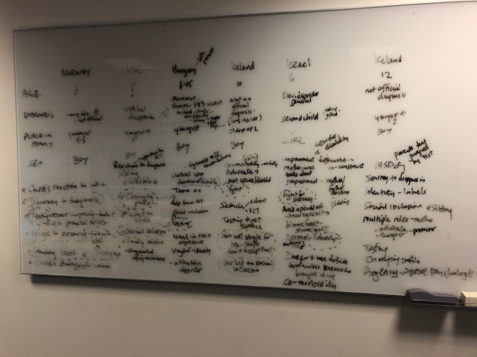

Process 2

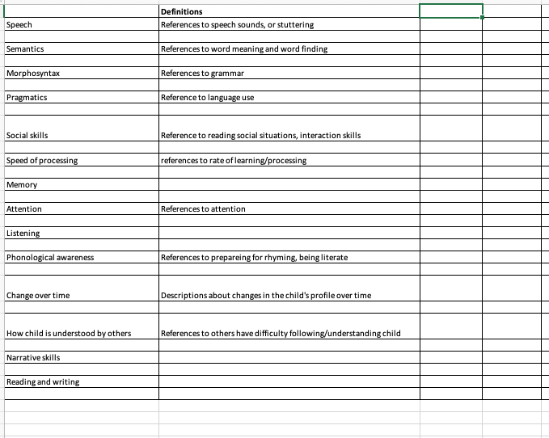

Process 3

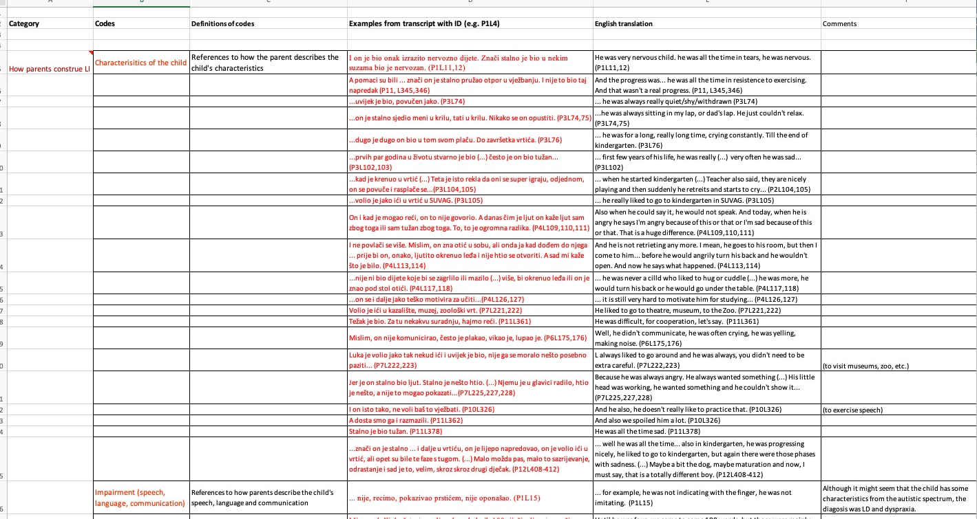

Process 4

