Appendix

Fig. A1 – Frequency in sport participation among Italian children age 6-17, 2016-2022
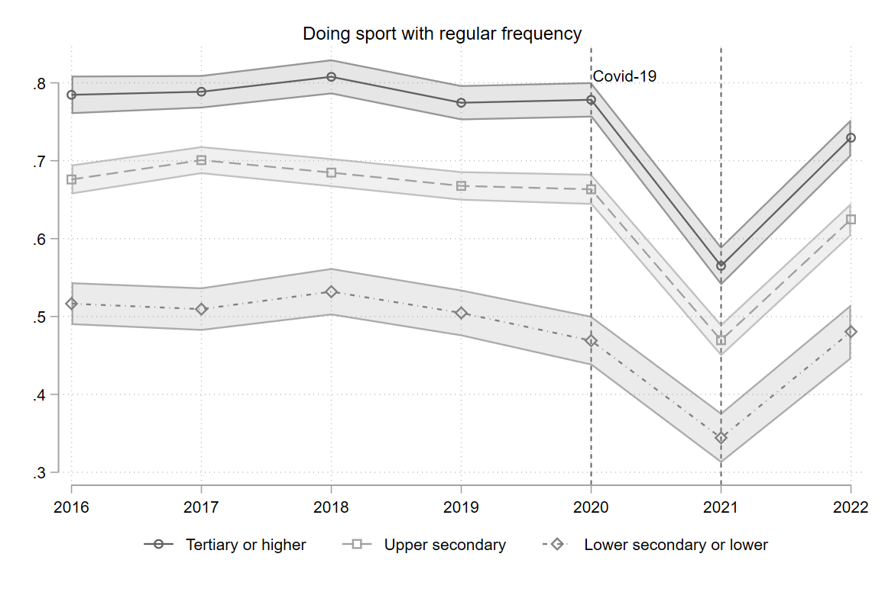
Notes: Authors’ elaboration of Multipurpose Survey of Daily Life 1997-2022. The dependent variable identifies children who practice sports at least once a week over the 12 months before the survey. Controls for gender, number of children in the household, age of the older parent, family type (couple, single parent, or other), region of residence, and level of parental self-reported health satisfaction and wave fixed effects are included.

Fig. A2 – Sport participation among Italian children age 6-17 by gender, 1997-2022

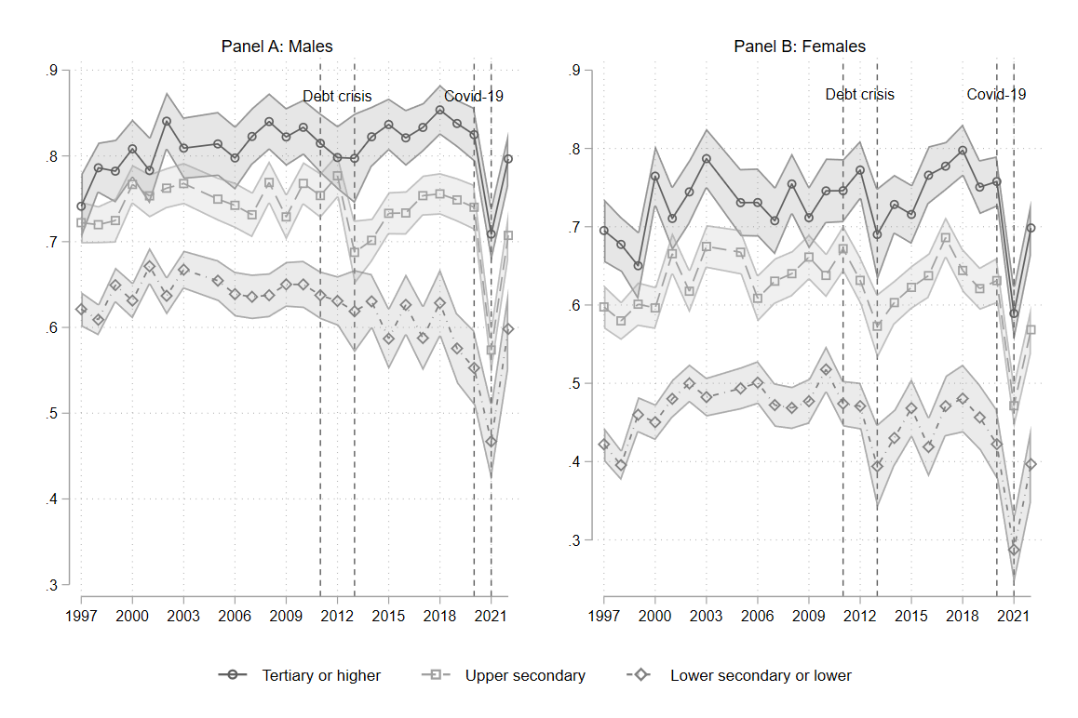
Notes: Authors’ elaboration of Multipurpose Survey of Daily Life 1997-2022. The dependent variables identify children engaging in regular or occasional sport activity for males and females in Panel A and B, respectively. Controls for number of children in the household, age of the older parent, family type (couple, single parent, or other), region of residence, and level of parental self-reported health satisfaction and wave fixed effects are included.

Fig. A3 – Participation in regular sport activity among Italian children by age group, 1997-2022
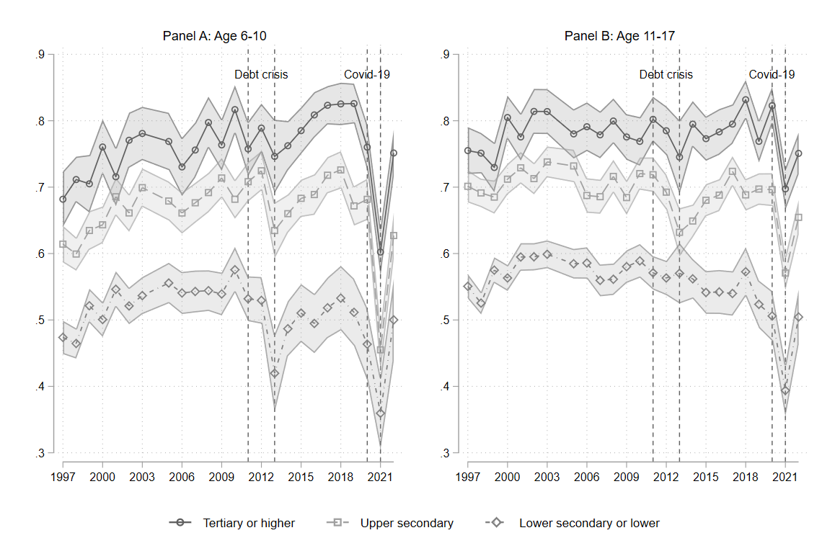
Notes: Authors’ elaboration of Multipurpose Survey of Daily Life 1997-2022. The dependent variables identify children engaging in regular or occasional sport activity for age groups 6-10 and 11-17 in Panel A and B, respectively. Controls for gender, number of children in the household, age of the older parent, family type (couple, single parent, or other), region of residence, and level of parental self-reported health satisfaction and wave fixed effects are included.

Table 1.1 - Sport participation among Italian children age 6-17, 1997-2022: multinomial logistic regression
 | (1) | (2)
 | Any physical activity | Doing sport regularly
Year=1998 | 0.0386 | 0.0995
 | (0.23) | (0.71)
Year=1999 | -0.167 | -0.106
 | (-0.94) | (-0.71)
Year=2000 | -0.403* | 0.151
 | (-2.11) | (0.98)
Year=2001 | -0.405* | -0.0682
 | (-2.19) | (-0.45)
Year=2002 | -0.630** | 0.0888
 | (-3.20) | (0.58)
Year=2003 | -0.661*** | 0.104
 | (-3.35) | (0.68)
Year=2005 | -0.766*** | -0.0980
 | (-3.89) | (-0.64)
Year=2006 | -0.843*** | -0.186
 | (-4.33) | (-1.24)
Year=2007 | -0.799*** | -0.152
 | (-4.21) | (-1.03)
Year=2008 | -0.931*** | -0.00848
 | (-4.70) | (-0.06)
Year=2009 | -0.645*** | -0.0760
 | (-3.48) | (-0.52)
Year=2010 | -0.672*** | 0.0480
 | (-3.46) | (0.32)
Year=2011 | -0.933*** | -0.121
 | (-4.80) | (-0.81)
Year=2012 | -0.603** | 0.0642
 | (-3.13) | (0.42)
Year=2013 | -0.909*** | -0.323
 | (-3.91) | (-1.83)
Year=2014 | -0.683*** | -0.0386
 | (-3.65) | (-0.26)
Year=2015 | -0.722*** | -0.0540
 | (-3.98) | (-0.38)
Year=2016 | -1.080*** | -0.0912
 | (-5.59) | (-0.63)
Year=2017 | -0.773*** | 0.112
 | (-4.32) | (0.80)
Year=2018 | -0.933*** | 0.188
 | (-4.77) | (1.27)
Year=2019 | -0.869*** | -0.00550
 | (-4.82) | (-0.04)
Year=2020 | -0.720*** | 0.0501
 | (-4.03) | (0.35)
Year=2021 | -0.493** | -0.617***
 | (-3.17) | (-4.73)
Year=2022 | -0.594*** | -0.162
 | (-3.49) | (-1.17)
Upper secondary | -0.313* | -0.471***
 | (-2.20) | (-3.91)
Lower secondary or lower | -0.240 | -1.041***
 | (-1.82) | (-9.18)
Year=1998 # Upper secondary | 0.134 | -0.0467
 | (0.71) | (-0.29)
Year=1998 # Lower secondary or lower | -0.0803 | -0.205
 | (-0.46) | (-1.35)
Year=1999 # Upper secondary | 0.117 | 0.0940
 | (0.57) | (0.55)
Year=1999 # Lower secondary or lower | -0.0596 | 0.123
 | (-0.31) | (0.76)
Year=2000 # Upper secondary | 0.338 | -0.0776
 | (1.57) | (-0.44)
Year=2000 # Lower secondary or lower | 0.0592 | -0.254
 | (0.29) | (-1.54)
Year=2001 # Upper secondary | 0.139 | 0.180
 | (0.65) | (1.04)
Year=2001 # Lower secondary or lower | -0.0364 | 0.0722
 | (-0.18) | (0.44)
Year=2002 # Upper secondary | 0.153 | -0.174
 | (0.68) | (-1.00)
Year=2002 # Lower secondary or lower | 0.0733 | -0.177
 | (0.35) | (-1.07)
Year=2003 # Upper secondary | 0.179 | -0.0338
 | (0.79) | (-0.19)
Year=2003 # Lower secondary or lower | -0.0346 | -0.217
 | (-0.16) | (-1.31)
Year=2005 # Upper secondary | 0.475* | 0.185
 | (2.11) | (1.06)
Year=2005 # Lower secondary or lower | 0.239 | 0.0523
 | (1.14) | (0.32)
Year=2006 # Upper secondary | 0.260 | -0.0174
 | (1.17) | (-0.10)
Year=2006 # Lower secondary or lower | 0.0494 | 0.00793
 | (0.24) | (0.05)
Year=2007 # Upper secondary | 0.175 | -0.0421
 | (0.80) | (-0.25)
Year=2007 # Lower secondary or lower | 0.160 | -0.0321
 | (0.78) | (-0.20)
Year=2008 # Upper secondary | 0.397 | -0.0284
 | (1.75) | (-0.16)
Year=2008 # Lower secondary or lower | 0.266 | -0.191
 | (1.25) | (-1.17)
Year=2009 # Upper secondary | 0.321 | 0.0830
 | (1.49) | (0.48)
Year=2009 # Lower secondary or lower | -0.119 | -0.115
 | (-0.59) | (-0.71)
Year=2010 # Upper secondary | 0.199 | -0.0675
 | (0.90) | (-0.39)
Year=2010 # Lower secondary or lower | -0.125 | -0.166
 | (-0.59) | (-0.99)
Year=2011 # Upper secondary | 0.619** | 0.221
 | (2.76) | (1.28)
Year=2011 # Lower secondary or lower | 0.120 | -0.127
 | (0.57) | (-0.78)
Year=2012 # Upper secondary | 0.273 | -0.0112
 | (1.23) | (-0.06)
Year=2012 # Lower secondary or lower | -0.0702 | -0.277
 | (-0.34) | (-1.65)
Year=2013 # Upper secondary | 0.336 | -0.0944
 | (1.27) | (-0.47)
Year=2013 # Lower secondary or lower | -0.0316 | -0.173
 | (-0.12) | (-0.85)
Year=2014 # Upper secondary | 0.215 | -0.231
 | (1.01) | (-1.37)
Year=2014 # Lower secondary or lower | -0.203 | -0.338*
 | (-0.98) | (-2.05)
Year=2015 # Upper secondary | 0.104 | -0.153
 | (0.50) | (-0.93)
Year=2015 # Lower secondary or lower | -0.246 | -0.376*
 | (-1.20) | (-2.31)
Year=2016 # Upper secondary | 0.377 | -0.113
 | (1.70) | (-0.68)
Year=2016 # Lower secondary or lower | 0.0880 | -0.362*
 | (0.41) | (-2.21)
Year=2017 # Upper secondary | 0.263 | -0.0655
 | (1.26) | (-0.40)
Year=2017 # Lower secondary or lower | 0.0597 | -0.437**
 | (0.29) | (-2.71)
Year=2018 # Upper secondary | 0.103 | -0.363*
 | (0.46) | (-2.15)
Year=2018 # Lower secondary or lower | 0.233 | -0.396*
 | (1.05) | (-2.31)
Year=2019 # Upper secondary | 0.291 | -0.150
 | (1.39) | (-0.92)
Year=2019 # Lower secondary or lower | 0.0971 | -0.403*
 | (0.47) | (-2.46)
Year=2020 # Upper secondary | 0.123 | -0.210
 | (0.59) | (-1.27)
Year=2020 # Lower secondary or lower | -0.0105 | -0.564***
 | (-0.05) | (-3.38)
Year=2021 # Upper secondary | -0.00902 | -0.249
 | (-0.05) | (-1.63)
Year=2021 # Lower secondary or lower | -0.0824 | -0.310
 | (-0.45) | (-1.93)
Year=2022 # Upper secondary | -0.0611 | -0.251
 | (-0.30) | (-1.55)
Year=2022 # Lower secondary or lower | -0.193 | -0.326
 | (-0.94) | (-1.94)
Female | -0.0730*** | -0.668***
 | (-3.88) | (-44.84)
2 | -0.0150 | -0.101***
 | (-0.55) | (-4.69)
3+ | -0.104*** | -0.443***
 | (-3.46) | (-18.60)
Single parent | -0.0492 | -0.0903***
 | (-1.56) | (-3.66)
Other | -0.169 | -0.456***
 | (-1.80) | (-5.87)
Lombardia | -0.180*** | -0.112**
 | (-3.40) | (-2.65)
Trentino | 0.409*** | 0.588***
 | (6.70) | (11.55)
Veneto | 0.0604 | 0.0226
 | (1.04) | (0.47)
Friuli Venezia Giulia | 0.150* | 0.0500
 | (2.03) | (0.82)
Liguria | -0.371*** | -0.367***
 | (-5.16) | (-6.57)
Emilia Romagna | -0.160** | -0.199***
 | (-2.62) | (-4.06)
Toscana | -0.360*** | -0.272***
 | (-5.80) | (-5.59)
Umbria | -0.642*** | -0.557***
 | (-8.44) | (-9.81)
Marche | -0.333*** | -0.360***
 | (-5.17) | (-7.07)
Lazio | -0.689*** | -0.714***
 | (-12.16) | (-16.37)
Abruzzo | -0.539*** | -0.710***
 | (-8.94) | (-15.02)
Molise | -0.605*** | -0.922***
 | (-9.54) | (-18.43)
Campania | -0.720*** | -1.423***
 | (-15.52) | (-37.60)
Puglia | -0.760*** | -1.161***
 | (-15.25) | (-29.12)
Basilicata | -0.440*** | -1.046***
 | (-7.59) | (-21.94)
Calabria | -0.597*** | -1.116***
 | (-11.59) | (-26.69)
Sicilia | -0.976*** | -1.385***
 | (-20.08) | (-35.91)
Sardegna | -0.311*** | -0.567***
 | (-5.37) | (-12.03)
35-44 | 0.0432 | 0.438***
 | (1.00) | (12.04)
45-54 | 0.136** | 0.567***
 | (3.10) | (15.36)
55-64 | 0.246*** | 0.550***
 | (4.49) | (12.03)
55+ | 0.199 | 0.541***
 | (1.39) | (4.69)
Satisfied | 0.0544 | 0.000271
 | (1.72) | (0.01)
Not satisfied | 0.0134 | -0.125***
 | (0.35) | (-4.09)
Very unsatisfied | -0.0138 | -0.388***
 | (-0.24) | (-8.18)
Constant | 0.894*** | 2.652***
 | (6.38) | (22.41)
Observations | 134348
Pseudo R2 | 0.077
LR chi2 | 18573.27
p-value | 0.000
Notes: Authors’ elaboration of Multipurpose Survey of Daily Life 1997-2022. The dependent variables identify children engaging in regular or occasional sport activity, any physical activity, and sedentary children as reference group. Controls for gender, number of children in the household, age of the older parent, family type (couple, single parent, or other), region of residence, and level of parental self-reported health satisfaction and wave fixed effects are included. * p < 0.05, ** p < 0.01, *** p < 0.001.

Table 1.2 - Longitudinal trajectories of sport participation among Italian children: doing sport regularly
Parental Education | Year | Margin | Std. Err. | z | P>|z| | [95% conf. interval]
Tertiary or higher | 1997 | 0.719 | 0.014 | 51.56 | 0.000 | 0.692 | 0.746
Tertiary or higher | 1998 | 0.733 | 0.012 | 62.83 | 0.000 | 0.710 | 0.756
Tertiary or higher | 1999 | 0.718 | 0.015 | 49.47 | 0.000 | 0.690 | 0.747
Tertiary or higher | 2000 | 0.786 | 0.013 | 59.21 | 0.000 | 0.760 | 0.812
Tertiary or higher | 2001 | 0.749 | 0.014 | 52.41 | 0.000 | 0.721 | 0.777
Tertiary or higher | 2002 | 0.794 | 0.014 | 58.55 | 0.000 | 0.767 | 0.820
Tertiary or higher | 2003 | 0.798 | 0.013 | 59.87 | 0.000 | 0.772 | 0.824
Tertiary or higher | 2005 | 0.774 | 0.014 | 53.51 | 0.000 | 0.745 | 0.802
Tertiary or higher | 2006 | 0.764 | 0.014 | 52.72 | 0.000 | 0.736 | 0.793
Tertiary or higher | 2007 | 0.767 | 0.014 | 55.47 | 0.000 | 0.740 | 0.794
Tertiary or higher | 2008 | 0.799 | 0.013 | 61.14 | 0.000 | 0.773 | 0.824
Tertiary or higher | 2009 | 0.768 | 0.013 | 57.72 | 0.000 | 0.742 | 0.794
Tertiary or higher | 2010 | 0.790 | 0.013 | 59.44 | 0.000 | 0.764 | 0.816
Tertiary or higher | 2011 | 0.781 | 0.014 | 57.66 | 0.000 | 0.755 | 0.808
Tertiary or higher | 2012 | 0.788 | 0.013 | 59.38 | 0.000 | 0.762 | 0.814
Tertiary or higher | 2013 | 0.745 | 0.020 | 37.17 | 0.000 | 0.706 | 0.785
Tertiary or higher | 2014 | 0.777 | 0.013 | 59.43 | 0.000 | 0.752 | 0.803
Tertiary or higher | 2015 | 0.778 | 0.012 | 62.79 | 0.000 | 0.753 | 0.802
Tertiary or higher | 2016 | 0.795 | 0.012 | 63.65 | 0.000 | 0.770 | 0.819
Tertiary or higher | 2017 | 0.807 | 0.011 | 75.83 | 0.000 | 0.786 | 0.828
Tertiary or higher | 2018 | 0.827 | 0.011 | 73.92 | 0.000 | 0.805 | 0.849
Tertiary or higher | 2019 | 0.795 | 0.011 | 70.63 | 0.000 | 0.773 | 0.817
Tertiary or higher | 2020 | 0.794 | 0.011 | 70.19 | 0.000 | 0.772 | 0.816
Tertiary or higher | 2021 | 0.651 | 0.012 | 52.67 | 0.000 | 0.627 | 0.675
Tertiary or higher | 2022 | 0.749 | 0.012 | 62.48 | 0.000 | 0.726 | 0.773
Upper secondary | 1997 | 0.662 | 0.009 | 70.59 | 0.000 | 0.643 | 0.680
Upper secondary | 1998 | 0.652 | 0.008 | 77.90 | 0.000 | 0.635 | 0.668
Upper secondary | 1999 | 0.665 | 0.010 | 68.51 | 0.000 | 0.646 | 0.684
Upper secondary | 2000 | 0.684 | 0.009 | 75.25 | 0.000 | 0.666 | 0.702
Upper secondary | 2001 | 0.712 | 0.009 | 75.70 | 0.000 | 0.693 | 0.730
Upper secondary | 2002 | 0.692 | 0.009 | 74.49 | 0.000 | 0.674 | 0.710
Upper secondary | 2003 | 0.723 | 0.009 | 77.80 | 0.000 | 0.704 | 0.741
Upper secondary | 2005 | 0.709 | 0.010 | 73.41 | 0.000 | 0.690 | 0.728
Upper secondary | 2006 | 0.677 | 0.010 | 66.47 | 0.000 | 0.657 | 0.697
Upper secondary | 2007 | 0.683 | 0.010 | 68.37 | 0.000 | 0.663 | 0.702
Upper secondary | 2008 | 0.706 | 0.010 | 72.31 | 0.000 | 0.687 | 0.725
Upper secondary | 2009 | 0.697 | 0.010 | 69.47 | 0.000 | 0.677 | 0.716
Upper secondary | 2010 | 0.705 | 0.010 | 73.48 | 0.000 | 0.686 | 0.723
Upper secondary | 2011 | 0.714 | 0.010 | 71.07 | 0.000 | 0.694 | 0.734
Upper secondary | 2012 | 0.706 | 0.010 | 69.54 | 0.000 | 0.686 | 0.726
Upper secondary | 2013 | 0.632 | 0.014 | 44.84 | 0.000 | 0.604 | 0.659
Upper secondary | 2014 | 0.654 | 0.010 | 67.97 | 0.000 | 0.635 | 0.672
Upper secondary | 2015 | 0.679 | 0.009 | 72.18 | 0.000 | 0.661 | 0.698
Upper secondary | 2016 | 0.687 | 0.010 | 71.02 | 0.000 | 0.668 | 0.706
Upper secondary | 2017 | 0.720 | 0.009 | 80.41 | 0.000 | 0.703 | 0.738
Upper secondary | 2018 | 0.702 | 0.009 | 75.14 | 0.000 | 0.683 | 0.720
Upper secondary | 2019 | 0.687 | 0.009 | 72.36 | 0.000 | 0.668 | 0.705
Upper secondary | 2020 | 0.687 | 0.010 | 68.97 | 0.000 | 0.668 | 0.707
Upper secondary | 2021 | 0.524 | 0.010 | 50.13 | 0.000 | 0.504 | 0.545
Upper secondary | 2022 | 0.640 | 0.011 | 59.89 | 0.000 | 0.619 | 0.661
Lower secondary or lower | 1997 | 0.525 | 0.008 | 68.97 | 0.000 | 0.510 | 0.540
Lower secondary or lower | 1998 | 0.506 | 0.007 | 72.92 | 0.000 | 0.492 | 0.520
Lower secondary or lower | 1999 | 0.558 | 0.008 | 70.62 | 0.000 | 0.542 | 0.573
Lower secondary or lower | 2000 | 0.544 | 0.008 | 67.99 | 0.000 | 0.528 | 0.559
Lower secondary or lower | 2001 | 0.579 | 0.008 | 68.79 | 0.000 | 0.562 | 0.595
Lower secondary or lower | 2002 | 0.570 | 0.008 | 67.81 | 0.000 | 0.554 | 0.587
Lower secondary or lower | 2003 | 0.578 | 0.009 | 67.38 | 0.000 | 0.561 | 0.595
Lower secondary or lower | 2005 | 0.577 | 0.009 | 62.78 | 0.000 | 0.559 | 0.595
Lower secondary or lower | 2006 | 0.572 | 0.010 | 59.10 | 0.000 | 0.553 | 0.591
Lower secondary or lower | 2007 | 0.556 | 0.010 | 57.02 | 0.000 | 0.537 | 0.575
Lower secondary or lower | 2008 | 0.555 | 0.010 | 58.09 | 0.000 | 0.536 | 0.574
Lower secondary or lower | 2009 | 0.566 | 0.010 | 56.78 | 0.000 | 0.547 | 0.586
Lower secondary or lower | 2010 | 0.586 | 0.010 | 56.28 | 0.000 | 0.565 | 0.606
Lower secondary or lower | 2011 | 0.558 | 0.010 | 53.91 | 0.000 | 0.538 | 0.578
Lower secondary or lower | 2012 | 0.553 | 0.011 | 51.91 | 0.000 | 0.532 | 0.574
Lower secondary or lower | 2013 | 0.512 | 0.019 | 27.56 | 0.000 | 0.476 | 0.548
Lower secondary or lower | 2014 | 0.535 | 0.012 | 43.12 | 0.000 | 0.510 | 0.559
Lower secondary or lower | 2015 | 0.529 | 0.013 | 39.92 | 0.000 | 0.503 | 0.555
Lower secondary or lower | 2016 | 0.526 | 0.014 | 38.66 | 0.000 | 0.499 | 0.552
Lower secondary or lower | 2017 | 0.531 | 0.014 | 38.46 | 0.000 | 0.504 | 0.558
Lower secondary or lower | 2018 | 0.557 | 0.015 | 37.05 | 0.000 | 0.527 | 0.586
Lower secondary or lower | 2019 | 0.517 | 0.015 | 34.65 | 0.000 | 0.488 | 0.547
Lower secondary or lower | 2020 | 0.489 | 0.016 | 30.78 | 0.000 | 0.458 | 0.520
Lower secondary or lower | 2021 | 0.381 | 0.016 | 23.23 | 0.000 | 0.349 | 0.413
Lower secondary or lower | 2022 | 0.500 | 0.018 | 28.47 | 0.000 | 0.466 | 0.535

Table 2.1 - Gender inequality in sport participation among Italian children age 6-17, 1997-2022: multinomial logit regression
 | (1) | (2)
 | Doing any physical activity | Doing sport regularly
Year=1998 | 0.207 | 0.401
 | (0.81) | (1.79)
Year=1999 | -0.351 | 0.0120
 | (-1.27) | (0.05)
Year=2000 | -0.576* | 0.0512
 | (-2.06) | (0.22)
Year=2001 | -0.700* | -0.175
 | (-2.48) | (-0.77)
Year=2002 | -0.694* | 0.220
 | (-2.27) | (0.91)
Year=2003 | -0.839** | -0.0763
 | (-2.92) | (-0.33)
Year=2005 | -0.974** | -0.104
 | (-3.25) | (-0.45)
Year=2006 | -1.104*** | -0.268
 | (-3.83) | (-1.21)
Year=2007 | -0.711* | 0.0799
 | (-2.49) | (0.35)
Year=2008 | -1.053*** | 0.0517
 | (-3.47) | (0.22)
Year=2009 | -1.051*** | -0.0803
 | (-3.62) | (-0.36)
Year=2010 | -1.047*** | 0.00334
 | (-3.58) | (0.01)
Year=2011 | -0.988*** | -0.105
 | (-3.42) | (-0.47)
Year=2012 | -0.602* | -0.0298
 | (-2.11) | (-0.13)
Year=2013 | -1.225*** | -0.318
 | (-3.35) | (-1.18)
Year=2014 | -1.124*** | -0.109
 | (-3.76) | (-0.48)
Year=2015 | -1.227*** | -0.0433
 | (-4.27) | (-0.20)
Year=2016 | -1.438*** | -0.232
 | (-4.93) | (-1.08)
Year=2017 | -0.906*** | 0.0637
 | (-3.35) | (0.30)
Year=2018 | -1.040*** | 0.166
 | (-3.53) | (0.73)
Year=2019 | -1.299*** | -0.0607
 | (-4.71) | (-0.29)
Year=2020 | -1.338*** | -0.171
 | (-4.68) | (-0.80)
Year=2021 | -0.736** | -0.605**
 | (-3.14) | (-3.08)
Year=2022 | -0.952*** | -0.210
 | (-3.63) | (-1.00)
Upper secondary | -0.486* | -0.403*
 | (-2.27) | (-2.20)
Lower secondary or lower | -0.365 | -0.814***
 | (-1.85) | (-4.74)
Year=1998 # Upper secondary | -0.0365 | -0.314
 | (-0.12) | (-1.24)
Year=1998 # Lower secondary or lower | -0.331 | -0.527*
 | (-1.21) | (-2.21)
Year=1999 # Upper secondary | 0.452 | 0.0593
 | (1.42) | (0.22)
Year=1999 # Lower secondary or lower | 0.0343 | -0.0617
 | (0.12) | (-0.25)
Year=2000 # Upper secondary | 0.506 | 0.155
 | (1.57) | (0.59)
Year=2000 # Lower secondary or lower | 0.180 | -0.224
 | (0.61) | (-0.92)
Year=2001 # Upper secondary | 0.283 | 0.131
 | (0.87) | (0.50)
Year=2001 # Lower secondary or lower | 0.205 | 0.139
 | (0.68) | (0.57)
Year=2002 # Upper secondary | 0.203 | -0.247
 | (0.59) | (-0.91)
Year=2002 # Lower secondary or lower | -0.0149 | -0.513*
 | (-0.05) | (-1.99)
Year=2003 # Upper secondary | 0.356 | 0.0848
 | (1.07) | (0.33)
Year=2003 # Lower secondary or lower | 0.0871 | -0.0928
 | (0.28) | (-0.38)
Year=2005 # Upper secondary | 0.579 | 0.0488
 | (1.69) | (0.18)
Year=2005 # Lower secondary or lower | 0.477 | -0.0115
 | (1.49) | (-0.05)
Year=2006 # Upper secondary | 0.649 | 0.145
 | (1.95) | (0.57)
Year=2006 # Lower secondary or lower | 0.311 | -0.0512
 | (1.00) | (-0.21)
Year=2007 # Upper secondary | 0.0924 | -0.333
 | (0.28) | (-1.28)
Year=2007 # Lower secondary or lower | -0.0886 | -0.416
 | (-0.29) | (-1.68)
Year=2008 # Upper secondary | 0.584 | -0.0296
 | (1.68) | (-0.11)
Year=2008 # Lower secondary or lower | 0.216 | -0.394
 | (0.66) | (-1.58)
Year=2009 # Upper secondary | 0.462 | -0.174
 | (1.38) | (-0.68)
Year=2009 # Lower secondary or lower | 0.343 | -0.151
 | (1.09) | (-0.62)
Year=2010 # Upper secondary | 0.658 | 0.0489
 | (1.95) | (0.19)
Year=2010 # Lower secondary or lower | 0.236 | -0.277
 | (0.74) | (-1.13)
Year=2011 # Upper secondary | 0.545 | 0.0514
 | (1.63) | (0.20)
Year=2011 # Lower secondary or lower | 0.146 | -0.239
 | (0.46) | (-0.97)
Year=2012 # Upper secondary | 0.0406 | 0.0585
 | (0.12) | (0.22)
Year=2012 # Lower secondary or lower | -0.243 | -0.346
 | (-0.77) | (-1.36)
Year=2013 # Upper secondary | 0.588 | -0.167
 | (1.43) | (-0.55)
Year=2013 # Lower secondary or lower | 0.126 | -0.206
 | (0.31) | (-0.68)
Year=2014 # Upper secondary | 0.527 | -0.290
 | (1.57) | (-1.13)
Year=2014 # Lower secondary or lower | 0.0411 | -0.357
 | (0.12) | (-1.43)
Year=2015 # Upper secondary | 0.656* | -0.181
 | (2.00) | (-0.73)
Year=2015 # Lower secondary or lower | 0.189 | -0.602*
 | (0.59) | (-2.48)
Year=2016 # Upper secondary | 0.702* | -0.0566
 | (2.10) | (-0.23)
Year=2016 # Lower secondary or lower | 0.306 | -0.269
 | (0.93) | (-1.11)
Year=2017 # Upper secondary | 0.292 | -0.192
 | (0.93) | (-0.78)
Year=2017 # Lower secondary or lower | 0.342 | -0.512*
 | (1.12) | (-2.08)
Year=2018 # Upper secondary | 0.226 | -0.360
 | (0.67) | (-1.40)
Year=2018 # Lower secondary or lower | 0.346 | -0.491
 | (1.03) | (-1.89)
Year=2019 # Upper secondary | 0.701* | -0.0892
 | (2.17) | (-0.37)
Year=2019 # Lower secondary or lower | 0.666* | -0.472
 | (2.12) | (-1.94)
Year=2020 # Upper secondary | 0.739* | -0.0261
 | (2.23) | (-0.11)
Year=2020 # Lower secondary or lower | 0.477 | -0.556*
 | (1.46) | (-2.24)
Year=2021 # Upper secondary | 0.185 | -0.365
 | (0.67) | (-1.59)
Year=2021 # Lower secondary or lower | 0.160 | -0.364
 | (0.58) | (-1.54)
Year=2022 # Upper secondary | 0.220 | -0.214
 | (0.71) | (-0.87)
Year=2022 # Lower secondary or lower | 0.0118 | -0.349
 | (0.04) | (-1.39)
Female | -0.443 | -0.515*
 | (-1.78) | (-2.43)
Year=1998 # Female | -0.247 | -0.510
 | (-0.73) | (-1.77)
Year=1999 # Female | 0.347 | -0.229
 | (0.96) | (-0.75)
Year=2000 # Female | 0.314 | 0.176
 | (0.82) | (0.57)
Year=2001 # Female | 0.533 | 0.159
 | (1.43) | (0.52)
Year=2002 # Female | 0.146 | -0.241
 | (0.36) | (-0.77)
Year=2003 # Female | 0.315 | 0.314
 | (0.79) | (1.02)
Year=2005 # Female | 0.383 | -0.0101
 | (0.96) | (-0.03)
Year=2006 # Female | 0.485 | 0.143
 | (1.24) | (0.47)
Year=2007 # Female | -0.138 | -0.418
 | (-0.36) | (-1.39)
Year=2008 # Female | 0.239 | -0.124
 | (0.60) | (-0.41)
Year=2009 # Female | 0.709 | -0.0205
 | (1.87) | (-0.07)
Year=2010 # Female | 0.688 | 0.0693
 | (1.75) | (0.23)
Year=2011 # Female | 0.103 | -0.0415
 | (0.26) | (-0.14)
Year=2012 # Female | -0.00806 | 0.142
 | (-0.02) | (0.46)
Year=2013 # Female | 0.563 | -0.0349
 | (1.19) | (-0.10)
Year=2014 # Female | 0.750 | 0.0811
 | (1.95) | (0.27)
Year=2015 # Female | 0.863* | -0.0466
 | (2.31) | (-0.16)
Year=2016 # Female | 0.648 | 0.233
 | (1.66) | (0.81)
Year=2017 # Female | 0.250 | 0.0587
 | (0.69) | (0.21)
Year=2018 # Female | 0.204 | 0.0138
 | (0.52) | (0.05)
Year=2019 # Female | 0.770* | 0.0814
 | (2.10) | (0.29)
Year=2020 # Female | 1.032** | 0.337
 | (2.79) | (1.19)
Year=2021 # Female | 0.448 | -0.0392
 | (1.43) | (-0.15)
Year=2022 # Female | 0.633 | 0.0552
 | (1.83) | (0.20)
Upper secondary # Female | 0.326 | -0.137
 | (1.13) | (-0.56)
Lower secondary or lower # Female | 0.246 | -0.449*
 | (0.93) | (-1.96)
Year=1998 # Upper secondary # Female | 0.251 | 0.444
 | (0.65) | (1.35)
Year=1998 # Lower secondary or lower # Female | 0.388 | 0.531
 | (1.08) | (1.71)
Year=1999 # Upper secondary # Female | -0.597 | 0.0947
 | (-1.43) | (0.27)
Year=1999 # Lower secondary or lower # Female | -0.193 | 0.351
 | (-0.50) | (1.07)
Year=2000 # Upper secondary # Female | -0.300 | -0.418
 | (-0.69) | (-1.19)
Year=2000 # Lower secondary or lower # Female | -0.223 | -0.0435
 | (-0.55) | (-0.13)
Year=2001 # Upper secondary # Female | -0.274 | 0.111
 | (-0.63) | (0.32)
Year=2001 # Lower secondary or lower # Female | -0.438 | -0.0826
 | (-1.09) | (-0.25)
Year=2002 # Upper secondary # Female | -0.119 | 0.131
 | (-0.26) | (0.37)
Year=2002 # Lower secondary or lower # Female | 0.121 | 0.640
 | (0.29) | (1.90)
Year=2003 # Upper secondary # Female | -0.315 | -0.202
 | (-0.69) | (-0.57)
Year=2003 # Lower secondary or lower # Female | -0.217 | -0.205
 | (-0.51) | (-0.62)
Year=2005 # Upper secondary # Female | -0.199 | 0.274
 | (-0.44) | (0.78)
Year=2005 # Lower secondary or lower # Female | -0.445 | 0.153
 | (-1.04) | (0.46)
Year=2006 # Upper secondary # Female | -0.705 | -0.282
 | (-1.57) | (-0.81)
Year=2006 # Lower secondary or lower # Female | -0.491 | 0.140
 | (-1.16) | (0.42)
Year=2007 # Upper secondary # Female | 0.127 | 0.525
 | (0.29) | (1.53)
Year=2007 # Lower secondary or lower # Female | 0.415 | 0.707*
 | (1.00) | (2.16)
Year=2008 # Upper secondary # Female | -0.346 | 0.0205
 | (-0.75) | (0.06)
Year=2008 # Lower secondary or lower # Female | 0.0540 | 0.394
 | (0.13) | (1.20)
Year=2009 # Upper secondary # Female | -0.235 | 0.501
 | (-0.54) | (1.45)
Year=2009 # Lower secondary or lower # Female | -0.811* | 0.109
 | (-1.97) | (0.33)
Year=2010 # Upper secondary # Female | -0.823 | -0.192
 | (-1.83) | (-0.55)
Year=2010 # Lower secondary or lower # Female | -0.669 | 0.242
 | (-1.56) | (0.72)
Year=2011 # Upper secondary # Female | 0.127 | 0.324
 | (0.28) | (0.93)
Year=2011 # Lower secondary or lower # Female | -0.0533 | 0.237
 | (-0.13) | (0.72)
Year=2012 # Upper secondary # Female | 0.390 | -0.113
 | (0.87) | (-0.32)
Year=2012 # Lower secondary or lower # Female | 0.299 | 0.168
 | (0.71) | (0.50)
Year=2013 # Upper secondary # Female | -0.450 | 0.160
 | (-0.84) | (0.39)
Year=2013 # Lower secondary or lower # Female | -0.288 | 0.0496
 | (-0.54) | (0.12)
Year=2014 # Upper secondary # Female | -0.517 | 0.160
 | (-1.19) | (0.47)
Year=2014 # Lower secondary or lower # Female | -0.405 | 0.0678
 | (-0.95) | (0.20)
Year=2015 # Upper secondary # Female | -0.947* | 0.0784
 | (-2.21) | (0.24)
Year=2015 # Lower secondary or lower # Female | -0.743 | 0.473
 | (-1.77) | (1.45)
Year=2016 # Upper secondary # Female | -0.591 | -0.0778
 | (-1.32) | (-0.23)
Year=2016 # Lower secondary or lower # Female | -0.410 | -0.157
 | (-0.93) | (-0.48)
Year=2017 # Upper secondary # Female | -0.0636 | 0.269
 | (-0.15) | (0.82)
Year=2017 # Lower secondary or lower # Female | -0.534 | 0.206
 | (-1.30) | (0.63)
Year=2018 # Upper secondary # Female | -0.234 | 0.0189
 | (-0.52) | (0.06)
Year=2018 # Lower secondary or lower # Female | -0.223 | 0.220
 | (-0.50) | (0.64)
Year=2019 # Upper secondary # Female | -0.733 | -0.0944
 | (-1.73) | (-0.29)
Year=2019 # Lower secondary or lower # Female | -1.038* | 0.187
 | (-2.47) | (0.57)
Year=2020 # Upper secondary # Female | -1.031* | -0.270
 | (-2.40) | (-0.81)
Year=2020 # Lower secondary or lower # Female | -0.804 | 0.0806
 | (-1.89) | (0.24)
Year=2021 # Upper secondary # Female | -0.359 | 0.242
 | (-0.98) | (0.79)
Year=2021 # Lower secondary or lower # Female | -0.458 | 0.0912
 | (-1.23) | (0.28)
Year=2022 # Upper secondary # Female | -0.500 | -0.0403
 | (-1.22) | (-0.12)
Year=2022 # Lower secondary or lower # Female | -0.371 | 0.0650
 | (-0.89) | (0.19)
2 | -0.0146 | -0.100***
 | (-0.53) | (-4.68)
3+ | -0.104*** | -0.444***
 | (-3.44) | (-18.63)
Single parent | -0.0487 | -0.0896***
 | (-1.54) | (-3.63)
Other | -0.167 | -0.456***
 | (-1.77) | (-5.87)
Lombardia | -0.180*** | -0.114**
 | (-3.39) | (-2.68)
Trentino | 0.410*** | 0.589***
 | (6.71) | (11.55)
Veneto | 0.0594 | 0.0221
 | (1.02) | (0.46)
Friuli Venezia Giulia | 0.148* | 0.0499
 | (2.01) | (0.82)
Liguria | -0.374*** | -0.369***
 | (-5.20) | (-6.60)
Emilia Romagna | -0.162** | -0.202***
 | (-2.65) | (-4.12)
Toscana | -0.359*** | -0.273***
 | (-5.78) | (-5.62)
Umbria | -0.642*** | -0.558***
 | (-8.44) | (-9.82)
Marche | -0.333*** | -0.361***
 | (-5.17) | (-7.07)
Lazio | -0.690*** | -0.716***
 | (-12.17) | (-16.41)
Abruzzo | -0.539*** | -0.715***
 | (-8.95) | (-15.10)
Molise | -0.605*** | -0.924***
 | (-9.53) | (-18.44)
Campania | -0.720*** | -1.428***
 | (-15.52) | (-37.67)
Puglia | -0.761*** | -1.164***
 | (-15.26) | (-29.17)
Basilicata | -0.441*** | -1.048***
 | (-7.60) | (-21.96)
Calabria | -0.599*** | -1.119***
 | (-11.61) | (-26.72)
Sicilia | -0.977*** | -1.389***
 | (-20.10) | (-35.99)
Sardegna | -0.311*** | -0.569***
 | (-5.36) | (-12.06)
35-44 | 0.0422 | 0.440***
 | (0.98) | (12.07)
45-54 | 0.136** | 0.568***
 | (3.09) | (15.37)
55-64 | 0.246*** | 0.552***
 | (4.48) | (12.06)
55+ | 0.191 | 0.537***
 | (1.34) | (4.64)
Satisfied | 0.0540 | 0.000261
 | (1.70) | (0.01)
Not satisfied | 0.0121 | -0.126***
 | (0.31) | (-4.11)
Very unsatisfied | -0.0154 | -0.388***
 | (-0.27) | (-8.18)
Constant | 1.094*** | 2.578***
 | (5.59) | (15.25)
Observations | 134348
Pseudo R2 | 0.078
LR chi2 | 18854.17
p-value | 0.000
Notes: Authors’ elaboration of Multipurpose Survey of Daily Life 1997-2022. The dependent variables identify children engaging in regular or occasional sport activity, any physical activity, and sedentary children as reference group. Controls for gender, number of children in the household, age of the older parent, family type (couple, single parent, or other), region of residence, and level of parental self-reported health satisfaction and wave fixed effects are included. * p < 0.05, ** p < 0.01, *** p < 0.001.

Table 2.2 - Longitudinal trajectories of sport participation by gender: Doing sport regularly
 | Males |  |  |  |  | Females
Parental Education | Year | Margin | Std. Err. | z | P>|z| | Year | Margin | Std. Err. | z | P>|z|
Tertiary or higher | 1997 | 0.741 | 0.019 | 38.60 | 0.000 | 1997 | 0.695 | 0.021 | 33.76 | 0.000
Tertiary or higher | 1998 | 0.786 | 0.015 | 52.21 | 0.000 | 1998 | 0.677 | 0.018 | 37.66 | 0.000
Tertiary or higher | 1999 | 0.782 | 0.019 | 41.78 | 0.000 | 1999 | 0.650 | 0.022 | 29.19 | 0.000
Tertiary or higher | 2000 | 0.808 | 0.018 | 46.14 | 0.000 | 2000 | 0.765 | 0.020 | 37.89 | 0.000
Tertiary or higher | 2001 | 0.783 | 0.020 | 39.32 | 0.000 | 2001 | 0.711 | 0.021 | 33.88 | 0.000
Tertiary or higher | 2002 | 0.841 | 0.017 | 48.44 | 0.000 | 2002 | 0.745 | 0.021 | 35.46 | 0.000
Tertiary or higher | 2003 | 0.809 | 0.018 | 44.09 | 0.000 | 2003 | 0.787 | 0.020 | 40.08 | 0.000
Tertiary or higher | 2005 | 0.814 | 0.019 | 42.61 | 0.000 | 2005 | 0.731 | 0.022 | 33.26 | 0.000
Tertiary or higher | 2006 | 0.798 | 0.019 | 42.14 | 0.000 | 2006 | 0.731 | 0.022 | 32.80 | 0.000
Tertiary or higher | 2007 | 0.823 | 0.017 | 48.43 | 0.000 | 2007 | 0.708 | 0.022 | 32.03 | 0.000
Tertiary or higher | 2008 | 0.840 | 0.017 | 49.66 | 0.000 | 2008 | 0.755 | 0.020 | 37.53 | 0.000
Tertiary or higher | 2009 | 0.822 | 0.017 | 47.58 | 0.000 | 2009 | 0.712 | 0.020 | 34.90 | 0.000
Tertiary or higher | 2010 | 0.833 | 0.017 | 50.46 | 0.000 | 2010 | 0.746 | 0.021 | 35.26 | 0.000
Tertiary or higher | 2011 | 0.815 | 0.018 | 45.57 | 0.000 | 2011 | 0.746 | 0.021 | 36.16 | 0.000
Tertiary or higher | 2012 | 0.798 | 0.019 | 42.15 | 0.000 | 2012 | 0.772 | 0.019 | 40.15 | 0.000
Tertiary or higher | 2013 | 0.797 | 0.027 | 29.82 | 0.000 | 2013 | 0.690 | 0.030 | 22.86 | 0.000
Tertiary or higher | 2014 | 0.822 | 0.018 | 45.72 | 0.000 | 2014 | 0.729 | 0.019 | 37.62 | 0.000
Tertiary or higher | 2015 | 0.837 | 0.016 | 53.93 | 0.000 | 2015 | 0.716 | 0.019 | 36.95 | 0.000
Tertiary or higher | 2016 | 0.821 | 0.017 | 49.10 | 0.000 | 2016 | 0.766 | 0.019 | 40.65 | 0.000
Tertiary or higher | 2017 | 0.833 | 0.015 | 57.37 | 0.000 | 2017 | 0.777 | 0.016 | 48.96 | 0.000
Tertiary or higher | 2018 | 0.854 | 0.015 | 57.22 | 0.000 | 2018 | 0.798 | 0.017 | 47.05 | 0.000
Tertiary or higher | 2019 | 0.838 | 0.014 | 58.95 | 0.000 | 2019 | 0.751 | 0.018 | 42.45 | 0.000
Tertiary or higher | 2020 | 0.825 | 0.016 | 51.32 | 0.000 | 2020 | 0.758 | 0.017 | 45.92 | 0.000
Tertiary or higher | 2021 | 0.709 | 0.017 | 42.52 | 0.000 | 2021 | 0.589 | 0.018 | 32.10 | 0.000
Tertiary or higher | 2022 | 0.797 | 0.016 | 49.38 | 0.000 | 2022 | 0.698 | 0.018 | 38.89 | 0.000
Lower second. or lower | 1997 | 0.621 | 0.010 | 60.25 | 0.000 | 1997 | 0.422 | 0.011 | 38.36 | 0.000
Lower second. or lower | 1998 | 0.609 | 0.009 | 64.81 | 0.000 | 1998 | 0.396 | 0.010 | 39.63 | 0.000
Lower second. or lower | 1999 | 0.649 | 0.011 | 61.47 | 0.000 | 1999 | 0.460 | 0.012 | 39.63 | 0.000
Lower second. or lower | 2000 | 0.631 | 0.011 | 58.62 | 0.000 | 2000 | 0.450 | 0.012 | 38.37 | 0.000
Lower second. or lower | 2001 | 0.671 | 0.011 | 60.18 | 0.000 | 2001 | 0.480 | 0.012 | 38.48 | 0.000
Lower second. or lower | 2002 | 0.637 | 0.011 | 56.02 | 0.000 | 2002 | 0.500 | 0.012 | 40.17 | 0.000
Lower second. or lower | 2003 | 0.667 | 0.011 | 58.43 | 0.000 | 2003 | 0.482 | 0.013 | 37.99 | 0.000
Lower second. or lower | 2005 | 0.655 | 0.012 | 53.67 | 0.000 | 2005 | 0.493 | 0.014 | 35.86 | 0.000
Lower second. or lower | 2006 | 0.639 | 0.013 | 47.89 | 0.000 | 2006 | 0.501 | 0.014 | 35.62 | 0.000
Lower second. or lower | 2007 | 0.636 | 0.013 | 47.76 | 0.000 | 2007 | 0.472 | 0.014 | 33.22 | 0.000
Lower second. or lower | 2008 | 0.638 | 0.013 | 48.56 | 0.000 | 2008 | 0.469 | 0.014 | 33.92 | 0.000
Lower second. or lower | 2009 | 0.650 | 0.013 | 48.43 | 0.000 | 2009 | 0.477 | 0.015 | 32.49 | 0.000
Lower second. or lower | 2010 | 0.650 | 0.014 | 46.10 | 0.000 | 2010 | 0.518 | 0.015 | 33.62 | 0.000
Lower second. or lower | 2011 | 0.638 | 0.014 | 44.69 | 0.000 | 2011 | 0.474 | 0.015 | 31.73 | 0.000
Lower second. or lower | 2012 | 0.631 | 0.015 | 42.69 | 0.000 | 2012 | 0.471 | 0.015 | 30.79 | 0.000
Lower second. or lower | 2013 | 0.619 | 0.025 | 25.15 | 0.000 | 2013 | 0.394 | 0.027 | 14.36 | 0.000
Lower second. or lower | 2014 | 0.630 | 0.016 | 38.62 | 0.000 | 2014 | 0.430 | 0.019 | 23.21 | 0.000
Lower second. or lower | 2015 | 0.587 | 0.018 | 31.90 | 0.000 | 2015 | 0.468 | 0.019 | 24.36 | 0.000
Lower second. or lower | 2016 | 0.626 | 0.018 | 34.07 | 0.000 | 2016 | 0.419 | 0.020 | 21.25 | 0.000
Lower second. or lower | 2017 | 0.588 | 0.019 | 30.22 | 0.000 | 2017 | 0.471 | 0.020 | 23.82 | 0.000
Lower second. or lower | 2018 | 0.629 | 0.020 | 30.97 | 0.000 | 2018 | 0.481 | 0.022 | 21.61 | 0.000
Lower second. or lower | 2019 | 0.576 | 0.021 | 27.48 | 0.000 | 2019 | 0.456 | 0.021 | 21.31 | 0.000
Lower second. or lower | 2020 | 0.553 | 0.022 | 24.82 | 0.000 | 2020 | 0.422 | 0.023 | 18.56 | 0.000
Lower second. or lower | 2021 | 0.467 | 0.023 | 20.15 | 0.000 | 2021 | 0.287 | 0.023 | 12.61 | 0.000
Lower second. or lower | 2022 | 0.598 | 0.024 | 24.80 | 0.000 | 2022 | 0.397 | 0.025 | 15.80 | 0.000

