Supplementary Data
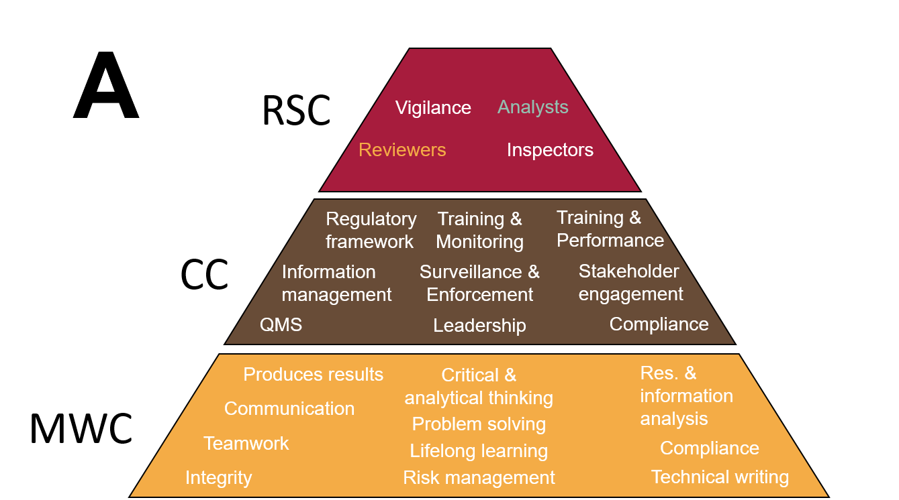
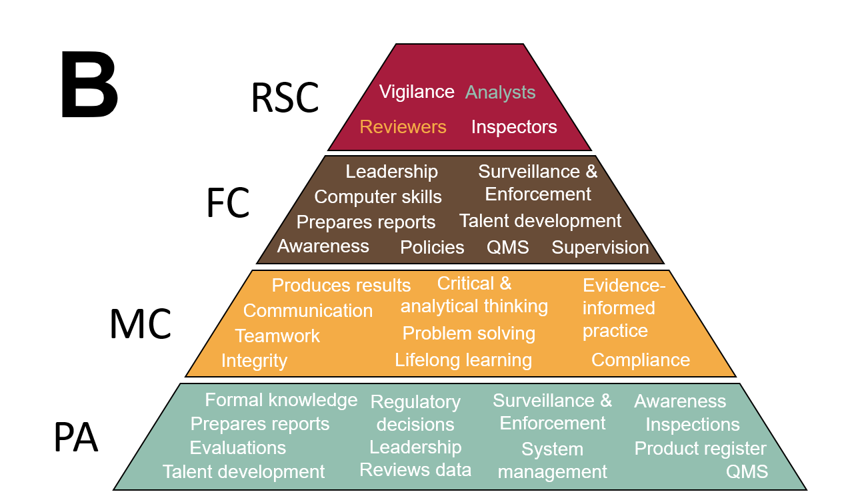
Supp. Fig. 1: The GCF drafts define the specific work functions (tasks/roles), underlying knowledge, and the skills or abilities to perform the detailed tasks/ roles for the core and role specific competencies. (A) GCF draft 1.2, which was used for PharmTrain phase I is modelled as follows: (MWC) Mandatory workplace competencies, (CC) Core or generic competencies, and (RSC) Role-specific or occupation-related competencies. (B) GCF draft 1.5.2, which was used for assessment of phase II is structured into (MC) meta-competencies, (FC) functional competencies, and (RSC) role-specific or occupation-related competencies, while it also defines the specific underlying (PA) practice activities. The acquisition or development of each competency within the respective category is organized in three proficiency levels. The three levels are basic (Level I), competent (Level II) and proficient / expert (Level III). This figure was adapted from the WHO (WHO, 2019b); the arrangement of the capacities within each category is random.

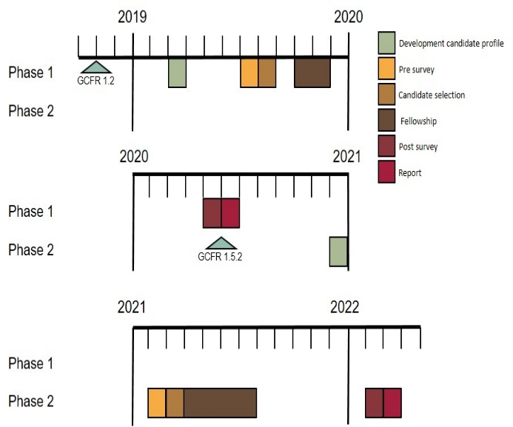
Supp. Fig. 2: Timeline of the different phases of the PharmTrain fellowship. Phase I took place as an eight-week onsite fellowship for two fellows from two different countries, while phase II had to take place online due to pandemic conditions and had nine participants from three countries.

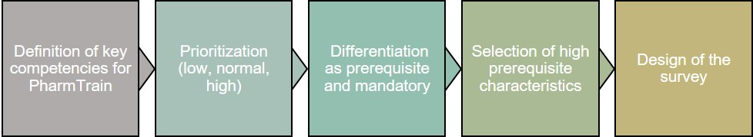
Supp. Fig. 3: Schematic of the candidate profile development for qualified participants for the PharmTrain fellowship and its subsequent selection process.
Supp. Fig. 4: Change in score from pre to post for all questions from during PharmTrain phase 2. Mean+SD

Supp. Tab. 1: Preselected mandatory workplace competencies according to GCF Draft version 1.2 with relevance to the capacity development module that were included in the survey for the selection and evaluation of fellows.
Competency
Makes accurate and evaluative records that can withstand scrutiny and challenge, and which substantiate evaluations
Takes part in needed learning activities in a way that makes the most of the learning experience (e.g., takes notes, asks questions, does required tasks)
Seeks feedback, and modifies behaviour for improvement
Takes charge of personal career development by identifying personal interests and career pathways
Is receptive and attentive.
Actively contributes to the team.
Is cooperative and committed.

Supp. Tab. 2: Preselected core or generic competencies according to GCF Draft version 1.2 with relevance to the capacity development module that were included in the survey for the selection and evaluation of fellows.
Competency
Uses word processing – to compose, organize, and edit documents and other business communications
Uses internet and e-mail – to search for information and communicate
Uses spreadsheet, database, and presentation software – to store, retrieve, and present data
Locate, understand, and interpret written technical and non-technical information in documents such as manuals, reports, memos, graphs, charts, tables, schedules, and signs
Reviews and analyse documentation

Supp. Tab. 3: Preselected role-specific or occupation-related competencies for reviewers according to GCF Draft version 1.with relevance to the capacity development module that were included in the survey for the selection and evaluation of fellows.
Competency
Individual at this level continues to develop in the job to enable them to take on more complex applications as their training and competency develops.
Preparing a comprehensive summary of the data reviewed and submits substantive recommendations and conclusions for approval.
Acting as a second reviewer of non-complex applications.
Writing and critically evaluating written assessment reports.
Participating in the review and analysis of study protocols, preclinical and clinical studies.
Reviewing pharmacokinetic, bioavailability / bioequivalence data, in vitro and in vivo studies with different end points.
Contributing to regulatory decisions on individual products based on appropriate reviews of documentation, inspections, and laboratory testing (if applicable).
Participating in regional/international assessment (collaboration) activities (if relevant).
Possess significant relevant experience.
Demonstrates a broad knowledge across a range of scientific activities or may be beginning to develop a specialist level of knowledge in one or more scientific areas.
Knowledge of the legislative system governing the process of approval of medical products at national, or regional level
Good clinical practice (GCP) & ethical conduct of research
Experienced individuals who are expected to make advanced contribution to the regulatory sciences and may be recognized as an expert in a particular field, based on increased breadth or depth of skills.
The individual should be able to assess a wide range of applications, including those with novel or complex issues, to ensure product compliance with regulatory requirements in accordance with required timelines.
Individual at this level should be able to mentor and develop less experienced reviewers.

Supp. Tab. 4: Preselected Practice Activities (core and reviewers) according to GCF Draft version 1.5.2 with relevance to the capacity development module that were included in the survey for the selection and evaluation of fellows.
Competency
Preparing reports to support decision making based on different sources of information, including own analysis or observations, or reliance on decisions from other authorities.
Contributing to regulatory, scientific, and clinical guidance for information related to medical products, new approvals, and the applicable laws and regulations.
Providing regulatory support/guidance to industry and other government departments on regulated issues.
Performing training of regulatory professionals (general and on job-specific tasks).
Participating in regional/international assessment (collaboration) activities.
Providing advice to sponsors regarding their development programmes throughout the drug development process.
Making/recommending regulatory decisions on individual products based on appropriate reviews of documentation, inspections, and laboratory testing (if applicable).
Evaluating clinical data (safety and efficacy) for clinical trials or marketing authorization for simpler molecules.
Evaluating clinical data (safety and efficacy) for clinical trials or marketing authorization for all types (complexity) of products.
Evaluating pharmacokinetic, bioavailability/bioequivalence data, in vitro, and in vivo studies with different endpoints.
Reviewing proposed drug labels to determine whether they contain truthful claims about the product’s effectiveness, appropriate warnings and precautions about the product’s safety, and adequate directions for the product’s use.
Identifying key issues and critically evaluating scientific information with minimal support.
Making consistent and reliable judgments on scientific and regulatory issues.

Supp. Tab. 5: Preselected Meta competencies according to GCF Draft version 1.5.2 with relevance to the capacity development module that were included in the survey for the selection and evaluation of fellows.
Competency
Integrating information from multiple sources in a local, and concise manner in written or verbal form.
Listening attentively and does not interrupt other speakers.
Preparing and delivering effective presentations.
Summarising the essential message and purpose of written materials, such as scientific publications, reports, or guidelines.
Interpreting correctly national and international regulations, standards, guidelines, and requirements as required.
Describing the relationship of the findings from a published study in a specific subject area to the current practice context.
Seeking feedback and modifying behaviour for improvement.
Taking part in needed learning activities in a way that makes the most of the learning experience (e.g., takes notes, asks questions, and does required tasks).
Recognizing shortcomings in knowledge and experience and knowing when to ask for advice either from colleagues or from a specific expert, according to the applicable operational procedures.
Continually acquiring and applying new knowledge and learning to improve job performance.
Coordinating activities with those of other team members.

Supp. Tab. 6: Preselected Functional competencies according to GCF Draft version 1.5.2 with relevance to the capacity development module that were included in the survey for the selection and evaluation of fellows.
Competency
Writing comprehensive, clear, and coherent technical reports.
Interpreting regulatory guidance and mentoring others in the translation of regulations into everyday practice.
Acting as a peer reviewer/mentor for the work of less experienced colleagues.
Transferring acquired knowledge and expertise with others.

Supp. Tab. 7: Preselected role-specific or occupation-related competencies for reviewers according to GCF Draft version 1.5.2 with relevance to the capacity development module that were included in the survey for the selection and evaluation of fellows.
Competency
Reviewing pharmacokinetic data and concluding appropriateness of study design, pharmacokinetic methods, bioanalytical methods used in the BE study, and acceptability of the data.
Describing the roles and responsibilities of IRB, regulatory bodies, and sponsors as outlined in local regulations and GCPs.
Reviewing and commenting on trial protocols to ensure the links between the objective of developing a new intervention and the related trial goal and design are accurate.
Describing basic statistical concepts (e.g., identify a research question, conceptualize hypotheses, identify sources of data, utilize appropriate study designs, determine appropriate analytical methods, and draw valid and meaningful conclusions).
Describing the process to identify, evaluate, and synthesize information from a randomized controlled trial (RCTs), observational studies, and other study designs.
Explaining the basic scientific principles that should be applied during the development of investigational biomedical products and health-related behavioural interventions.
Critiquing the level of quality of results associated with study reports and publications.
Reviewing a clinical study protocol to ensure all needed elements are included.
Evaluating the clinical study design for scientific rigour and appropriateness to the research objectives.
Explaining the regulations to protect vulnerable populations
Identifying the key documents that ensure the protection of human participants in clinical research (Declaration of Helsinki, Belmont Report, CIOMS, Nuremberg report, ICH guidelines, Investigators Brochure, product label, etc.).
Discussing parameters for testing in specialized populations (e.g., paediatrics, geriatrics, altered organ function, cardiac toxicity).
Examining the pros and cons of conducting clinical trials in low and middle-income countries.
Describing the concepts, major elements, and objectives of investigational products development life cycle management process for investigational products.
Identifying the key international or local historical events that took place which influenced the current regulatory environment that exists today.
Outlining parameters for clinical proof of mechanism and proof of concept.
Comparing and contrasting the different procedures (e.g., normal applications, expedited applications, facilitated pathways (recognition/reliance approaches), regional collaborations), and the differences in assessment reports that are applicable for these procedures (for new applications, additional data, etc.).
Assessing the potential impact of post-approval changes to the quality, safety, or efficacy of a product.
Describing the principles of good review practices.
Explaining the common technical document (CTD) format and content of a dossier.
Reviewing the suitability of data for assessments and identifies when to investigate/validate further

