Supplementary material

Appendix 1 - Trajectory modeling
Overview of summary statistics for up to 5 physiotherapy latent classes
N Class | Log Likelihood | AIC | BIC | Entropy | Frequency | Poster probability
1 | -603504.8 | 1207015.6 | 1207039.6 | 1.00 | 100% | 1.00
2 | -528119.2 | 1056252.4 | 1056308.4 | 1.00 | 6% / 94% | 0.99 / 1.00
3 | -504592.2 | 1009206.5 | 1009294.5 | 0.99 | 2% / 90% / 8% | 1.00 / 1.00 / 0.98
4 | -495383.9 | 990797.9 | 990918.0 | 0.99 | 89% / 2% / 5% / 4% | 1.00 / 1.00 / 0.96 / 0.97
5 | -488499.6 | 977037.3 | 977189.4 | 0.99 | 3% / 5% / 86% / 1% / 5% | 0.99 / 0.96 / 1.00 / 0.99 / 0.95

Overview of summary statistics for up to 5 Chiropractic latent classes
N Class | Log Likelihood | AIC | BIC | Entropy | Frequency | Poster probability
1 | -492271.0 | 984550.0 | 984581.0 | 1.00 | 100% | 1.00
2 | -481103.7 | 962225.4 | 962295.2 | 0.97 | 7% / 93% | 0.94 / 0.99
3 | -478234.4 | 956496.8 | 956605.3 | 0.96 | 1% / 91% / 9% | 0.99 / 0.99 / 0.92
4 | -476561.5 | 953161.0 | 953308.2 | 0.95 | 88% / 4% / 1% / 6% | 0.99 / 0.85 / 0.98 / 0.89
5 | -475437.2 | 950922.4 | 951108.3 | 0.95 | 1% / 6% / 3% / 87% / 4% | 0.98 / 0.88 / 0.85 / 0.98 / 0.86

AIC and BIC scores for up to 5 Physiotherapy latent classes
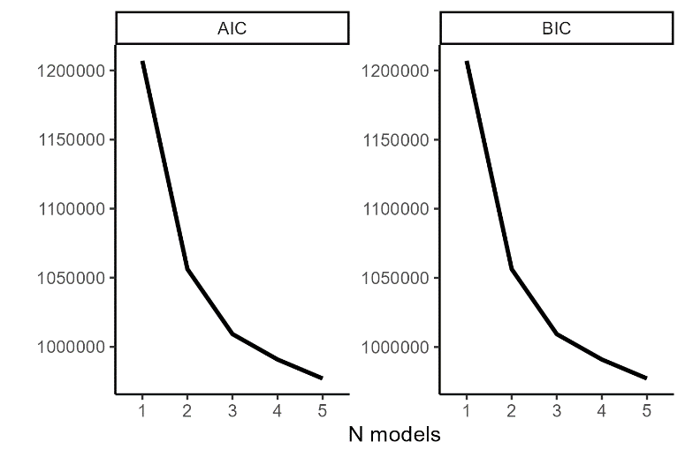
AIC and BIC scores for up to 5 Chiropractic classes
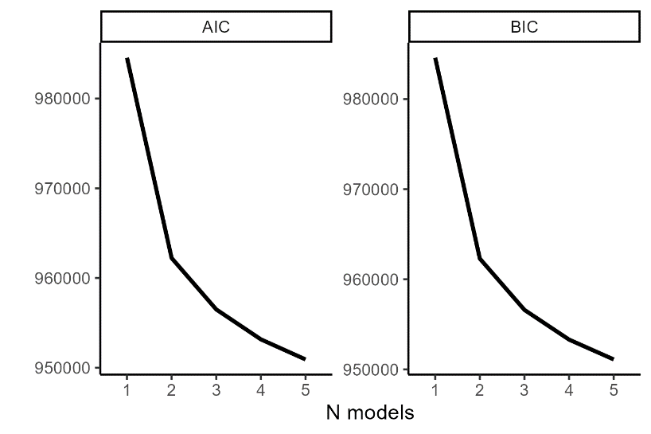
Numbers of individuals with low posterior probability for up to 5 Physiotherapy latent classes
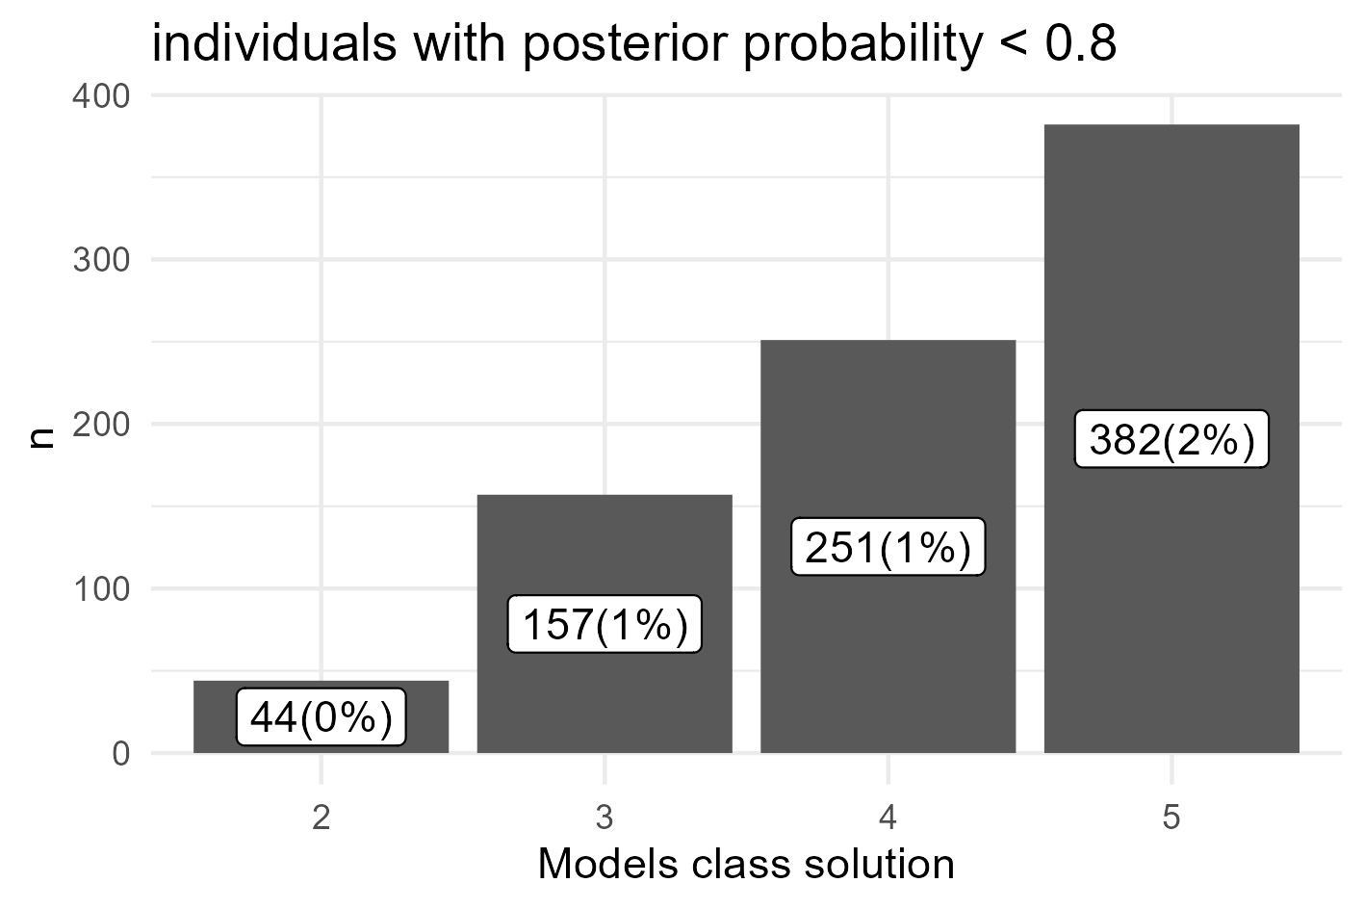
Numbers of individuals with low posterior probability for up to 5 Chiropractic latent classes 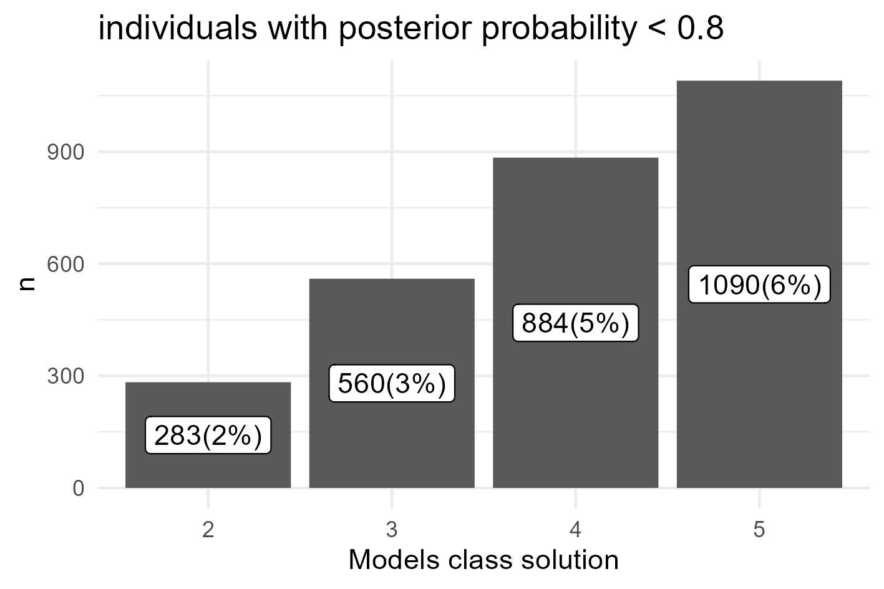
Mean trajectories plotted for up to five Physiotherapy latent classes
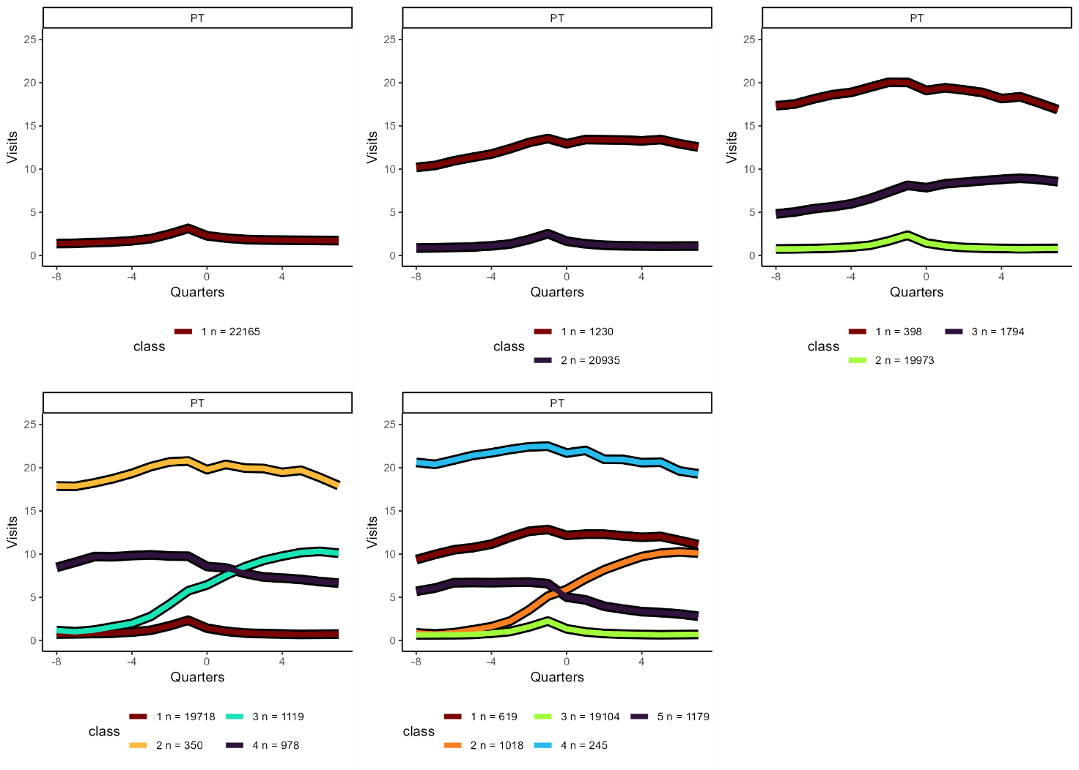
Mean trajectories plotted for up to five Chiropractic latent classes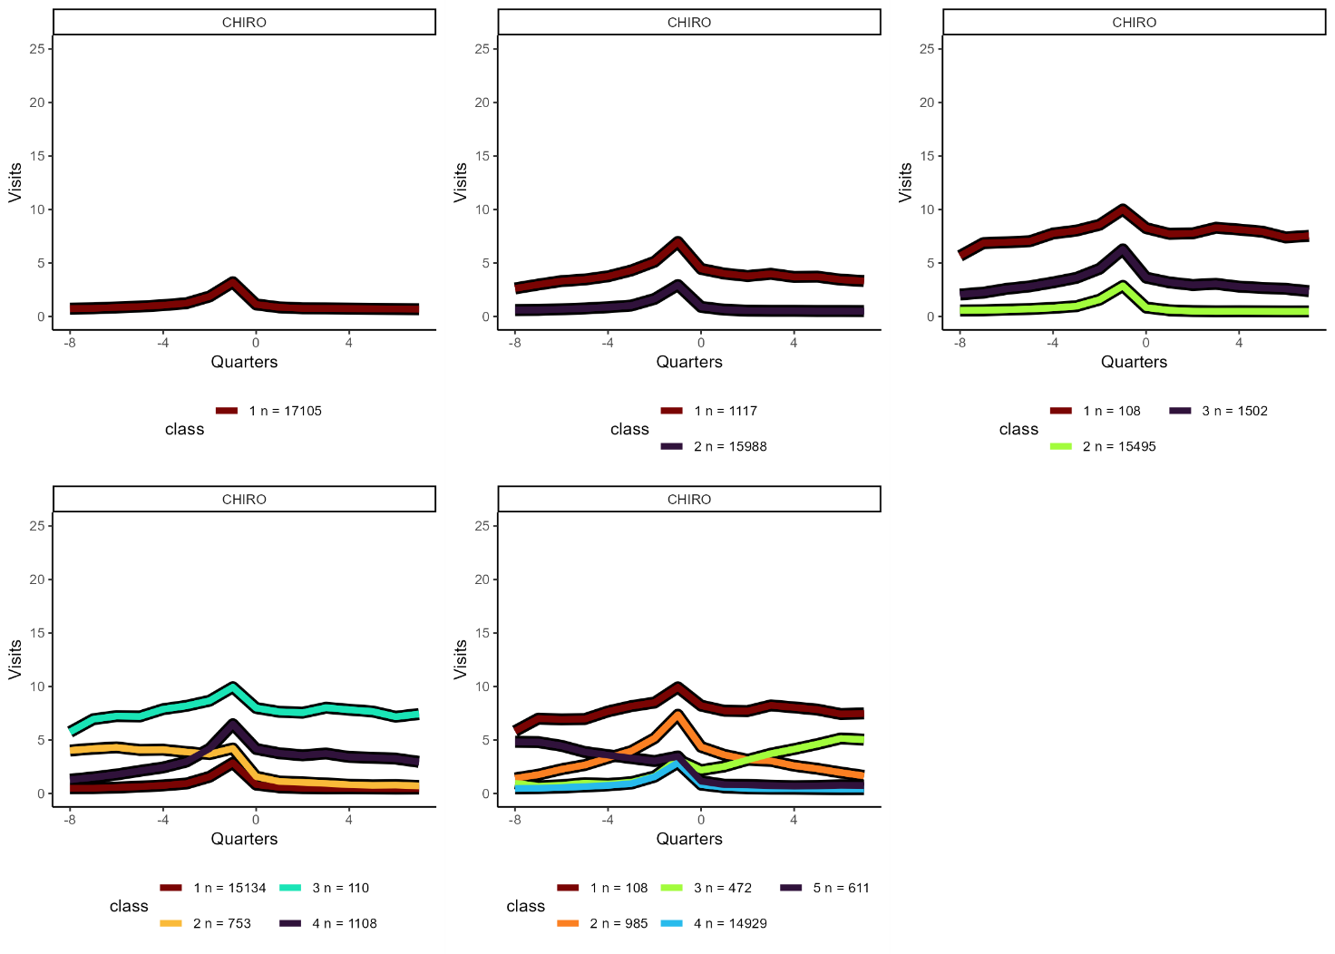

Predicted trajectories (splines) plotted for up to five Physiotherapy latent classes
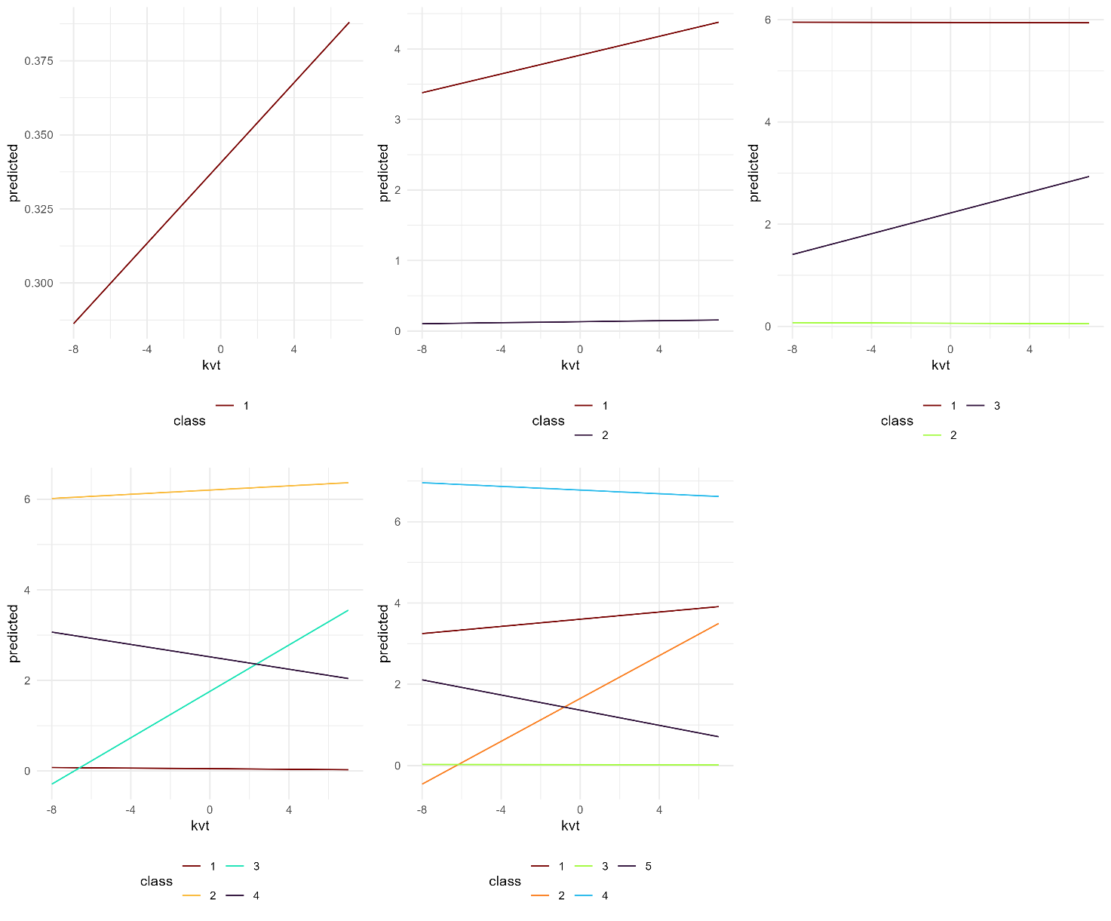

Predicted trajectories (splines) plotted for up to five Chiropractic latent classes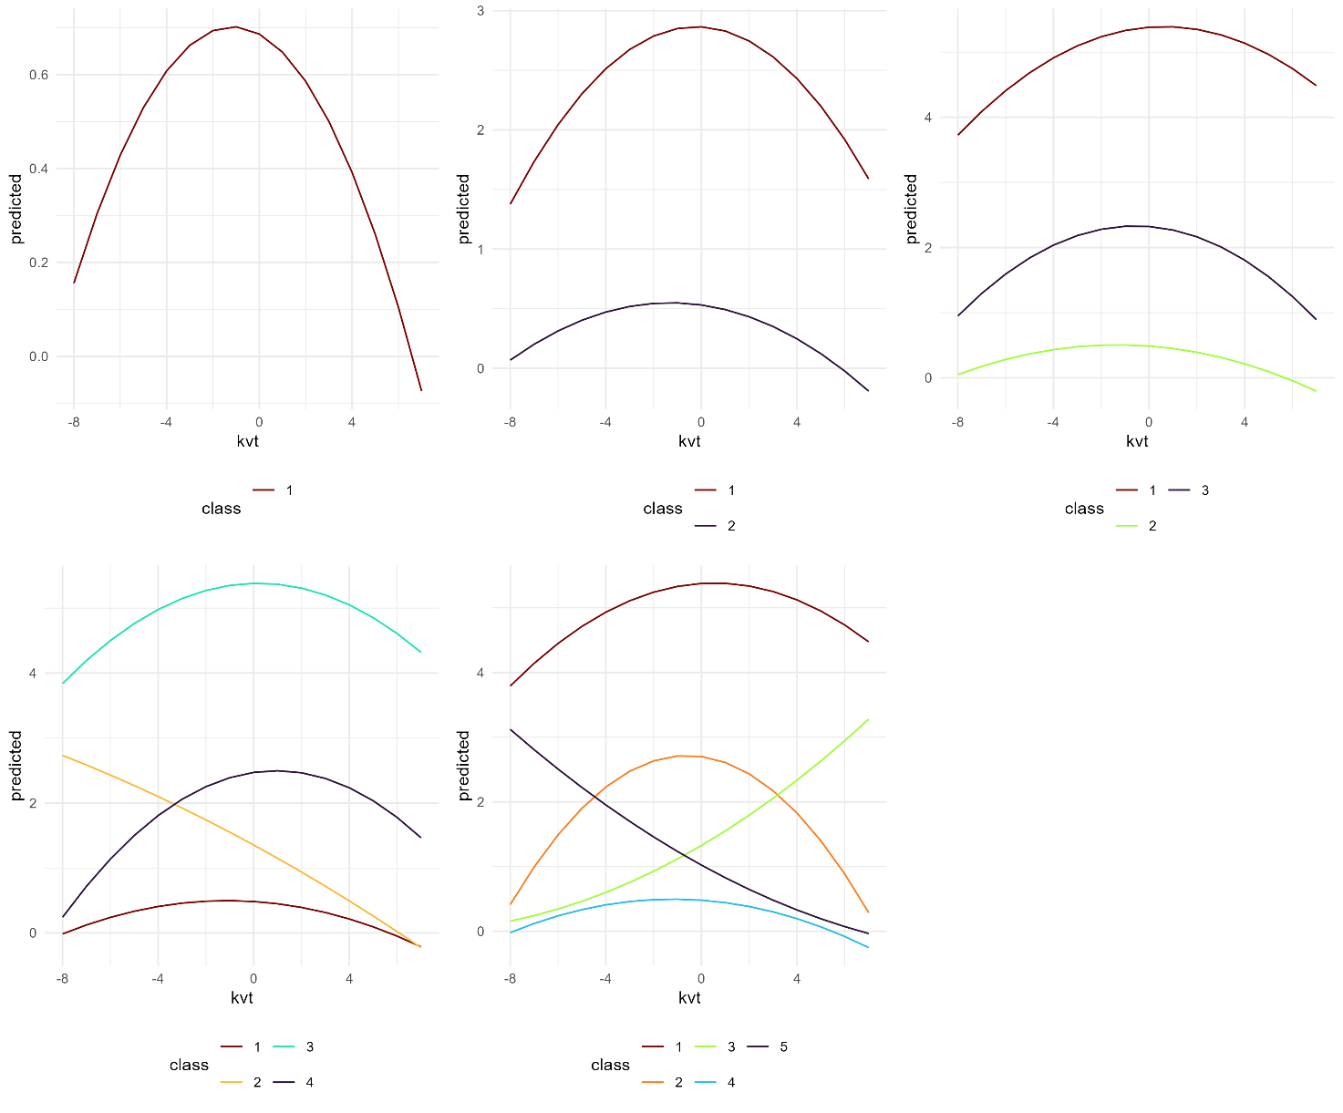

Appendix 2 - Labeling of latent classes and summary usage statistics
Mean and aggregated trajectories plotted for the “six” class Physiotherapy solution

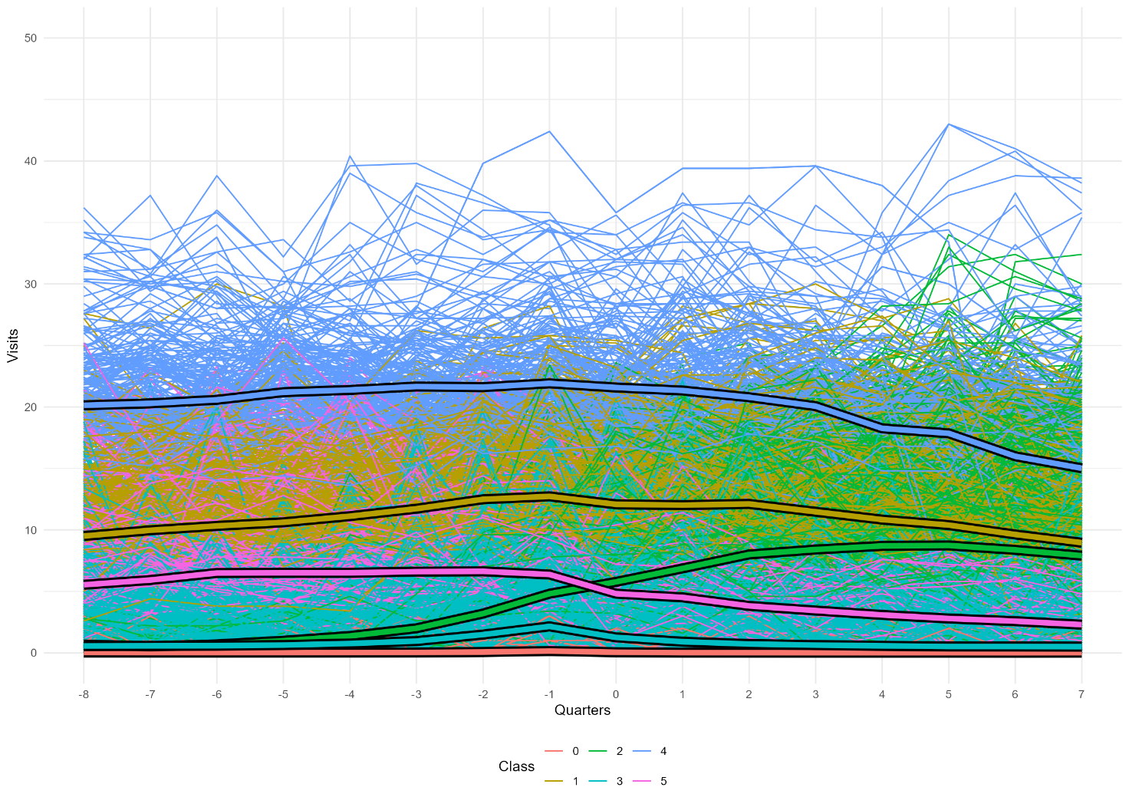
50 random aggregated trajectories plotted for the “six” class Physiotherapy solution

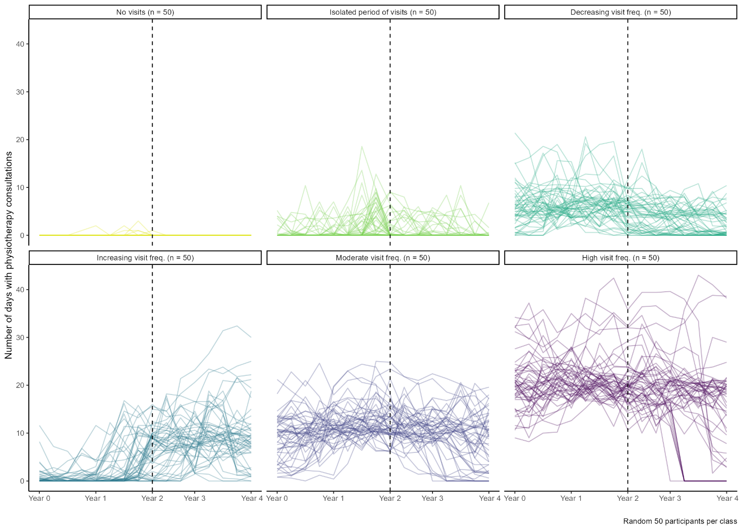

Mean and aggregated trajectories plotted for the “six” class Chiropractic solution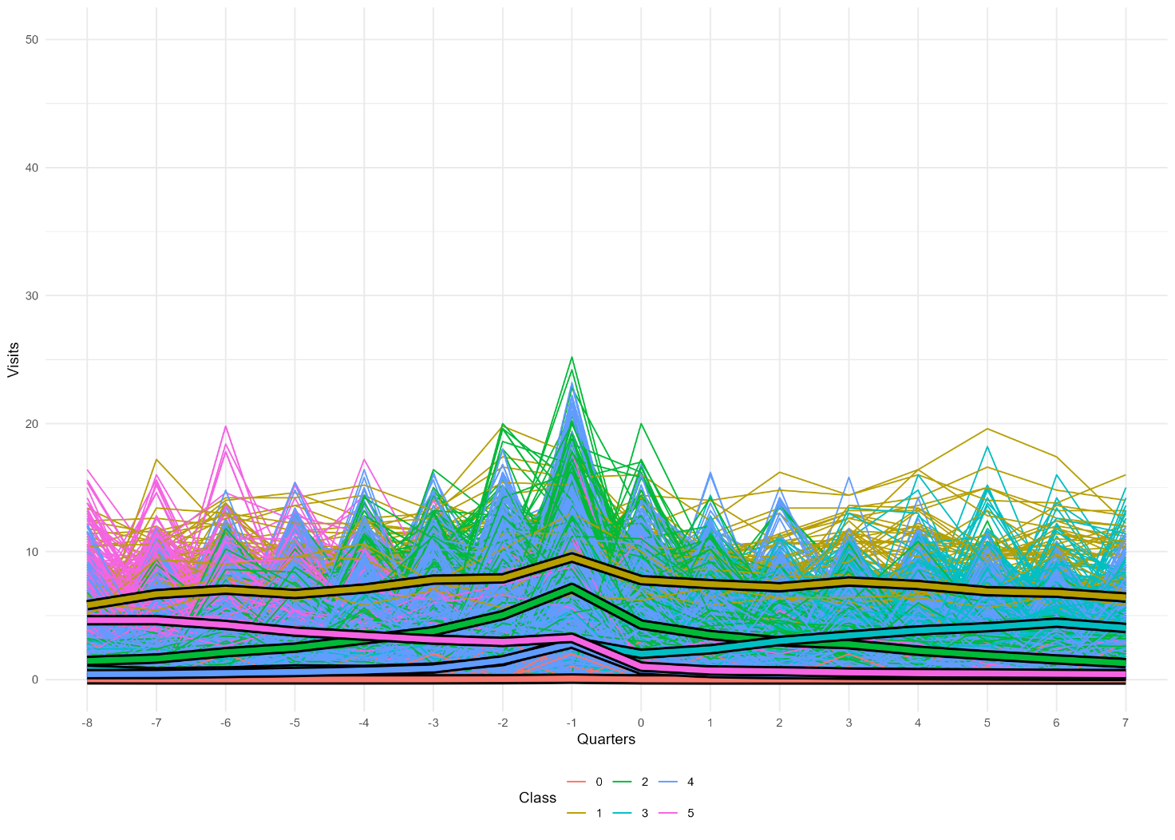
50 random aggregated trajectories plotted for the “six” class Chiropractic solution
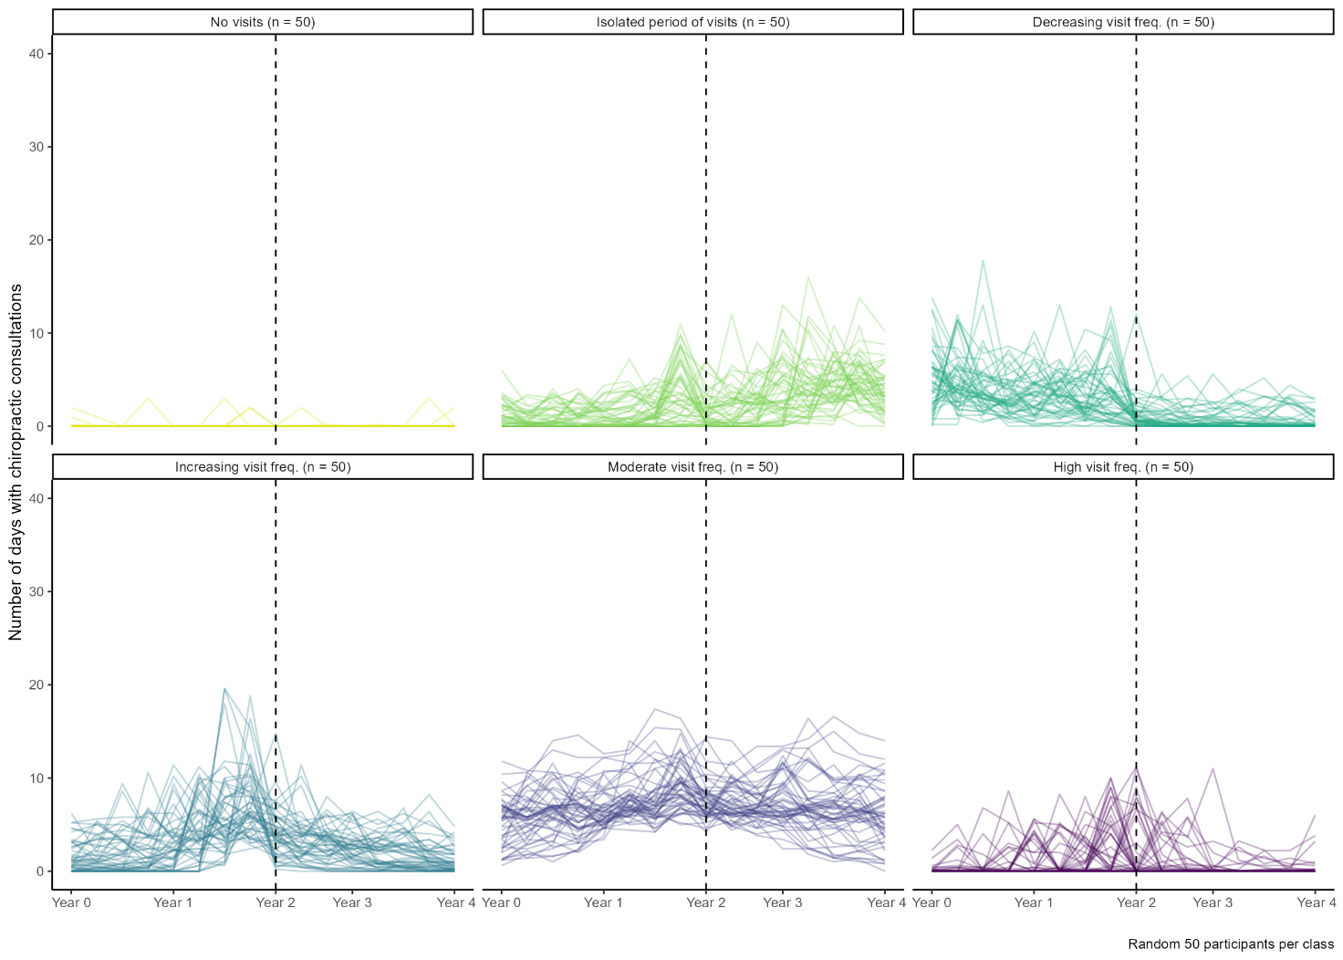

Appendix 3 - Multivariable multinomial regression results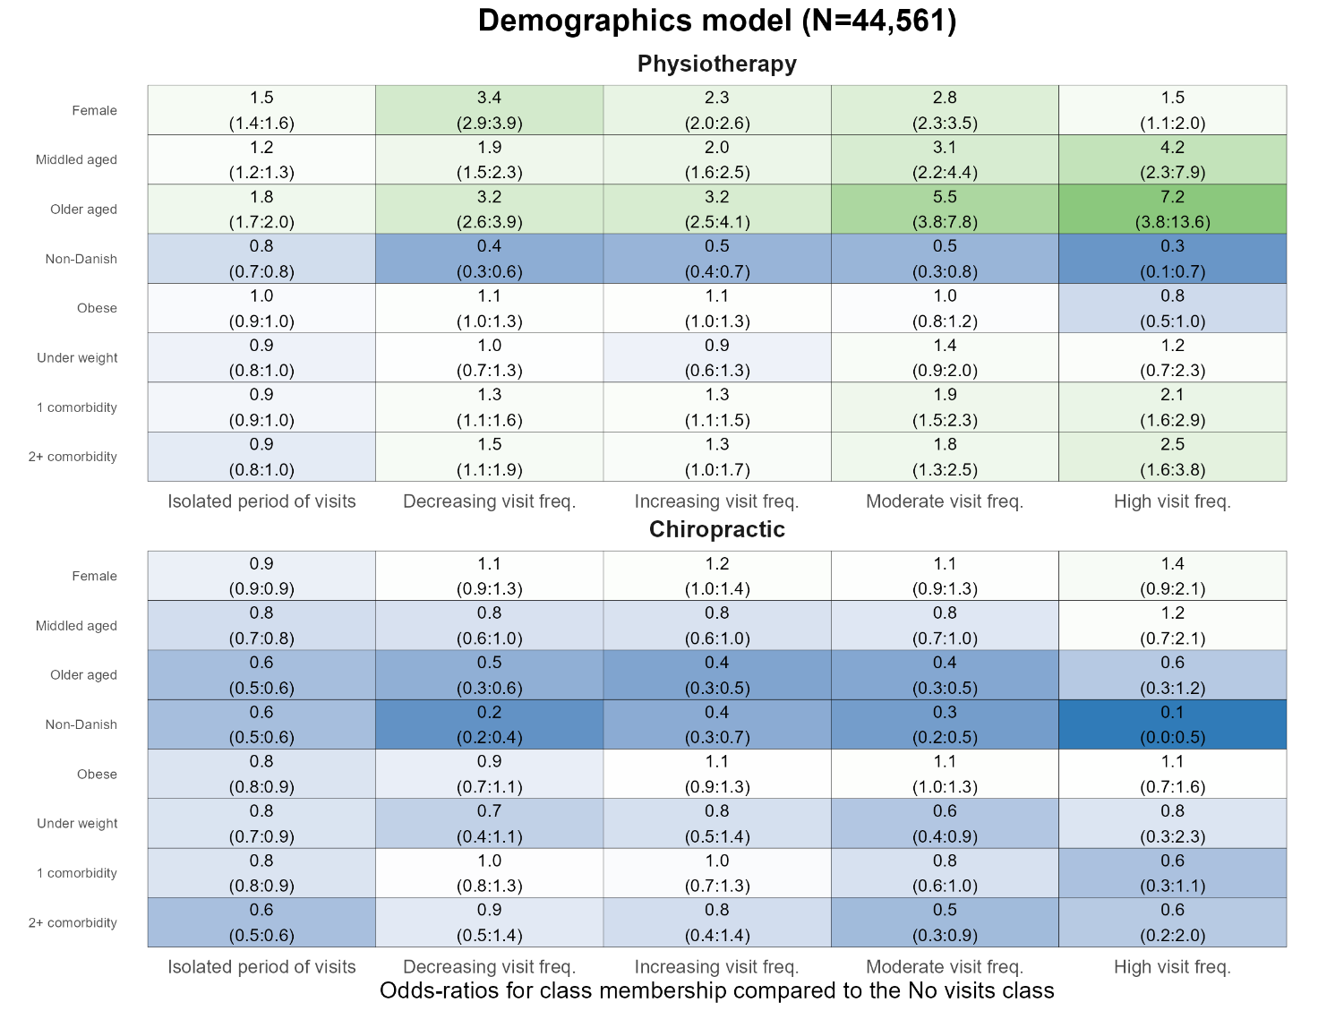
Reference class is “no visits”. Independent reference groups: female to male, middle aged and older aged to young adults, non-Danish to Danish origin, obese and underweight to normal weight, 1 and 2+ comorbidity to no comorbidities

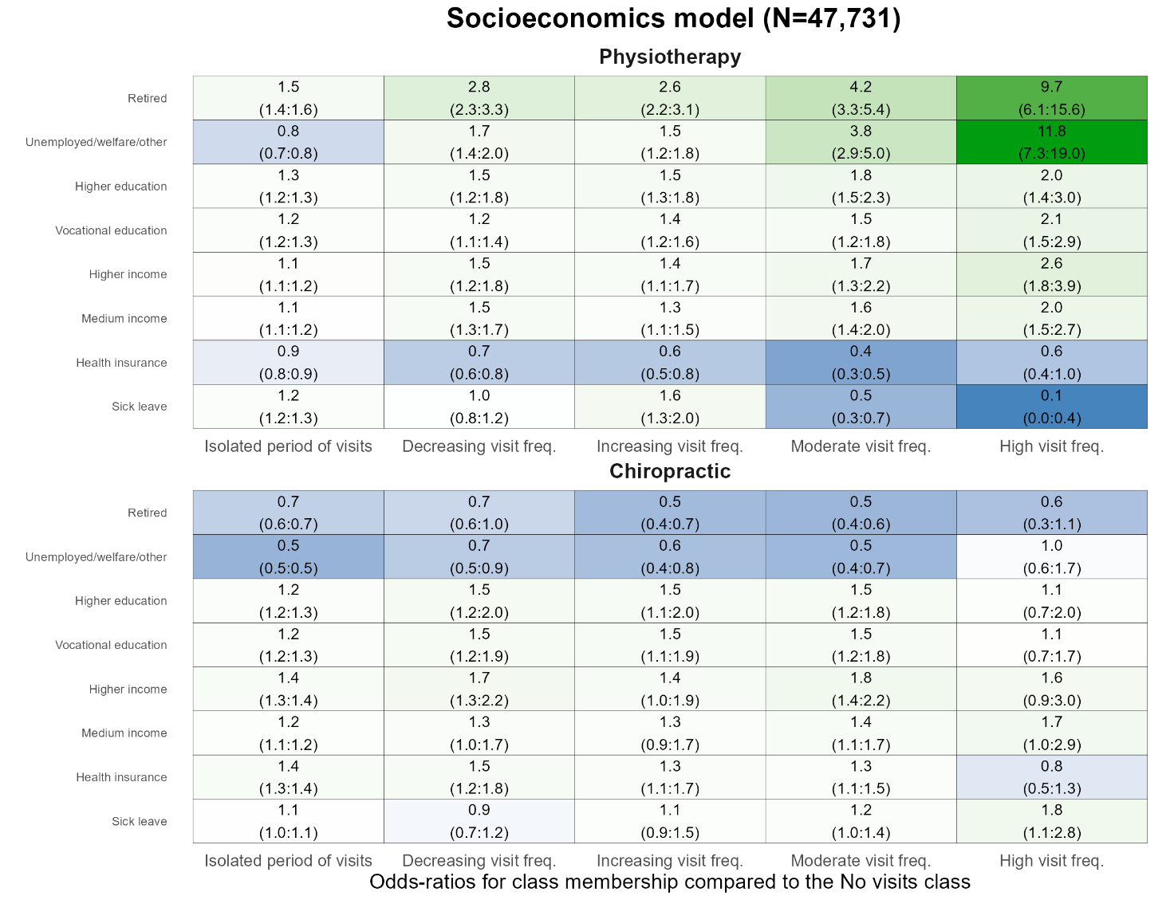
Reference class is No visits. Independent reference groups: retired and unemployed/welfare/other to working, higher and vocational education to primary education, higher and medium income to lower income, health insurance yes to no, sick leave yes to no

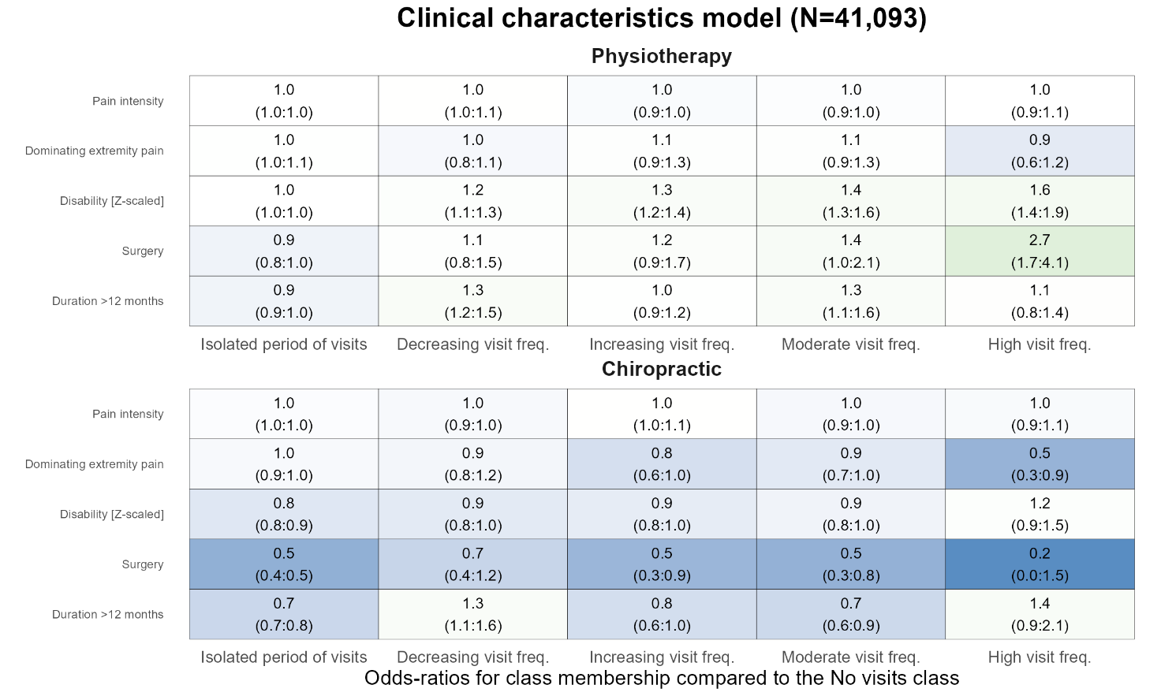
Reference class is No visits. Independent reference groups: pain intensity (0-10 scale), disability (z-scaled), surgery yes to no, duration > 12 months to duration ≤ 12 months.

Appendix 4 - Univariable multinomial regression results
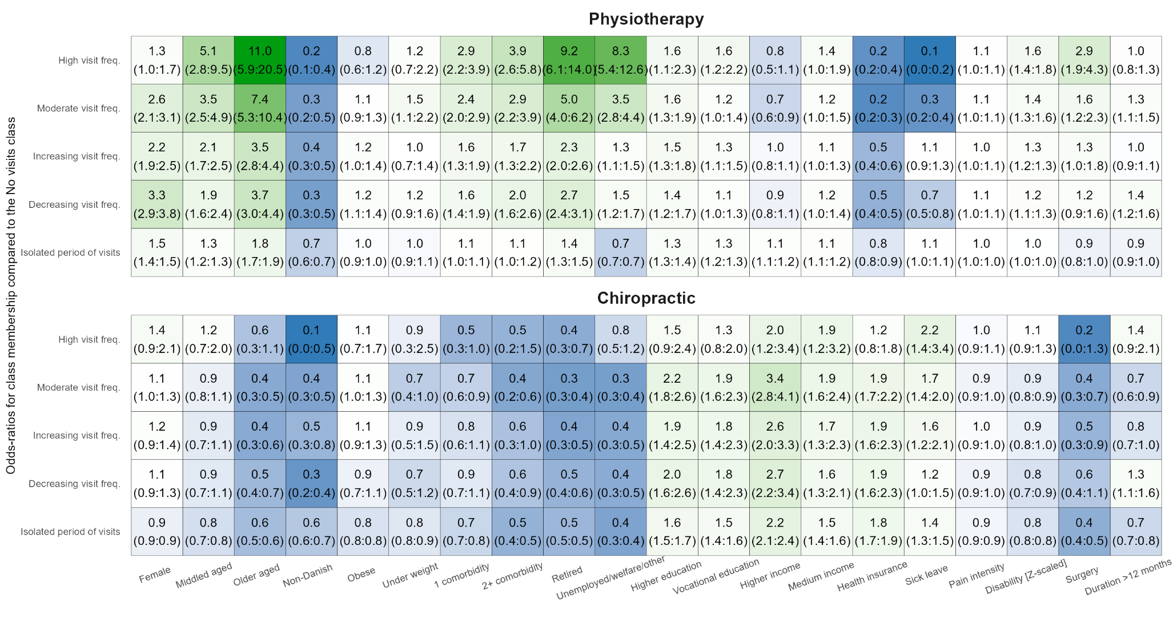
Reference class is No visits. Independent reference groups: female to male, middle aged and older aged to young adults, non-Danish to Danish origin, obese and underweight to normal weight, 1 and 2+ comorbidity to no comorbidities, retired and unemployed/welfare/other to working, higher and vocational education to primary education, higher and medium income to lower income, health insurance yes to no, sick leave yes to no, pain intensity (0-10 scale), disability (z-scaled), surgery yes to no, duration > 12 months to duration ≤ 12 months.

