Is more Muscle Mass linked to less Hypertension? Exploring Sex-Specific Effects and the role of Body Composition in Older European Adults

Table 2: Univariate Odds Ratios for Hypertension across Skeletal Muscle Mass Indices
 | Total |  | Women |  |  | Men
Variable | OR (95% CI) | p-value | OR (95% CI) | p-value |  | OR (95% CI) | p-value
TSMM (kg) | 1.0 (0.98- 1.02) | ns | 0.94 (0.89-1.0) | ns |  | 0.99 (0.95-1.03) | ns
RSMM (%) | 0.95 (0.93 -0.97) | <0.001 | 0.88 (0.84-0.93) | <0.001 |  | 0.92 (0.88-0.95) | <0.001
SMI (kg/m²) | 1.02 (0.95 – 1.10) | ns | 0.93 (0.78-1.1) | ns |  | 1.00 (0.88-1.14) | ns
OR (Odds Ratio); CI (Confidence Interval)
ns (non-significant)
TSMM (Total Skeletal Muscle Mass, kg)
RSMM (Relative Skeletal Muscle Mass, %)
SMI (Skeletal Muscle Index, kg/m²)

Table 3: Variation Inflation Factors (VIF) of Skeletal Muscle Mass Indices
 |  |  |  | Variation Inflation Factor (VIF)
Model | Index |  | Total | Women | Men
1. TSMM (Adjusted 1) | TSMM |  | 4.49 | 1.69 | 1.57
2. TSMM (Adjusted 2) | TSMM |  | 5.86 | 2.53 | 2.13
3. RSMM (Adjusted 1) | RSMM |  | 2.91 | 1.46 | 1.83
4. RSMM (Adjusted 2) | RSMM |  | 4.95 | 2.59 | 2.97
5. SMI (Adjusted 1) | SMI |  | 3.25 | 1.62 | 1.60
6. SMI (Adjusted 2) | SMI |  | 5.12 | 2.89 | 2.51
7. TSMM (Adjusted 3) | TSMM |  | 5.11 | 2.25 | 1.78
8. RSMM (Adjusted 3) | RSMM |  | 7.23 | 3.48 | 4.87
9. SMI (Adjusted 3) | SMI |  | 3.66 | 2.09 | 1.71
Supplementary models
S.1. LMI (Adjusted 1) | LMI |  | 2.35 | 1.38 | 1.18
S.2. LMI (Adjusted 3) | LMI |  | 3.62 | 2.88 | 1.61
S.3. TSMM (Adjusted 2, 3) | TSMM |  | 6.27 | 2.60 | 2.19
TSMM (Total Skeletal Muscle Mass, kg); RSMM (Relative Skeletal
Muscle Mass, %); SMI (Skeletal Muscle Index, kg/m²); LMI (Lean Mass Index, kg/m²)
Adjusted 1: Age, Exercise, Smoking Status, Diabetes, Study site and Sex
Adjusted 2: Adjusted 1 + Body Mass Index (kg/m²)
Adjusted 3: Adjusted 1 + Total Fat Mass (kg)

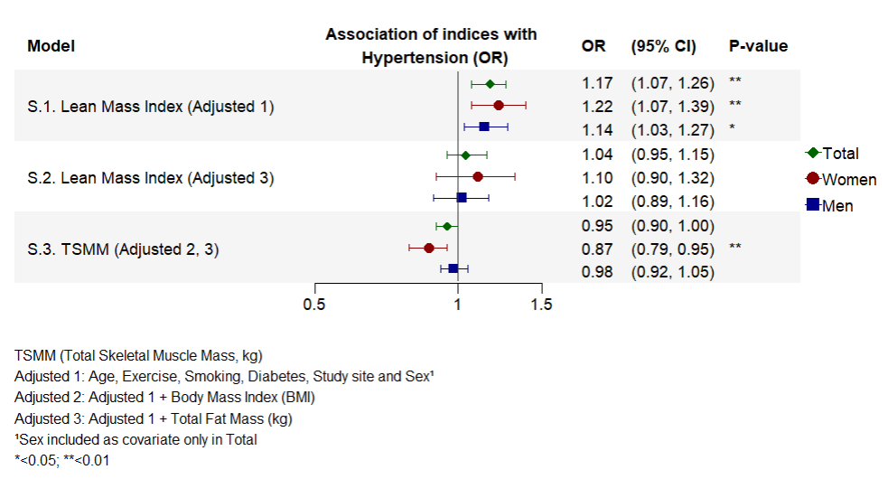

Figure 5: The association between Lean Mass Index (kg/m²) and hypertension while adjusting for age, exercise, smoking status, diabetes, study site and sex (base covariates) (model S.1) and base covariates and fat mass (TFM, kg) (model S.2.), as well as the association between Total Skeletal Muscle Mass (TSMM, kg) and hypertension while adjusting for base covariates and Body Mass Index and fat mass (TFM, kg) (Model S.3.). Estimates were produced from adjusted multivariable logistic regression models as indicated by the model description. Estimates were done for the total population (Total, green) and stratified by sex (Women, red; Men, blue).

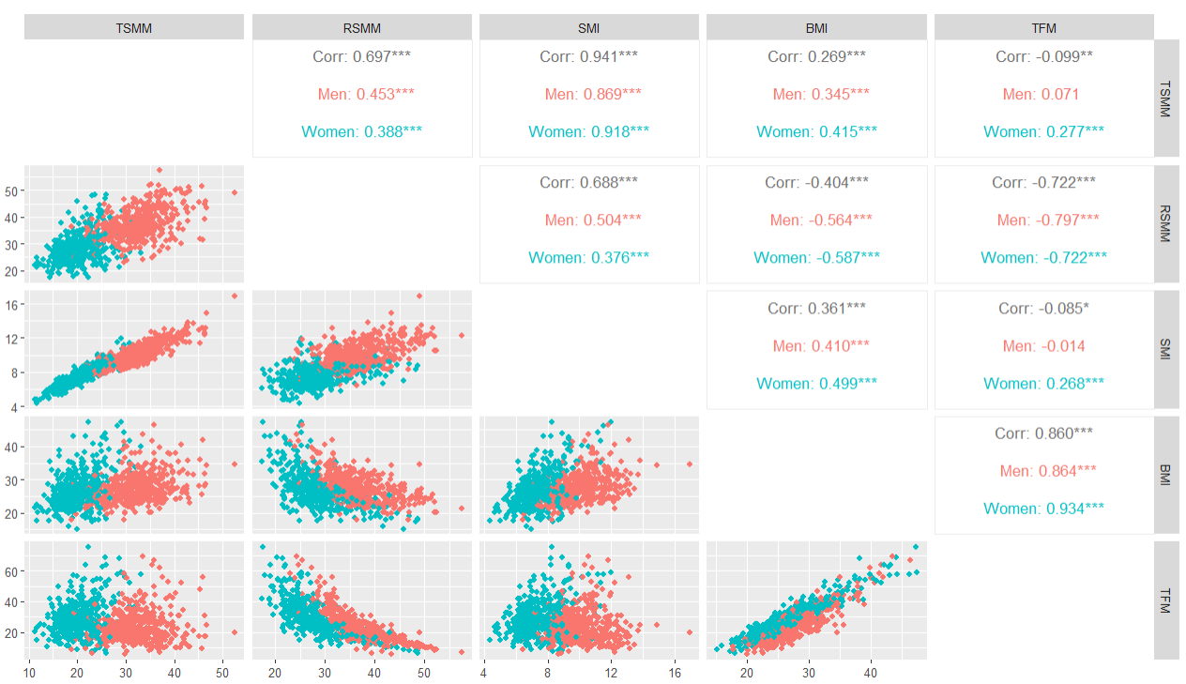

Figure 6: Correlation matrix of key study characteristics, including skeletal muscle indices Total Skeletal Muscle Mass (TSMM, kg), Relative Skeletal Muscle Mass (RSMM, %) and Skeletal Muscle Index (SMI, kg/m²), as well as body composition measures comprising Body Mass Index (BMI, kg/m²) and Total Fat Mass (TFM, kg). The upper-right triangle displays Pearson correlation coefficients together with p-values calculated for the total population (grey) and separately for men (red) and women (green). Asterisks indicate the significance level of the p-values (*<0.05, **<0.01, ***<0.001). Non-significant correlation coefficients are left blank. The lower-left triangle displays scatter plots of characteristics as indicated by column and row.

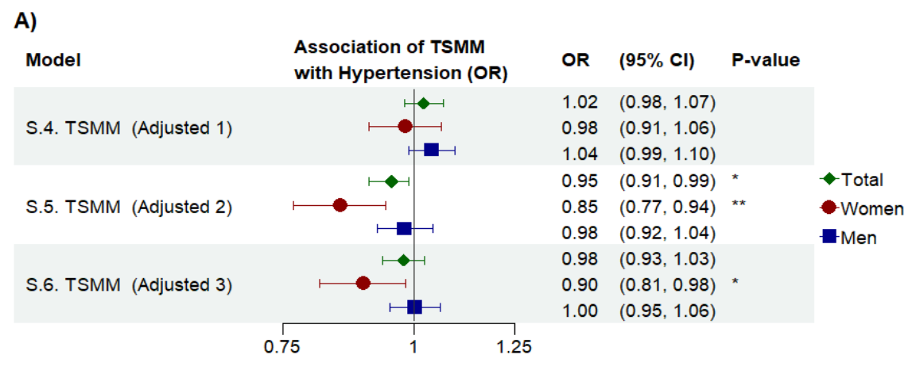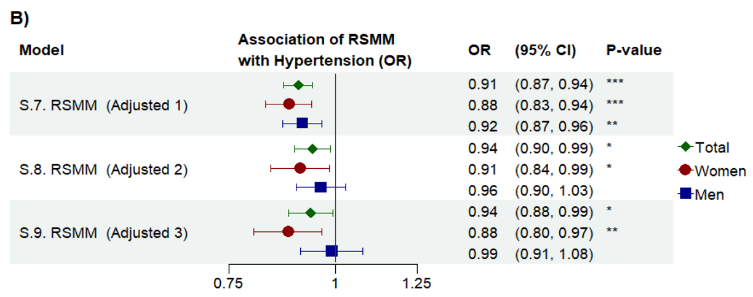
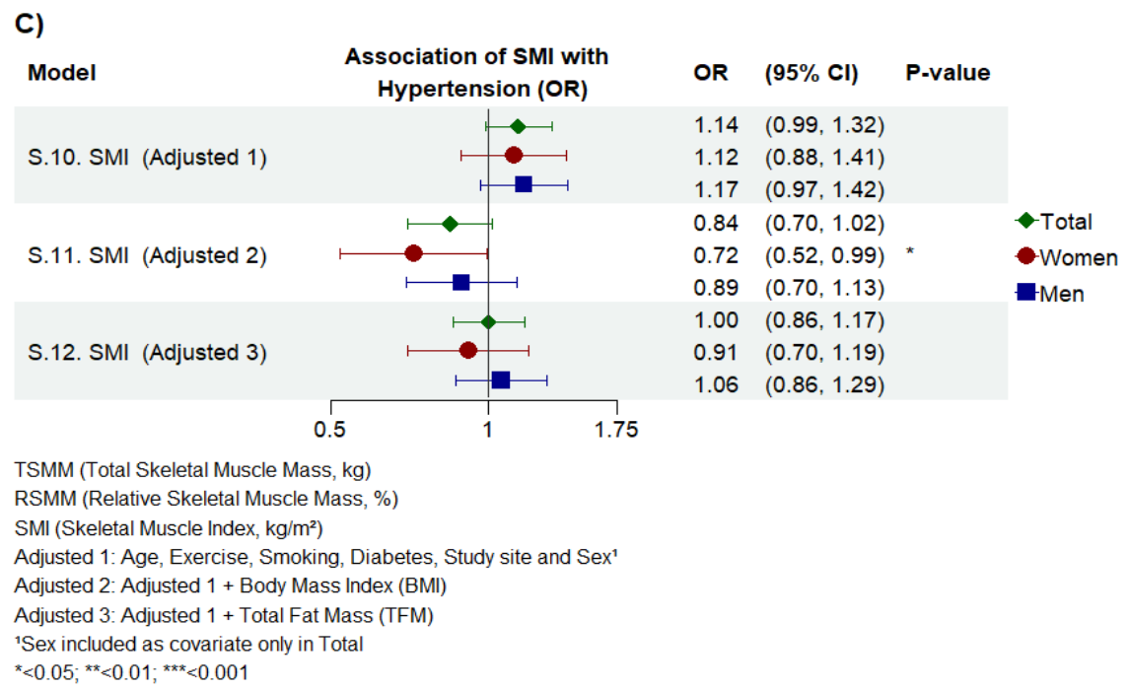

Figure 7: Results of logistic regression models excluding Barcelona (N=84). The association between Total Skeletal Muscle Mass (TSMM, kg) (A), Relative Skeletal Muscle Mass (RSMM, %) (B) and Skeletal Muscle Index (SMI, kg/m²) (C) and odds of hypertension in middle-aged and older men and women from Aarhus (Denmark), Norway (Bergen), Sweden (Uppsala) and Iceland (Reykjavik). The figure presents odds ratios (OR) and corresponding 95% Confidence Intervals (CI) for TSMM, RSMM and SMI estimated from multivariable logistic regression models. Models adjust for age, exercise, smoking, diabetes, study site and sex¹ alone, or along with Body Mass Index (BMI) or fat mass (TFM) as indicated by the model description. Both total population (Total, green) and sex-stratified models (Women, red; Men, blue) were fitted.

