Explicit explanation of the search strategy

The present study is a scoping review aiming to systematically identify the health-related, nursing, and medical needs of homeless and inadequately housed people. The conduct and reporting of the review followed the PRISMA-ScR guidelines. The underlying research question of the scoping review was:

What health-related, nursing, and medical needs exist among homeless and inadequately housed people?

Predefined inclusion and exclusion criteria were established for the selection of relevant studies.
Studies were included if they:
- addressed homelessness or housing insecurity,
- focused on health-related issues,
- were conducted in the context of homelessness or housing insecurity,
- were published in German or English,
- were published between 2015 and 2025.
Studies were excluded if they:
- examined a different population (homeless and inadequately housed migrants) or an irrelevant context,
- showed no substantive relevance to the research question,
- did not provide full-text access,
- were commentaries, editorials, or opinion pieces.
The systematic literature search was conducted in the electronic databases PubMed and SpringerLink. In addition, a search was performed using Google Scholar. The search covered the period from 1 February 2025 to 30 March 2025. The final search query was conducted on 29 March 2025. The search strategy for PubMed is presented in Figure 1.
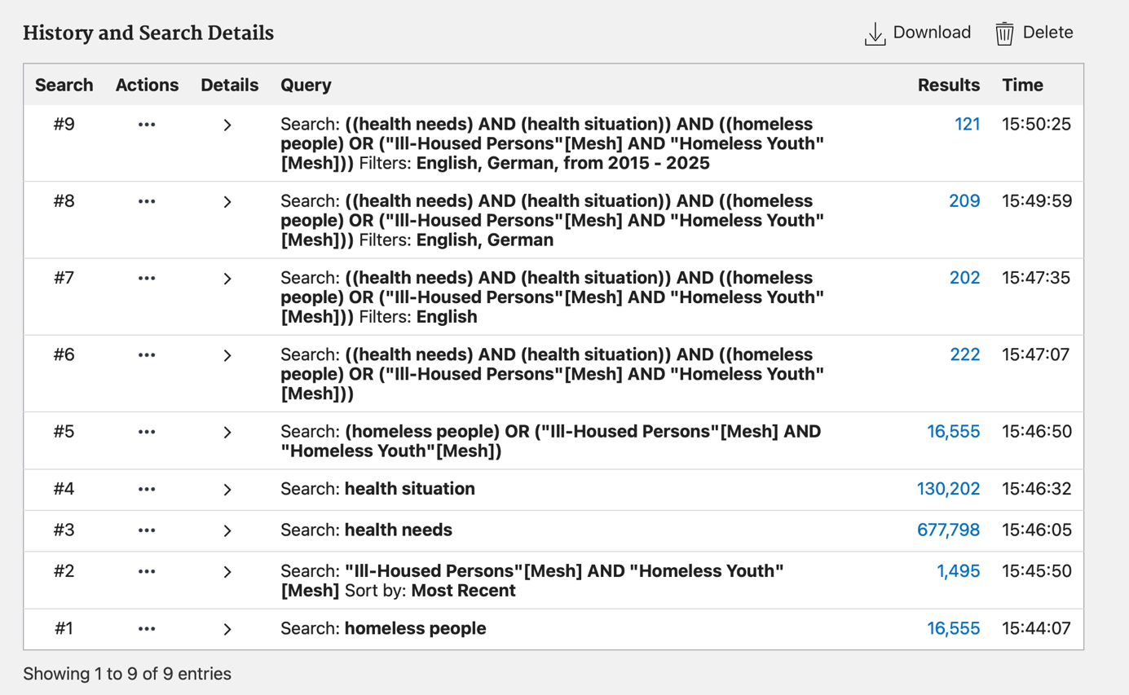
The study selection process was carried out in two stages. First, titles and abstracts of all identified records were screened based on the inclusion and exclusion criteria. In the second stage, the full texts of potentially relevant studies were assessed. Citavi was used for literature management. The study selection process is illustrated using a PRISMA flow diagram, which presents the number of identified, excluded, and included studies as well as the reasons for exclusion at the full-text level. Data extraction was performed using a specifically developed data extraction form (see Table 1). A formal quality appraisal of the included studies was not conducted, as scoping reviews primarily aim to map the existing evidence.

