Dietary patterns and subsequent risk of Colorectal Cancer (CRC) / Colorectal Adenoma among Japanese adults aged 60 and older.

Supplementary Figures
Supplementary Figure 1. Schematic flowchart of the study population for CRC events
Supplementary Figure 2. Schematic flowchart of the study population for Colorectal adenoma events.

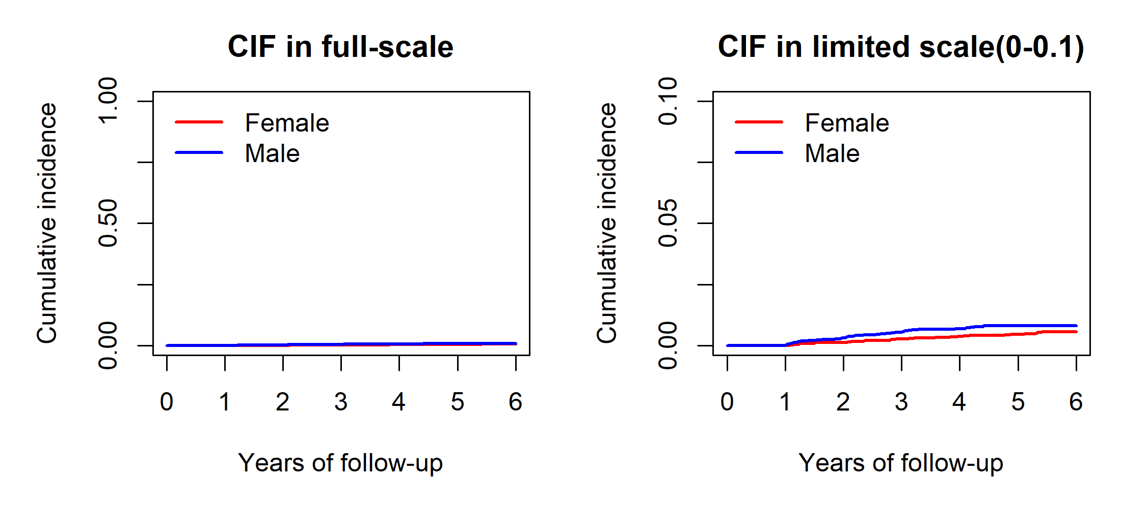

Supplementary Figure 3. Cumulative Incidence Function (CIF) for CRC study population by gender
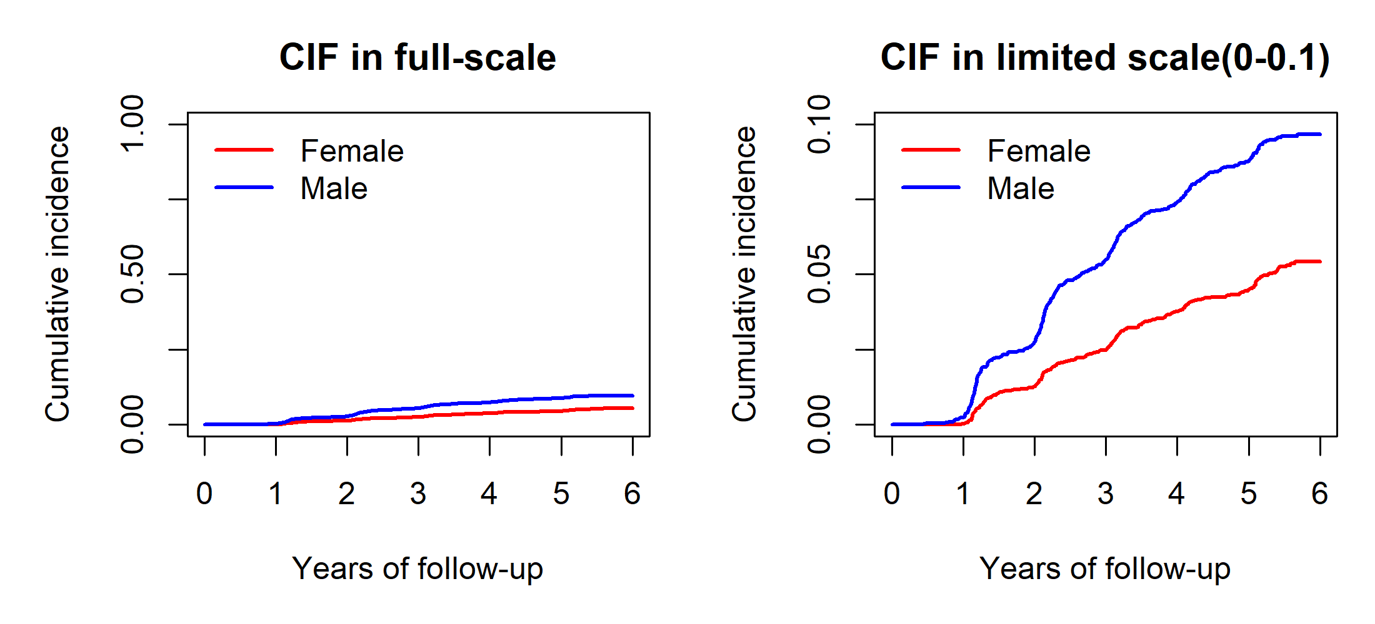
Supplementary Figure 4. CIF for Colorectal Adenoma study population by gender

