Dean flow focusing and separation of small microspheres within a narrow size range.

I.D. Johnston¹, M. B. M^{c}Donnell², C.K.L. Tan¹, D.K. M^{c}Cluskey¹, M.J. Davies³ and M.C. Tracey¹.

(1) School of Engineering and Technology, University of Hertfordshire, College Lane, Hatfield, Hertfordshire, AL10 9AB, UK
(2) Dstl, Porton Down, Salisbury, Wiltshire, SP4 0JQ, UK
(3) Department. of Biochemical Engineering, University College London, Gower St, London, WC1E 6BT, UK

In order to utilise flow cytometry for quantification of flow separation at the individual device outputs it was first necessary to determine suitable gating regions from which the particle count information could be accurately attained. To this end monodisperse microsphere solutions containing concentrations of either 1.9 x 10⁶ ml⁻¹, 2.1 x 10⁵ ml⁻¹ and 6.4 x 10⁴ ml⁻¹ of 1.0 µm, 2.1 µm and 3.2 µm diameter microspheres respectively were analysed in the flow cytometer. Figures 1 - 3 show the selected gated regions on data plots of side scatter as a function of forward scatter for the monodisperse solutions.
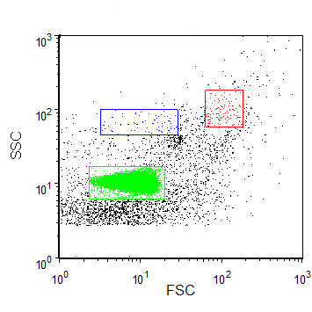
Figure 1. scatter plot of flow cytometry data obtained from a sample of 0.1 micron filtered de-ionised water containing 1.0 µm diameter microspheres showing the location of the 1.0 µm gate region employed in green.

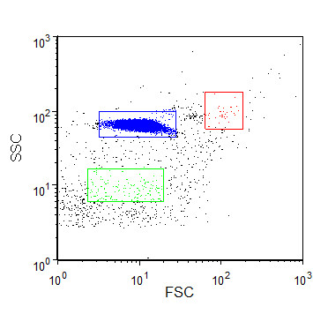
Figure 2. scatter plot of flow cytometry data obtained from a sample of 0.1 micron filtered de-ionised water containing 2.1 µm diameter microspheres showing the location of the 2.1 µm gate region employed in blue.

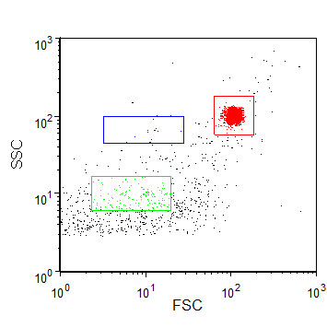
Figure 3. scatter plot of flow cytometry data obtained from a sample of 0.1 micron filtered de-ionised water containing 3.2 µm diameter microspheres showing the location of the 3.2 µm gate region employed in red.

In order to ensure accurate particle count information for collected samples it was necessary to perform a background particle count using pure sample of 0.1 micron filtered de-ionised water. Figure 4 shows the plot of side scatter as a function of forward scatter for the pure sample of 0.1 micron filtered de-ionised water. The count data showed that the worst case background counts obtained were below 1% of subsequently measured microsphere counts for the 1µm microsphere gated region, the larger microsphere gated regions displayed even lower counts.
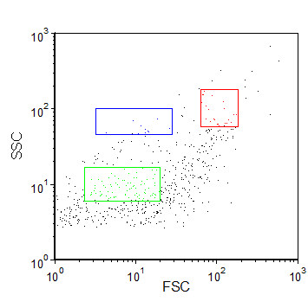
Figure 4. scatter plot of flow cytometry data obtained from a sample of 0.1 micron filtered de-ionised water.

