Electronic supplementary material
Rotatable microfluidic device for simultaneous study of bilateral chemosensory neurons in Caenorhabditis elegans

Jinyang Chung†ª, Christopher A. Brittin†^{b}, Stephen D. Evans ª, Netta Cohen*^{b}, and Jung-uk Shim*ª
a. School of Physics and Astronomy, University of Leeds, Leeds, UK
b. School of Computing, University of Leeds, Leeds, UK
† These authors contributed equally.

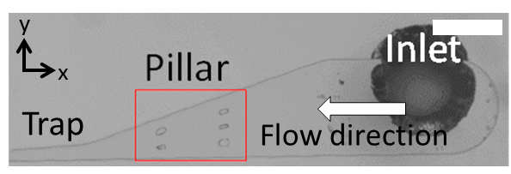
Fig. S1. The wide entrance region of the worm trap. The pillar structure forces a worm to enter the trap with their head first. The wide and shallow channel located at the entrance of the trap lets a worm crawl on a x-y plane, which aligns the dorso-ventral plane of a worm parallel to x-y plane by itself. The width between pillars are 50 μm. Scale bar indicates 500 µm.

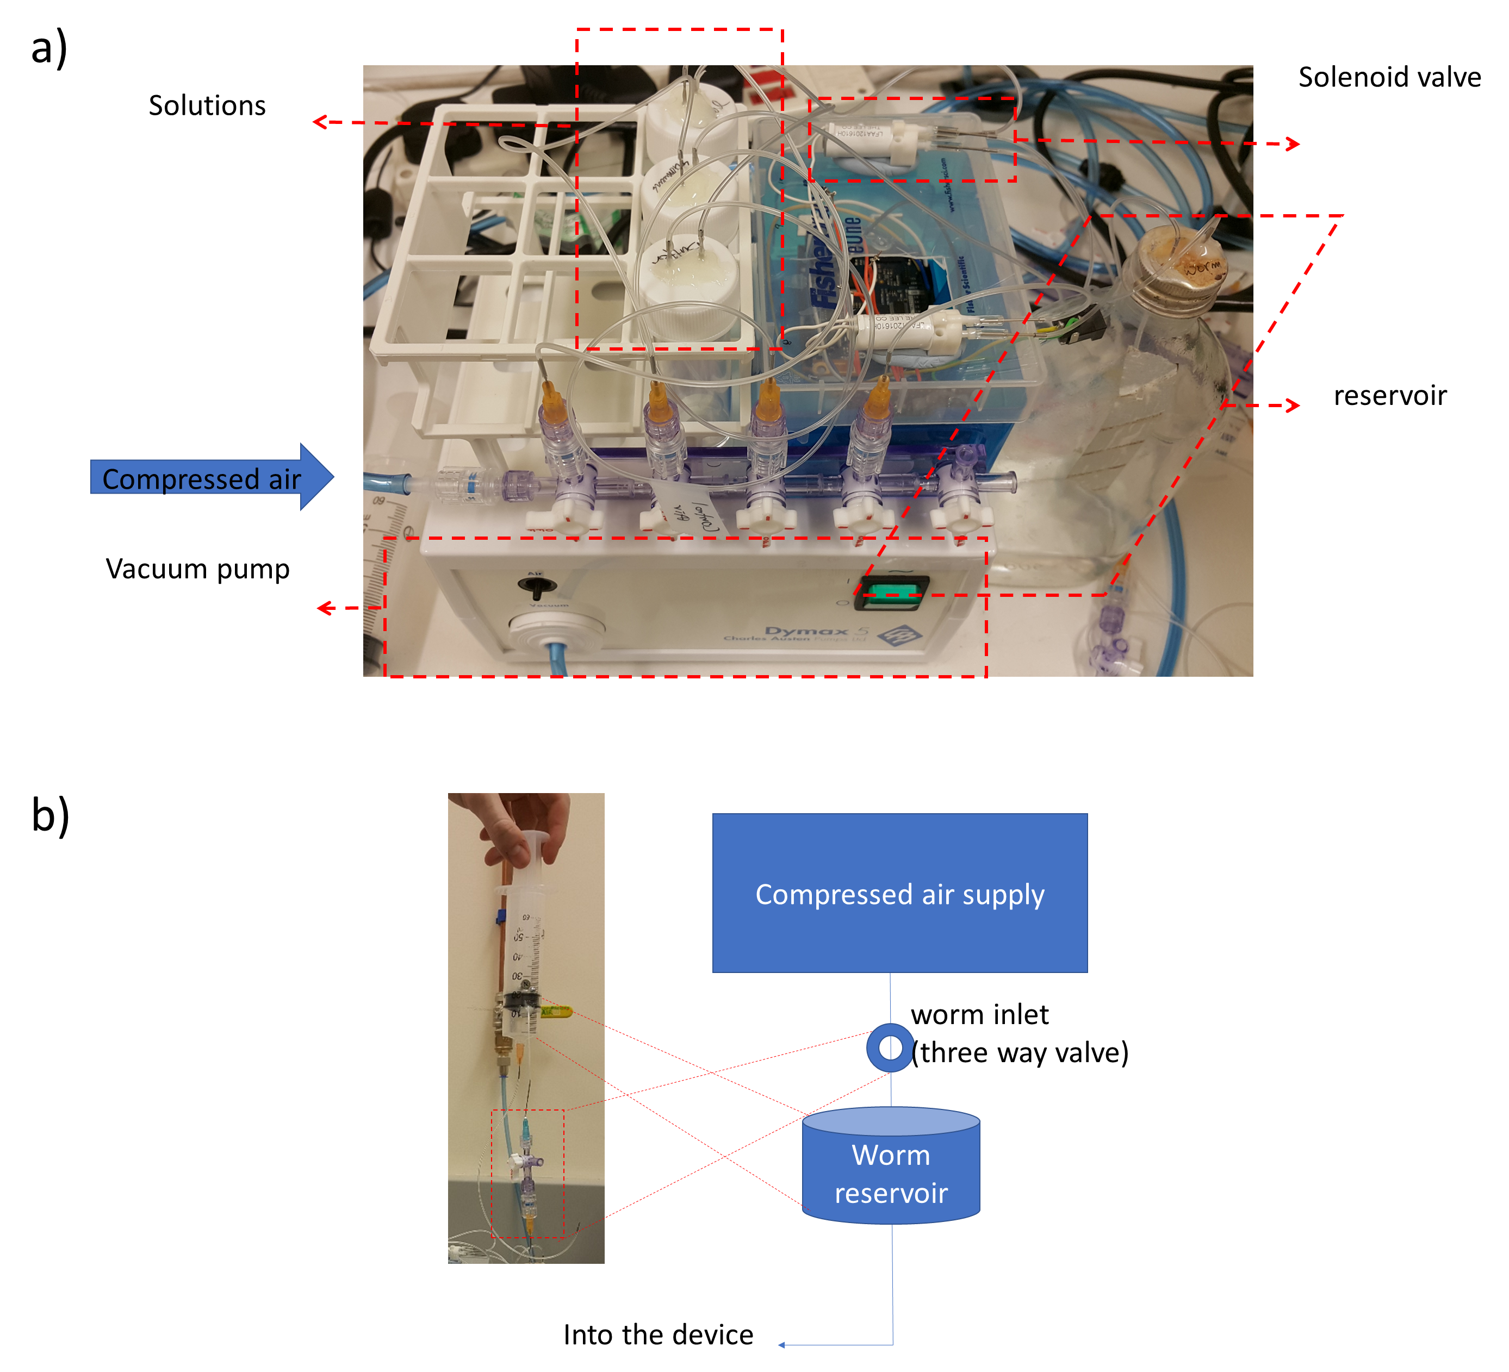
Fig. S2. The experimental setup for manipulating pressures and delivering worms. a) Pressure supply system. b) Semi-automatic worm delivery module.

Determination of the twisted angle
We choose the rotation angle (10˚) as an acceptable condition because the right and left cells of a neuron are located within the depth of field of our microscope system. The microscope equips with a 40X magnification objective and numerical aperture of 0.6. In this system, and the depth of field is approximately 2 µm. It was calculated with the following equation.
$$d= \frac{λ\sqrt{n^{2}-{(na)}^{2}}}{{(na)}^{2}}$$
where d the depth of field, 𝛌 the wavelength (540 nm), n the refractive index of PDMS (1.43) and na the numerical aperture of the objective (0.6). The rotation angle (θ) is calculated by
$$θ=\sin^{-1}{({(d+2 ×0.5c)}/{l)}}$$
The distance between the left and right cells (l) is 25 ± 1.0 µm, which was measured from thirteen worms. The cell body diameter (c) of the neuron is known as 2 µm.
We measured the twist angle of worms for each assay, and we took measurements if the angle is less than 10 degree. Although we didn’t measure the angle after completion of the measurements, we haven’t observed any sudden twist-movement of worms during the measurements (for 1-2 minutes) and thus any significant changes in the fluorescence intensities.

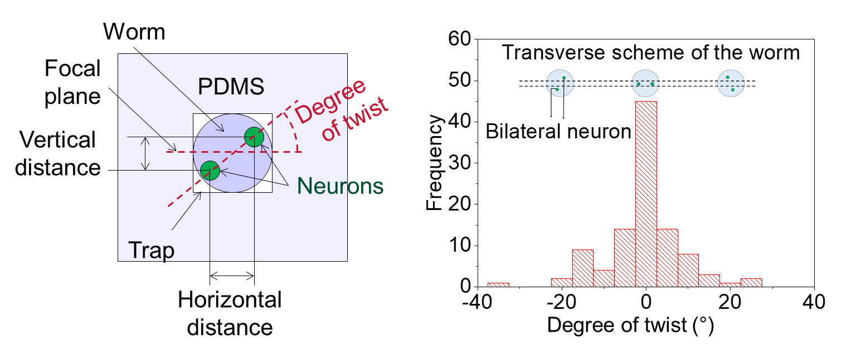
Fig. S3. Distribution of the twisted angle of immobilised worms. The focus knob of a microscope is used to measure the height (vertical distance) between the pair of bilateral neurons. To calibrate the height measured with the focus knob, a suspension of beads (1 μm, polystyrene) is injected and dried in a microfluidic channel. We took the height difference of beads that was adsorbed on ceiling and bottom of the channel. The actual channel sizes are determined by measuring dimensions of photoresist patterns fabricated on a Si wafer with a profiler. We find the 76% of immobilised worms (80 / 105 worms) are twisted within 10 degrees from a focal plane. This method has minor level of errors due to the eye-observation.

Table S1. Peak intensities of responsive ASH neurons. The peak intensity increased as the concentration of NaCl increased. There was no difference between left and right neurons.

Stimulus | ASHL | ASHR
500 mM | 4.2 ± 0.3 | 3.9 ± 0.3
300 mM | 3.3 ± 0.5 | 2.9 ± 0.4
200 mM | 2.5 ± 0.3 | 3.1 ± 0.4
100 mM* | 1.1 ± 0.0 | 1.0 ± 0.0
0 mM* | 1.1 ± 0.0 | 1.1 ± 0.0
*: The peak intensity in 0 mM and 100 mM was calculated with non-responsive neurons as there was no responsive neuron in 0 mM and 100 mM.

Table S2. The fraction of synchronous ASE pair and the probability of synchrony. The threshold of the responsive neuron was set as 1.35 of the G-CaMP intensity change. This value was determined after viewing all the calcium transient images. The maximum G-CaMP intensity change between 0 and 30 seconds at both upstep and downstep were used for determining the neuron being responsive.

Fraction of synchronous neuron pairs
Stimulus | Both  responsive | ASEL only  responsive | ASER only  responsive | neither  responsive | total |  | Fraction of synchronous neuron pair  (both or neither neurons respond)
 |  |  |  |  |  | =>
50 mM -> 100 mM -> 50 mM | 10 | 4 | 3 | 1 | 18 |  | 0.61

Probability of synchrony
Stimulus | ASEL (p_{L}) | ASER (p_{R}) |  | Probability of synchrony  (P=p_{L}p_{R} + (1-p_{L})(1-p_{R})) | STD/n
Stimulus | ASEL (p_{L}) | ASER (p_{R}) | => |  | STD/n
50 mM -> 100 mM -> 50 mM | 0.78 | 0.72 |  | 0.62 | 0.11

Table S3. The fraction of synchronous ASH pair and the probability of synchrony continuing on figure 2e and figure 4. The threshold of the responsive neuron was set as 1.35 of the G-CaMP intensity change (F/F₀). This value was determined after viewing all the calcium transient images. The neurons of which the maximum intensities between 2 and 4 second are higher than the threshold are regarded as responsive neurons. The fraction of the responsive neurons increased as the concentration of NaCl increased.

Fraction of synchronous neuron pairs
Stimulus | Both  responsive | ASHL only  responsive | ASHR only  responsive | neither  responsive | total |  | Fraction of synchronous neuron pair  (both or neither neurons respond)
500mM | 17 | 0 | 0 | 0 | 17 |  | 1.00
300mM | 7 | 0 | 2 | 3 | 12 | => | 0.83
200mM | 6 | 2 | 0 | 5 | 13 |  | 0.85
100mM | 0 | 0 | 0 | 8 | 8 |  | 1.00
0mM | 0 | 0 | 0 | 7 | 7 |  | 1.00

Probability of synchrony
Stimulus | ASHL (p_{L}) | ASHR (p_{R}) |  | Probability of synchrony  (P=p_{L}p_{R} + (1-p_{L})(1-p_{R})) | STD/n
500mM | 1.00 | 1.00 |  | 1.00 | 0.00
300mM | 0.58 | 0.75 | => | 0.54 | 0.14
200mM | 0.62 | 0.46 |  | 0.49 | 0.14
100mM | 0.00 | 0.00 |  | 1.00 | 0.00
0mM | 0.00 | 0.00 |  | 1.00 | 0.00

Fraction of responsive neuron pair and probability of both neuron response
Stimulus | Fraction of responsive neuron pair | Probability of both neuron response (pLpR) | STD/n
500mM | 1.00 | 1.00 | 0.00
300mM | 0.58 | 0.44 | 0.14
200mM | 0.46 | 0.29 | 0.14
100mM | 0.00 | 0.00 | 0.00
0mM | 0.00 | 0.00 | 0.00

Fraction of non-responsive neuron pair and probability of neither neuron response
Stimulus | Fraction of non-responsive neuron pair | Probability of neither neuron response (P=(1-p_{l})(1-p_{R})) | STD/n
500mM | 0.00 | 0.00 | 0.00
300mM | 0.25 | 0.11 | 0.13
200mM | 0.38 | 0.21 | 0.13
100mM | 1.00 | 1.00 | 0.00
0mM | 1.00 | 1.00 | 0.00

Video S1 (VideoS1_Flowredirection.avi). The redirection of the stimulus flow. Buffer containing fluorescein is used to indicate the stimulus flow. The direction of the flow is repeatedly switched with the interval of 1 second. The fluorescein solution flows toward or against the amphid of the immobilised worm.

Video S2 (VideoS2_ASE.avi). The response of ASE left and right. The worm is in chemotaxis buffer containing 50 mM NaCl. After the immobilisation and incubation for 5 minutes, the amphid of the worm is exposed to the higher concentration of NaCl (100 mM) for 60 seconds and is followed by the base concentration for another 60 seconds. The ASEL responds to the increased concentration and ASER to the decreased concentration. The movie is recorded with the speed of 6X.

Video S3 (VideoS3_ASH.avi). The response of ASH left and right. The stimulus (500 mM NaCl) is treated to the amphid of the C. elegans for 3 seconds after the immobilisation and incubation for 5 minutes. Both ASHL and ASHR responses to the stimulus and the repolarisation started as soon as the stimulus is eliminated.

