Electronic Supplementary Information (ESI)

Investigating oxygen transport efficiencies in precision-cut liver slice-based organ-on-a-chip devices

Martin G. Christensen¹, Chris Cawthorne², Charlotte E. Dyer², John Greenman², Nicole Pamme^{1*}

¹ Department of Chemistry and Biochemistry, University of Hull, Cottingham Road, Hull, HU6 7RX, UK.
E-mail: n.pamme@hull.ac.uk; Tel: +44 (0) 1482 465027.
² Department of Biomedical Sciences, University of Hull, Cottingham Road, Hull, HU6 7RX, UK.

1. Mesh Convergence 2
2. Schematics of chip components 5
3. Assembly of tissue unit 7
4. Attachment of PDMS Layers 8
5. Generation of Precision-cut Liver Slices 9
6. Experimental Setup for Running Chip 10

Mesh Convergence

A mesh convergence assessment was conducted to determine appropriate mesh densities for capturing the mass transport of oxygen in the tissue and liquid. The mesh of model was split into two based on computational considerations as the tissue mesh would require higher mesh densities compared to the bulk liquid in order to capture and resolve the rapid consumption occurring within the tissue volumes.
For the mesh assessment the proposed chip design was utilised running with a flow rate of 2 μL min⁻¹ and an oxygen tension of 95%.
The base mesh settings in COMSOL (Table S1.1) served as the basis for the meshes used in the simulation (Table S1.2). The assessment of convergence was performed based on the proportion of tissue maintained within the in vivo oxygen tension range. It can be seen from the graph that a tissue mesh of Finer and liquid mesh of Normal is required before any increase in the in vivo response parameter is observed (Table S1.2 and Figure S1.1). The highest mesh density setting tested showed only marginal increase of approximately 0.002% in the in vivo response parameter upon increasing the liquid mesh from Finer to Extra Fine setting. Based on this observation the tissue mesh density was set at extremely fine (Max. Element size 0.010 mm) and liquid mesh density of extra fine for all simulations.

Table S1:.1 Default settings for COMSOL meshes
Mesh Setting | Extremely Fine | Extra Fine | Finer | Fine | Normal | Coarse | Coarser
Max. Element size (mm) | 0.0184 | 0.0325 | 0.0523 | 0.075 | 0.0948 | 0.141 | 0.184
Min. Element size (mm) | 2.83E-4 | 0.00212 | 0.00566 | 0.0141 | 0.283 | 0.0424 | 0.0566
Max. Element growth rate | 1.05 | 1.08 | 1.1 | 1.13 | 1.15 | 1.2 | 1.25
Curvature Factor | 0.2 | 3 | 0.4 | 0.5 | 0.6 | 0.7 | 0.8
Resolution of Narrow Regions | 1 | 0.95 | 0.9 | 0.8 | 0.7 | 0.6 | 0.5

Table S1.2: Settings used in the mesh convergence simulations
Simulation No. | Tissue | Liquid | in vivo %
1 | Extremely Fine  (Max Element size = 0.1 mm) | Extra Fine | 0.27772
2 | Extremely Fine  (Max Element size = 0.1 mm) | Finer | 0.27579
3 | Extremely Fine  (Max Element size = 0.15 mm) | Extra Fine | 0.23393
4 | Extra Fine  (Max Element size = 0.15 mm) | Finer | 0.20694
5 | Extra Fine | Fine | 0.15603
6 | Extremely Fine  (Max Element size = 0.15 mm) | Finer  (Max Element size = 0.0425 mm) | 0.10253
7 | Finer | Normal | 7.68E-04
8 | Fine | coarse | 0
9 | Normal | coarser | 0

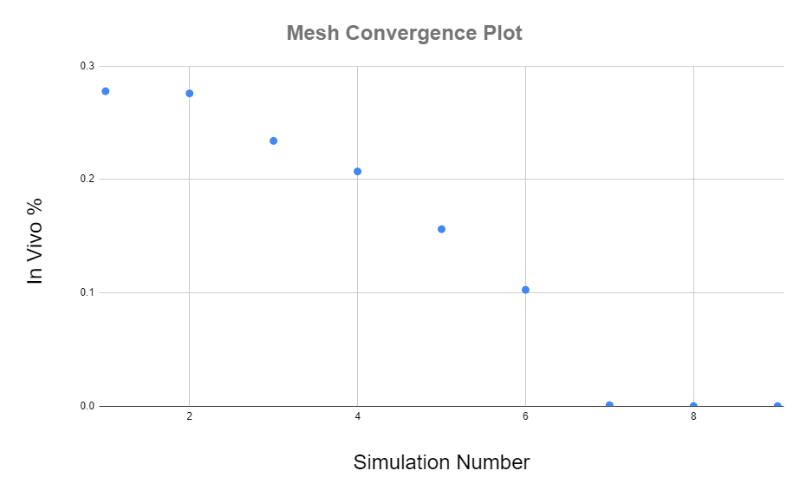
Figure S1.1: Mesh convergence plot of the range of mesh densities tested

Schematics of chip components

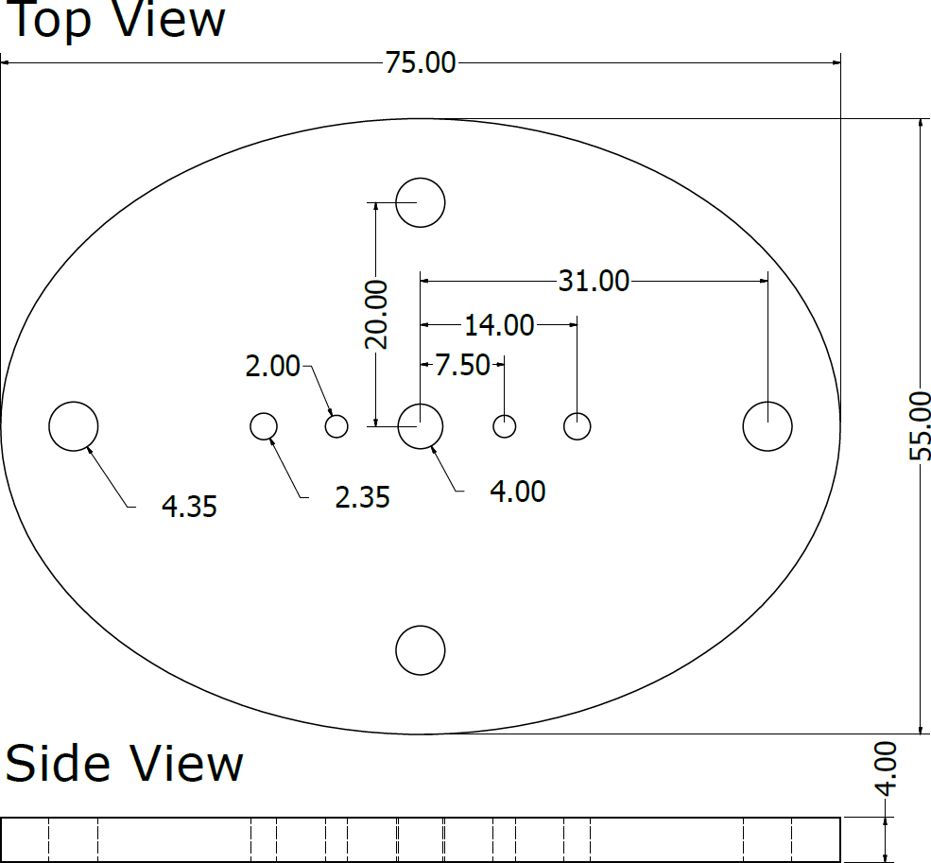

Figure S2.1: 2D schematic of top layer.

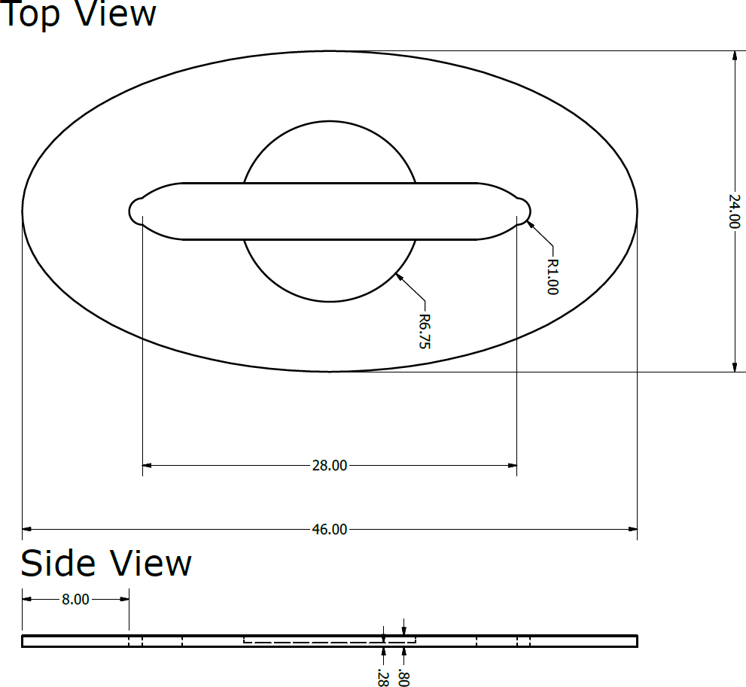
Figure S2.2: 2D schematic of tissue layer.

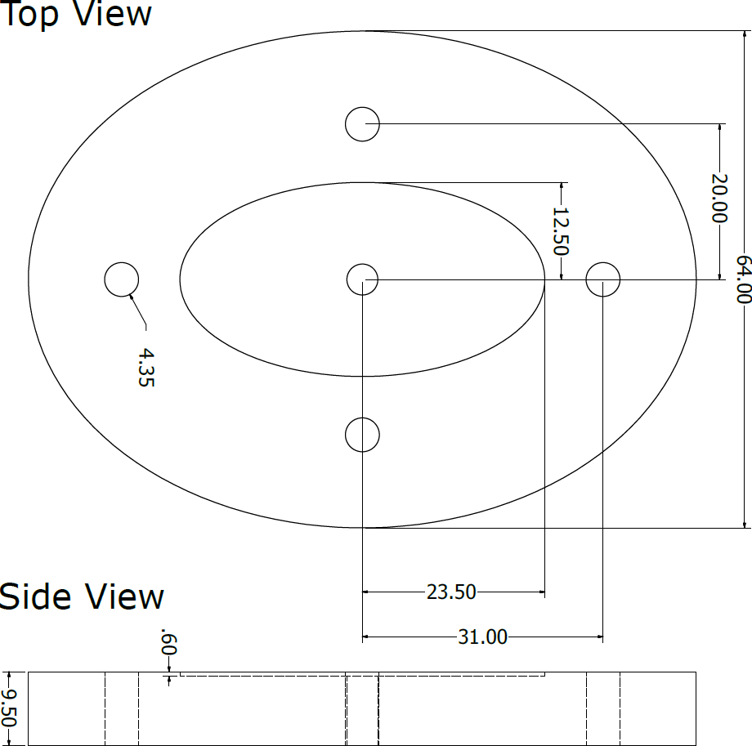

Figure S2.3: 2D Schematic of bottom layer.

Assembly of tissue unit
To position PCLS within the device, a PMMA holding unit was designed to encapsulate the slice. This holding unit consisted of two PMMA rings attached to nylon meshes. Rings were made with different diameters allowing the smaller to slot into the larger diameter ring. The PMMA rings were laser cut from 129 ± 4 μm thick PMMA sheets generated by hot pressing PMMA pellets. These were chloroform bonded to the 60 μm pore sized nylon mesh (fig S3.1).

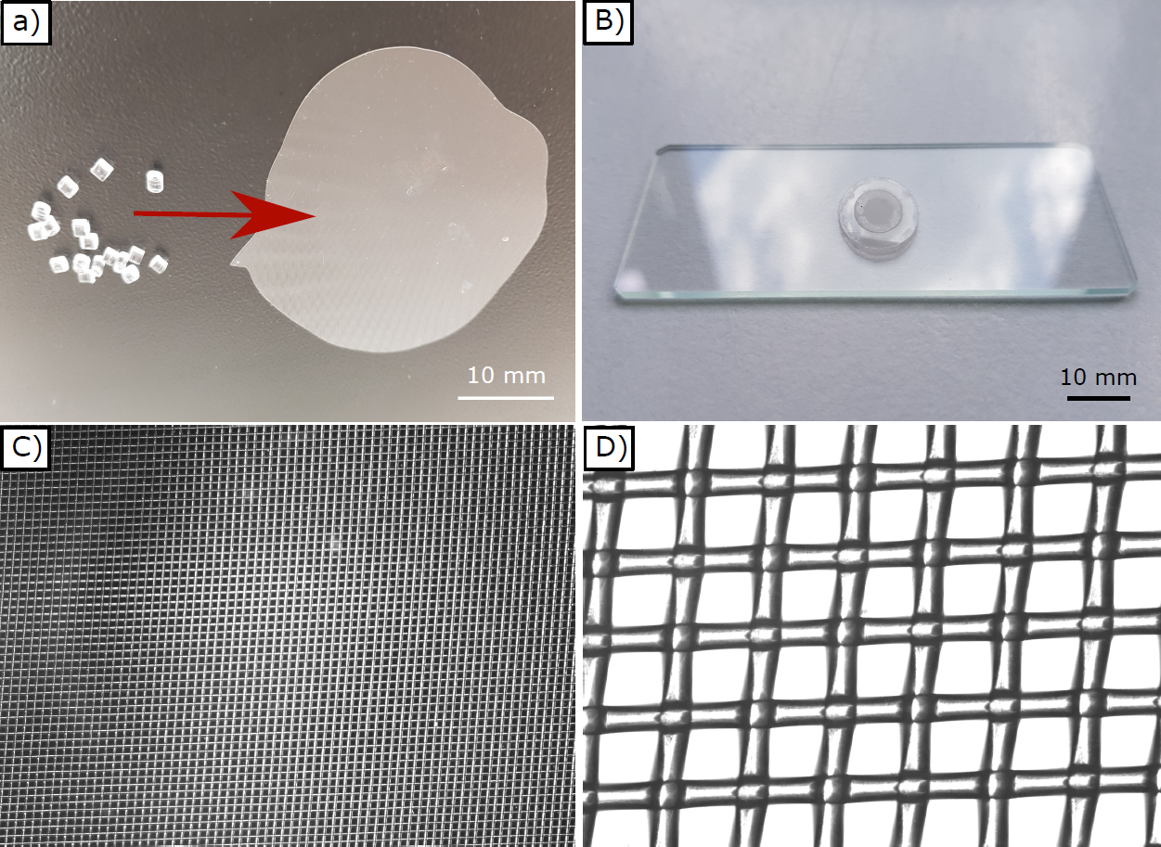
Figure S3.1: (a) Photo of the PMMA pellets used to generate a thin PMMA wafer via hot pressing (Red arrow indicates change from pellets to wafer). (b) Assembled tissue unit consisting of the top and bottom PMMA/nylon mesh rings as fitted together and placed on top of a microscope slide for display. (c,d) Brightfield images of the 60 μm pore sized nylon mesh membranes used for the tissue unit carriers 2x magnification (C) and (D) 20x magnification.

Attachment of PDMS Layers
To form the upper enclosure for the fluidic channel, a two layer PDMS composite was attached to the top layer part of the chip. Initially, a 3 mm thick PDMS layer was attached by stamping a thinly scrapped layer of Araldite 2014-1 epoxy glue onto the top layer piece. This was subsequently treated with plasma together with the PDMS layer and both were afterwards immediately brought into contact and left to bond overnight at 60 ᵒC under compression.
Biopsy punches with a diameter of 2 mm and 4 mm was then used to create openings for the bolts, breathing window, purge vales, inlets and outlets. The last piece of the PDMS composite consisted of a 50 μm thick PDMS layer attached via plasma bonding where after all holes except the “breathing window” was punched open once again.
In case of the attachment of the 50 μm thick PDMS layer to the tissue layer component, no thick intermediary layer was used, which again was performed according to the aforementioned protocol.
The 2 mm wide purge valves holes which were incorporated to prevent the entrapment of air during the chip sealing were threaded after the CNC-machining. The valves were made from M2 screws mounting an O-ring and with one side of the threading filed off. Valve operation could thus be achieved by screwing down the screw and compressing the O-ring to form a tight seal.
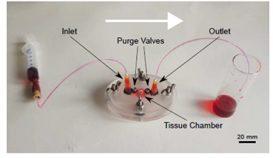

Figure S4.1: Photo of the complete chip with red dye solution pumped to test for leakages.

Generation of Precision-cut Liver Slices
The process of generating and incubating the tissues is illustrated in fig S5.1. From the slicing experiments (fig S5.1a) it was observed that the leading edge of the liver slices tended to be thicker than the bulk slice thickness. This was especially noticeably on the slices which were generated in the first few passes of the vibratome (fig S5.1b). The regions of the tissue slices which, from visible inspection, displayed the greatest homogeneity, were used to generate uniformly sized PCLS with a 4 mm diameter biopsy punch for subsequent incubation experiments (fig S5.1c and d).

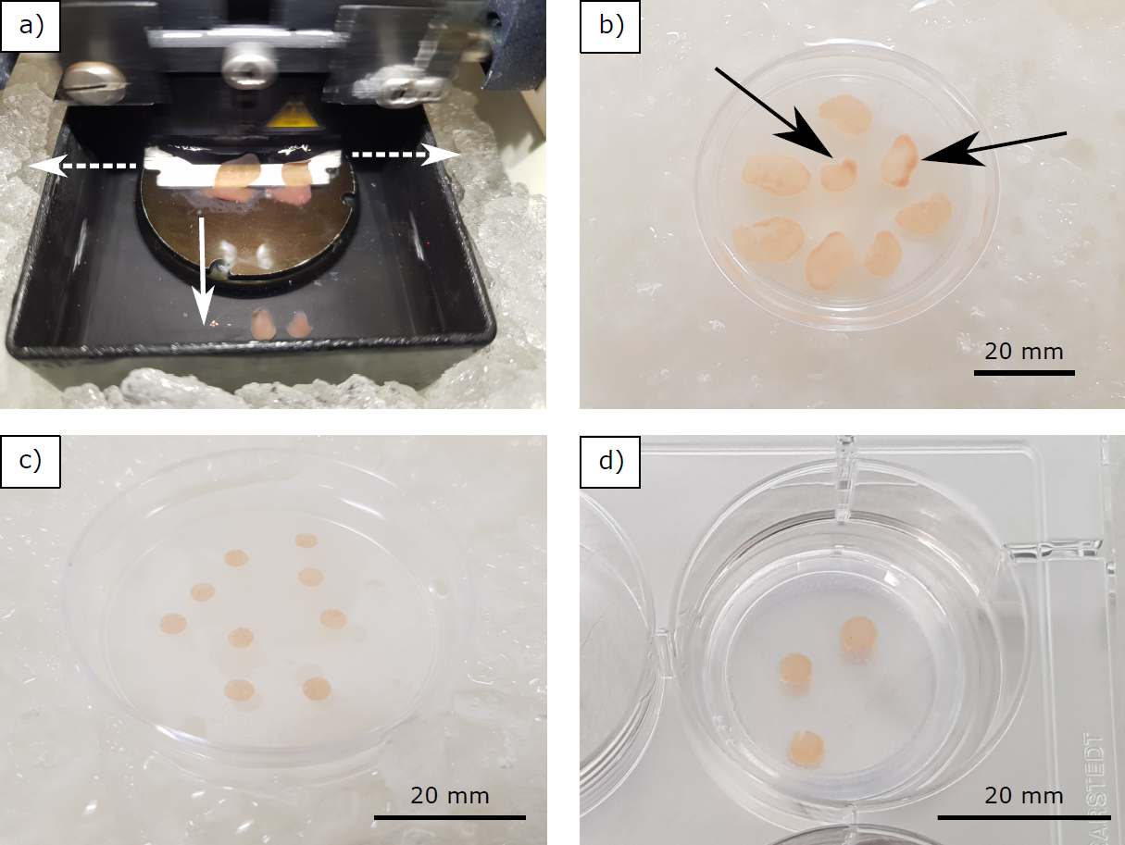
Figure S5.1: The process generating tissue slicing for incubation experiments. a) Slicing action of the vibratome head as it oscillates the mounted razor blade side ways (indicated with dashed arrows) and proceed forward whilst gradually cutting though the liver lobes which have been immobilised with glue on the stage. b) Multiple slices as generated from several passes along the length of the tissues by the vibratome mounted razor blade. Slices generated from the initial slicing pass have noticeable thicker leading edges (indicated with black arrows). c) Uniformly sized PCLS as generated from the usage of a 4 mm biopsy punch on the slices shown in Figure b. d) Well plate incubated PCLS on a PICMORG50 within a 6 well plate.

Experimental Setup for Running Chip
A gas washer was used to humidify the inflowing 95% gas while two syringe pumps were used to deliver the medium flows (fig S6.1a and b) The egg incubator and the purging vessel for the gas outflow were located within a fume hood for safety purposes (fig S6.1c). The glass container used for housing the microfluidic chips was placed within the heated egg incubator and contained connections to enable the in- and outflow of the applied gas atmosphere as well as the cell medium (fig S6.1d).

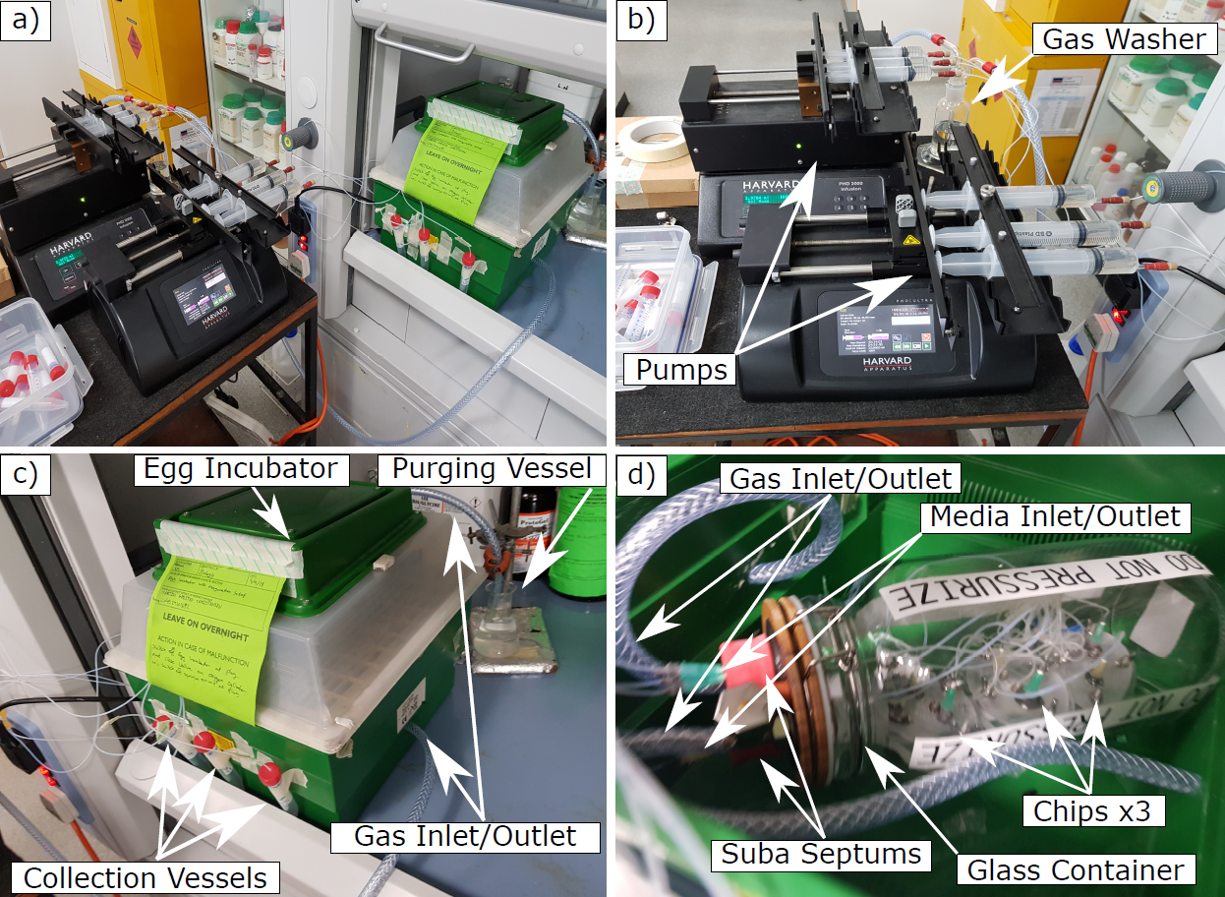
Figure S6.1: Experimental setup for the custom-made 95% O₂ and 5% CO₂ box as intended for the incubation experiments with chip version 4. a) Image of the entire experimental setup. b) Syringe pumps and gas washer. c) Heated egg incubator and purging vessel for gas outflow located in the fume hood for safety purposes. d) The glass container which housed the microfluidic chips as well as the connectors for the gas and medium flows was placed within the heated egg incubator.

