Supplementary material
Strategy for fast manufacturing of 3D hydrodynamic focusing multilayer microfluidic chips and its application for flow-based synthesis of gold nanoparticles
Yanwei Wang ª and Michael Seidel*ª
Institute of Hydrochemistry, Chair of Analytical Chemistry and Water Chemistry, Technical University of Munich, Elisabeth-Winterhalter-Weg 6, 81377 Munich, Germany. Yanwei.wang@tum.de
* Correspondence: E-mail: Michael.Seidel@mytum.de, Tel: +49 89 2180 78252, Fax: +49 89 2180 78255

Figure S 1 Main dimensions of the microreactor.
The effect of flow rates on the focus stream
There were two sheath flows, and the flow rates were the same. The sum of these two flow rates was defined as flow rate (FR) of sheath flow. By variation of both flow rates of sheath flow and central flow, the profile of the focused stream could be adjusted. The flow profile was made visible by using blue dye for the central stream and water for the sheath streams. The profiles of focus streams for varied flow rates are shown in Figure S 2. With the same flow rate ratio between sheath streams and central stream (Figure S 2 a and c), the central stream was slightly focused for a stream flow rate of 5 μl/s and it was focused to a line by a stream flow rate of 50 μl/s. For the same central flow rate of 0.5 μl/s (Figure S 2 a and b), the one with higher sheath flow rate was more focused. It can be concluded that increasing the flow rate of the sheath stream made the central stream more focused. Also, higher flow rates of both streams with the same flow rate ratio led to a narrow focus stream. The microfluidic reactor can withstand a maximum total flow rate of 300 μl/s which is applicable to most applications.(Mark et al. 2010)

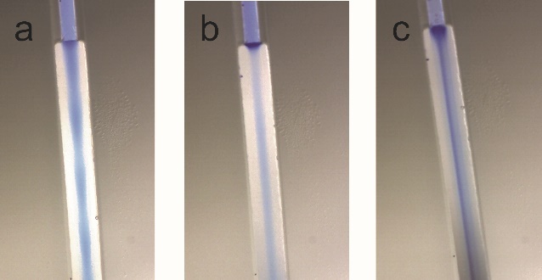

Figure S 2. The profile of the focus stream with different flow rates: (a) central stream 0.5 μl/s, sheath streams 5 μl/s; (b) central stream 0.5 μl/s, sheath streams 20 μl/s; (c) central stream 5 μl/s, sheath stream 50 μl/s

Figure S 3. SEM image of AuNPs synthesized at pH = 8.46 with 20 mM AA, 1 mM HAuCl4, 1% PVP and FR 10-3. Histograms with the respective particle size distributions and the percentage are included as inset.
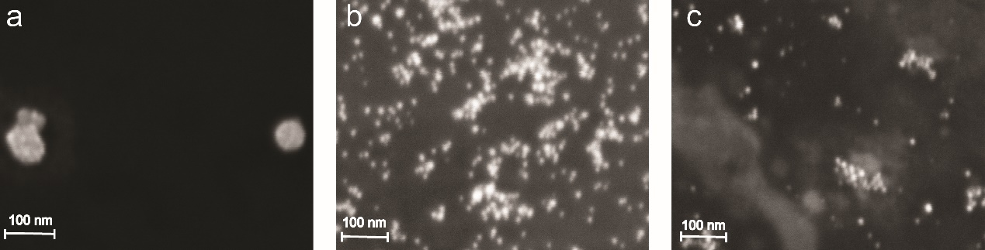
Figure S 4. SEM images of AuNPs synthesized with 20 mM AA, 1 mM HAuCl4, 1% PVP and FR 10-5 at different pH. (a) pH4.30, (b) pH9.34, (c)11.30.
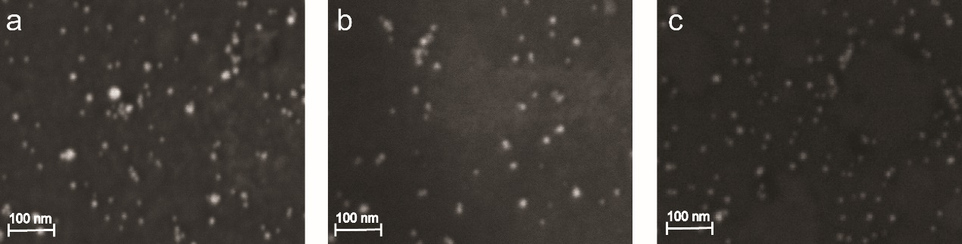
Figure S 5. SEM images of AuNPs synthesized with 20 mM AA (pH 9.34), 1 mM HAuCl4, 1% PVP and different FR. (a)FR10-4, (b)FR 10-8, (c)FR 10-16

