Internal field study of 21700 battery based on long-life embedded wireless temperature sensor
Le Yang¹, Na Li^{2,3}, Likun Hu⁴, Shaoqi Wang⁴, Lin Wang⁵, Jiang Zhou⁵, Wei-Li Song^{2,3}, Lei Sun⁴, Tai-Song Pan⁶, Hao-Sen Chen^{2,3*}, Daining Fang^{2,3}
¹ AML, CNMM, Department of Engineering Mechanics, Tsinghua University, Beijing 100084, China
² Institute of Advanced Structure Technology, Beijing Institute of Technology, Beijing 100081, China
³ Beijing Key Laboratory of Lightweight Multi-functional Composite Materials and Structures, Beijing Institute of Technology, Beijing 100081, China
⁴ School of Information and Electronics, Beijing Institute of Technology Beijing, Beijing, 100081, China,
⁵ Lishen Research Institute, Tianjin Lishen Battery Joint-stock Co., Ltd., Tianjin 300384, China
⁶State Key Laboratory of Electronic Thin Films and Integrated Devices, University of Electronic Science and Technology of China, Chengdu 610054, China

* Corresponding author
E-mail address: chenhs@bit.edu.cn(H.S. Chen)

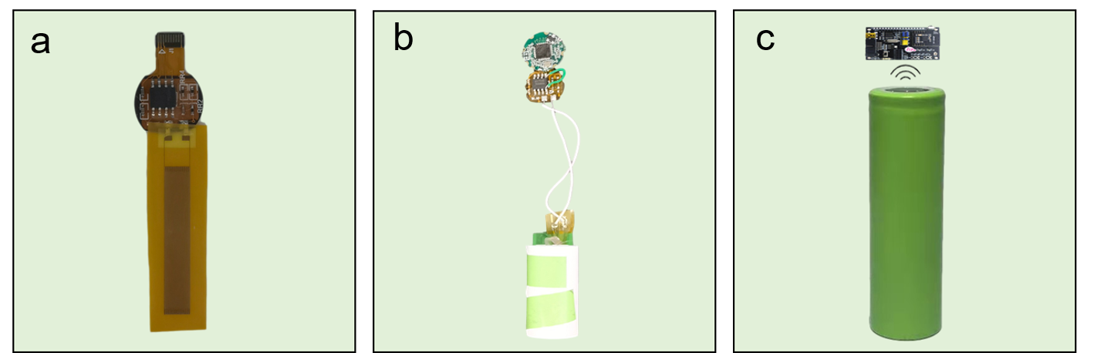

Figure S1 Digital photos of temperature sensor (a), battery with chips (b) and lithium-ion battery (c).
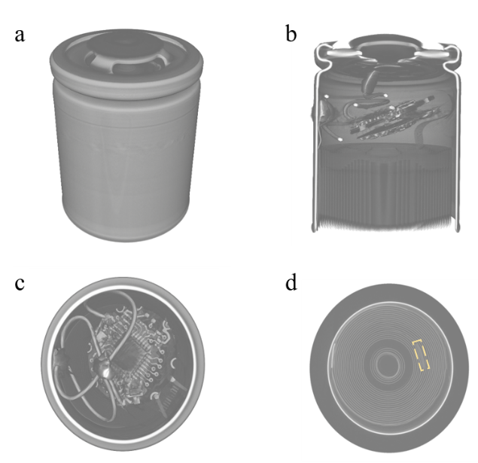

Figure S2 X-ray tomography images of sensor in cylindrical cells. (a) 21700 Lithium-ion battery; (b) the profile of Lithium-ion battery in vertical direction; (c) and (d) 2D slices showing cross sections of the integrated battery.

