SUPPLEMENTARY MATERIAL
Appendix 1. Comparison of baseline characteristics between participants included and excluded from the study
Compared with participants included in the main analytical sample (n=2895), the 204 excluded individuals were significantly older (84.6±7.4 vs 75.8±7.5 years, p<0.001) and more likely to be women (72.1% vs 59%, p<0.001), and reported a higher prevalence of diabetes (24% vs 16.1%, p=0.003) and cardiovascular diseases (47.5% vs 22.1%, p<0.001). They reported also lesser health risk behaviors (never smokers: 79.4% vs 60.1%, p<0.001; abstemious: 89.2% vs 69.5%, p<0.001), but were more likely to have cognitive impairment (83.8% vs 40.1% had a Mini-Mental State Examination [MMSE] <24, p<0.001). No significant differences were observed in body mass index (BMI), chronic obstructive pulmonary disease diagnosis (COPD) or cancer.

Appendix 2. Assessments of sociodemographic, clinical and biochemical data
Sociodemographic and clinical data. In addition to basic sociodemographic information (age, sex and living arrangements), we collected data on each participant’s educational level (categorised as ≤5 or >5 years, 5 years being the duration of primary schooling in Italy) and monthly income (≤ vs >€500). Clinical status was assessed from standardised questionnaires, self-reported symptoms, medical and hospital records, blood tests, physical examination and medication being taken. At baseline, we recorded the presence of: hypertension, diagnosed according to validated guidelines for the adult population¹; chronic obstructive pulmonary disease (COPD); cancer; osteoarticular diseases, defined as the presence of osteoporosis, or a history of hip fracture or osteoarthritis in the hand, knee or hip; and cardiovascular diseases (CVD), defined as the presence of at least one of the following: congestive heart failure, angina requiring a stent, angioplasty or hospitalisation, myocardial infarction and stroke. We also recorded the use of lipid lowering drugs (LLD). Finally, we tested cognitive performance with the Mini-Mental State Examination (MMSE; cognitive impairment was defined as a score <24)², and the presence of depressive symptoms with the 30-item Geriatric Depression Scale (GDS; a score >10 indicating probable depression)³.
Biochemical data. Venous blood samples were collected from participants at baseline after an overnight fast, then centrifuged and stored at −80 °C. For the purposes of our study, in addition to assess LDL-cholesterol, HbA1c and fasting glycaemia, we examined serum creatinine, fibrinogen levels and the erythrocyte sedimentation rate (ESR). Routine biochemical analyses were performed at the local hospital following standard quality-control procedures. Serum creatinine was measured by the standard creatinine Jaffe method (Roche Diagnostics, Germany) and used to compute the glomerular filtration rate (GFR, ml/min) using the Modification of Diet in Renal Disease Study formula. ESR was measured in sodium citrate–anticoagulated blood samples by the Westergren method.

REFERENCES
1. Pickering TG, Hall JE, Appel LJ, et al. Recommendations for blood pressure measurement in humans and experimental animals: part 1: blood pressure measurement in humans: a statement for professionals from the Subcommittee of Professional and Public Education of the American Heart Association Cou. Circulation. 2005;111(5):697-716. doi:10.1161/01.CIR.0000154900.76284.F6
2. Tombaugh TN, McIntyre NJ. The mini-mental state examination: a comprehensive review. J Am Geriatr Soc. 1992;40(9):922-935. http://www.ncbi.nlm.nih.gov/pubmed/1512391. Accessed December 8, 2015.
3. Yesavage JA, Brink TL, Rose TL, et al. Development and validation of a geriatric depression screening scale: a preliminary report. J Psychiatr Res. 1982;17(1):37-49. http://www.ncbi.nlm.nih.gov/pubmed/7183759. Accessed August 25, 2014.

Figure A1. Frequency of healthy cardiovascular factors in the men (n=1187) and women (n=1708) included in our sample
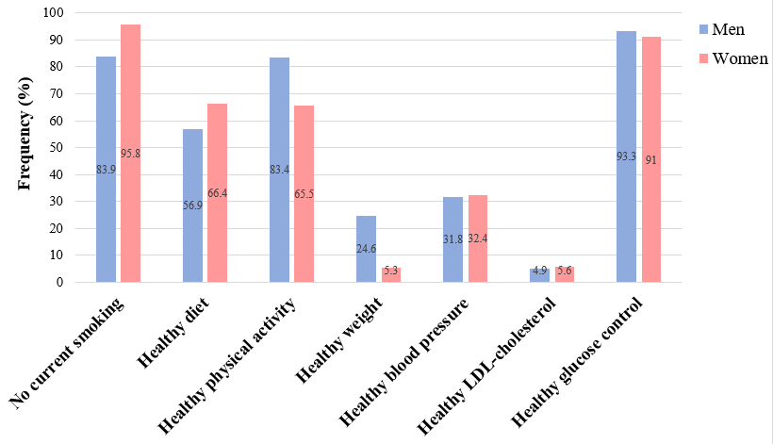

Table A1. Cox regression on the associations between cardiovascular risk profile with 20-year all-cause and cardiovascular mortality in older men and women, stratified by age class
 | Hazard ratios and 95% Confidence Intervals for mortality
 | 65-74 years |  | 75-84 years |  | ≥85
 | Men | Women | Men | Women | Men | Women
 | All-cause mortality
Cardiovascular risk profile
Very high | 1.00 | 1.00 | 1.00 | 1.00 | 1.00 | 1.00
High | 0.82 (0.61-1.12) | 0.61 (0.44-0.84)** | 0.76 (0.49-1.18) | 0.72 (0.56-0.93)* | 0.92 (0.53-1.60) | 0.92 (0.65-1.32)
Medium | 0.61 (0.45-0.83)** | 0.54 (0.40-0.74)*** | 0.76 (0.50-1.15) | 0.64 (0.50-0.82)*** | 0.70 (0.42-1.18) | 0.92 (0.62-1.34)
Low | 0.52 (0.36-0.74)*** | 0.51 (0.36-0.73)*** | 0.77 (0.48-1.23) | 0.58 (0.43-0.80)*** | 0.77 (0.44-1.32) | 0.93 (0.55-1.57)
Very low | 0.35 (0.18-0.69)*** | 0.36 (0.18-0.74)*** | 0.98 (0.52-1.84) | 0.41 (0.18-0.94)* | 0.67 (0.31-1.48) | 0.22 (0.05-0.96)*
p per trend | <0.001 | <0.001 | 0.88 | <0.001 | 0.1713 | 0.2304
 | Cardiovascular mortality
Cardiovascular risk profile
Very high | 1.00 | 1.00 | 1.00 | 1.00 | 1.00 | 1.00
High | 0.63 (0.38-1.06) | 0.61 (0.38-1.00)* | 1.03 (0.50-2.15) | 0.67 (0.48-0.93)* | 1.09 (0.52-2.27) | 0.90 (0.57-1.41)
Medium | 0.66 (0.40-1.08) | 0.56 (0.35-0.90)* | 1.11 (0.55-2.24) | 0.53 (0.38-0.75)*** | 0.86 (0.43-1.72) | 0.83 (0.50-1.37)
Low | 0.36 (0.19-0.68)** | 0.49 (0.28-0.86)* | 1.16 (0.54-2.51) | 0.52 (0.35-0.80)** | 0.87 (0.42-1.80) | 0.78 (0.38-1.55)
Very low | 0.19 (0.04-0.80)* | 0.20 (0.05-0.87)* | 1.48 (0.56-3.91) | 0.12 (0.02-0.87)* | 0.30 (0.08-1.16) | 0.19 (0.02-1.51)
p per trend | 0.001 | 0.008 | 0.3825 | <0.001 | 0.1171 | 0.1558
Model adjusted for educational level (≥5 vs <5 years), monthly income (< vs ≥500€), living arrangements (living with somebody vs living alone), chronic obstructive pulmonary disease, osteoarticular diseases, cancer, cognitive impairment, cardiovascular diseases. *p<0.05; **p<0.01; ***p<0.001

Table A2. Association between cardiovascular risk factors with 10- and 20-year all-cause and cardiovascular mortality
 | Hazard ratios and 95% Confidence Intervals for mortality
 | All-cause |  | Cardiovascular
 | Men | Women | Men | Women
Cardiovascular risk profile | 10-year follow-up
Healthy glucose control (yes vs no) | 0.79 (0.59-1.06) | 0.60 (0.48-0.75)*** | 0.94 (0.60-1.47) | 0.80 (0.57-1.13)
Healthy LDL-cholesterol (yes vs no) | 1.11 (0.76-1.62) | 1.36 (0.95-1.95) | 1.06 (0.59-1.92) | 1.26 (0.73-2.19)
Healthy blood pressure (yes vs no) | 0.95 (0.80-1.13) | 0.87 (0.73-1.03) | 0.87 (0.68-1.13) | 0.81 (0.63-1.03)
Healthy physical activity (yes vs no) | 0.67 (0.55-0.81)*** | 0.77 (0.65-0.92)** | 0.63 (0.48-0.83)** | 0.60 (0.47-0.77)
Healthy diet (yes vs no) | 0.94 (0.80-1.10) | 0.90 (0.76-1.06) | 0.91 (0.72-1.16) | 0.75 (0.60-0.94)*
No current smoking habits (yes vs no) | 0.75 (0.60-0.93)** | 0.82 (0.50-1.34) | 0.90 (0.63-1.28) | 2.36 (0.75-7.44)
Healthy weight (yes vs no) | 1.08 (0.90-1.29) | 0.85 (0.57-1.25) | 1.01 (0.77-1.33) | 0.89 (0.53-1.51)
 | 20-year follow-up
Healthy glucose control (yes vs no) | 0.74 (0.59-0.94)* | 0.63 (0.53-0.75)*** | 0.92 (0.63-1.36) | 0.83 (0.63-1.10)
Healthy LDL-cholesterol (yes vs no) | 0.99 (0.73-1.34) | 1.43 (1.12-1.82)** | 1.00 (0.63-1.59) | 1.18 (0.80-1.73)
Healthy blood pressure (yes vs no) | 0.91 (0.80-1.04) | 0.90 (0.80-1.01) | 0.84 (0.68-1.04) | 0.81 (0.68-0.96)*
Healthy physical activity (yes vs no) | 0.72 (0.60-0.85)*** | 0.82 (0.73-0.92)** | 0.66 (0.52-0.85)** | 0.70 (0.60-0.83)***
Healthy diet (yes vs no) | 0.90 (0.79-1.02) | 0.92 (0.82-1.03) | 0.97 (0.80-1.18) | 0.87 (0.74-1.02)
No current smoking habits (yes vs no) | 0.75 (0.63-0.89)*** | 0.66 (0.50-0.87)** | 0.97 (0.73-1.29) | 1.10 (0.66-1.82)
Healthy weight (yes vs no) | 1.05 (0.91-1.22) | 0.92 (0.71-1.18) | 1.04 (0.84-1.30) | 1.02 (0.72-1.44)
Model adjusted for educational level (≥5 vs <5 years), monthly income (< vs ≥500€), living arrangements (living with somebody vs living alone), chronic obstructive pulmonary disease, osteoarticular diseases, cancer, cognitive impairment, cardiovascular diseases. *p<0.05; **p<0.01; ***p<0.001

