Appendix
Tables
Table A1 Descriptive Statistics
 | No Parental Gray Divorce |  | Parental Gray Divorce |  | Overall
Mother
Frequency of Contact | 6.12 |  | 5.87 |  | 6.10
 | (1.12) |  | (1.49) |  | (1.15)
Emotional Closeness | 4.12 |  | 4.00 |  | 4.11
 | (0.88) |  | (1.08) |  | (0.90)
Instrumental Support | 3.98 |  | 3.93 |  | 3.98
 | (1.55) |  | (1.59) |  | (1.55)
Emotional Support | 5.46 |  | 5.71 |  | 5.48
 | (1.75) |  | (1.97) |  | (1.77)
Father
Frequency of Contact | 5.92 |  | 4.85 |  | 5.84
 | (1.26) |  | (1.90) |  | (1.35)
Emotional Closeness | 3.90 |  | 3.43 |  | 3.87
 | (0.96) |  | (1.24) |  | (0.99)
Instrumental Support | 3.80 |  | 3.35 |  | 3.77
 | (1.50) |  | (1.48) |  | (1.50)
Emotional Support | 4.74 |  | 4.52 |  | 4.73
 | (1.68) |  | (1.90) |  | (1.70)
Sociodemographic Factors
Age | 29.42 |  | 26.29 |  | 29.19
 | (9.29) |  | (8.64) |  | (9.28)
Personal Net Income | 1065.73 |  | 814.56 |  | 1046.83
 | (1345.51) |  | (1015.41) |  | (1325.19)
Years of Schooling | 11.52 |  | 10.38 |  | 11.44
 | (5.37) |  | (5.43) |  | (5.38)

Table A2 RIF Regression Results: Parental Divorce and Intergenerational Relationship Outcomes (standard errors in parentheses)
 | Contact frequency | Contact frequency | Contact frequency | Contact frequency | Emotional closeness | Emotional closeness | Emotional closeness | Emotional closeness
 | Q(25) | Median | Q(75) | Variance | Q(25) | Median | Q(75) | Variance
Age | -0.024*** | -0.047*** | -0.068*** | -0.012⁺ | -0.000 | -0.003** | -0.013*** | -0.016**
 | (0.002) | (0.001) | (0.001) | (0.006) | (0.001) | (0.001) | (0.001) | (0.005)
Age-squared | 0.000*** | 0.001*** | 0.001*** | 0.000*** | -0.000 | -0.000 | 0.000*** | 0.000**
 | (0.000) | (0.000) | (0.000) | (0.000) | (0.000) | (0.000) | (0.000) | (0.000)
Parental divorce | -0.115*** | -0.044*** | -0.005 | 0.760*** | -0.029*** | -0.021*** | -0.002 | 0.295***
 | (0.010) | (0.008) | (0.005) | (0.041) | (0.007) | (0.006) | (0.007) | (0.034)
Constant | -0.047⁺ | 1.126*** | 2.130*** | 0.923*** | -0.768*** | 0.269*** | 1.416*** | 1.186***
 | (0.024) | (0.018) | (0.011) | (0.097) | (0.017) | (0.015) | (0.017) | (0.079)
N | 106,658 | 106,658 | 106,658 | 106,658 | 106,296 | 106,296 | 106,296 | 106,296

 | Instrumental support | Instrumental support | Instrumental support | Instrumental support | Emotional support | Emotional support | Emotional support | Emotional support
 | Q(25) | Median | Q(75) | Variance | Q(25) | Median | Q(75) | Variance
Age | -0.052*** | -0.085*** | -0.132*** | -0.143*** | 0.006 | 0.014** | 0.018*** | 0.003
 | (0.005) | (0.004) | (0.006) | (0.013) | (0.004) | (0.005) | (0.005) | (0.010)
Age-squared | 0.001*** | 0.001*** | 0.002*** | 0.002*** | -0.000⁺ | -0.000*** | -0.000*** | -0.000
 | (0.000) | (0.000) | (0.000) | (0.000) | (0.000) | (0.000) | (0.000) | (0.000)
Parental divorce | -0.085*** | -0.045⁺ | -0.022 | -0.004 | -0.002 | -0.038 | 0.033 | 0.025
 | (0.025) | (0.023) | (0.033) | (0.070) | (0.023) | (0.028) | (0.029) | (0.058)
Constant | 0.456*** | 1.696*** | 3.149*** | 3.190*** | -0.595*** | -0.024 | 0.588*** | 1.059***
 | (0.067) | (0.062) | (0.089) | (0.188) | (0.063) | (0.076) | (0.077) | (0.155)
N | 35,706 | 35,706 | 35,706 | 35,706 | 35,672 | 35,672 | 35,672 | 35,672
Source: Pairfam (Wave 1-13), Release 13.0, authors’ own calculations, ⁺ p < 0.10, * p < 0.05, ** p < 0.01, *** p < 0.001.
Table A3 Arellano-Bond generalized method of moments (GMM) results
 | Contact frequency | Emotional closeness | Instrumental Support | Emotional Support
Lagged dependent variable | 0.443 *** | 0.433 *** | 0.603 *** | 0.311 ***
 | (0.053) | (0.086) | (0.077) | (0.072)
Age | -0.088 *** | -0.014 *** | -0.061 *** | 0.004
 | (0.008) | (0.003) | (0.012) | (0.007)
Age-squared | 0.001 *** | 0.001 * | 0.001 *** | -0.000
 | (0.000) | (0.000) | (0.000) | (0.000)
Parental divorce | -0.374 *** | -0.118 * | -0.329 ** | -0.143
 | (0.052) | (0.050) | (0.103) | (0.102)
Constant | 1.555 *** | 0.282 *** | 0.911 *** | -0.065
 | (0.147) | (0.069) | (0.214) | (0.099)
Validity of instrument with Hansen test (Prob > chi2) | 0.000 | 0.000 | 0.200 | 0.714
N | 83,788 | 83,436 | 22,078 | 22,110
Source: Pairfam (Wave 1-13), Release 13.0, authors’ own calculations, + p < 0.10, * p < 0.05, ** p < 0.01, *** p < 0.001.

Figures
Figure A1 Sample selection
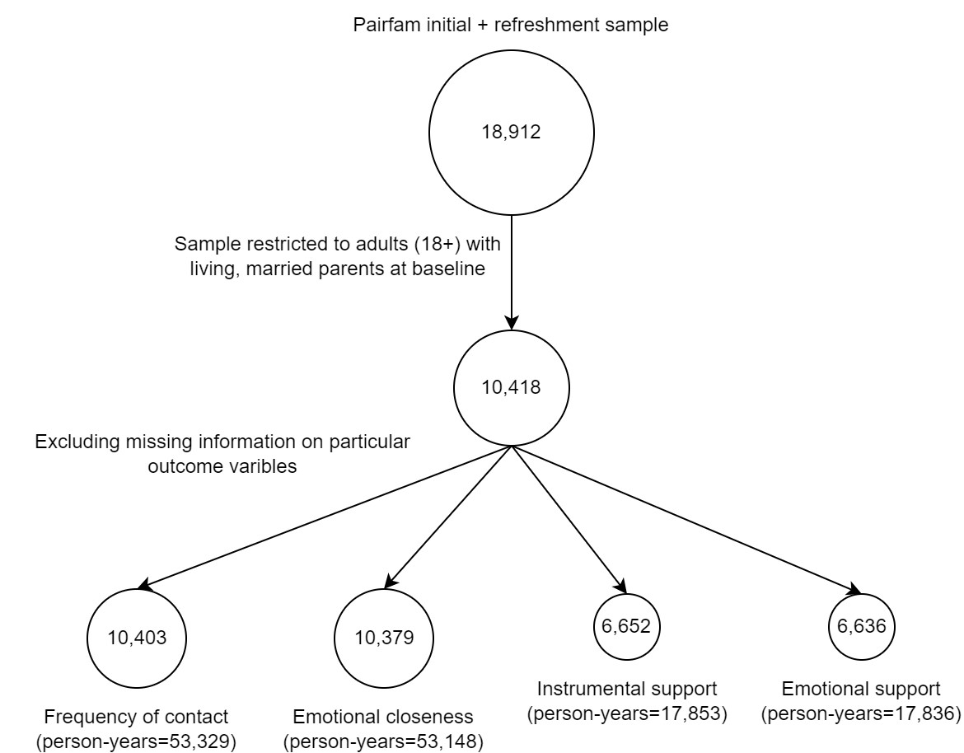

Figure A3 Findings from RIF regressions separately for mothers and fathers
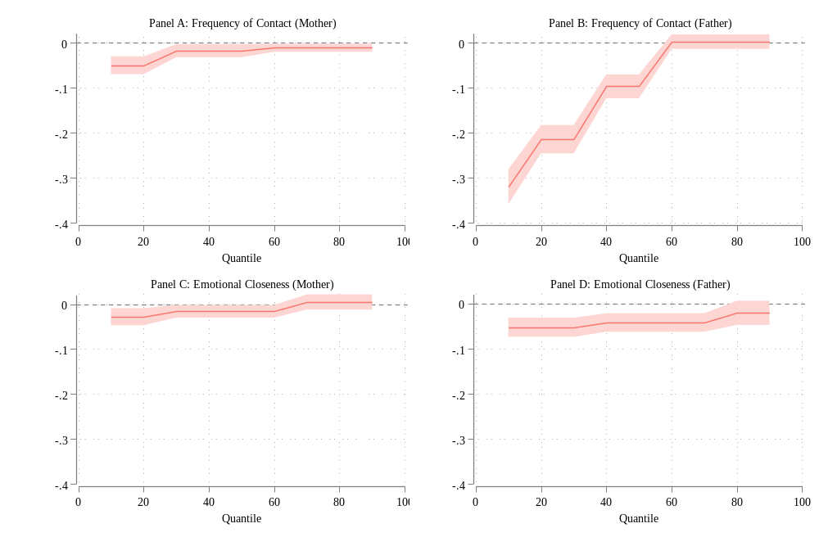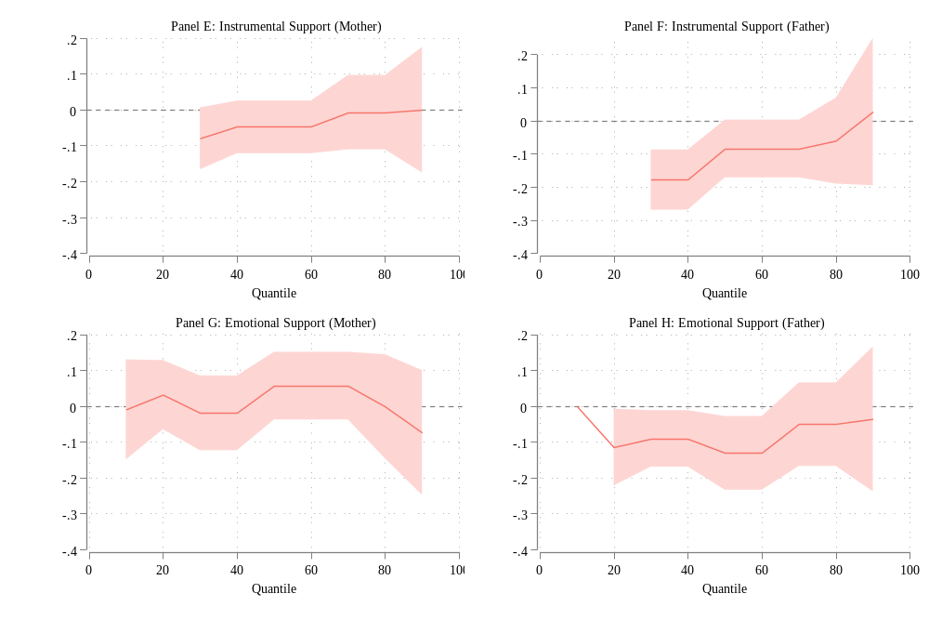 Source: Pairfam (Wave 1-13), release 13.0.
Note: Instrumental support estimates for adult children providing support to their parents were not available for the 10th and 20th quantiles.

Figure A4 Findings from augmented inverse probability weighting (AIPW) models
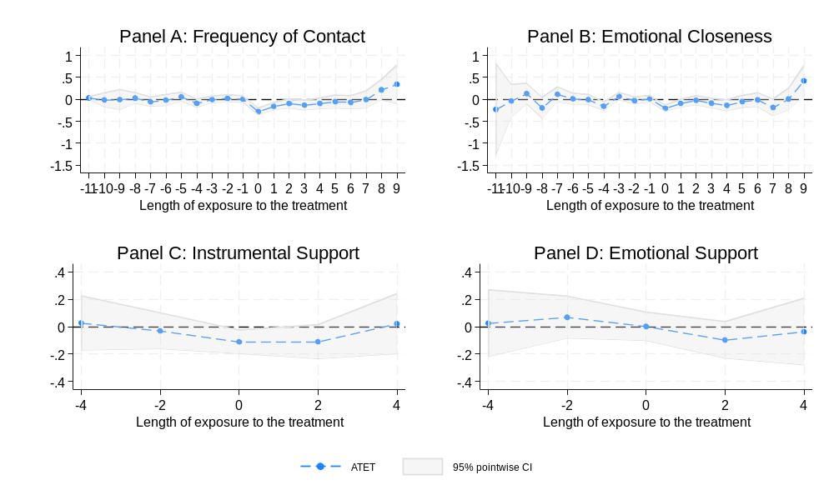Source: Pairfam (Wave 1-13), release 13.0.
Figure A5 Findings from RIF regressions with an Event Study Design
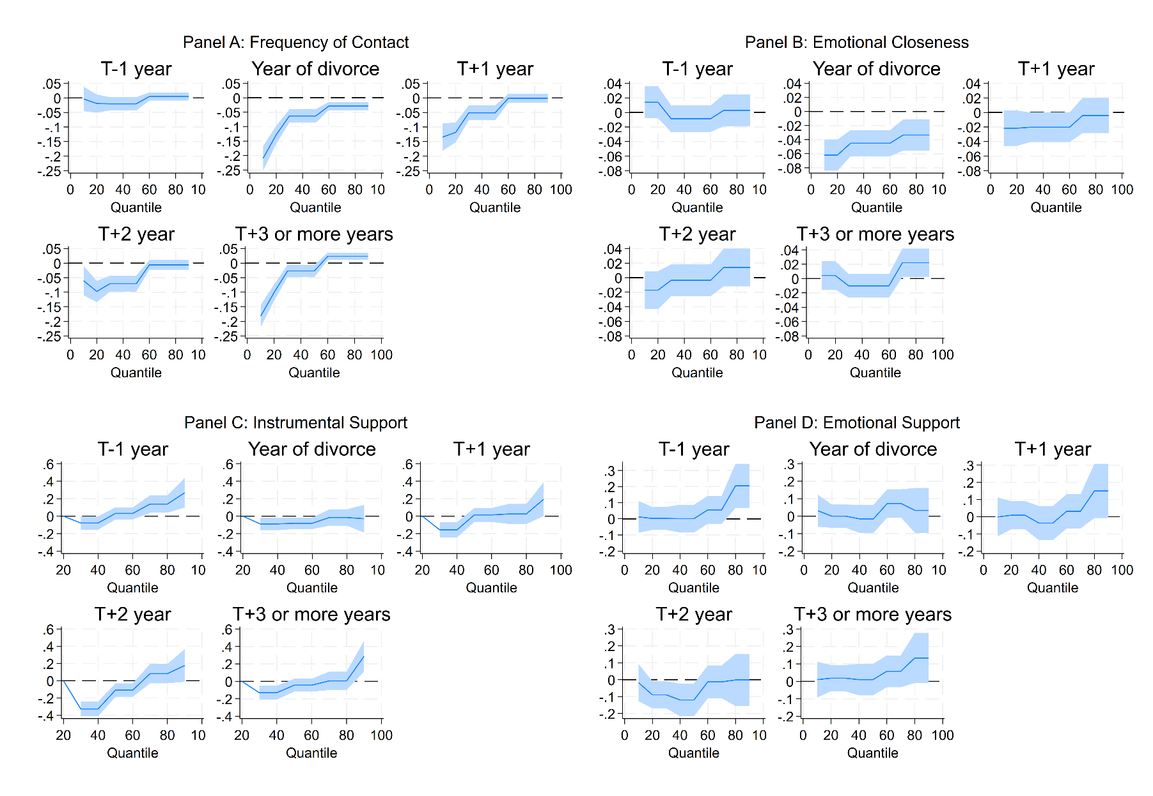
Source: Pairfam (Wave 1-13), release 13.0.

