Supplementary Materials

Table S-1
Factors associated with the use of Direct Payments (N = 568)
 | Model 1 | Model 2
Age | 0.010 (0.012) | 0.009 (0.012)
Sex | -0.037 (0.203) | -0.076 (0.206)
Education | 0.242 (0.201) | 0.275 (0.203)
Household size | -0.220* (0.105) | -0.248* (0.109)
Income | 0.451* (0.178) | 0.473** (0.181)
ADLs | -0.108⁺ (0.058) | -0.112⁺ (0.068)
IADLs | 0.009 (0.242) | 0.009 (0.242)
Informal care | 0.123 (0.200) | 0.119 (0.202)
Unmet needs |  | 0.007 (0.072)
Depression |  | -0.050 (0.045)
Quality of life |  | -0.003 (0.006)
Pseudo-R² | 0.029 | 0.031
Notes: All models adjusted for lagged covariates and reported robust standard errors. ⁺ P < .1, *P < .05, **P < .01, ***P < .001.

Table S-2
Random effects and population-averaged models (N = 568)
 | Random effects model |  | Population-averaged model
 | b | SE | b | SE
Unmet needs (dummy) | -0.15*** | 0.039 | -0.17*** | 0.038
Unmet needs (Continuous) | -0.73*** | 0.197 | -0.73*** | 0.167
Depression | 0.27 | 0.188 | 0.28 | 0.173
Quality of life | 2.16 | 1.449 | 2.26 | 1.414
Notes: b denotes coefficients, and SE represents standard errors. In the random effects model, we used cluster-robust standard errors. *P < .05, **P < .01, ***P < .001.

Table S-3
Rosenbaum-bound sensitivity analysis
 | 1) Unmet needs (dummy) |  | 2) Unmet needs (continuous) |  | 3) Depression |  | 4) Quality of life
Γ | Sig+ | Sig- | Sig+ | Sig- | Sig+ | Sig- | Sig+ | Sig-
1.0 | 0.000 | 0.000 | 0.000 | 0.000 | 0.000 | 0.000 | 0.011 | 0.011
1.1 | 0.000 | 0.000 | 0.000 | 0.000 | 0.005 | 0.000 | 0.071 | 0.001
1.2 | 0.000 | 0.000 | 0.000 | 0.001 | 0.033 | 0.000 | 0.231 | 0.000
1.3 | 0.000 | 0.000 | 0.000 | 0.007 | 0.120 | 0.000 | 0.475 | 0.000
1.4 | 0.000 | 0.000 | 0.000 | 0.031 | 0.287 | 0.000 | 0.712 | 0.000
1.5 | 0.000 | 0.000 | 0.000 | 0.095 | 0.503 | 0.000 | 0.873 | 0.000
1.6 | 0.000 | 0.000 | 0.000 | 0.212 | 0.706 | 0.000 | 0.954 | 0.000
1.7 | 0.000 | 0.001 | 0.000 | 0.376 | 0.852 | 0.000 | 0.986 | 0.000
1.8 | 0.000 | 0.002 | 0.000 | 0.555 | 0.935 | 0.000 | 0.996 | 0.000
1.9 | 0.000 | 0.004 | 0.000 | 0.715 | 0.975 | 0.000 | 0.999 | 0.000
2.0 | 0.000 | 0.009 | 0.000 | 0.836 | 0.992 | 0.000 | 1.000 | 0.000
2.1 | 0.000 | 0.019 | 0.000 | 0.914 | 0.997 | 0.000 | 1.000 | 0.000
2.2 | 0.000 | 0.034 | 0.000 | 0.959 | 0.999 | 0.000 | 1.000 | 0.000
2.3 | 0.000 | 0.057 | 0.000 | 0.982 | 1.000 | 0.000 | 1.000 | 0.000
Notes: Γ: log odds of differential assignment due to unobserved factors. Sig+: upper bound significance level. Sig-: lower bound significance level.

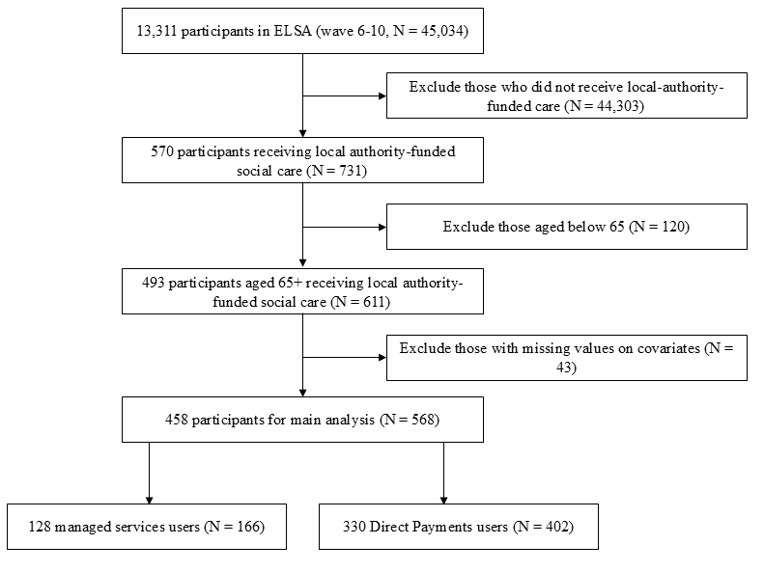
Figure S-1
Flowchart of sample selection from the ELSA

