Supplementary materials for
Age differences in pro-environmental behaviors: Is it about me or future generations?

Part 1 Sample description
The household income level and educational level of our sample are comparable to the general levels of the corresponding generations in Hong Kong. In terms of education, for younger generation, the enrollment rate of in higher education was above 70% in 2015 and keeps growing (UNESCO, 2019). For older generation, approximately 12% of the population aged 55+ years possess a post-secondary degree (Census and Statistics Department of Hong Kong SAR Government, 2021). In terms of household income, the median monthly household income of Hong Kong is HKD 30,000 (Census and Statistics Department of Hong Kong, 2024). The older sample of this study scored lower on household income compared to the younger sample and the median level of Hong Kong, likely because they have retired and their pension per month may not be as high as their salary before retirement. However, this does not necessarily imply that the older sample has a lower socioeconomic status compared to the younger sample, as older adults usually have higher savings than younger adults. The older participants scored slightly higher than younger participants on subjective socioeconomic status, measured by MacArthur’s ten level ladder (Adler et al., 2000).

Reference
Adler, N. E., Epel, E. S., Castellazzo, G., & Ickovics, J. R. (2000). Relationship of subjective and objective social status with psychological and physiological functioning: Preliminary data in healthy, White women. Health Psychology, 19(6), 586. https://doi.org/10.1037/0278-6133.19.6.586
Census and Statistics Department of Hong Kong SAR Government. 2021. Thematic Household Survey Report. Retrieved October 16, 2024, from https://www.census2021.gov.hk/en/publications.html
Census and Statistics Department of Hong Kong SAR Government. 2024. Population and Households. Retrieved October 16, 2024, from https://www.censtatd.gov.hk/en/scode500.html
United Nations Educational Scientific, and Cultural Organization (UNESCO). (2019). UNESCO Institute for Statistics. “UIS.Stat”. Retrieved October 16, 2024, from http://data.uis.unesco.org/

Table 1 Age differences (independent sample t test) in reasons for pro-environmental behaviors
 | Age Group | Mean | SD | t (223) | p | Cohen’s d
R_Environment | YA | 3.68 | 0.81 | -5.143 | <.001 | -.687
 | OA | 4.18 | 0.61 | -5.143 | <.001 | -.687
R_Habit | YA | 3.92 | 0.58 | -4.212 | <.001 | -.563
 | OA | 4.22 | 0.50 | -4.212 | <.001 | -.563
R_Norm | YA | 2.78 | 0.90 | -3.460 | <.001 | .259
 | OA | 3.20 | 0.89 | -3.460 | <.001 | .259
R_Money | YA | 3.66 | 0.75 | 1.941 | .027 | -.462
 | OA | 3.43 | 0.97 | 1.941 | .027 | -.462
Note: YA = younger adults, OA = older adults. Reasons for engaging in behaviors: R_Environment = pro-environmental reason, R_Habit = habitual reason, R_Norm = norm conformity, R_Money = saving money
Table 2 Correlations between key variables among younger and older adults using sub-dimensions of pro-environmental behaviors
Variable | M | SD | 1 | 2 | 3 | 4 | 5 | 6 | 7 | 8 | 9 | 10 | 11 | 12
1. Age_group
2. RPs_Worry | 2.55 | 0.88 | -.03
 |  |  | [-.12, .06]
3. RPs_Harm | 2.56 | 0.76 | -.04 | .65**
 |  |  | [-.13, .05] | [.60, .70]
4. RPs_Urgency | 24.40 | 26.50 | -.06 | -.12** | -.12**
 |  |  | [-.15, .03] | [-.21, -.03] | [-.21, -.03]
5. RPs_Future | 3.25 | 0.71 | -.01 | .51** | .54** | -.19**
 |  |  | [-.10, .08] | [.43, .57] | [.47, .60] | [-.28, -.10]
6. SGS | 5.43 | 1.04 | .35** | .34** | .28** | -.07 | .20**
 |  |  | [.27, .43] | [.25, .41] | [.20, .37] | [-.16, .02] | [.11, .28]
7. Recycling | 3.30 | 0.94 | .34** | .17** | .12** | -.02 | .17** | .32**
 |  |  | [.26, .42] | [.08, .26] | [.03, .21] | [-.11, .07] | [.08, .25] | [.24, .40]
8. Household | 4.02 | 0.80 | .04 | .17** | .15** | -.07 | .11* | .19** | .23**
 |  |  | [-.05, .13] | [.08, .26] | [.06, .24] | [-.16, .02] | [.02, .20] | [.10, .27] | [.14, .31]
9. Consumption | 3.58 | 0.82 | .36** | .20** | .16** | -.08 | .13** | .43** | .43** | .29**
 |  |  | [.28, .44] | [.11, .28] | [.07, .25] | [-.17, .01] | [.04, .21] | [.36, .50] | [.35, .50] | [.21, .37]
10. Transport | 3.89 | 1.22 | -.08 | .12** | .10* | -.06 | .10* | .10* | .13** | .28** | .11*
 |  |  | [-.17, .01] | [.03, .21] | [.01, .19] | [-.15, .03] | [.01, .19] | [.01, .19] | [.04, .21] | [.19, .36] | [.02, .20]
11. Civic | 1.48 | 0.61 | .03 | .24** | .16** | -.00 | .13** | .27** | .32** | .14** | .27** | .12**
 |  |  | [-.06, .12] | [.15, .32] | [.07, .24] | [-.09, .09] | [.04, .21] | [.18, .35] | [.23, .40] | [.05, .23] | [.18, .35] | [.03, .21]
12. Political | 1.30 | 0.63 | .21** | .16** | .12** | .02 | .05 | .24** | .16** | -.01 | .24** | -.02 | .46**
 |  |  | [.12, .29] | [.07, .24] | [.03, .21] | [-.07, .11] | [-.04, .14] | [.16, .33] | [.08, .25] | [-.10, .08] | [.15, .32] | [-.11, .07] | [.39, .53]
13. EB_all | 2.83 | 0.49 | .31** | .29** | .23** | -.06 | .20** | .46** | .75** | .51** | .73** | .36** | .63** | .45**
 |  |  | [.23, .39] | [.21, .38] | [.14, .31] | [-.15, .03] | [.11, .28] | [.39, .53] | [.71, .79] | [.44, .58] | [.69, .77] | [.28, .44] | [.57, .68] | [.38, .52]
Note: ** Correlation is significant at the 0.01 level. * Correlation is significant at the 0.05 level. RPs_Worry = “How worried are you about climate change?”, RPs_Harm = “How much do you think climate change harms you personally?”, RPs_Urgency = “When do you think climate change will start to harm people in your city?”, RPs_Future = “How much do you think climate change will harm future generations?”, SGS = social generativity scale. Age_group is coded as 0 = younger adults, 1 = older adults. EB_all = mean score of pro-environmental behaviors across all dimensions.

Table 3 Standardized estimates and 95% confidence intervals for linear regression model predicting pro-environmental behaviors, controlling for income, subjective SES, and subjective health
 | beta | 95% CI | p
AgeGroup (AG) | .24 | [.14, .33] | <.001
CCRPs_Worry | .16 | [.05, .27] | .006
CCRPs_Harm | .00 | [-.11, .12] | .937
CCRPs_Urgency | .00 | [-.08, .08] | .917
CCRPs_Future | .04 | [-.06, .14] | .413
SGS | .28 | [.18, .38] | <.001
Subjective health | .07 | [-.02, .16] | .108
Income | .02 | [-.07, .12] | .619
Sub_SES | .11 | [.03, .20] | .010
AG × CCRPs_Worry | .00 | [-.11, .12] | .940
AG × CCRPs_Harm | .08 | [-.03, .20] | .141
AG × CCRPs_Urgency | .05 | [-.03, .13] | .216
AG × CCRPs_Future | -.01 | [-.10, .09] | .897
AG × SGS | -.11 | [-.21, -.02] | .019
R² / R² adjusted | .313 / .291
Notes: CCRPs = climate change risk perceptions. SGS = social generativity concerns. AG = age groups. SES = socioeconomic status.

Table 4 Unstandardized estimates and 95% confidence intervals for linear regression model predicting pro-environmental behaviors with year as a moderator
Predictors | beta | 95% CI | p
AgeGroup | .21 | [.13, .29] | <.001
Year | -.12 | [-.19, -.04] | .004
CCRPs_Worry | .15 | [.04, .26] | .006
CCRPs_Harm | .01 | [-.10, .12] | .854
CCRPs_Urgency | -.01 | [-.09, .07] | .805
CCRPs_Future | .05 | [-.04, .15] | .290
SGS | .33 | [.24, .42] | <.001
AgeGroup × Year | -.02 | [-.11, .06] | .615
Year × CCRPs_Worry | .09 | [-.02, .20] | .112
Year × CCRPs_Harm | -.05 | [-.16, .05] | .329
Year × CCRPs_Urgency | .00 | [-.08, .08] | .966
Year × CCRPs_Future | .00 | [-.10, .09] | .956
Year × SGS | -.05 | [-.15, .04] | .238
R² / R² adjusted | .292 / .272
Notes: *** means p < .001, ** means p < .01, * means p < .05. CCRPs = climate change risk perceptions. SGS = social generativity concerns. AG = age groups.

Table 5 Standardized estimates and 95% confidence intervals for hierachical regression model predicting pro-environmental behaviors with age groups and reasons
 | Pro-environmental: All
Predictors | beta | 95% CI | p | beta | 95% CI | p
R_Environment | .55 | [.43, .67] | <.001 | .55 | [.41, .69] | <.001
R_Habit | .20 | [.08, .33] | .001 | .16 | [.03, .29] | .015
R_Norm | -.11 | [-.21, -.01] | .036 | -.08 | [-.18, .03] | .167
R_Money | .07 | [-.04, .17] | .202 | .02 | [-.08, .12] | .705
AG |  |  |  | .15 | [.04, .25] | .007
AG × R_Environment |  |  |  | .11 | [-.03, .25] | .133
AG × R_Habit |  |  |  | -.01 | [-.15, .12] | .842
AG × R_Norm |  |  |  | .02 | [-.08, .13] | .694
AG × R_Money |  |  |  | .04 | [-.06, .15] | .411
R² / R² adjusted | .482 / .472 |  |  | .514 / .493
Notes: R_Environment = pro-environmental reason, R_Habit = habitual reason, R_Norm = norm conformity, R_Money = saving money. AG = age groups, 0 = younger adults, 1 = older adults

Table 6 Standardized estimates and 95% confidence intervals for regression models predicting sub-dimensions of pro-environmental behaviors
 | Recycle |  |  | Household |  |  | Consumption
Predictors | beta | 95% CI | p | beta | 95% CI | p | beta | 95% CI | p
AG | .58 | [.40, .76] | <.001 | .01 | [-.19, .20] | .941 | .53 | [.36, .70] | <.001
CCRPs_Worry | .12 | [-.05, .29] | .164 | .02 | [-.16, .20] | .842 | .02 | [-.14, .18] | .795
CCRPs_Harm | -.13 | [-.30, .05] | .156 | .12 | [-.07, .31] | .220 | -.12 | [-.29, .04] | .141
CCRPs_Urgency | -.04 | [-.16, .09] | .561 | -.09 | [-.22, .05] | .192 | -.07 | [-.19, .05] | .252
CCRPs_Future | .06 | [-.09, .21] | .423 | -.02 | [-.18, .14] | .817 | .14 | [-.00, .28] | .055
SGS | .24 | [.12, .36] | <.001 | .19 | [.06, .32] | .005 | .40 | [.28, .51] | <.001
CCRPs_Worry × AG | -.08 | [-.31, .15] | .483 | .13 | [-.12, .38] | .313 | .11 | [-.11, .33] | .313
CCRPs_Harm × AG | .17 | [-.06, .40] | .154 | -.13 | [-.38, .12] | .317 | .24 | [.02, .46] | .034
CCRPs_Urgency × AG | .13 | [-.04, .30] | .140 | .10 | [-.09, .28] | .297 | .09 | [-.08, .25] | .301
CCRPs_Future × AG | .11 | [-.10, .31] | .304 | .03 | [-.19, .25] | .777 | -.24 | [-.43, -.05] | .016
SGS × AG | -.16 | [-.35, .04] | .121 | -.14 | [-.35, .07] | .200 | -.23 | [-.42, -.04] | .018
R² / R² adjusted | .198 / .179 |  |  | .059 / .037 |  |  | .272 / .255
 | Civic activities |  |  | Political participation |  |  | Transportation
Predictors | beta | 95% CI | p | beta | 95% CI | p | beta | 95% CI | p
AG | -.07 | [-.25, .12] | .493 | .31 | [.12, .50] | .002 | .11 | [-.09 – .31] | .266
CCRPs_Worry | .18 | [.01, .36] | .043 | .12 | [-.06, .30] | .191 | -.01 | [-.20 – .18] | .921
CCRPs_Harm | -.04 | [-.22, .14] | .679 | .01 | [-.17, .19] | .914 | -.06 | [-.25 – .13] | .532
CCRPs_Urgency | -.03 | [-.16, .10] | .667 | .08 | [-.05, .22] | .206 | .02 | [-.12 – .15] | .807
CCRPs_Future | -.03 | [-.19, .13] | .689 | -.06 | [-.22, .09] | .420 | -.02 | [-.19 – .14] | .776
SGS | .30 | [.17, .43] | <.001 | .10 | [-.03, .23] | .127 | .08 | [-.05 – .22] | .232
CCRPs_Worry × AG | -.01 | [-.26, .23] | .922 | -.03 | [-.28, .21] | .793 | -.11 | [-.36 – .15] | .419
CCRPs_Harm × AG | .01 | [-.24, .26] | .936 | .08 | [-.17, .32] | .546 | .12 | [-.13 – .38] | .344
CCRPs_Urgency × AG | .12 | [-.06, .30] | .187 | -.09 | [-.27, .09] | .309 | .05 | [-.14 – .24] | .583
CCRPs_Future × AG | .08 | [-.13, .30] | .453 | .03 | [-.19, .24] | .794 | .13 | [-.10 – .35] | .272
SGS × AG | -.19 | [-.39, .02] | .079 | .15 | [-.06, .36] | .166 | -.20 | [-.42 – .01] | .066
R² / R² adjusted | .111 / .089 |  |  | .101 / .080 |  |  | .020 / .013
Notes: CCRPs = climate change risk perceptions. SGS = social generativity concerns. AG = age groups.

Table 7 Group invariance
7.1 One-factor model (overall pro-environmental behaviors):
 | df | AIC | BIC | Chi-square | Chi-square diff | p
Configural | 14 | 6364.7 | 6531.1 | 23.273
Metric | 19 | 6365.3 | 6510.9 | 33.915 | 10.642 | .060
Scalar | 21 | 6421.8 | 6546.5 | 100.337 | 66.422 | <.001
Scalar (free 3 ints) | 22 | 6365.4 | 6498.5 | 39.974 | 6.0592 | .109
Notes: Configural invariance = structural invariance. Metric invariance = factor loadings invariance. Scalar invariance = factor intercepts invariance. Scalar (free 3 ints) model freed the intercepts of the three factors where we found group differences (recycling, consumption, and political support), while keeping the intercepts of the other factors fixed. By doing this, partial scalar invariance was achieved. To provide more unbiased analyses, we used sub-dimensions to compare group mean differences and the overall score for examining associations between variables.
7.2 Six-sub-dimension model
 | df | AIC | BIC | Chi-square | Chi-square diff | p
Configural | 124 | 17263 | 17737 | 174.64
Metric (fix all) | 132 | 17288 | 17729 | 215.99 | 41.346 | <.001
Metric (fix civic) | 126 | 17292 | 17758 | 208.09 | 33.452 | <.001
Metric (fix recyc) | 126 | 17264 | 17730 | 179.61 | 4.9678 | .083
Metric (fix politic) | 125 | 17262 | 17732 | 175.77 | 1.126 | .288
Metric (fix house) | 125 | 17262 | 17732 | 175.85 | 1.210 | .271
Metric (fix consum) | 126 | 17260 | 17725 | 175.34 | 0.705 | .703
Notes: Configural invariance = structural invariance. Metric (fix all) = factor loadings on all six factors were constrained to be the same. Metric (fix civic/recyc/politic/house/comsum) = only factor loadings on civic activities/recycling/political participation/household activities/consumption were constrained. Each model was compared with configural invariance model.
Factor structure (configural) and factor loadings (metric) invariance held for one-factor model. Intercepts (scalar) invariance did not hold for one-factor model, which is reasonable given that older and younger adults scored differently on the overall score of pro-environmental behaviors. Only factor structure invariance held for six-sub-dimension model. We further constrained the factor loadings on each sub-dimension one by one. Older and younger groups loaded only differently on civic activities and invariantly on other sub-dimensions.

Table 8 Standardized estimates and 95% confidence intervals for regression models using continuous age
 | Pro-environmental: All
Predictors | beta | 95% CI | p
Age | 0.19 | 0.11 – 0.28 | <0.001
CCRPs_Worry | 0.16 | 0.05 – 0.27 | 0.006
CCRPs_Harm | -0.02 | -0.13 – 0.09 | 0.735
CCRPs_Urgency | 0 | -0.08 – 0.08 | 0.999
CCRPs_Future | 0.05 | -0.05 – 0.15 | 0.314
SGS | 0.31 | 0.22 – 0.41 | <0.001
CCRPs_Worry × AG | 0.01 | -0.10 – 0.13 | 0.801
CCRPs_Harm × AG | 0.08 | -0.04 – 0.20 | 0.17
CCRPs_Urgency × AG | 0.05 | -0.04 – 0.14 | 0.266
CCRPs_Future × AG | -0.01 | -0.11 – 0.09 | 0.87
SGS × AG | -0.11 | -0.20 – -0.01 | 0.023
R² / R² adjusted | 0.275 / 0.257
Notes: CCRPs = climate change risk perceptions. SGS = social generativity concerns. AG = age groups.

Figure 1 Interaction between continuous age and social generativity on pro-environmental behavior
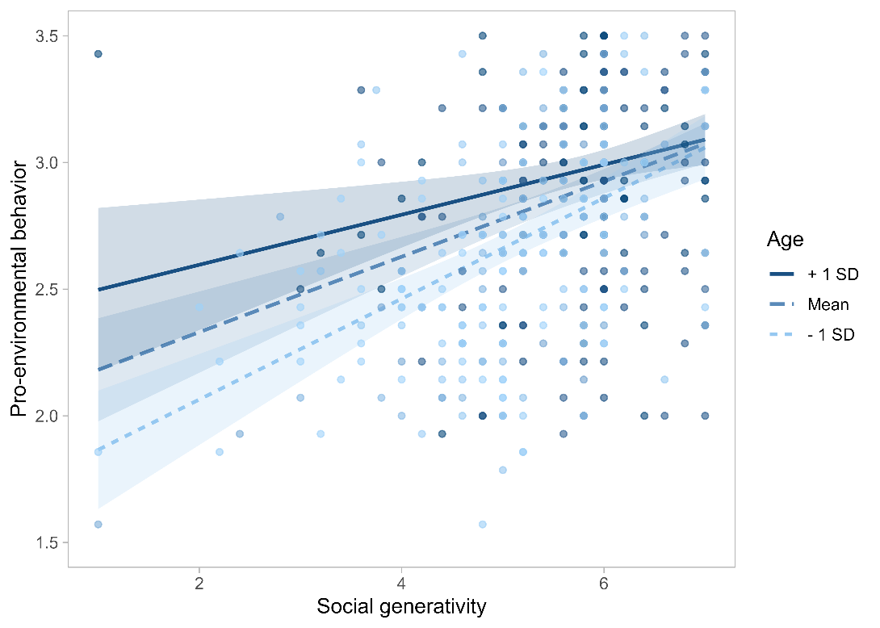
Note: The shadow represents the 95% confidence interval.

Part 9 Deleted items from original pro-environmental scale

I am an active member of an environmental group
I systematically take part in protests regarding environmental protection
I take part in reforestation or beach cleaning actions
I vote a political party that support stronger environmental laws
I ride a bicycle or take public transportation to work or school
For longer journeys (more than 6 h), I take an airplane/train/bus
In winter, I turn down the heat when I leave my apartment for more than 4 h or at night
I buy seasonal produce

