Supplementary Information
SI 1 Attribute list used for the analysis of the lithic assemblage at Toumboura III. (*for blanks following the definition of Auffermann, et al., 1990 and Nigst, 2012; for cores following the definition of Hahn, 1982 and Nigst, 2012)
General | Blanks | Tools | Cores
Refitting affiliation | Blank type | Tool type | Core type
Raw material category | Diagnostic technical category | Position of retouch | Original morphology
Raw material unit | Morphology | Location of retouch | Number of striking platforms
Patination | Dorsal scar number | Delineation of retouch | Relation of platforms
Thermal alteration | Dorsal scar orientation | Extent of retouch | Number of removal surfaces
Cortex proportion | Platform type | Morphology of retouch | Orientation negatives on removal surface
Edge state | Platform form | Angle of retouch | Length of removal surface
Fragmentation | Platform width | Number of retouch scars | Width of removal surface
Technical accident | Platform depth | Fragmentation of retouch | Shape of removal surface
Length* | Dorsal reduction | Number of retouched edges | Striking platform type
Width* | Lipping |  | Angle between removal surface and striking platform
Thickness* | Hertzian cone |  | Last operation
Weight | Bulb |  | Last productional operation
Maximum dimension | Shattered bulb |  | Length of last end product
 | Bulbar scar |  | Width of last end product
 | Exterior platform angle |  | Core back
 | Interior platform angle |  | Core base
 | Distal termination |  | Stigmata of technique
 | Cross section |  | Discard factor
 | Profile

SI 2 Recording form with attributes especially compiled for the technological and techno-functional analysis of the bifacially pieces of Toumboura III

SI 3 3D models by photogrammetry, Toumboura III
The 3D models have been made by photogrammetry. For the shooting, we used a camera Canon EOS 6D, a lens Canon EF 100 mm 1 :2.8 L IS USM, an automatic turntable, a set of 12 bits coded targets, a tripod and a light box Havox HBP-40XD with 6 dimmable LED bar with a 93 CRI. The 3D models were generated with the software Agisoft Metashape v.1.6.2. A classical workflow was used for close-range photogrammetric modeling using the following parameters in Metashape: first, with the alignment in high accuracy of the set of photos; second, the building of a dense cloud in high quality; third, the building of a mesh in high quality, the scaling with 12 bits targets and then the building of the texture in the generic or the adaptive orthophoto mapping mode with a 4096 texture size/count.

Three archaeological pieces have been modeled in 3D. The 3D models can be found at the following address online:
- preform of a bifacial piece TMBIII_UJ_A1_22 => https://visual.ariadne-infrastructure.eu/3d/d21a2b2d296789d71d1b62e8ba2eb0e9
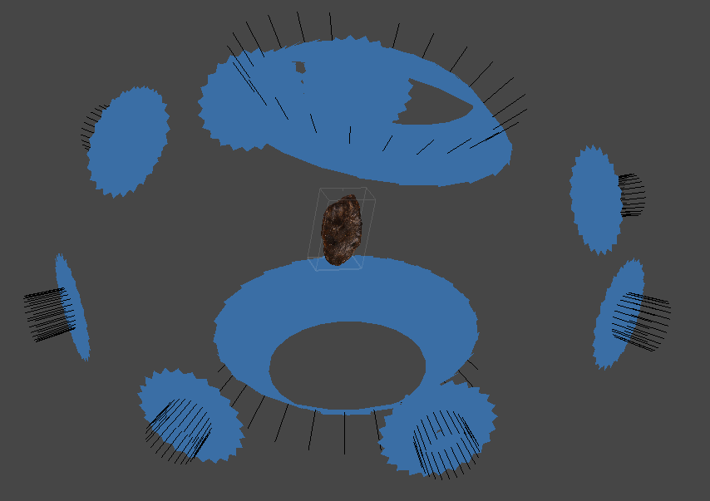
- bifacial piece TMBIII_UJ_A1_17 => https://visual.ariadne-infrastructure.eu/3d/6b91c135583c27766a9fcbb18f7c7ed6
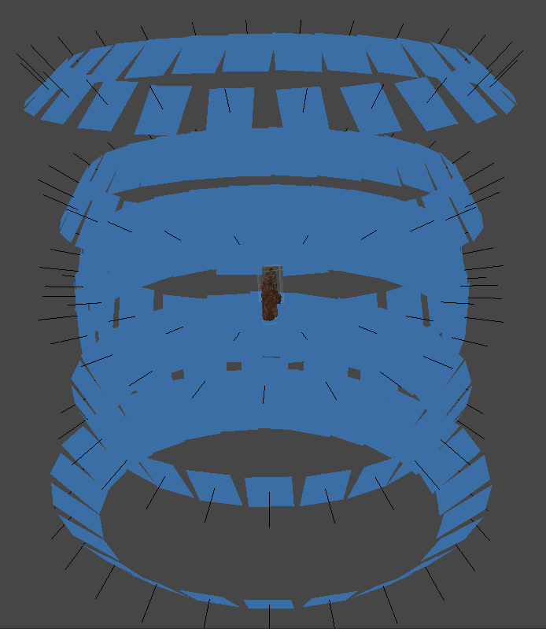
- bifacial piece TMBIII_UJ_A1_16 => https://visual.ariadne-infrastructure.eu/3d/10de63c867503ea7413042de3d2dd12b
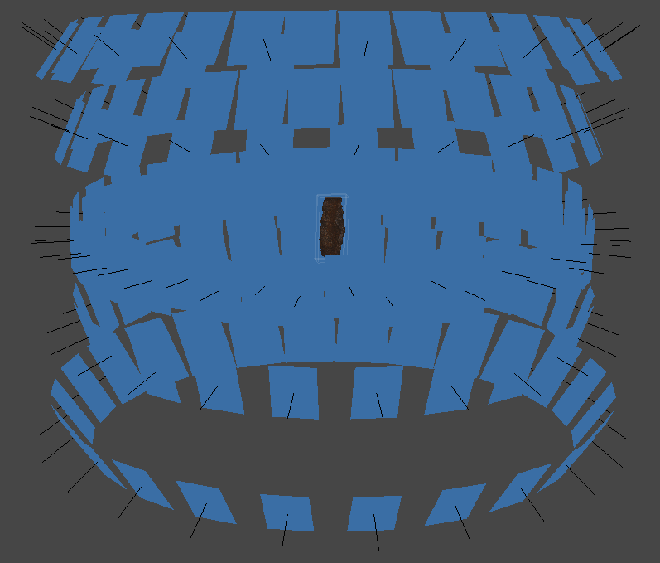

The detailed processing parameters and proprieties of the three 3D models are presented hereafter:

1) Processing Parameters for the 3D model of the preform of a bifacial piece TMBIII_UJ_A1_22
General
Cameras 239
Aligned cameras 239
Markers 30
Scale bars 14
Coordinate system Local Coordinates (m)
Rotation angles Yaw, Pitch, Roll
Point Cloud
Points 678,908 of 835,275
RMS reprojection error 0.189069 (0.834296 pix)
Max reprojection error 7.89878 (49.0869 pix)
Mean key point size 3.60873 pix
Point colors 3 bands, uint8
Key points No
Average tie point multiplicity 8.37882
Alignment parameters
Accuracy High
Generic preselection No
Reference preselection Estimated
Key point limit 400,000
Tie point limit 50,000
Filter points by mask Yes
Mask tie points No
Guided image matching Yes
Adaptive camera model fitting Yes
Matching time 7 hours 8 minutes
Matching memory usage 1.04 GB
Alignment time 31 minutes 51 seconds
Alignment memory usage 546.39 MB
Optimization parameters
Parameters f, b1, b2, cx, cy, k1-k4, p1, p2
Fit additional corrections Yes
Adaptive camera model fitting Yes
Optimization time 3 minutes 29 seconds
Depth Maps
Count 239
Depth maps generation parameters
Quality High
Filtering mode Aggressive
Dense Point Cloud
Points 9,880,354
Point colors 3 bands, uint8
Depth maps generation parameters
Quality High
Filtering mode Aggressive
Processing time 6 hours 15 minutes
Dense cloud generation parameters
Processing time 1 hours 51 minutes
Model
Faces 1,500,000
Vertices 750,224
Vertex colors 3 bands, uint8
Texture 4,096 x 4,096, 3 bands, uint8
Texturing parameters
Mapping mode Generic
UV mapping time 1 minutes 55 seconds
System
Software name Agisoft Metashape Professional
Software version 1.6.2 build 10247
OS Windows 64 bit
RAM 63.85 GB
CPU Intel(R) Xeon(R) CPU E3-1505M v6 @ 3.00GHz
GPU(s) Quadro M2200

2) Proprieties of the 3D model of the preform of a bifacial piece TMBIII_UJ_A1_22
Scaling
Label Distance (m) Error (m)
target 14_target 20 0.0897803 -0.000219704
target 15_target 21 0.0895815 -0.000418542
target 16_target 22 0.0896309 -0.000369117
target 15_target 21 0.0895639 -0.000436077
target 16_target 22 0.0896096 -0.000390404
target 14_target 20 0.0901806 0.000180557
target 15_target 21 0.0899829 -1.70578e-05
target 16_target 22 0.090019 1.90187e-05
target 17_target 23 0.0900778 7.78329e-05
target 18_target 24 0.0901832 0.000183195
target 14_target 20 0.0904567 0.000456696
target 15_target 21 0.0902035 0.000203463
target 17_target 23 0.0902937 0.000293678
target 18_target 24 0.0904222 0.000422157
Total 0.000303501

Resolution: 0.0956 mm/pix
Point density: 109 points/mm²
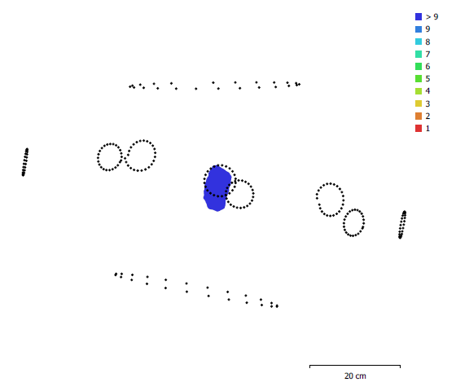
Fig. 1. Camera locations and image overlap of the 3D model of the preform of a bifacial piece TMBIII_UJ_A1_22.

3) Processing Parameters for the 3D model of the bifacial piece TMBIII_UJ_A1_17
General
Cameras 144
Aligned cameras 144
Markers 48
Scale bars 24
Coordinate system Local Coordinates (m)
Rotation angles Yaw, Pitch, Roll
Point Cloud
Points 220,247 of 267,713
RMS reprojection error 0.124631 (0.642417 pix)
Max reprojection error 0.498044 (34.0123 pix)
Mean key point size 3.96986 pix
Point colors 3 bands, uint8
Key points No
Average tie point multiplicity 2.97122
Optimization parameters
Parameters f, b1, b2, cx, cy, k1-k4, p1, p2
Adaptive camera model fitting Yes
Optimization time 6 seconds
Depth Maps
Count 144
Depth maps generation parameters
Quality High
Filtering mode Mild
Processing time 20 minutes 52 seconds
Dense Point Cloud
Points 5,097,445
Point colors 3 bands, uint8
Depth maps generation parameters
Quality High
Filtering mode Mild
Processing time 20 minutes 52 seconds
Dense cloud generation parameters
Processing time 21 minutes 39 seconds
Model
Faces 1,500,000
Vertices 750,002
Vertex colors 3 bands, uint8
Texture 4,096 x 4,096, 3 bands, uint8
Depth maps generation parameters
Quality High
Filtering mode Mild
Processing time 20 minutes 52 seconds
Reconstruction parameters
Surface type Arbitrary
Source data Dense cloud
Interpolation Enabled
Strict volumetric masks No
Processing time 3 minutes 49 seconds
Texturing parameters
Mapping mode Adaptive orthophoto
UV mapping time 1 minutes 36 seconds
System
Software name Agisoft Metashape Professional
Software version 1.6.2 build 10247
OS Windows 64 bit
RAM 63.85 GB
CPU Intel(R) Xeon(R) CPU E3-1505M v6 @ 3.00GHz
GPU(s) Quadro M2200

4) Proprieties of the 3D model of the bifacial piece TMBIII_UJ_A1_17
Scaling
Label Distance (m) Error (m)
target 1a_target 7a 0.045125 0.000125019
target 2a_target 8a 0.0451994 0.000199373
target 3a_target 9a 0.0451344 0.000134406
target 4a_target 10a 0.0450587 5.86679e-05
target 5a_target 11a 0.0450313 3.12711e-05
target 6a_target 12a 0.0450836 8.35893e-05
target 13a_target 19a 0.0904157 0.000415715
target 14a_target 20a 0.0904032 0.000403244
target 15a_target 21a 0.090201 0.000201025
target 16a_target 22a 0.0902375 0.000237535
target 17a_target 23a 0.0903285 0.000328475
target 18a_target 24a 0.0904194 0.000419413
target 1_target 7 0.0448457 -0.000154329
target 2_target 8 0.0449093 -9.07052e-05
target 3_target 9 0.0448479 -0.000152105
target 4_target 10 0.0447596 -0.000240361
target 5_target 11 0.0447226 -0.000277352
target 6_target 12 0.0447905 -0.000209486
target 13_target 19 0.089788 -0.000211957
target 14_target 20 0.0897805 -0.000219529
target 15_target 21 0.0895927 -0.000407294
target 16_target 22 0.0896041 -0.000395852
target 17_target 23 0.0896743 -0.000325701
target 18_target 24 0.0897831 -0.000216877
Total 0.000258481

Resolution: 0.0389 mm/pix
Point density: 661 points/mm²

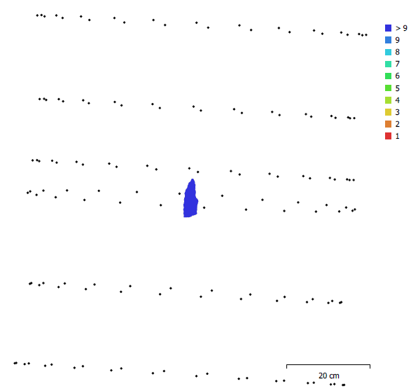
Fig. 2. Camera locations and image overlap of the 3D model of the bifacial piece TMBIII_UJ_A1_17.

5) Processing Parameters for the 3D model of the bifacial piece TMBIII_UJ_A1_16
General
Cameras 144
Aligned cameras 144
Markers 49
Scale bars 24
Coordinate system Local Coordinates (m)
Rotation angles Yaw, Pitch, Roll
Point Cloud
Points 270,647 of 356,434
RMS reprojection error 0.117386 (0.620041 pix)
Max reprojection error 0.377489 (22.0393 pix)
Mean key point size 4.09157 pix
Point colors 3 bands, uint8
Key points No
Average tie point multiplicity 2.7647
Depth Maps
Count 144
Depth maps generation parameters
Quality High
Filtering mode Mild
Processing time 21 minutes 32 seconds
Dense Point Cloud
Points 4,824,072
Point colors 3 bands, uint8
Depth maps generation parameters
Quality High
Filtering mode Mild
Processing time 21 minutes 32 seconds
Dense cloud generation parameters
Processing time 22 minutes 51 seconds
Model
Faces 1,500,000
Vertices 750,002
Vertex colors 3 bands, uint8
Texture 4,096 x 4,096, 4 bands, uint8
Depth maps generation parameters
Quality High
Filtering mode Mild
Processing time 21 minutes 32 seconds
Reconstruction parameters
Surface type Arbitrary
Source data Dense cloud
Interpolation Enabled
Strict volumetric masks Yes
Processing time 3 minutes 39 seconds
Texturing parameters
Mapping mode Adaptive orthophoto
Blending mode Mosaic
Texture size 4,096
Enable hole filling No
Enable ghosting filter No
UV mapping time 1 minutes 23 seconds
Blending time 50 seconds
System
Software name Agisoft Metashape Professional
Software version 1.6.2 build 10247
OS Windows 64 bit
RAM 63.85 GB
CPU Intel(R) Xeon(R) CPU E3-1505M v6 @ 3.00GHz
GPU(s) Quadro M2200

6) Proprieties of the 3D model of the bifacial piece TMBIII_UJ_A1_16
Scaling
Label Distance (m) Error (m)
target 1a_target 7a 0.0449075 -9.24726e-05
target 2a_target 8a 0.0449704 -2.95811e-05
target 3a_target 9a 0.0449154 -8.46143e-05
target 4a_target 10a 0.0448429 -0.000157058
target 5a_target 11a 0.0448095 -0.000190506
target 6a_target 12a 0.0448619 -0.000138099
target 13a_target 19a 0.0899791 -2.08946e-05
target 14a_target 20a 0.0899674 -3.25674e-05
target 15a_target 21a 0.0897844 -0.000215569
target 16a_target 22a 0.0898462 -0.000153761
target 17a_target 23a 0.0898021 -0.000197915
target 18a_target 24a 0.0899375 -6.2488e-05
target 1_target 7 0.0451131 0.000113129
target 2_target 8 0.0451761 0.000176091
target 3_target 9 0.0451121 0.000112142
target 4_target 10 0.0450302 3.01668e-05
target 5_target 11 0.0450202 2.01651e-05
target 6_target 12 0.0450546 5.45653e-05
target 14_target 20 0.0902015 0.000201529
target 15_target 21 0.0900685 6.8548e-05
target 16_target 22 0.0899277 -7.23403e-05
target 17_target 23 0.0900394 3.9362e-05
target 18_target 24 0.0902857 0.000285674
target 13_target 19 0.0902483 0.000248267
Total 0.000139541

Resolution: 0.0376 mm/pix
Point density: 706 points/mm²

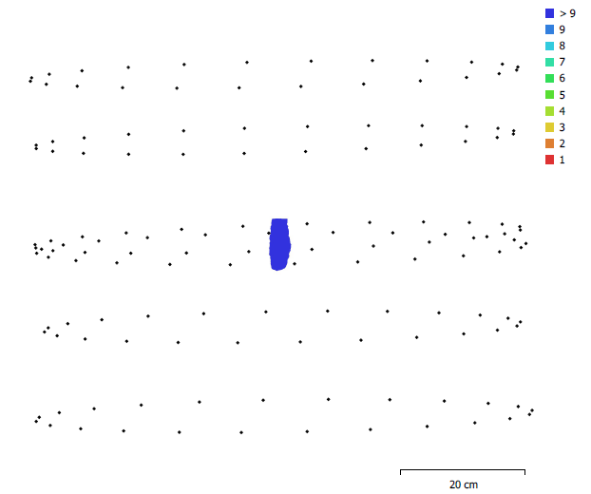
Fig. 3. Camera locations and image overlap of the 3D model of the bifacial piece TMBIII_UJ_A1_16.

SI 4 Frequency distribution of lithic artefacts at Toumboura III. a) Frequency distribution of lithic artefacts > 20 mm and small debitage by décapage in square A1; b) Frequency distribution of lithic artefacts > 20 mm and small debitage by décapage in square B1

a)
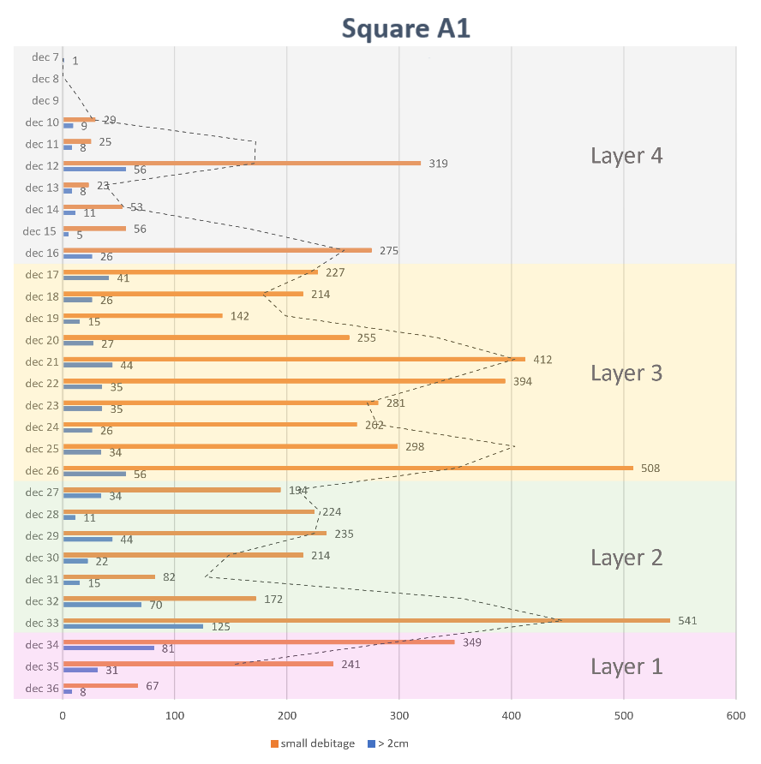
b)
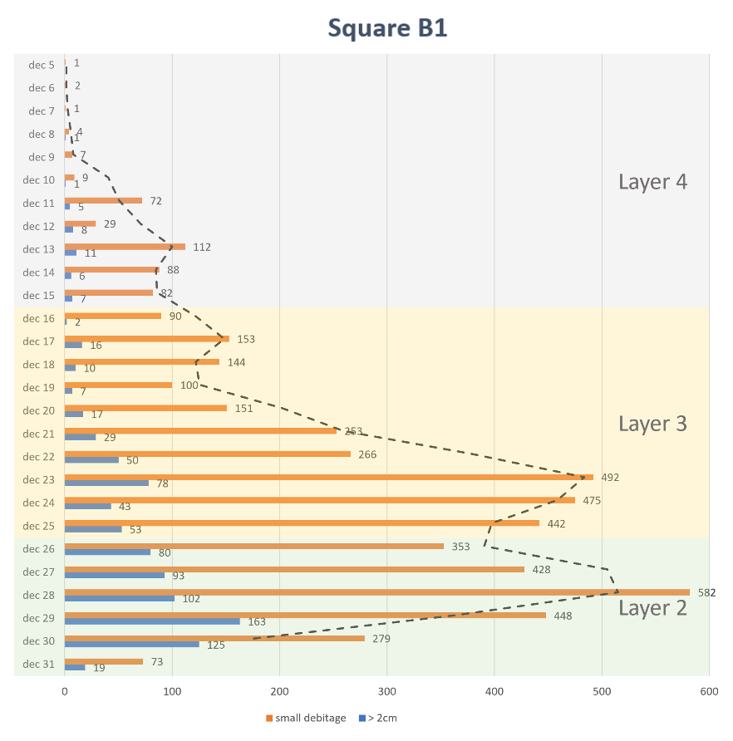

SI 5 Descriptive statistics of length, width, thickness, weight, platform depth, External Platform Angle (EPA), and Internal Platform Angle (IPA) of the different phases of shaping flakes from Toumboura III
 |  | Early  shaping |  | Advanced  shaping |  | Final shaping | Re-  structuration
Length (mm) | n | 71 |  | 92 |  | 8 | 3
 | Mean | 30.3 | Mann–Whitney U test  (early/advanced): | 24.5 | Mann–Whitney U test  (advanced/final): | 18.9 | 21
 | Median | 28.3 | U = 2,447.5 | 22.5 | U = 218 | 19.5 | 21.5
 | SD | 13.9 | p = 0.0078 | 8.6 | p = 0.0555 | 2.3 | 2.3
Width (mm) | n | 137 |  | 349 |  | 47 | 20
 | Mean | 31.4 | Mann–Whitney U test (early/advanced): | 25.9 | Mann–Whitney U test (advanced/final): | 21.0 | 24.2
 | Median | 29.2 | U = 17,890 | 24.2 | U = 4,848.5 | 21.0 | 23.5
 | SD | 12.5 | p < 0.0001 | 7.7 | p < 0.0001 | 2.5 | 5.1
Thickness (mm) | n | 277 |  | 683 |  | 77 | 32
 | Mean | 8.5 | Mann–Whitney U test (early/advanced): | 5.6 | Mann–Whitney U test (advanced/final): | 4.3 | 5.6
 | Median | 7.8 | U = 50,055 | 5.0 | U = 16,175 | 4.3 | 5.6
 | SD | 4.1 | p < 0.0001 | 2.2 | p < 0.0001 | 0.8 | 1.5
Weight (g) | n | 49 |  | 64 |  | 6 | 3
only completely preserved pieces considered | Mean | 15.3 | Mann–Whitney U test (early/advanced): | 5.6 | Mann–Whitney U test (advanced/final): | 1.3 | 3.0
 | Median | 7.0 | U = 950.5 | 4.0 | U = 58 | 1.0 | 2.0
 | SD | 20.6 | p = 0.0005 | 5.8 | p = 0.0028 | 0.5 | 1.7
Platform depth (mm) | n | 100 |  | 214 |  | 56 | 26
 | Mean | 7.6 | Mann–Whitney U test (early/advanced): | 4.2 | Mann–Whitney U test (advanced/final): | 2.8 | 5.4
 | Median | 6.6 | U = 4,942 | 3.7 | U = 3,517.5 | 2.6 | 5.1
 | SD | 4.9 | p < 0.0001 | 2.3 | p < 0.0001 | 0.9 | 1.7
Platform width (mm) | n | 67 |  | 161 |  | 45 | 19
 | Mean | 20.1 | Mann–Whitney U test (early/advanced): | 13.6 | Mann–Whitney U test (advanced/final): | 10.0 | 18.7
 | Median | 17.2 | U = 3,017 | 12.5 | U = 2,431 | 9.8 | 19.0
 | SD | 10.4 | p < 0.0001 | 6.3 | p = 0.0006 | 3.7 | 4.4
EPA (°) | n | 126 |  | 274 |  | 63 | 31
 | Mean | 71.6 | Mann–Whitney U test (early/advanced): | 68.2 | Mann–Whitney U test (advanced/final): | 63.0 | 68.6
 | Median | 74.0 | U = 13,666 | 69.5 | U = 5,480.5 | 62.0 | 70.0
 | SD | 12.8 | p = 0.0011 | 10.7 | p < 0.0001 | 7.5 | 10.6
IPA (°) | n | 126 |  | 274 |  | 63 | 31
 | Mean | 110.1 | Mann–Whitney U test (early/advanced): | 110.8 | Mann–Whitney U test (advanced/final): | 112.5 | 106.8
 | Median | 110.0 | U = 16,812 | 110.0 | U = 7,573.5 | 114.0 | 107.0
 | SD | 10.5 | p = 0.6766 | 9.7 | p = 0.1262 | 7.4 | 13.0

