Supplementary Information (SI)

Current Condition of the Iya in Benin City, the Gates and Future Preservation Strategies
African Archaeological Review

Christian Schepers, Jan Hubert, Uwagbale Edward-Ekpu, Caleb Adebayo Folorunso, Sofia Fonseca, Charles le Quesne, Oluwadamilare Omogbai, Jörg Linstädter

Corresponding Author: Christian Schepers, German Archaeological Institute, Commission for Archaeology of Non-European Cultures, scheperc@smail.uni-koeln.de

SI Figures
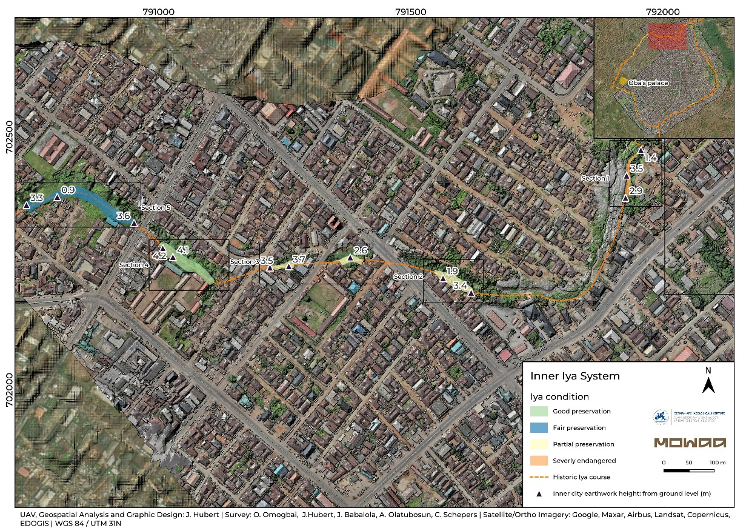
SI-Fig. 1 Iya Condition Sections 1-6

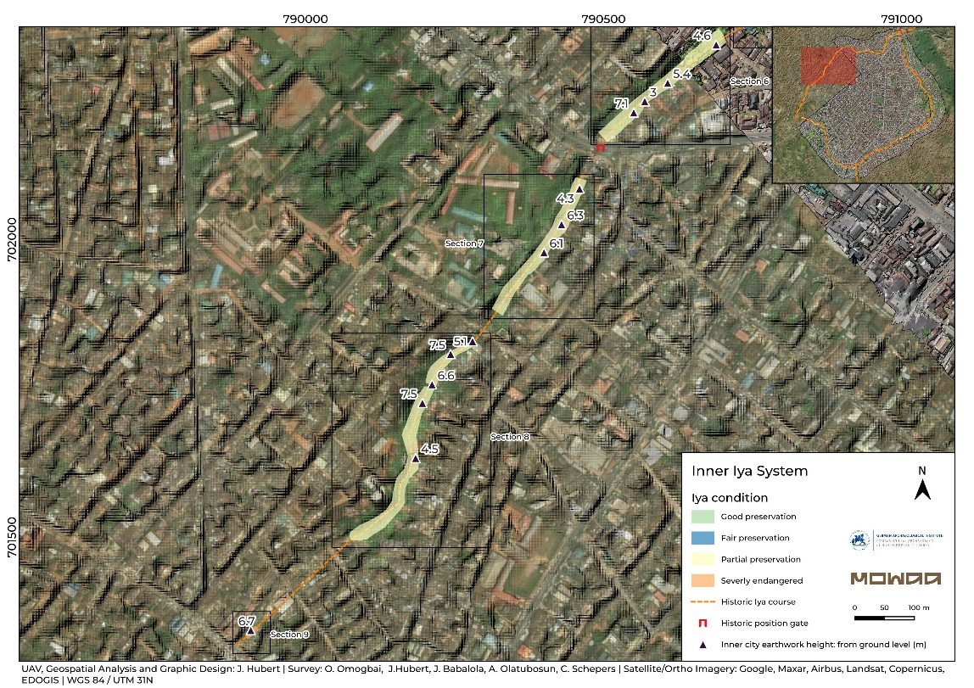
SI-Fig. 2 Iya Condition Sections 6-9

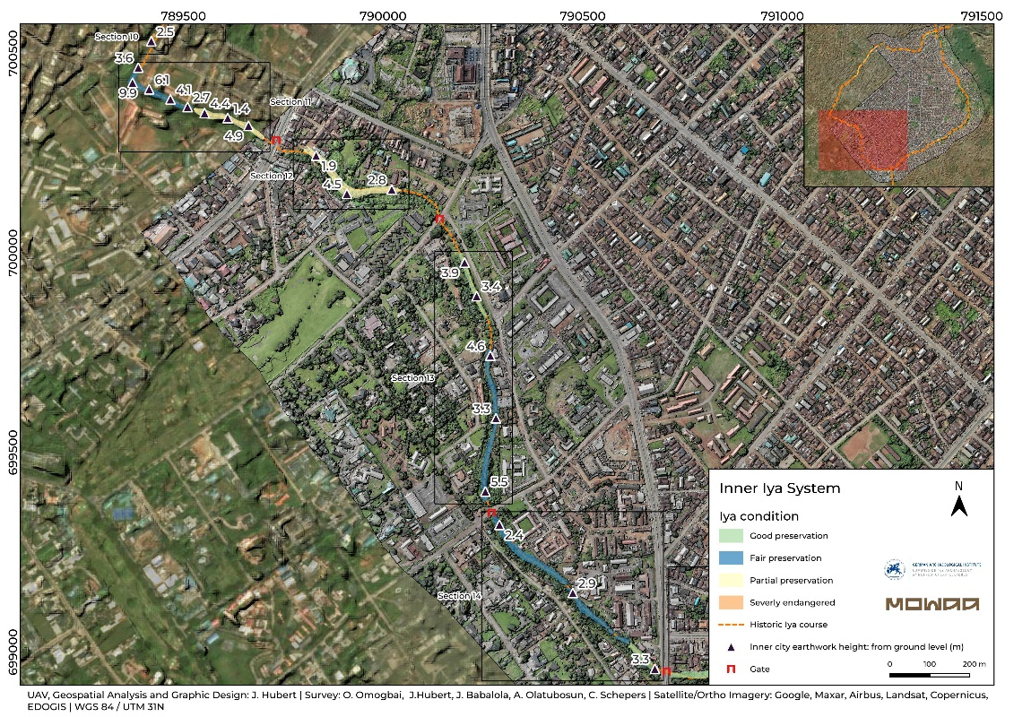
SI-Fig. 3 Iya Condition Sections 10-14

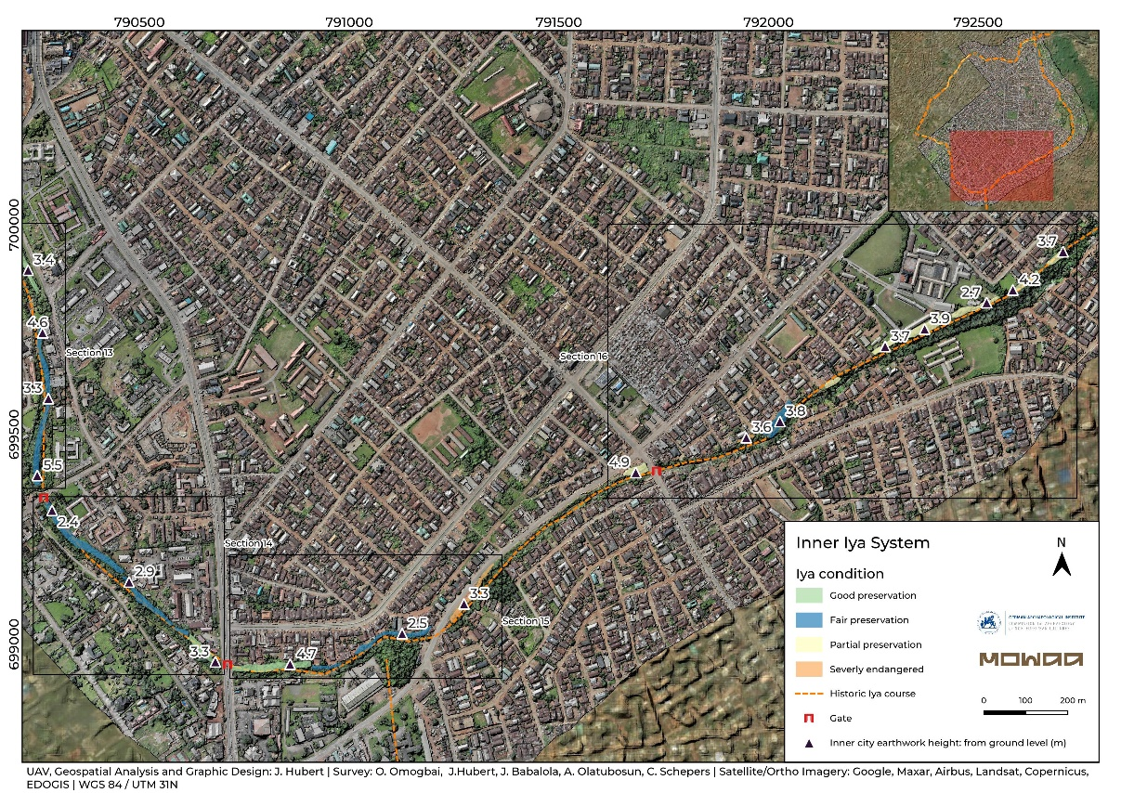
SI-Fig. 4 Iya Condition Sections 15-16

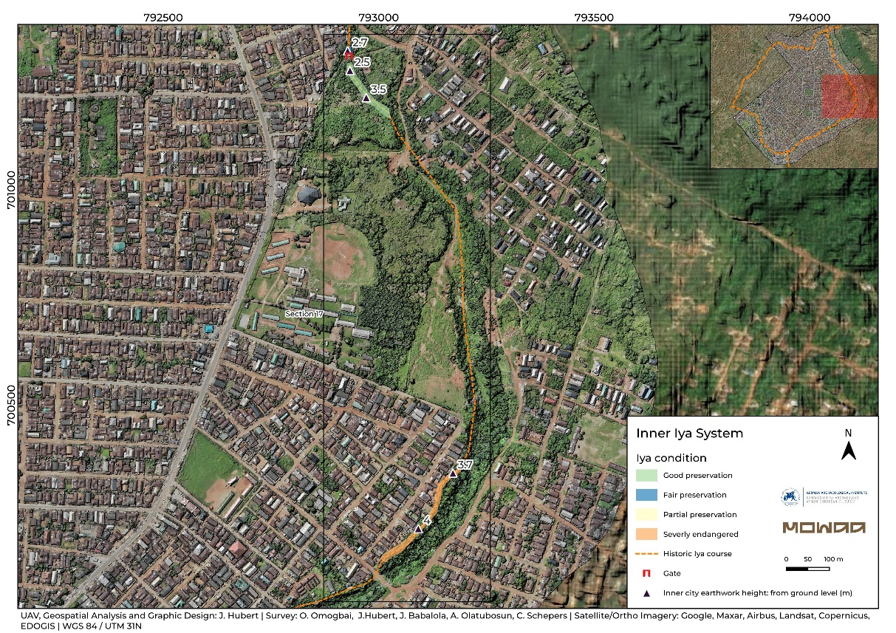
SI-Fig. 5 Iya Condition Sections 18

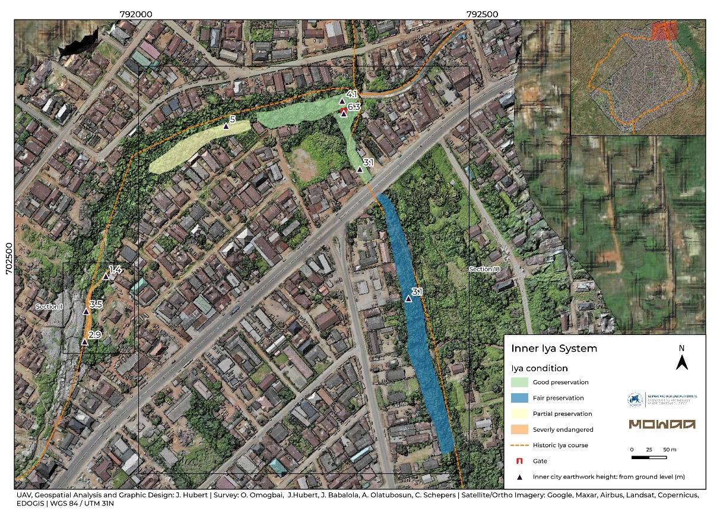
SI-Fig. 6 Iya Condition Section 18

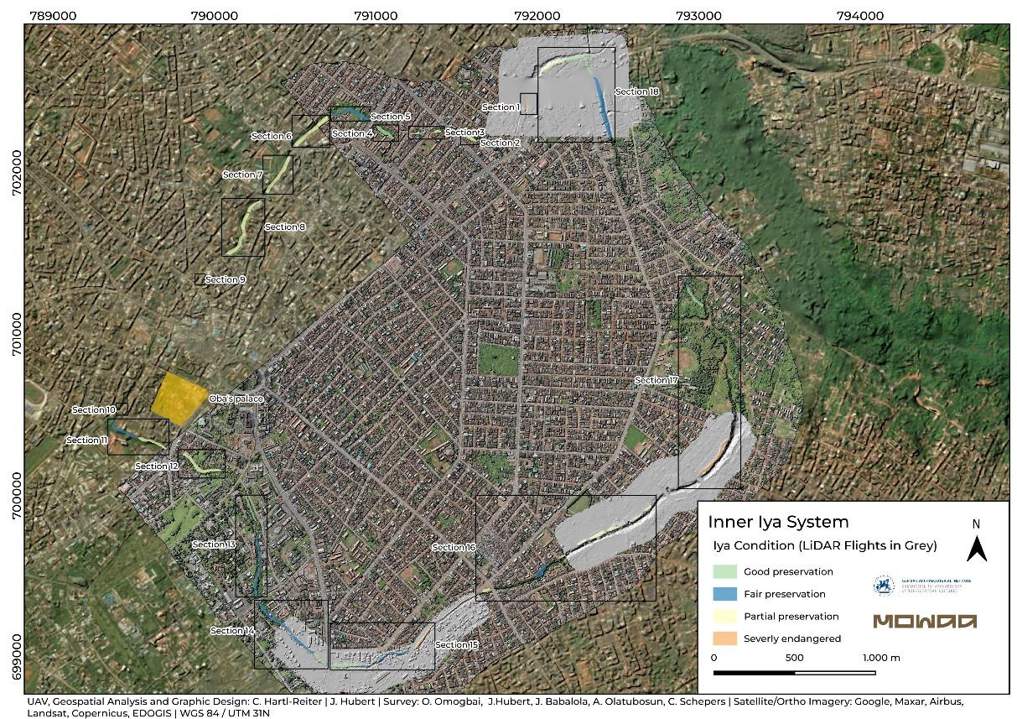
SI-Fig. 7 Inner City Iya of Benin with current Condition and three DTM derived from UAV LiDAR Data

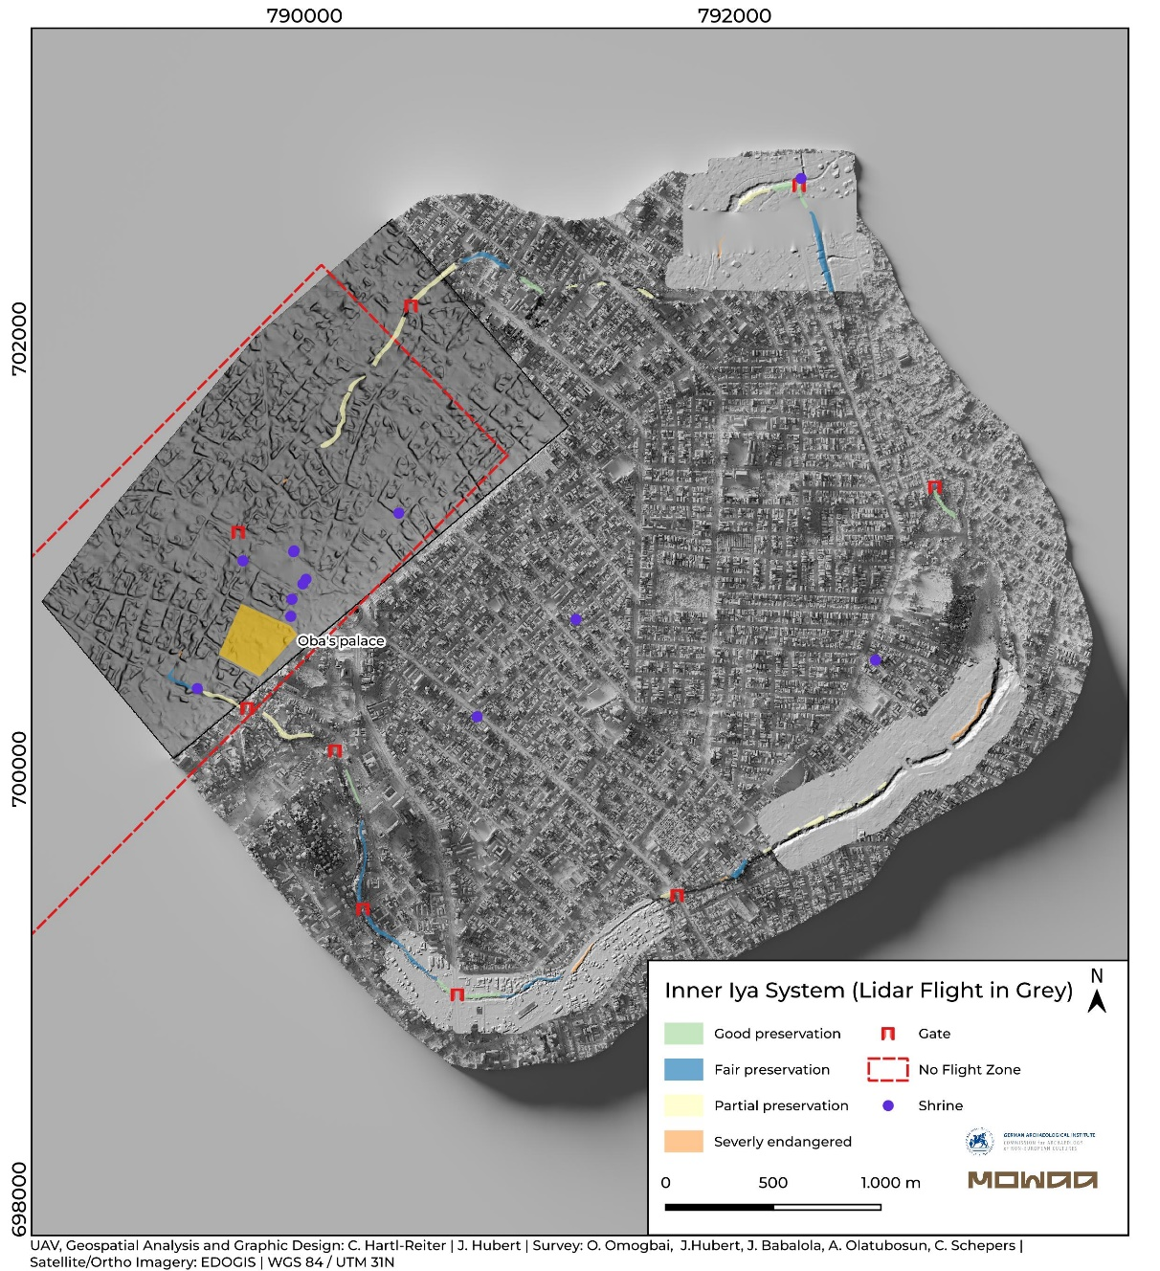
SI-Fig. 8 Inner City Iya of Benin with current Condition and three DTM derived from UAV LiDAR Data. Mapping of possible gates (Urho), shrines and the no flight zone affecting the survey. (Map by J. Hubert, UAV Data by C. Hartl-Reiter).

