ELECTRONIC SUPPLEMENTARY MATERIAL

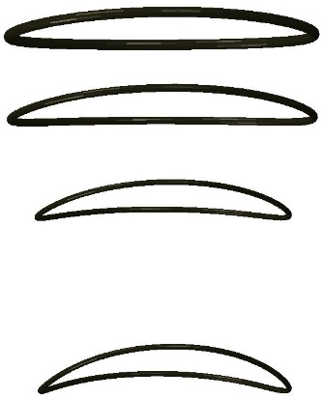
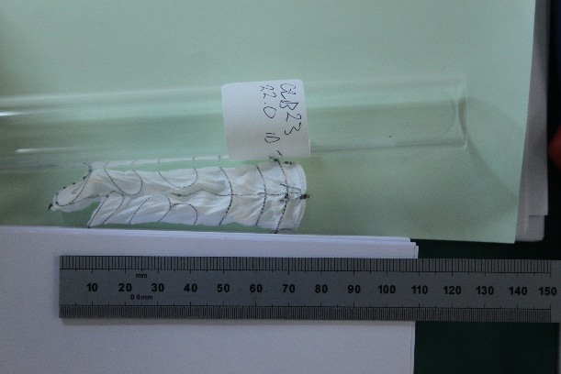
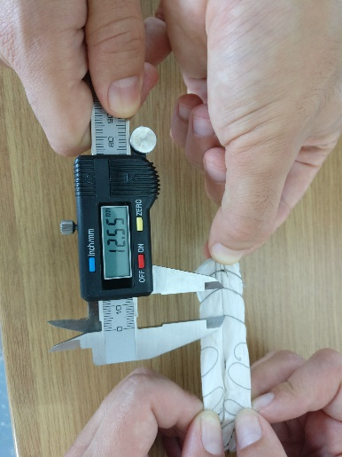
R1
R2
R4
R3
Peak
Valley
(a) (b) (c)
Fig. S1 The distance between R1-R2 and R3-R4 was measured at the peaks and the valleys (jointly named as saddles) of the OLB23 AnacondaTM endograft (a). The resting state (b) and the full extension state (c) were considered.

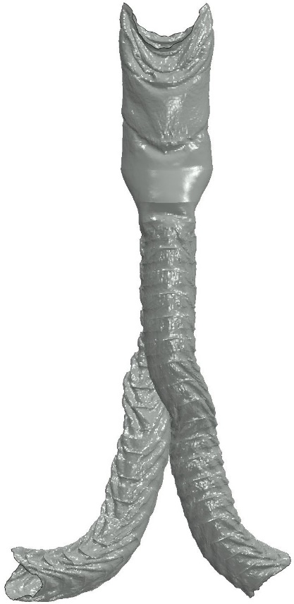
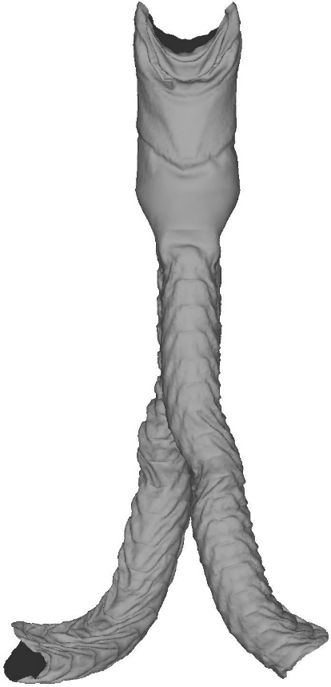
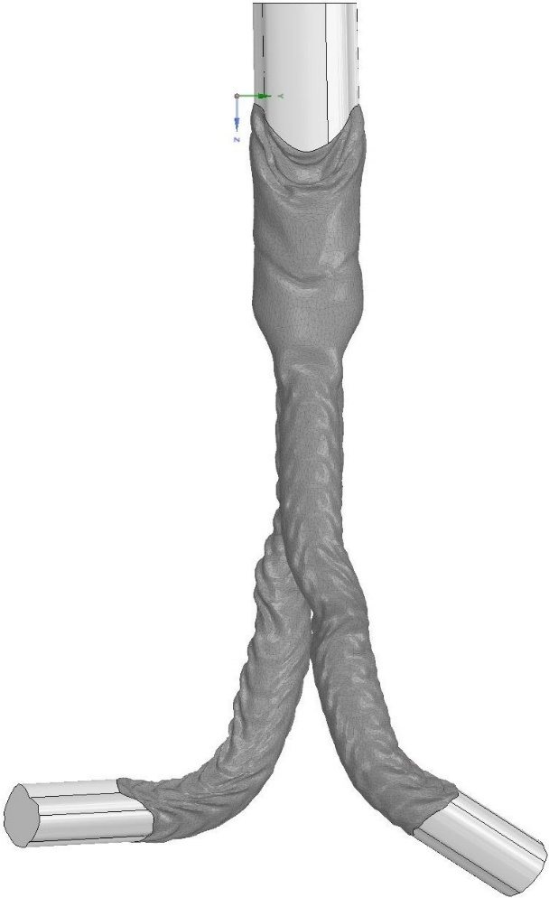
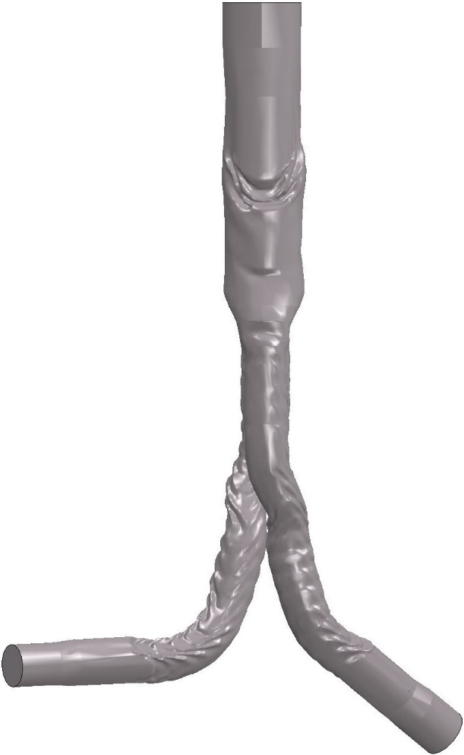
(a) (b)
(c) (d)
Fig. S2 The deformed fabric geometry exported as an FEA result (a), smoothened (b), attached to straight tubes (c) and reintroduced to Abaqus for CFD analysis (d).
Fig. S3 The velocity (left) and pressure (right) waveforms as implemented in the inlet and outlet of the aneurysm respectively. The black marks refer to the time-points of the maximum and minimum velocity inlet of the 3rd cycle, i.e. the time-points of output.

