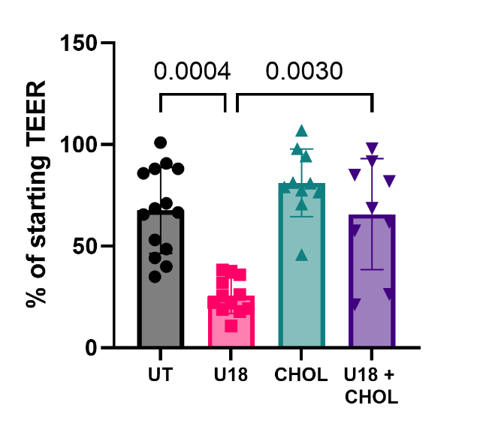

Supplemental Figure 1. Water-soluble cholesterol (CHOL) prevented loss of barrier function in U18666A-treated hiBMEC. TEER for hiBMEC that were untreated (UT) or treated with 10 μM U18666A (U18), 50 μM water-soluble cholesterol (CHOL), or both (U18 + CHOL) for 48 hours. n = 9-14 from 3 independent experiments. Statistical significance determined with Kruskal-Willis non-parametric test followed by Dunn’s multiple comparison test.

