Supplementary Information

S.1
Code Verification: A verification study was conducted to confirm accurate numerical implementation of the droplet deformation model. Published analytical solutions for droplet deformation in arbitrary shear, planar extensional, and uniaxial extensional flows that use the original expressions for f₁ and f₂ were used for the verification study [17]. The tensorial structure of the velocity gradient in each case is as follows: one non-zero component for simple shear flow ($\frac{{∂u}_{1}}{{∂x}_{2}}$), two non-zero components for planar hyperbolic flow ($\frac{{∂u}_{1}}{{∂x}_{1}}=-\frac{{∂u}_{2}}{{∂x}_{2}}$), and three non-zero components for uniaxial extensional flow ($\frac{{∂u}_{1}}{{∂x}_{1}}=-2\frac{{∂u}_{2}}{{∂x}_{2}}=-2\frac{{∂u}_{3}}{{∂x}_{3}}$). Time step refinement was used to evaluate the accuracy of the solutions in each case, using time steps from an order of 10⁻⁶ to 10⁻⁸ s. The numerical errors on the eigenvalues of S ${(λ}_{i}$) are shown in Figure S.1.1 for Ca = 0.2175. Error decays with time step refinement below 10⁻⁴ in all cases.
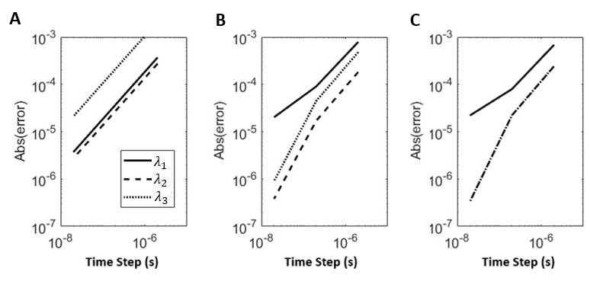
Figure S.1.1. Numerical verification study results. Three flow types are evaluated using time step refinement for code verification: (A) Simple Shear, (B) Planar Hyperbolic, and (C) Uniaxial Extensional Flow. The numerical error of solutions (the droplet eigenvalues, $λ_{i}$) at Ca = 0.2175 is plotted for each flow type.

S.2
Model Constitutive Parameter Modifications: The original form of f₁ from Maffettone and Minale’s droplet deformation model is shown in Eqn S.2.1[17]. There are two expressions presented for f₂: one which varies only with $α$ (Eqn S.2.2), and one that varies with both $α$ and Ca to capture deformation in high Ca flows (Eqn S.2.3)[17].

$f_{1}=\frac{40(α+1)}{(2α+3)(19α+16)}$(S.2.1)

$f_{2}=\frac{5}{2α+3}$ (S.2.2)

$f_{2}=\frac{5}{2α+3}+ \frac{3{Ca}^{2}}{2+6{Ca}^{2}}$ (S.2.3)

Deformation index comparisons using Eqn S.2.1 for f₁ and Eqn S.2.2 or Eqn S.2.3 for f₂ in shear flow (Plane 1 displayed only for brevity) are shown in Figure S.2.1. Data are presented in Figure S.2.1 with in vitro deformation results from this study. Deformation results using Eqn S.2.2 do not have accurate strain-rate-varying behavior, while results using f₂ as a function of Ca (Eqn S.2.3) predict droplet breakup prematurely.

Deformation index comparisons using Eqn S.2.1 for f₁ and Eqn S.2.2 for f₂ in extensional flow at 1,330 s⁻¹ (Plane 1 displayed only for brevity) are shown in Figure S.2.2. Data are presented in Figure S.2.2 with in vitro deformation results from this study. Data are only shown using Eqn S.2.2 for f₂ as droplet breakup was predicted in any case using Eqn S.2.3. The numerical behaviors shown in Figures S.2.1 and S.2.2 are generally preserved regardless of the droplet relaxation time.

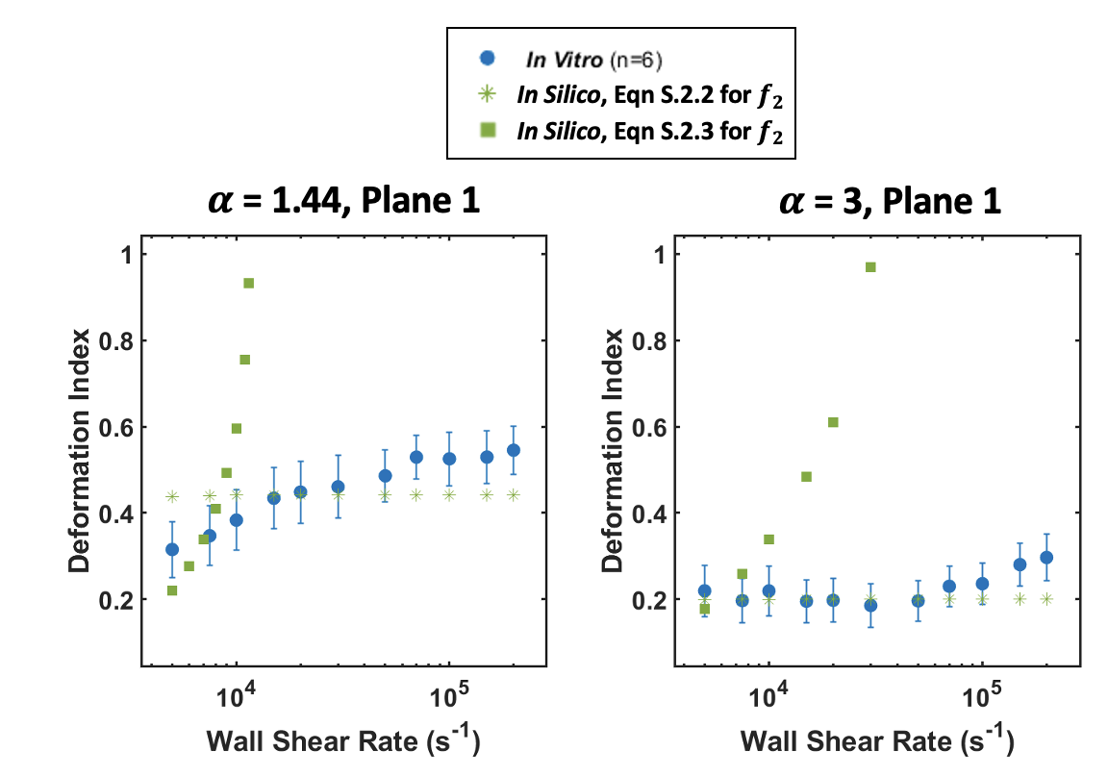

Figure S.2.1. In vitro and numerical shear flow results using Eqn S.2.1 for f₁ and Eqn S.2.2 or Eqn S.2.3 for f₂ at two viscosity conditions ($α=1.44$ and $α=3$). Data are shown in Plane 1 only for brevity.
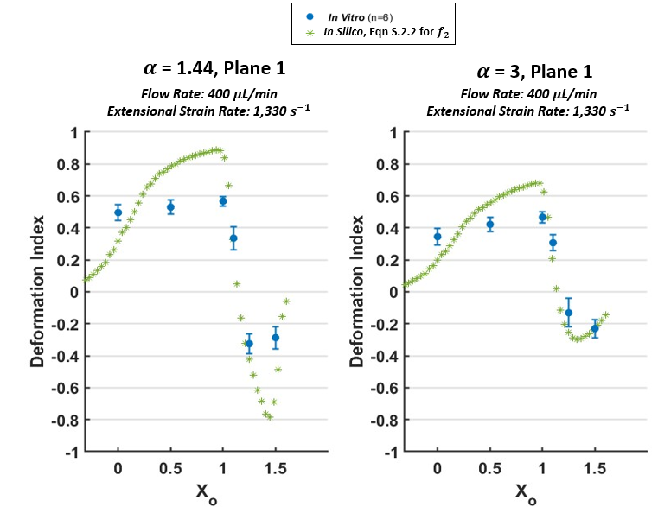
Figure S.2.2. In vitro and numerical extensional flow results using Eqn S.2.1 for f₁ and Eqn S.2.2 for f₂ at two viscosity conditions ($α=1.44$ and $α=3$). Data are shown in Plane 1 only for brevity.

These data demonstrated that f₂ required higher asymptotic limits to match the threshold deformations accurately in shear but also required a restorative effect to not produce premature droplet breakup at high strains and/or in extensional flows. Therefore, the coefficients on f₂ were modified to alter its asymptotic limits, while f₁ was modified to increase with increasing tensor magnitude to preserve droplet stability in high Ca flows. A hyperbolic tangent function was used to produce this increasing behavior for f₁ so that it remained bounded as physically required by the droplet deformation model. The modifications implemented to both parameters are shown in Figure S.2.3.

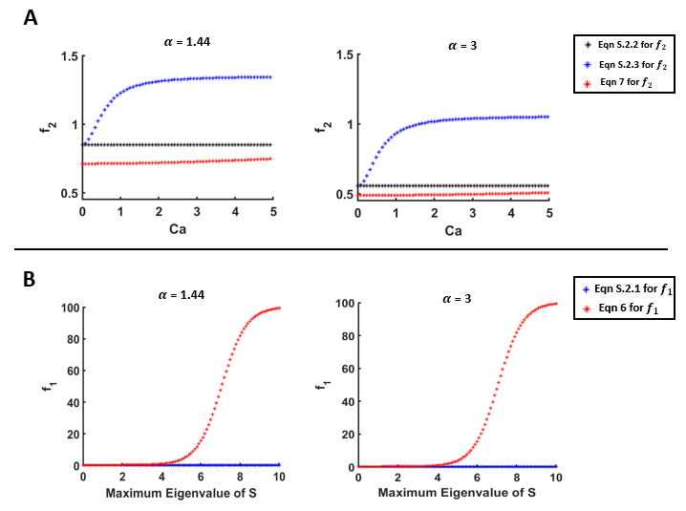Figure S.2.3. Dependence of f₂ on Ca and dependence of f₁ on the maximum eigenvalue of the morphology tensor. A: f₂ vs. Ca for both viscosity conditions, where the final expression for f₂ used in this study is shown with red markers. B: f₁ vs. the maximum eigenvalue of the morphology tensor, where the final expression for f₁ used in this study is shown with the red markers.

We note here for clarity that $f_{1}$and $f_{2}$ are dimensionless numerical coefficients that do not correspond directly to a single RBC mechanical property. Instead, they are the mathematical result of a first-order expansion of Eqn 3 which can be found in [31] and their values are restricted only by the physical requirements of the model (i.e., the parameters are non-negative and bounded). We therefore selected $f_{1}$and $f_{2}$ to ensure (1) stability of the morphology tensor and (2) recovery of experimentally measured asymptotic deformation limits (DI ≈0.6 at supraphysiological strain rates). Further, with these modifications implemented, droplet deformation remains physical according to the requirements presented by Maffettone and Minale: deformation varies linearly with Ca in low Ca flows and droplet volume is preserved at any Ca [17].
We also note here that the combination of all constitutive parameters ($τ{, f}_{1}$, and $f_{2}$) produce the in silico deformation behavior(s). As there is a wide range of experimentally determined interfacial tension values for the RBC membrane [32-36], $τ$ and Ca (and subsequently, $f_{1}$, and $f_{2}$) will be affected significantly by selecting a different interfacial tension value within this range. If a different value of interfacial tension is selected, the equations for$f_{1}$ and $f_{2}$ will need to be updated to reflect the differing relaxation dynamics.

S.3

Computational Refinement: The in silico solutions were verified to be independent of the computational mesh used. Three meshes were investigated for the simple shear channels: structured hex elements of 50,000, 112,000 and 180,000 cells were made with OpenFOAM’s (version 7) blockMesh utility. The grid was refined near the walls in the shear channels to capture high velocity gradients. The hyperbolic converging microchannel was meshed using Fidelity Pointwise 2023.1.1 (Cadence Design Systems, San Jose, CA), and the grid was refined near the channel walls and corners at its throat. Grids comprising of 58,000, 272,000, and 539,000 structured hex elements were used. The minimum and maximum flow rates were used for each flow type for the mesh independence study (manuscript text Table 2). The fluid mechanics were first deemed mesh independent using OpenFOAM v7 by comparing the velocity, pressure, and velocity gradient values at the regions of interest in the channels. For shear flow there was ~8% difference between the coarse and medium meshes, and a 1-2.2% difference between the medium and fine meshes for the flow parameters in both flow conditions. In extensional flow, there was a 6% difference in flow parameters between coarse and medium meshes and less than 2% differences between the medium and fine meshes. The deformation model was then run using each mesh. For shear flow, there was <5% difference in deformation results between the coarse and medium meshes and <1% difference in deformation results between the medium and fine meshes. For extensional flow, 6% difference in deformation existed between the coarse and medium meshes, while there was <1% difference in deformation between the medium and fine meshes. Therefore, the medium meshes were used for all in silico experiments.

S.4
Mean Absolute Error Values for In Silico Deformation Predictions: The mean absolute error (MAE, Eqn 13) was calculated for in silico DI data in both Plane 1 and Plane 2 for α = 3 and α = 1.44 across all shear and extensional flow conditions. The results from this analysis are shown in Table S.4.1, Table S.4.2, and Table S.4.3.
Table S.4.1 shows the MAE values across the 11 shear flow conditions in both Plane 1 and Plane 2 for both viscosity conditions (α = 1.44 and α = 3). Table S.4.2 shows the MAE values across the 3 extensional flow conditions at each of the 6 imaging locations (X_{o} = 0, 0.5, 1, 1.1, 1.25, and 1.5) in both Plane 1 and Plane 2 for α = 1.44. Table S.4.3 shows the MAE values across the 3 extensional flow conditions at each of the 6 imaging locations (X_{o} = 0, 0.5, 1, 1.1, 1.25, and 1.5) in both Plane 1 and Plane 2 for α = 3.

Table S.4.1. MAE values of the in silico DI prediction compared with in vitro DI values across 11 shear flow conditions in two visualization planes (Plane 1, Plane 2) and two viscosity conditions (α = 1.44 and α = 3).
 |  | α = 1.44 |  | α = 3
 |  | Plane 1 | Plane 2 | Plane 1 | Plane 2
Wall Shear Rate, ${\dot{γ}}_{Shear}$ (s⁻¹) | 5,000 | 0.12 | 0.09 | 0.09 | 0.10
Wall Shear Rate, ${\dot{γ}}_{Shear}$ (s⁻¹) | 7,500 | 0.12 | 0.08 | 0.10 | 0.09
Wall Shear Rate, ${\dot{γ}}_{Shear}$ (s⁻¹) | 10,000 | 0.15 | 0.08 | 0.11 | 0.09
Wall Shear Rate, ${\dot{γ}}_{Shear}$ (s⁻¹) | 15,000 | 0.14 | 0.07 | 0.09 | 0.10
Wall Shear Rate, ${\dot{γ}}_{Shear}$ (s⁻¹) | 20,000 | 0.15 | 0.06 | 0.09 | 0.10
Wall Shear Rate, ${\dot{γ}}_{Shear}$ (s⁻¹) | 30,000 | 0.14 | 0.06 | 0.10 | 0.09
Wall Shear Rate, ${\dot{γ}}_{Shear}$ (s⁻¹) | 50,000 | 0.11 | 0.05 | 0.09 | 0.09
Wall Shear Rate, ${\dot{γ}}_{Shear}$ (s⁻¹) | 70,000 | 0.09 | 0.06 | 0.09 | 0.11
Wall Shear Rate, ${\dot{γ}}_{Shear}$ (s⁻¹) | 100,000 | 0.12 | 0.06 | 0.10 | 0.10
Wall Shear Rate, ${\dot{γ}}_{Shear}$ (s⁻¹) | 150,000 | 0.11 | 0.05 | 0.10 | 0.09
Wall Shear Rate, ${\dot{γ}}_{Shear}$ (s⁻¹) | 200,000 | 0.10 | 0.06 | 0.08 | 0.09

Table S.4.2. MAE values of the in silico DI value compared with in vitro deformation data at each of the 6 imaging locations in the hyperbolic converging microchannel (X_{o} = 0, 0.5, 1, 1.1, 1.25, and 1.5) in both visualization planes (Plane 1, Plane 2) for α = 1.44.
 |  | Plane 1 |  |  |  |  |  | Plane 2
X_{o} |  | 0 | 0.5 | 1 | 1.1 | 1.25 | 1.5 | 0 | 0.5 | 1 | 1.1 | 1.25 | 1.5
Extensional Strain Rate, ~2*${\dot{γ}}_{Extension}$ (s⁻¹) | 330 | 0.17 | 0.15 | 0.12 | 0.10 | 0.10 | 0.19 | 0.17 | 0.13 | 0.14 | 0.11 | 0.11 | 0.17
Extensional Strain Rate, ~2*${\dot{γ}}_{Extension}$ (s⁻¹) | 670 | 0.17 | 0.10 | 0.09 | 0.10 | 0.12 | 0.15 | 0.17 | 0.10 | 0.11 | 0.16 | 0.12 | 0.16
Extensional Strain Rate, ~2*${\dot{γ}}_{Extension}$ (s⁻¹) | 1,330 | 0.13 | 0.09 | 0.06 | 0.09 | 0.13 | 0.08 | 0.11 | 0.12 | 0.11 | 0.11 | 0.14 | 0.08

Table S.4.3. MAE values of the in silico DI value compared with in vitro deformation data at each of the 6 imaging locations in the hyperbolic converging microchannel (X_{o} = 0, 0.5, 1, 1.1, 1.25, and 1.5) in both visualization planes (Plane 1, Plane 2) for α = 3.
 |  | Plane 1 |  |  |  |  |  | Plane 2
X_{o} |  | 0 | 0.5 | 1 | 1.1 | 1.25 | 1.5 | 0 | 0.5 | 1 | 1.1 | 1.25 | 1.5
Extensional Strain Rate, ~2*${\dot{γ}}_{Extension}$ (s⁻¹) | 330 | 0.19 | 0.17 | 0.17 | 0.08 | 0.09 | 0.18 | 0.15 | 0.12 | 0.13 | 0.10 | 0.12 | 0.18
Extensional Strain Rate, ~2*${\dot{γ}}_{Extension}$ (s⁻¹) | 670 | 0.20 | 0.11 | 0.09 | 0.10 | 0.07 | 0.13 | 0.14 | 0.08 | 0.08 | 0.10 | 0.09 | 0.15
Extensional Strain Rate, ~2*${\dot{γ}}_{Extension}$ (s⁻¹) | 1,330 | 0.17 | 0.09 | 0.07 | 0.22 | 0.08 | 0.05 | 0.17 | 0.10 | 0.10 | 0.22 | 0.13 | 0.08

S.5

Inter- and Intra-Donor RBC Deformation Variability: To evaluate the per-donor variance in in vitro DI measurements, intraclass correlation coefficients (ICCs, Eqn S.5.1) were quantified across the conditions tested in this study. This method has been used in previous studies to evaluate inter- and intra- donor blood measurement variability [40].
Briefly, the ICC is a ratio between the inter-donor DI variance ($σ_{Between Donors}^{2}$) and the combined sum of inter-donor and average intra-donor DI variance ($σ_{Between Donors}^{2}, σ_{Within Donors}^{2}$, respectively). This analysis was completed for a subset of the experimental conditions tested in our study for brevity.
$ICC= \frac{σ_{Between Donors}^{2}}{σ_{Between Donors}^{2}+σ_{Within Donors}^{2}}$ (S.5.1)
ICC values in shear flow for 5,000, 20,000, 100,000, and 200,000 s⁻¹ are shown in Table S.5.1 for both visualization planes (Pane 1, Plane 2) and both viscosity conditions (α=1.44, α=3). The shear flow ICC values range from 0.01 – 0.34, indicating that 1-34% of the total variability in shear flow-induced deformation data is attributed inter-donor RBC variability.
Table S.5.1. ICC values across 11 shear flow conditions for two visualization planes (Plane 1, Plane 2) and two viscosity conditions (α=1.44 and α=3).
 |  | α=1.44 |  | α=3
 |  | Plane 1 | Plane 2 | Plane 1 | Plane 2
Shear Rate (s⁻¹) | 5,000 | 0.30 | 0.05 | 0.34 | 0.01
Shear Rate (s⁻¹) | 20,000 | 0.23 | 0.03 | 0.19 | 0.08
Shear Rate (s⁻¹) | 100,000 | 0.03 | 0.02 | 0.05 | 0.1
Shear Rate (s⁻¹) | 200,000 | 0.08 | 0.01 | 0.08 | 0.05

ICC values in extensional flow at X_{o} = 1 (peak extensional strain) are shown for the three flow conditions tested (300, 670, 1,300 s⁻¹) in both planes (Plane 1, Plane 2) for both viscosity conditions (α=1.44, α=3) in Table S.5.2. The extensional flow ICC values at X_{o} = 1 range from 0.03 – 0.28, indicating that 3-28% of the total variability in extensional flow-induced deformation data is attributed inter-donor RBC variability.
Table S.5.2. ICC values across 3 extensional flow conditions at X_{o} = 1 for two visualization planes (Plane 1, Plane 2) and two viscosity conditions (α=1.44 and α=3).
 |  | α=1.44 |  | α=3
 |  | Plane 1 | Plane 2 | Plane 1 | Plane 2
Extensional Strain Rate (s⁻¹) | 330 | 0.14 | 0.16 | 0.04 | 0.15
Extensional Strain Rate (s⁻¹) | 670 | 0.20 | 0.19 | 0.09 | 0.09
Extensional Strain Rate (s⁻¹) | 1,330 | 0.10 | 0.28 | 0.05 | 0.03

Further, ICC values in extensional flow at X_{o} = 1.5 are shown for both planes (Plane 1, Plane 2) and both viscosity conditions (α=1.44, α=3) in Table S.5.3. The extensional flow ICC values at X_{o} = 1.5 range from 0.06 – 0.35, indicating that 6-35% of the total variability in these flow-induced deformation data is attributed inter-donor RBC variability.

Table S.5.3. ICC values across 3 extensional flow conditions at X_{o} = 1.5 for two visualization planes (Plane 1, Plane 2) and two viscosity conditions (α=1.44 and α=3).
 |  | α=1.44 |  | α=3
 |  | Plane 1 | Plane 2 | Plane 1 | Plane 2
Extensional Strain Rate (s⁻¹) | 330 | 0.31 | 0.08 | 0.35 | 0.06
Extensional Strain Rate (s⁻¹) | 670 | 0.15 | 0.33 | 0.25 | 0.17
Extensional Strain Rate (s⁻¹) | 1,330 | 0.22 | 0.20 | 0.24 | 0.06

