Supplemental Digital Content 1
Optimising Fronto-orbital Distraction for Management of Unicoronal Craniosynostosis

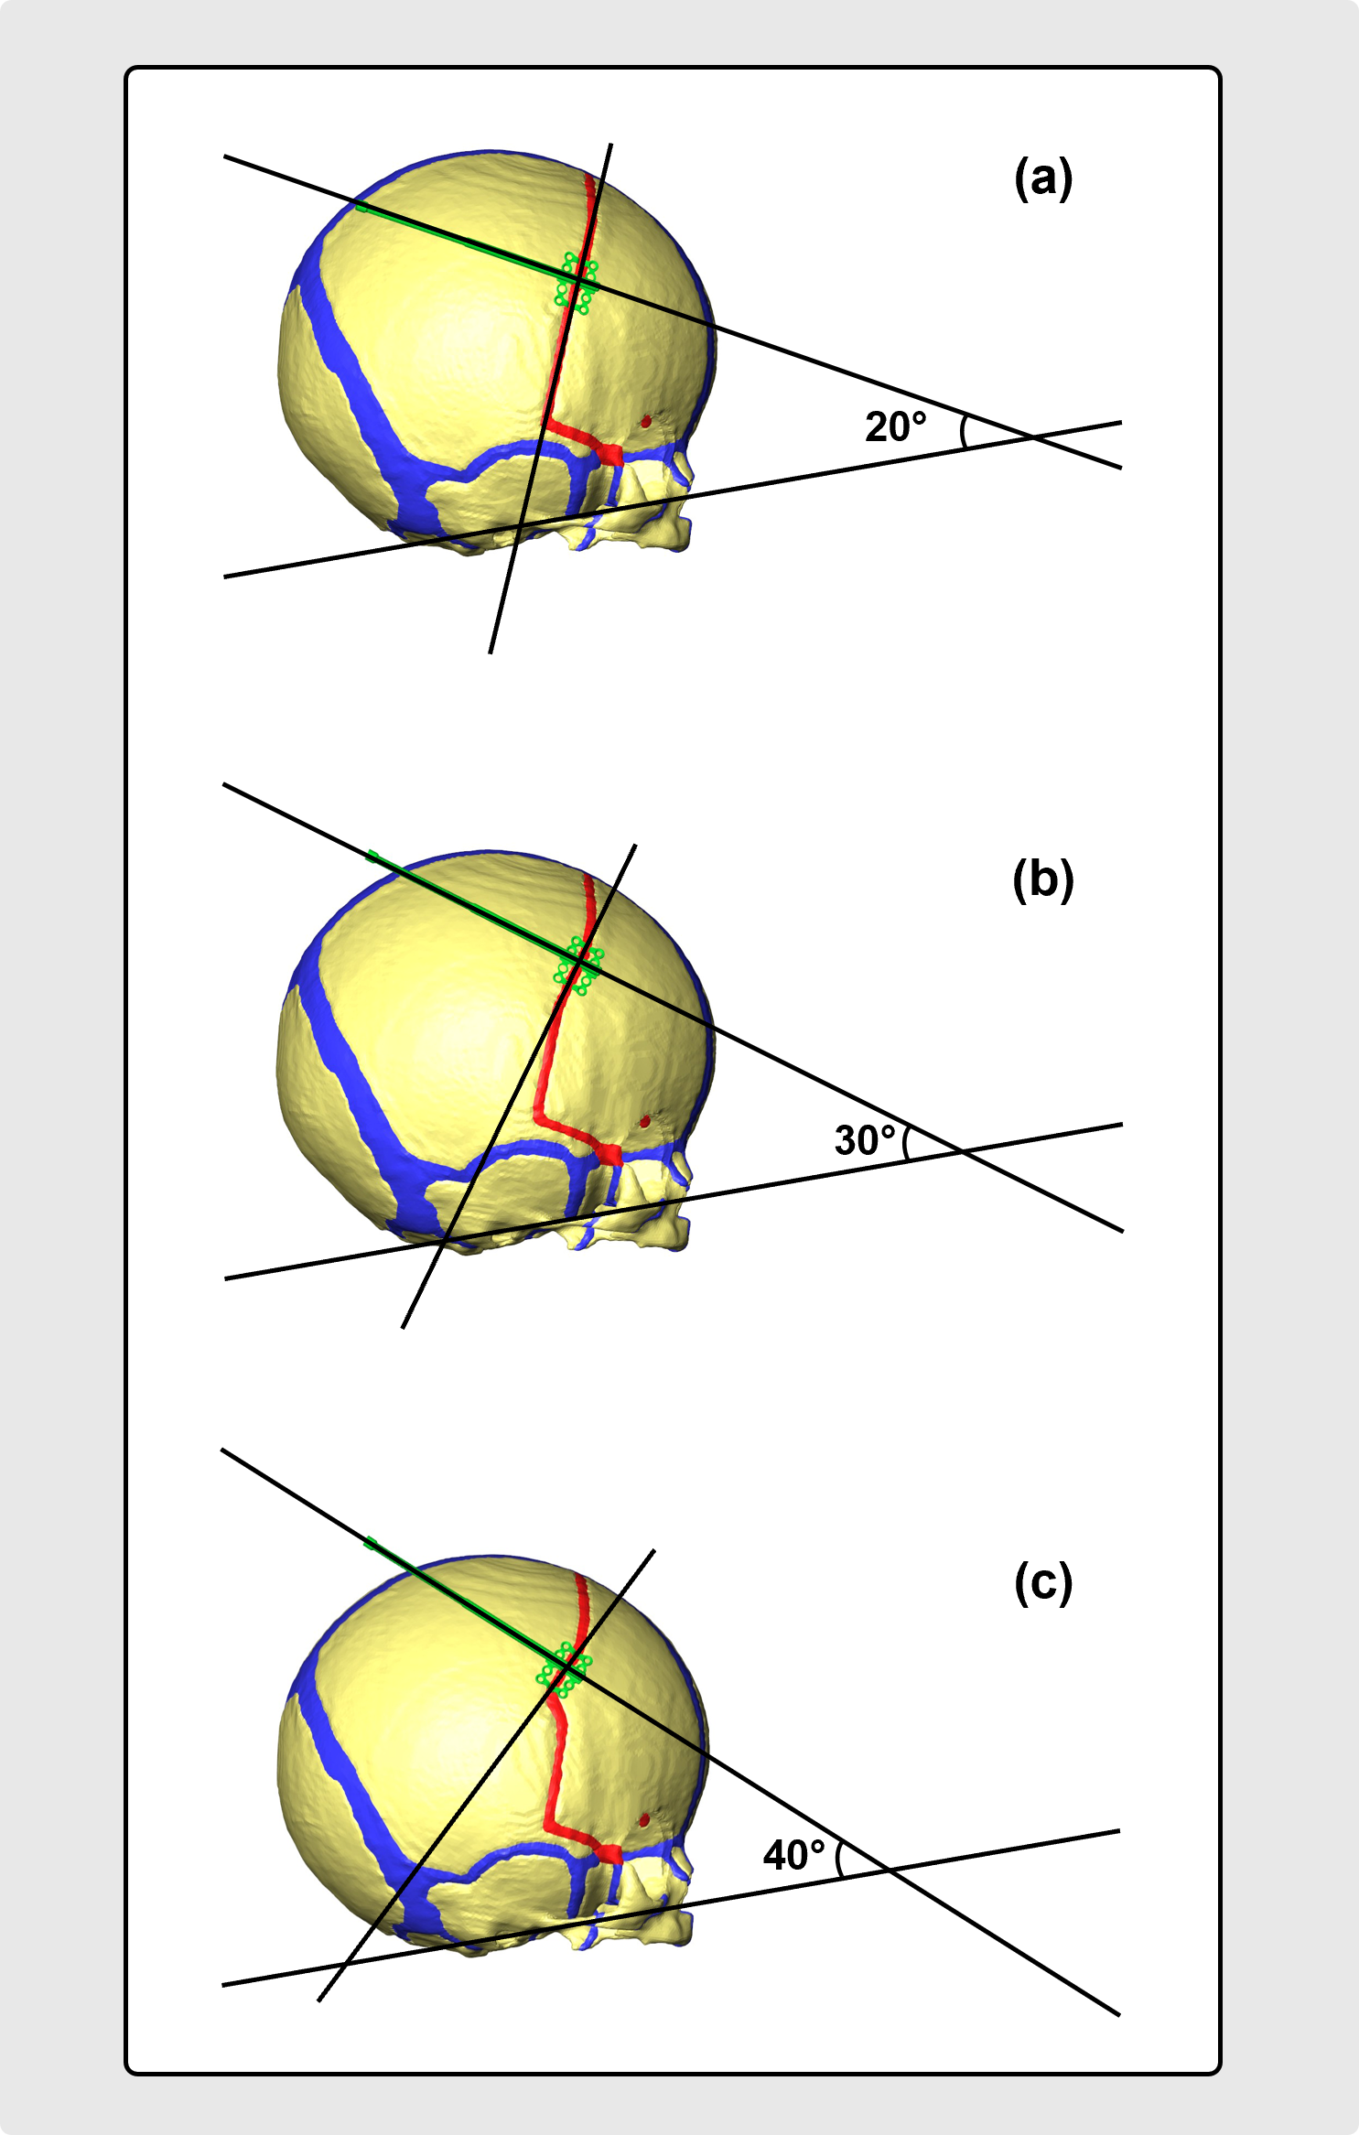
Fig. 1. Preoperative computational models of UCS patient showing angles [(a) 20°, (b) 30°, and (c) 40°] relative to the Frankfurt horizontal plane.

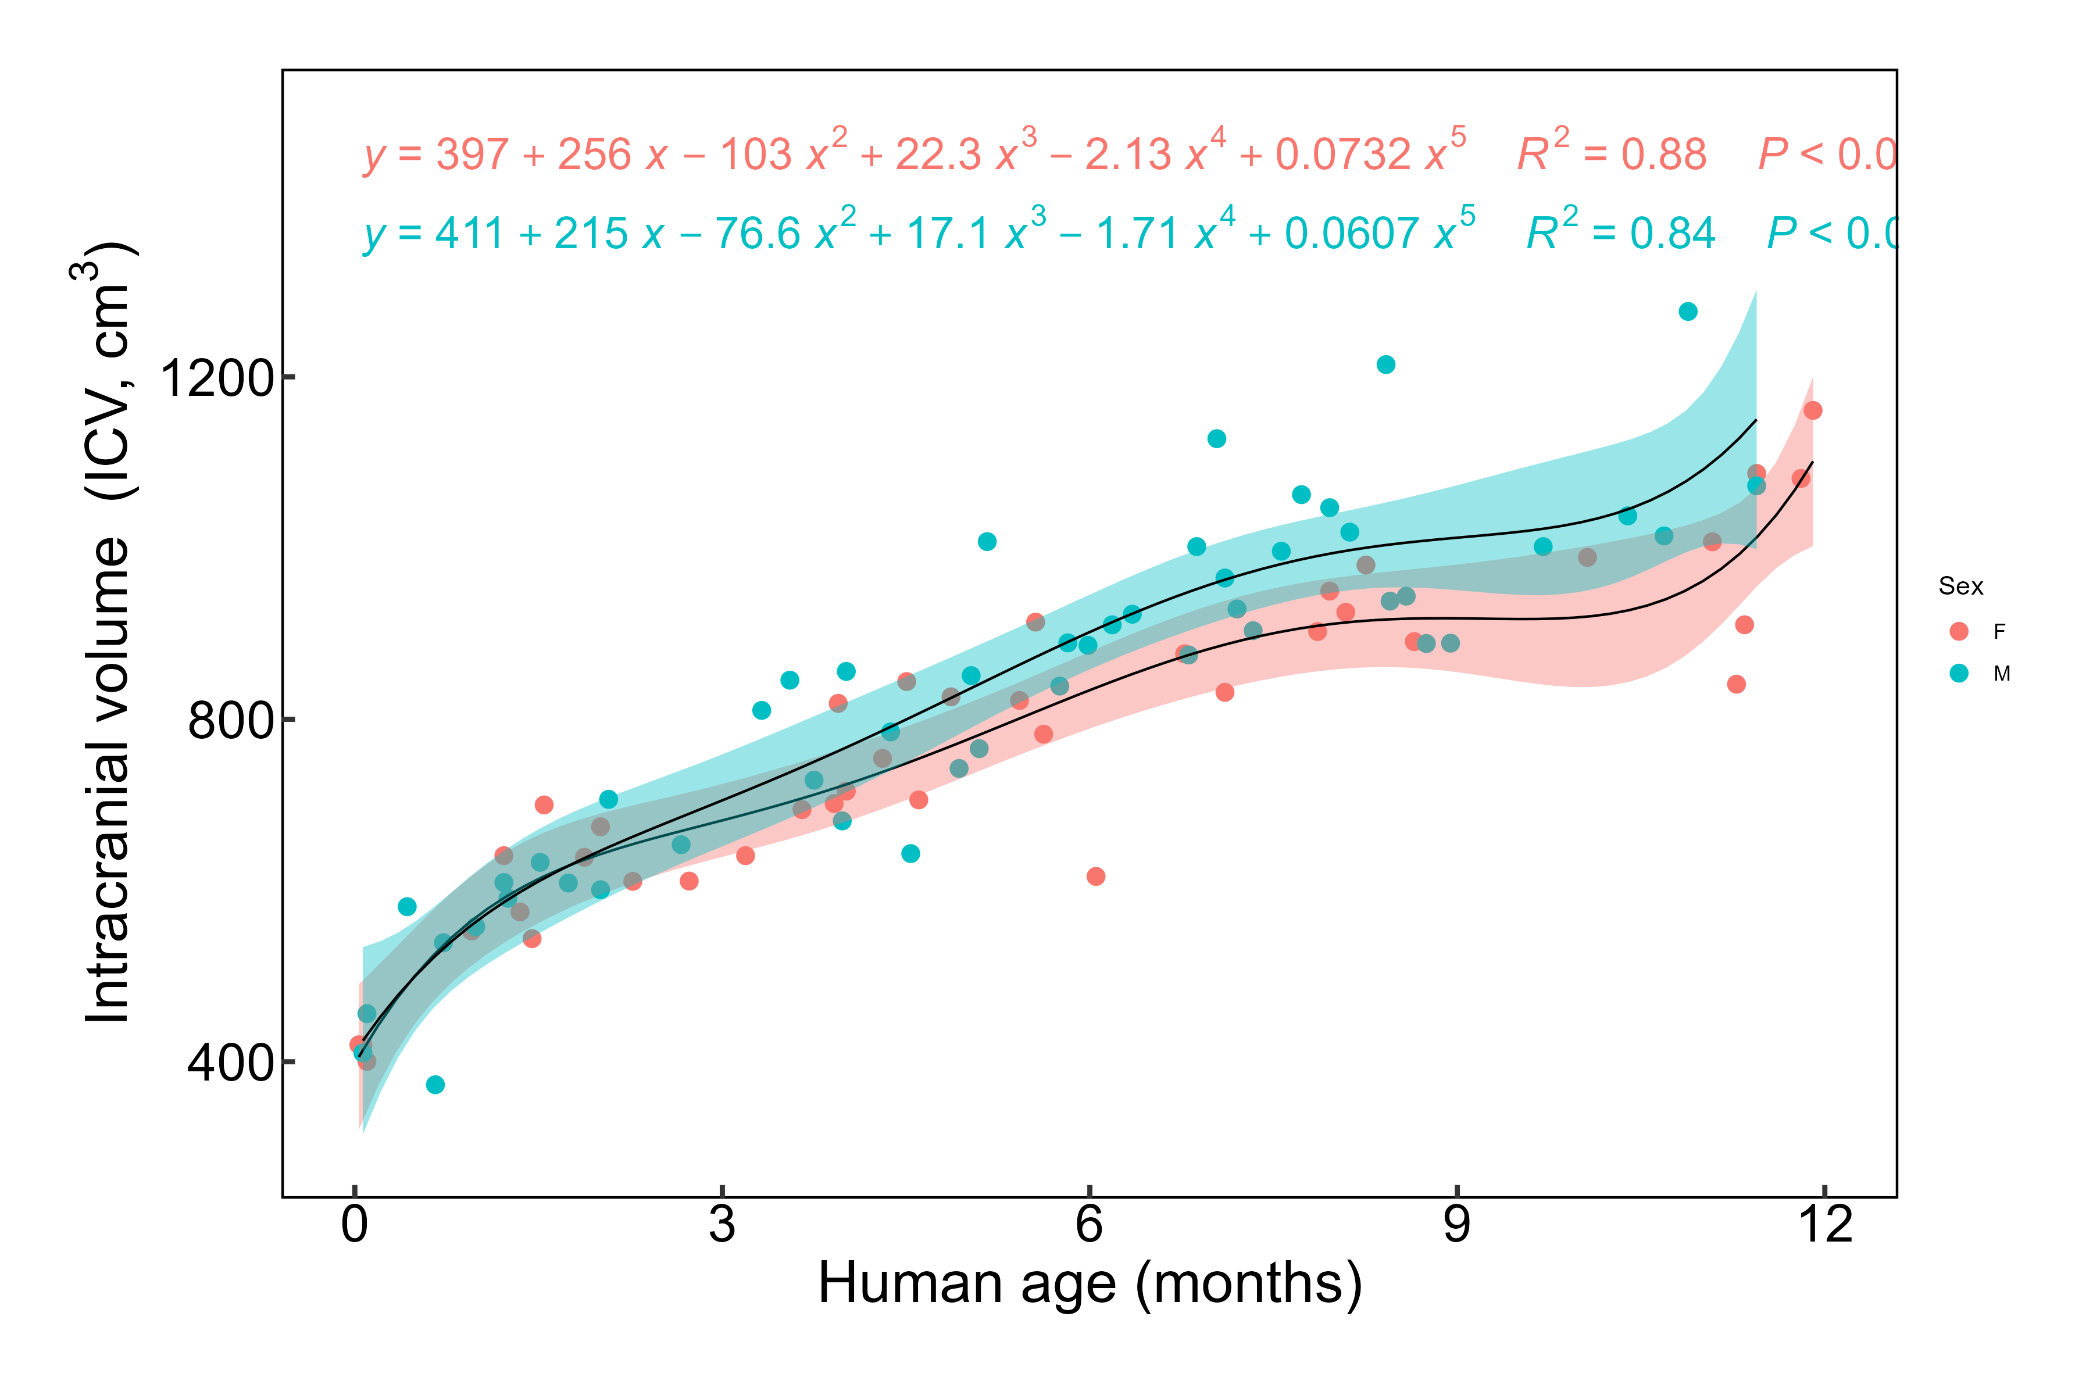
Fig 2. Normative intracranial-volume (ICV) growth, 0–12 months. Sex-specific fifth-order polynomial fits to the normative ICV-versus-age data of Liang et al. ⁴⁸ (female, red; male, teal). Female fit: ICV(x) = 397 + 256x − 103x² + 22.3x³ − 2.13x⁴ + 0.0732x⁵ (R² = 0.88). This 0–12-month curve was derived from the dataset of Liang et al. ⁴⁸ and used to set the age-specific intracranial-volume growth targets; for the predictive analysis, it was anchored to the patient by a constant offset so that it passed through the measured preoperative ICV. The 0–12-month restriction is previously unpublished and is reproduced with permission from the authors of Liang et al. ⁴⁸

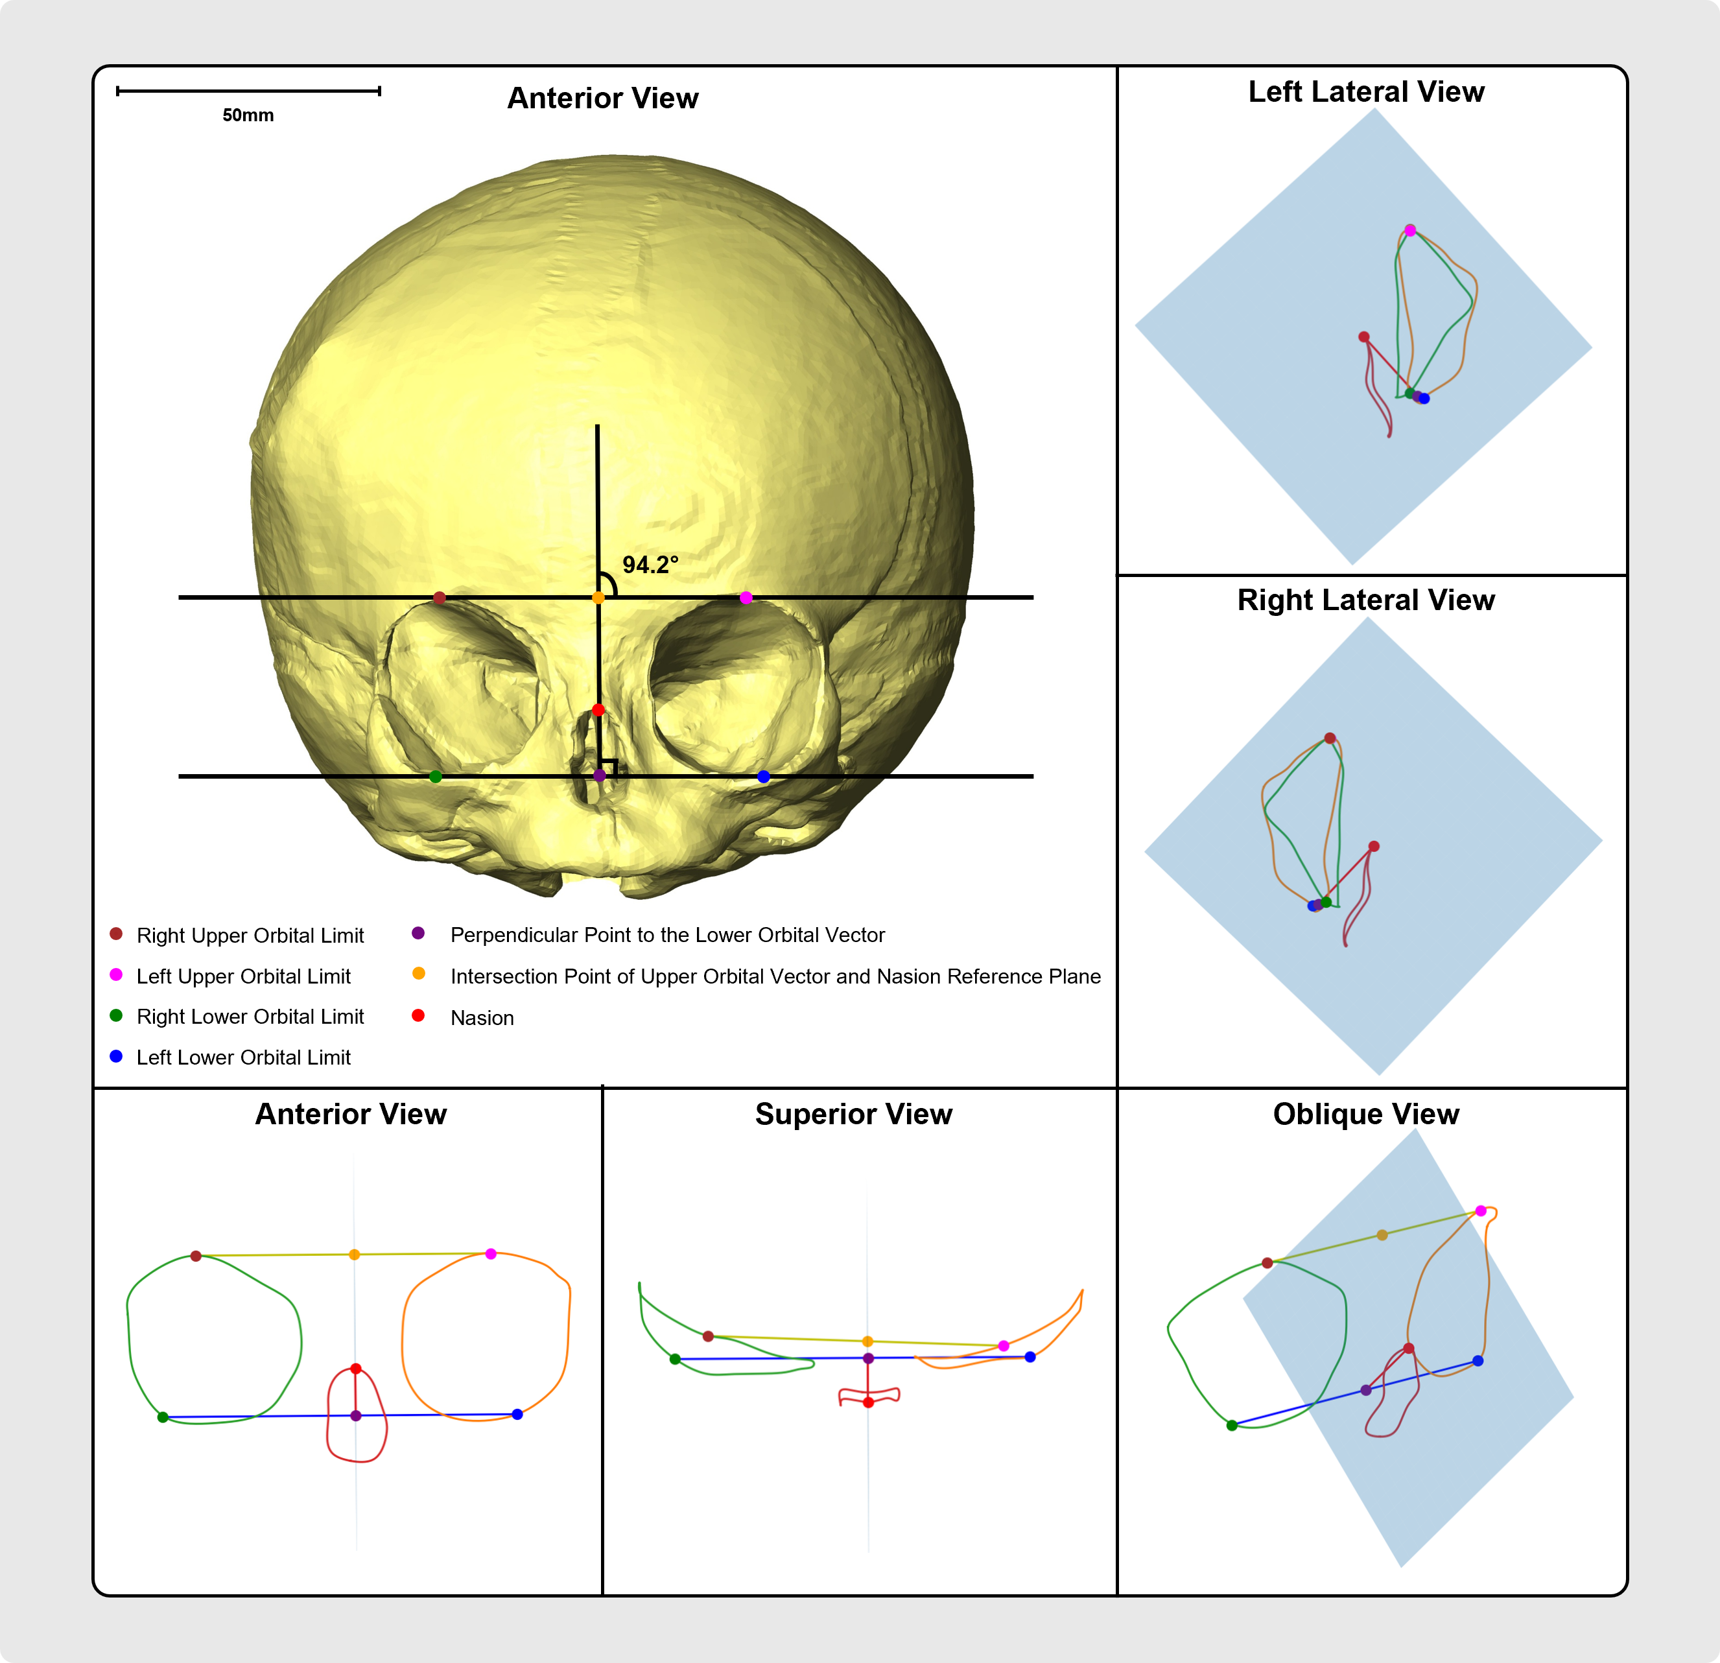
Fig 3. Geometric definition of the orbital dystopia angle (ODA). The nasion reference plane (shaded) passes through the nasion perpendicular to the vector joining the lower orbital limits; the upper orbital vector connects the right and left upper orbital limits. The ODA is the angle between the upper orbital vector and the reference plane, reported as the deviation from 90° (0° = perfect symmetry); the illustrated case shows an intersection angle of 94.2°, i.e. an ODA of 4.2°. Anterior, lateral, superior and oblique views show the orbital and nasal outlines relative to the plane. See Methods for the full derivation.

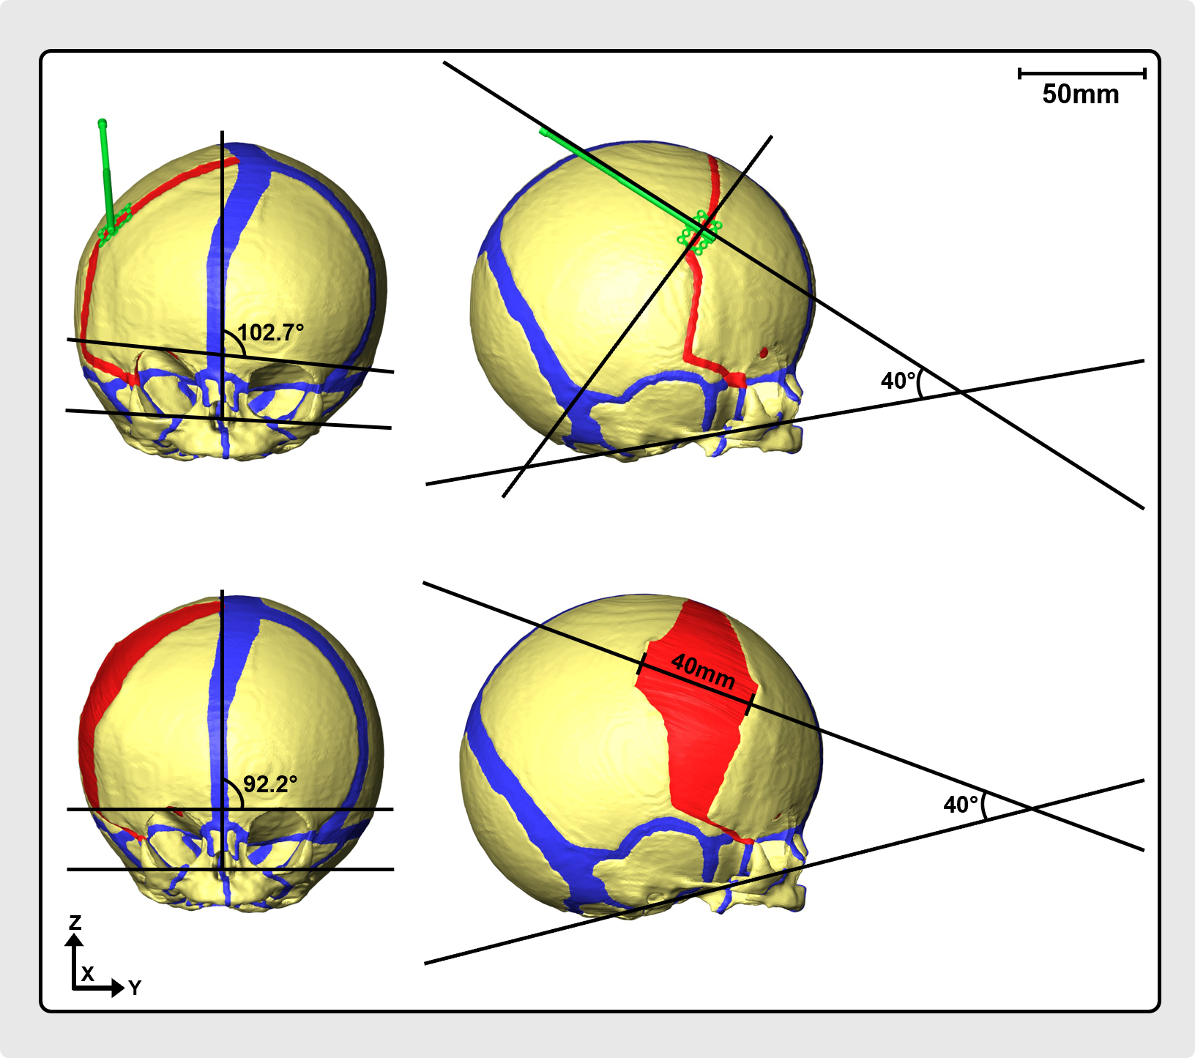
Fig. 4. Optimal distractor configuration for unicoronal synostosis. Schematic illustration showing Single distractor positioned at 40° angle with 40-mm distraction.

Table 1. Thermal expansion coefficients by transition
Transition / stage | Bone / region | ALPX | ALPY | ALPZ
1-3 Months | ICV | 0.0017 | 0.0017 | 0.0017
1-3 Months | OV Volume Right | 0.0022 | 0.0022 | 0.0022
1-3 Months | OV Volume Left | 0.0022 | 0.0022 | 0.0022
1-3 Months | Occipital Lateral Right | 0.0005 | 0.0005 | 0.0005
1-3 Months | Occipital Basillar | 0.0003 | 0.0003 | 0.0003
1-3 Months | Occipital Lateral Left | 0.0005 | 0.0005 | 0.0005
1-3 Months | Sphenoid | 0 | 0.00035 | 0.0005
1-3 Months | Temporal Left | 0.0006 | 0.0006 | 0.0006
1-3 Months | Temporal Right | 0.0006 | 0.0006 | 0.0006
1-3 Months | Zygoma Left | 0.0005 | 0.0005 | 0.0005
1-3 Months | Zygoma Right | 0.0005 | 0.0005 | 0.0005
1-3 Months | Maxilla Left | 0.0003 | 0.0004 | 0.0007
1-3 Months | Maxilla Right | 0.0003 | 0.0004 | 0.0007
3-5 Months | ICV | 0.0015 | 0.0015 | 0.0015
3-5 Months | OV Volume Right | 0.0022 | 0.0022 | 0.0022
3-5 Months | OV Volume Left | 0.0022 | 0.0022 | 0.0022
3-5 Months | Occipital Lateral Right | 0.0005 | 0.0005 | 0.0005
3-5 Months | Occipital Basillar | 0.0003 | 0.0003 | 0.0003
3-5 Months | Occipital Lateral Left | 0.0005 | 0.0005 | 0.0005
3-5 Months | Sphenoid | 0 | 0.00035 | 0.0005
3-5 Months | Temporal Left | 0.0006 | 0.0006 | 0.0006
3-5 Months | Temporal Right | 0.0006 | 0.0006 | 0.0006
3-5 Months | Zygoma Left | 0.0005 | 0.0005 | 0.0005
3-5 Months | Zygoma Right | 0.0005 | 0.0005 | 0.0005
3-5 Months | Maxilla Left | 0.0003 | 0.0004 | 0.0007
3-5 Months | Maxilla Right | 0.0003 | 0.0004 | 0.0007
5-6 Months | Occipital Lateral Right | 0.00025 | 0.00025 | 0.00025
5-6 Months | Occipital Basillar | 0.00015 | 0.00015 | 0.00015
5-6 Months | Occipital Lateral Left | 0.00025 | 0.00025 | 0.00025
5-6 Months | Sphenoid | 0 | 0.000175 | 0.00025
5-6 Months | Temporal Left | 0.0003 | 0.0003 | 0.0003
5-6 Months | Temporal Right | 0.0003 | 0.0003 | 0.0003
6-9 Months | ICV | 0.005 | 0.005 | 0.005
6-9 Months | Occipital Lateral Right | 0.00075 | 0.00075 | 0.00075
6-9 Months | Occipital Basillar | 0.00045 | 0.00045 | 0.00045
6-9 Months | Occipital Lateral Left | 0.00075 | 0.00075 | 0.00075
6-9 Months | Sphenoid | 0 | 0.000525 | 0.00075
6-9 Months | Temporal Left | 0.0009 | 0.0009 | 0.0009
6-9 Months | Temporal Right | 0.0009 | 0.0009 | 0.0009
6-9 Months | Zygoma Left | 0.00075 | 0.00075 | 0.00075
6-9 Months | Zygoma Right | 0.00075 | 0.00075 | 0.00075
6-9 Months | Maxilla Left | 0.00045 | 0.0006 | 0.00105
6-9 Months | Maxilla Right | 0.00045 | 0.0006 | 0.00105
6-9 Months | OV Volume Right | 0.0033 | 0.0033 | 0.0033
6-9 Months | OV Volume Left | 0.0033 | 0.0033 | 0.0033
9-11 Months | ICV | 0.0025 | 0.0025 | 0.0025
9-11 Months | Occipital Lateral Right | 0.0005 | 0.0005 | 0.0005
9-11 Months | Occipital Basillar | 0.0003 | 0.0003 | 0.0003
9-11 Months | Occipital Lateral Left | 0.0005 | 0.0005 | 0.0005
9-11 Months | Sphenoid | 0 | 0.00035 | 0.0005
9-11 Months | Temporal Left | 0.0006 | 0.0006 | 0.0006
9-11 Months | Temporal Right | 0.0006 | 0.0006 | 0.0006
9-11 Months | Zygoma Left | 0.0005 | 0.0005 | 0.0005
9-11 Months | Zygoma Right | 0.0005 | 0.0005 | 0.0005
9-11 Months | Maxilla Left | 0.0003 | 0.0004 | 0.0007
9-11 Months | Maxilla Right | 0.0003 | 0.0004 | 0.0007
9-11 Months | OV Volume Right | 0.0022 | 0.0022 | 0.0022
9-11 Months | OV Volume Left | 0.0022 | 0.0022 | 0.0022

Table 2. Predictive analysis: orbital outcomes for each distraction configuration when the model is grown to the prospectively estimated final intracranial volume (Est., ≈1138.56 mL, derived from the preoperative ICV and the normative growth curve of Liang et al. ⁴⁸) versus the volume measured on the follow-up CT (CT, ≈1322 mL).
Configuration  (primary / secondary, mm) | ODA (°) |  | AOI |  | NAOI |  | OID (%)
Configuration  (primary / secondary, mm) | Est. | CT | Est. | CT | Est. | CT | Est. | CT
20 / 0 | 5.63 | 5.23 | 97.98 | 97.34 | 91.13 | 90.34 | 7.24 | 7.46
20 / 10 | 5.84 | 5.36 | 98.91 | 98.27 | 92.86 | 92.01 | 6.30 | 6.58
20 / 20 | 4.56 | 4.38 | 110.42 | 110.12 | 93.34 | 91.41 | 16.77 | 18.57
30 / 0 | 4.18 | 3.85 | 96.50 | 96.02 | 93.61 | 92.88 | 3.05 | 3.33
30 / 10 | 4.12 | 3.65 | 91.08 | 90.78 | 94.21 | 93.46 | 3.38 | 2.92
30 / 20 | 3.36 | 3.24 | 103.90 | 103.15 | 95.69 | 94.99 | 8.23 | 8.23
30 / 30 | 4.35 | 4.50 | 117.26 | 116.17 | 96.64 | 96.06 | 19.28 | 18.95
40 / 0 | 2.76 | 2.51 | 96.05 | 95.74 | 96.24 | 95.57 | 0.20 | 0.17
40 / 10 | 3.18 | 2.65 | 94.80 | 94.55 | 97.25 | 96.48 | 2.55 | 2.03
40 / 20 | 2.15 | 2.05 | 97.82 | 97.47 | 98.67 | 97.98 | 0.87 | 0.53
40 / 30 | 3.48 | 3.75 | 112.24 | 111.30 | 99.57 | 98.99 | 11.96 | 11.71
40 / 40 | 5.87 | 6.12 | 126.18 | 125.04 | 99.89 | 99.40 | 23.26 | 22.85

Table 3. Spearman rank correlation (ρ) and the minimum, mean and maximum absolute difference between the prospectively estimated (preoperative-anchored) and CT-anchored simulations.
Metric | Spearman ρ | Min |diff| | Mean |diff| | Max |diff|
ODA | 0.99 | 0.10° | 0.29° | 0.53°
OID | 0.99 | 0.00 | 0.41 | 1.80
AOI | 0.99 | 0.25 | 0.60 | 1.14
NAOI | 0.99 | 0.49 | 0.79 | 1.93

