Supplemental Information to accompany:

“A Reference High-Pressure CH₄ Adsorption Isotherm for Zeolite Y:
Results of an Interlaboratory Study”

H. G. T. Nguyen,^{1*} C. M. Sims,¹ B. Toman,¹ J. Horn,¹ R. D. van Zee,¹ M. Thommes,² R. Ahmed,³ J. F. M. Denayer,⁴ G. V. Baron,⁴ E. Napolitano,⁵ M. Bielewski,⁵ E. Mangano,⁶ S. Brandani,⁶ D. P. Broom,⁷ M. J. Benham,⁷ A. Dailly,⁸ F. Dreisbach,⁹ S. Edubilli,¹⁰ S. Gumma,^{10, †} J. Möllmer,¹¹ M. Lange,¹¹ M. Tian,^{12, ‡} T. J. Mays,¹² T. Shigeoka,¹³ S. Yamakita,¹³ M. Hakuman,¹³ Y. Nakada,¹³ K. Nakai,¹³ J. Hwang,¹⁴ R. Pini,¹⁴ H. Jiang,¹⁵ A. D. Ebner,¹⁵ M. A. Nicholson,¹⁵ J. A. Ritter,¹⁵ J. Farrando-Pérez,¹⁶ C. Cuadrado-Collados,¹⁶ J. Silvestre-Albero,¹⁶ C. Tampaxis,¹⁷ T. Steriotis,¹⁷ D. Řimnáčová,¹⁸ M. Švábová,¹⁸ M. Vorokhta,¹⁸ H. Wang,¹⁹ E. Bovens,²⁰ N. Heymans,²⁰ G. De Weireld²⁰

*Corresponding author email: huong.nguyen@nist.gov
¹National Institute of Standards and Technology, Gaithersburg MD, USA
²Friedrich-Alexander University Erlangen-Nuremberg, Nuremberg, Germany
³Anton Paar QuantaTec Inc. Boynton Beach FL, USA
⁴Vrije Universiteit Brussel, Brussels, Belgium
⁵European Commission, Joint Research Centre (JRC), Petten, Netherlands
⁶University of Edinburgh, Edinburgh, UK
⁷Hiden Isochema Limited, Warrington, UK
⁸General Motors, Warren MI, USA
⁹TA Instruments, Bochum, Germany
¹⁰Indian Institute of Technology Guwahati, Assam, India
¹¹ Institute of Non-Classical Chemistry, Leipzig, Germany
¹²University of Bath, Bath, UK
¹³MicrotracBEL, Suminoe-ku, Osaka, Japan
¹⁴Imperial College London, London, UK
¹⁵University of South Carolina, Columbia SC, USA
¹⁶University of Alicante, Alicante, Spain
¹⁷National Centre for Scientific Research “Demokritos”, Greece
¹⁸Czech Academy of Sciences, Prague, Czech Republic
¹⁹National Institute of Metrology, Beijing, China
²⁰University of Mons, Mons, Belgium
† Current affiliation: Indian Institute of Technology Tirupati, Andhra Pradesh, India
‡Current affiliation: University of Exeter, Exeter, UK

Table of Contents
S1. Surface and pore characterization of Zeolite Y
S2. ILS2 CO₂/ZSM-5 isotherms (all datasets)
S3. ILS2 goodness-of-fit values
S4. ILS2 CO₂/ZSM-5 isotherms (individual datasets #1-14, 16-18)
S5. ILS2 CH₄/Zeolite Y isotherms (datasets #1-28)
S6. ILS2 CH₄/Zeolite Y isotherms (all datasets > 2 MPa and ≥ 7.5 MPa)
S7. OpenBUGS codes (goodness-of-fit and methane fit)
S1. Surface and pore characterization of Zeolite Y

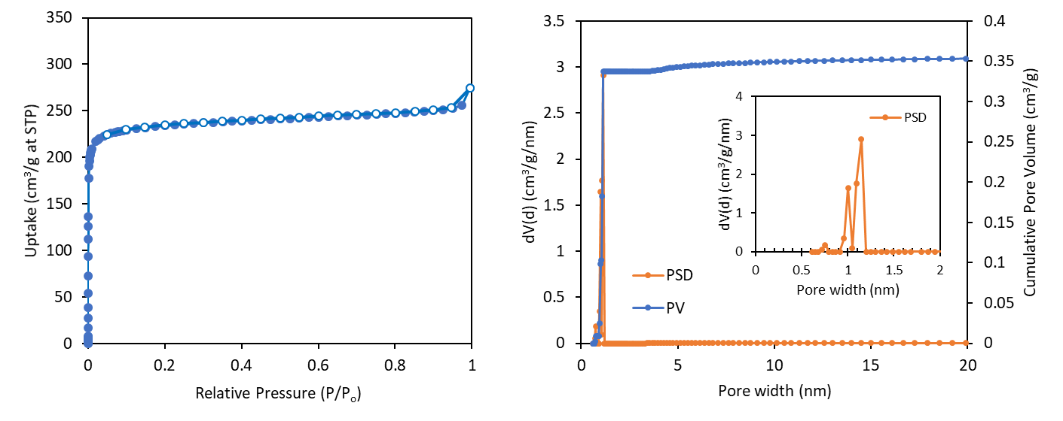

Figure S1. Ar isotherms at 87 K and pore volume and pore-size distribution for Zeolite Y (RM 8850). The BET surface area calculated from P/P_{o} = 0.008 to 0.04 is 819 ± 13 m²/g. The pore volume (PV) and pore-size-distribution (PSD) was determined using NLDFT calculation model on the equilibrium branch of the Ar isotherm at 87 K for zeolites with spherical/cylindrical pores.

S2. ILS2 CO₂/ZSM-5 isotherms (all datasets)

Figure S2. ILS2 CO₂ adsorption isotherms at 20 °C for ZSM-5 for all submitted datasets.

S3. ILS2 goodness-of-fit values

Table S1. goodness-of-fit values for ILS2 CO₂ adsorption isotherms at 20 °C for ZSM-5.
dataset | goodness-of-fit value*
1 | 0.13
2 | 0.07
3 | 0.12
4 | 0.18
5 | 0.08
6 | 0.06
7 | 0.03
8 | 0.12
9 | 0.09
10 | 0.15
11 | 0.08
12 | 0.11
13 | 0.07
14 | 0.38
16 | 0.07
17 | 0.02
18 | 0.07
*green = pass; orange = borderline; red = fail

S4. ILS2 CO₂/ZSM-5 isotherms (individual datasets #1-18)
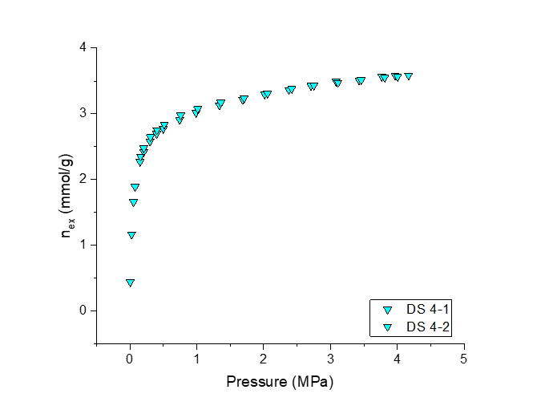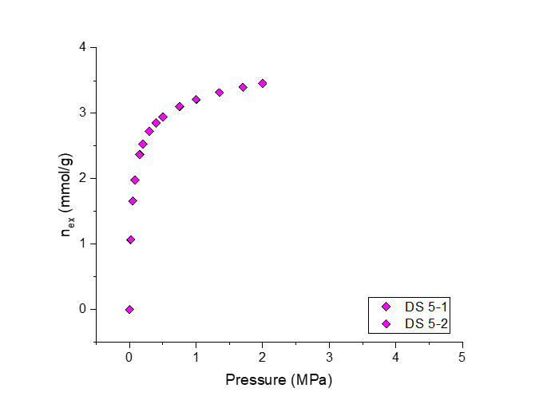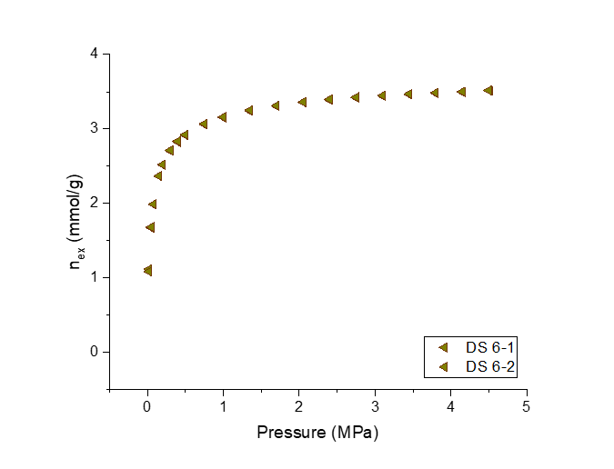
Figure S3. ILS2 CO₂ adsorption isotherms at 20 °C for ZSM-5 for datasets 1-6.

Figure S4. ILS2 CO₂ adsorption isotherms at 20 °C for ZSM-5 for datasets 7-12.

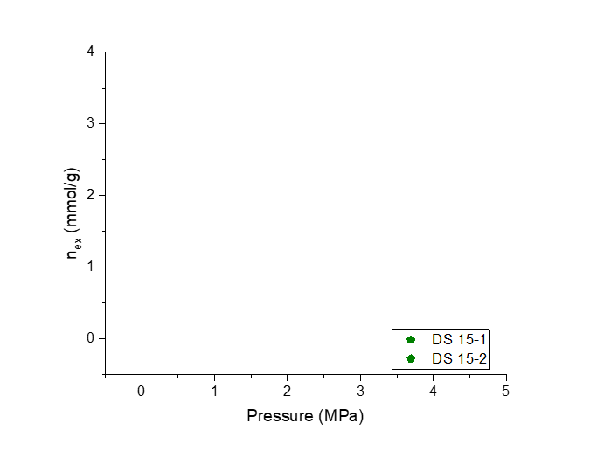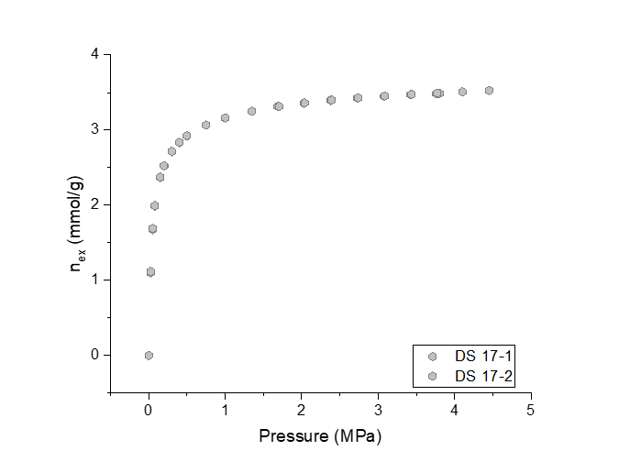

Figure S5. ILS2 CO₂ adsorption isotherms at 20 °C for ZSM-5 for datasets 13-18. No data was submitted for dataset #15.

S5. ILS2 CH₄/Zeolite Y isotherms (datasets #1-28)
Figure S6. ILS2 CH₄ adsorption isotherms at 25 °C for Zeolite Y for datasets 1-6.
Figure S7. ILS2 CH₄ adsorption isotherms at 25 °C for Zeolite Y for datasets 7-12.

Figure S8. ILS2 CH₄ adsorption isotherms at 25 °C for Zeolite Y for datasets 13-18.

Figure S9. ILS2 CH₄ adsorption isotherms at 25 °C for Zeolite Y for datasets 19-24.
Figure S10. ILS2 CH₄ adsorption isotherms at 25 °C for Zeolite Y for datasets 25-28.

S6. ILS2 CH₄/Zeolite Y isotherms (all datasets > 2 MPa and ≥ 7.5 MPa)
Figure S11. ILS2 CH₄ adsorption isotherms at 25 °C for Zeolite Y for all datasets minus datasets only up to 2 MPa (datasets 5, 10, 11, 19, 23, and 25)
Figure S12. ILS2 CH₄ adsorption isotherms at 25 °C for Zeolite Y for all datasets minus datasets not measured up to 7.5 MPa (datasets 5, 10, 11, 19, 23, 25, 3, 7, 9, 12, 18, 22, 24, 27, and 28)

S7. OpenBUGS codes
S7.1. OpenBUGS code for CH₄/Zeolite Y isotherm at 25 °C reference fit
{
g~dunif(0,10)
a~dunif(-10,5)
b~dunif(0,5)
f~dunif(0,5)

for(i in 1:12){sig[i]~dgamma(1.0E-5,1.0E-5)}
T1~dcat(P1[])
P1[1:12]~ddirich(alpha1[])
alpha1[1]<-1
alpha1[2]<-0.1
alpha1[3]<-1
alpha1[4]<-1
alpha1[5]<-1
alpha1[6]<-1
alpha1[7]<-1
alpha1[8]<-1
alpha1[9]<-1
alpha1[10]<-0.1
alpha1[11]<-0.1
alpha1[12]<-1

sigp<-sig[T1]

for (i in 1:1079){lpress[i]<-log(press[i])
bot[i]<-1+exp((-lpress[i]+a)/b)
mean[i]<-g/pow(bot[i],f)
uptake[i]~dnorm(mean[i],sig[lab[i]])}

for(i in 1:1079){dif[i]<-uptake[i]-predy[i]
predy[i]~dnorm(mean[i],sigp)
}

for(i in 1:131){pressl[i]<--9.2+0.1*i
pressp[i]<-exp(pressl[i])}

for (i in 1:131){
lpredp[i]<-log(pressp[i])
botp[i]<-1+exp((-lpredp[i]+a)/b)
meanp[i]<-g/pow(botp[i],f)
pred[i]<-meanp[i]
predb[i]~dnorm(pred[i],sigp)}

a.cut<-cut(a)
b.cut<-cut(b)
f.cut<-cut(f)
g.cut<-cut(g)
for(i in 1:18){sign[i]~dgamma(1.0E-5,1.0E-5)}

for( i in 1:883){lpressn[i]<-log(pressn[i])
botn[i]<-1+exp((-lpressn[i]+a.cut)/b.cut)
meann[i]<-g.cut/pow(botn[i],f.cut)
meann.cut[i]<-cut(meann[i])
uptaken[i]~dnorm(meann.cut[i],sign[labn[i]])
predbn[i]~dnorm(meann.cut[i],sign[labn[i]])}

}

list(sig=c(1, 1,1,1,1,1,1,1,1,1,1,1),sign=c(1,1,1,1,1,1,1,1,1,1,1,1,1,1,1,1,1,1) )

S7.2. OpenBUGS code for goodness-of-fit determination for CO₂/ZSM-5 isotherms at 20 °C.
{
g~dunif(0,10)
a~dunif(-10,5)
b~dunif(0,5)
f~dunif(0,5)

for(i in 1:12){sig[i]~dgamma(1.0E-5,1.0E-5)}
T1~dcat(P1[])
P1[1:12]~ddirich(alpha1[])
alpha1[1]<-1
alpha1[2]<-0.1
alpha1[3]<-1
alpha1[4]<-1
alpha1[5]<-1
alpha1[6]<-1
alpha1[7]<-1
alpha1[8]<-1
alpha1[9]<-1
alpha1[10]<-0.1
alpha1[11]<-0.1
alpha1[12]<-1

sigp<-sig[T1]

for (i in 1:1079){lpress[i]<-log(press[i])
bot[i]<-1+exp((-lpress[i]+a)/b)
mean[i]<-g/pow(bot[i],f)
uptake[i]~dnorm(mean[i],sig[lab[i]])}

for(i in 1:1079){dif[i]<-uptake[i]-predy[i]
predy[i]~dnorm(mean[i],sigp)
}

for(i in 1:131){pressl[i]<--9.2+0.1*i
pressp[i]<-exp(pressl[i])}

for (i in 1:131){
lpredp[i]<-log(pressp[i])
botp[i]<-1+exp((-lpredp[i]+a)/b)
meanp[i]<-g/pow(botp[i],f)
pred[i]<-meanp[i]
predb[i]~dnorm(pred[i],sigp)}

a.cut<-cut(a)
b.cut<-cut(b)
f.cut<-cut(f)
g.cut<-cut(g)
for(i in 1:18){sign[i]~dgamma(1.0E-5,1.0E-5)}

for( i in 1:883){lpressn[i]<-log(pressn[i])
botn[i]<-1+exp((-lpressn[i]+a.cut)/b.cut)
meann[i]<-g.cut/pow(botn[i],f.cut)
meann.cut[i]<-cut(meann[i])
uptaken[i]~dnorm(meann.cut[i],sign[labn[i]])
predbn[i]~dnorm(meann.cut[i],sign[labn[i]])}

}

list(sig=c(1, 1,1,1,1,1,1,1,1,1,1,1),sign=c(1,1,1,1,1,1,1,1,1,1,1,1,1,1,1,1,1,1) )

