Fabrication of Nanozeolite-Y/Chitosan Composite Based on Rice Husks for Efficient Adsorption of Methylene Blue Dye: Kinetic and Thermodynamic Studies.
Amany G. Braish, Asaad F. Hassan*, Shimaa A. El-Essawy, Mohsen M.T. El-Tahawy*
Chemistry department, Faculty of science, Damanhour university, Damanhour, Egypt
*Corresponding authors: (AH)asmz68@sci.damu.edu.eg; (ME) mohsen.eltahawy@sci.dmu.edu.eg

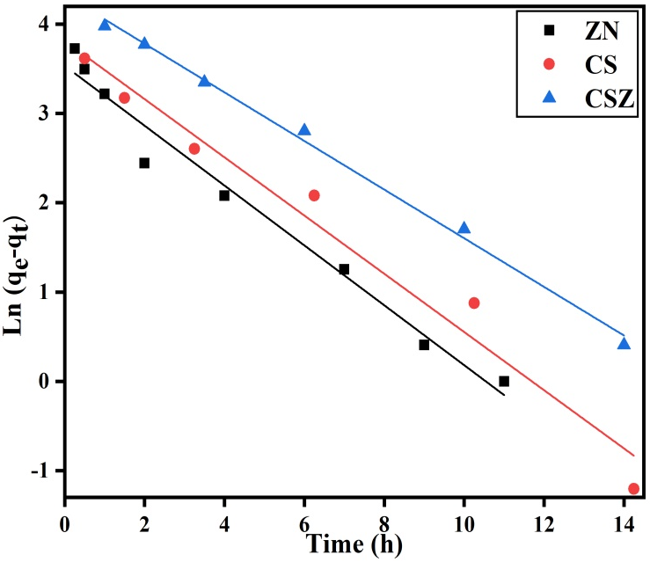
Fig. S1. Pseudo-first order kinetic model plot for MB adsorption onto ZN, CS, and CSZ at 20 ℃.
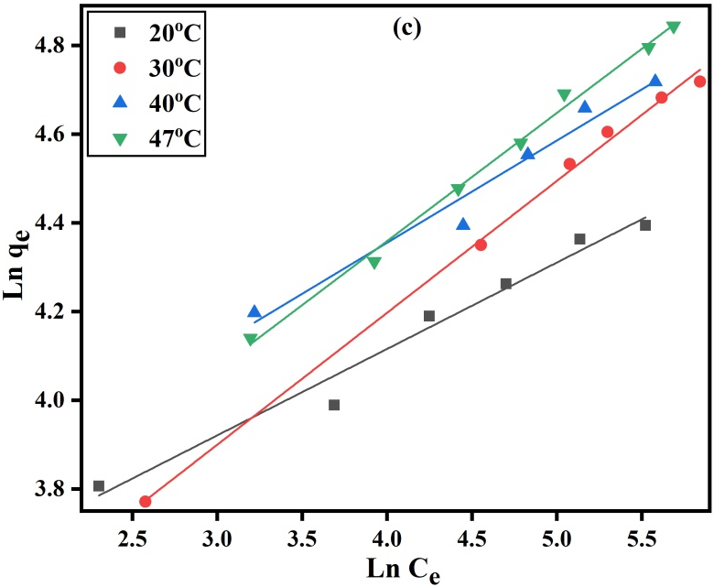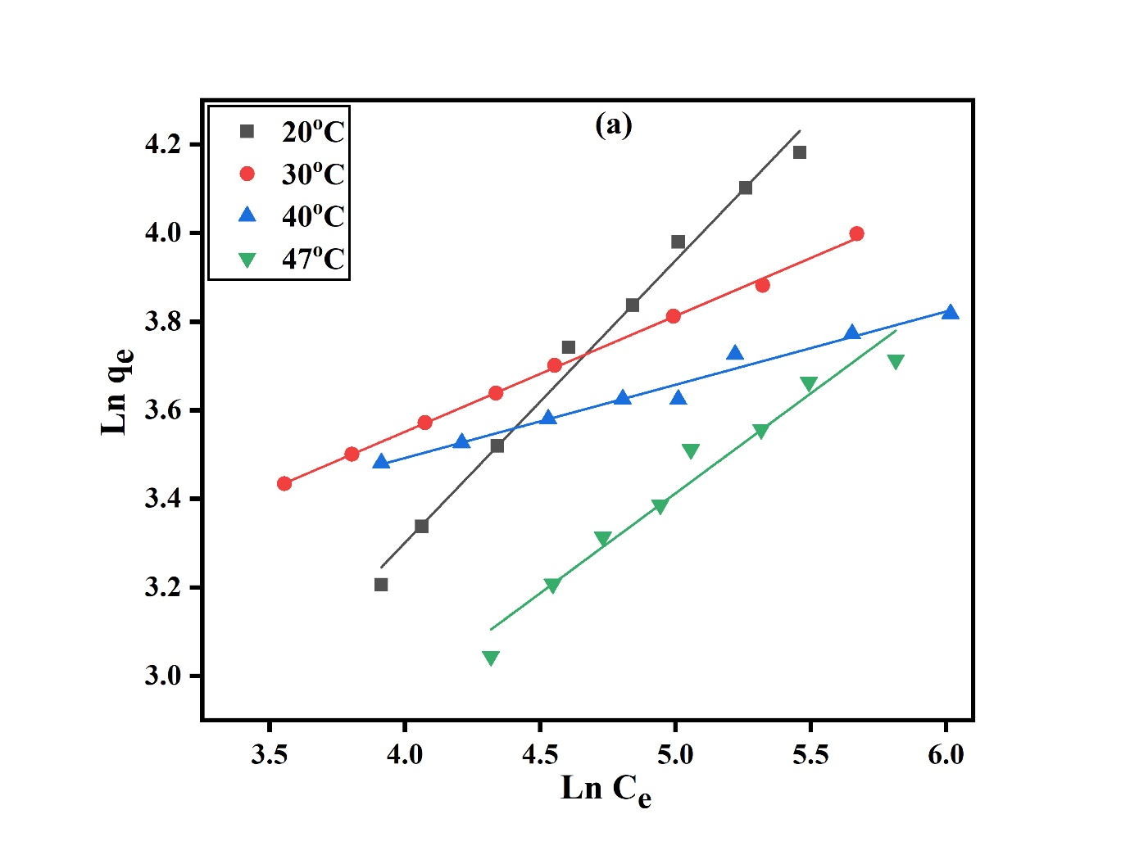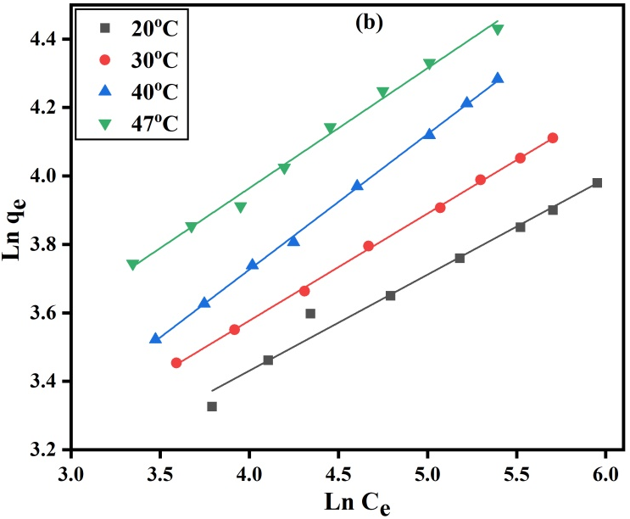
Fig. S2. Freundlich isotherms plots (a-c) for the adsorption of MB onto ZN, CS, and CSZ, respectively at 20, 30, 40, and 47 ℃
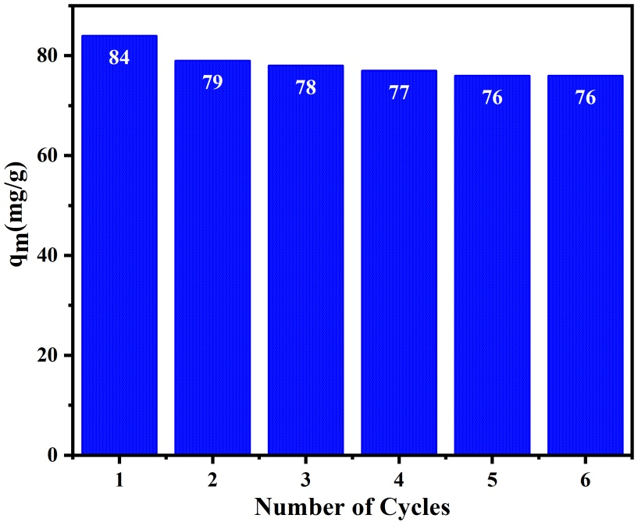
Fig. S3. Reusability of CSZ after six adsorption/desorption cycles

