Figure S1: Mean ± SD juvenile somatic growth rate g [d⁻¹] of D. pulex growing on C. klinobasis that had either been cultured under control conditions (Control) or incubated on a rotary shaker for 24 h (Shaker) or incubated on a rotary shaker in antibiotic-containing medium (Antibiotics). Light grey bars indicate the chemical absence of Chaoborus, and dark grey bars indicate the chemical presence of Chaoborus. Details on the statistical analysis can be found in Table S1.

Table S1: Results of a three-way ANOVA type 2 for the analysis of the somatic growth rates g (see Fig. S1). Significant p-values are indicated in bold.
 | Df | Sum Sq | Mean Sq | F-value | p-value
Food concentration | 1 | 0.1655 | 0.16548 | 22.11 | 2.2e-05
Treatment | 2 | 0.0091 | 0.00454 | 0.60 | 0.548
Kairomone | 1 | 0.0280 | 0.02795 | 3.73 | 0.059
Food conc. × Treatment | 2 | 0.0194 | 0.00970 | 1.29 | 0.282
Food conc. × Kairomone | 1 | 0.0058 | 0.00584 | 0.78 | 0.381
Treatment × Kairomone | 2 | 0.0172 | 0.00858 | 1.14 | 0.326
Food conc. × Treatment × Kairomone | 2 | 0.0148 | 0.00740 | 0.98 | 0.379
Residuals | 48 | 0.3591 | 0.00748

Figure S2: Mean ± SD of the size of the first clutch [eggs / ind.] of D. pulex growing on C. klinobasis that had either been cultured under control conditions (Control) or incubated on a rotary shaker for 24 h (Shaker) or incubated on a rotary shaker in antibiotic-containing medium (Antibiotics). Light grey bars indicate the chemical absence of Chaoborus and dark grey bars indicate the chemical presence of Chaoborus. Details on the statistical analysis can be found in Table S2.

Table S2: Results of a three-way ANOVA type 3 for the analysis of the clutch size (see Fig. S2). Significant p-values are indicated in bold.
 | Sum Sq | Df | F-value | p-value
(Intercept) | 4176.2 | 1 | 1964.15 | < 2.2e-16
Food concentration | 148.2 | 1 | 69.67 | 1.286e-10
Treatment | 1.1 | 2 | 0.25 | 0.776
Kairomone | 0.0 | 1 | 0.00 | 0.994
Food conc. × Treatment | 4.5 | 2 | 1.06 | 0.351
Food conc. × Kairomone | 18.4 | 1 | 8.63 | 0.005
Treatment × Kairomone | 7.0 | 2 | 1.64 | 0.205
Food conc. × Treatment × Kairomone | 2.1 | 2 | 0.48 | 0.619
Residuals | 93.6 | 44

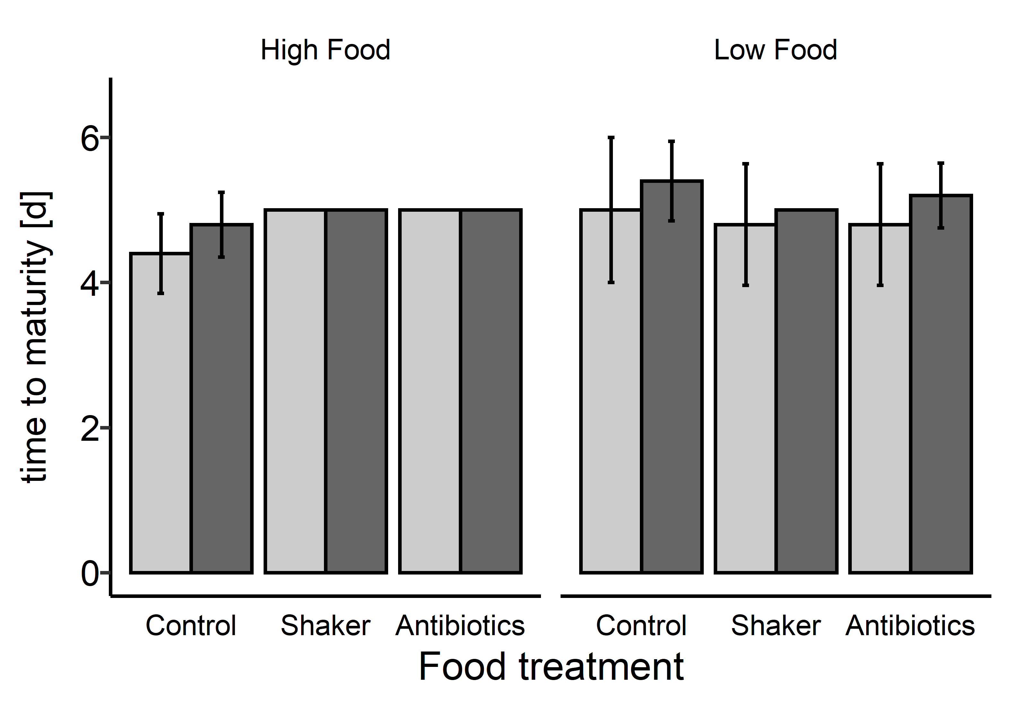
Figure S3: Mean ± SD of the time to maturity [d] of D. pulex growing on C. klinobasis that had either been cultured under control conditions (Control) or incubated on a rotary shaker for 24 h (Shaker) or incubated on a rotary shaker in antibiotic-containing medium (Antibiotics). Light grey bars indicate the chemical absence of Chaoborus and dark grey bars indicate the chemical presence of Chaoborus. Details on the statistical analysis can be found in Table S3. Missing error bars indicate SD = 0.

Table S3: Results of a Kruskal-Wallis rank sum test for the analysis of the time until maturity (see Fig. S3).
χ² | df | p-value
11.577 | 11 | 0.3963

