Supplementary material

Overview of microbial communities in the surface water of the Seine River to understand their response to climate change and human activities

Sadia BAGAGNAN¹, Sabrina GUERIN-RECHDAOUI², Anthony MARCONI², Vincent ROCHER², Stéphanie GIUSTI-MILLER³, Régis MOILLERON¹ and My Dung JUSSELME^{1,*}
¹Leesu, Univ Paris Est Creteil, Ecole des ponts, Creteil, France
²SIAAP, Direction de l’Innovation, F-92700 Colombes, France
³IEES, Univ Paris Est Creteil, F-94010 Creteil, France

Figure S1: Map of study area and location of sampling sites in Seine River, Ile-de-France Region, France
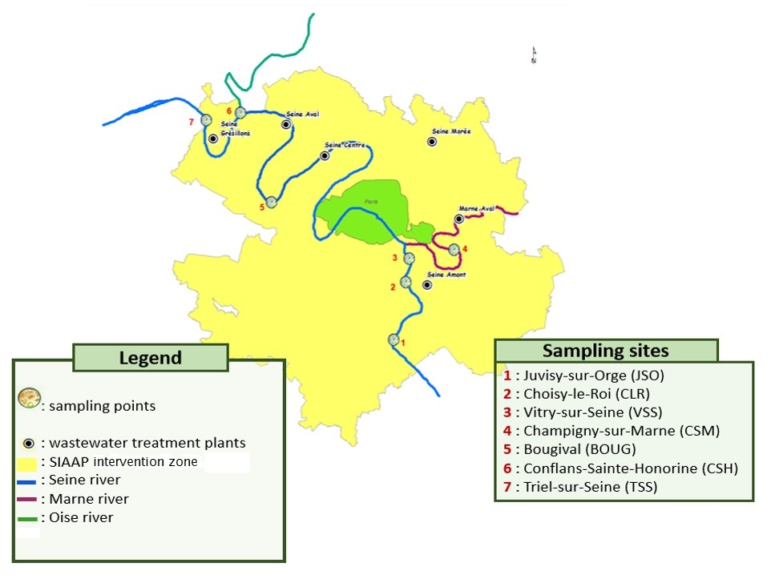

Figure S2. Correlation between microbial cells and microbial activity in all samples collected at all sites for both seasons
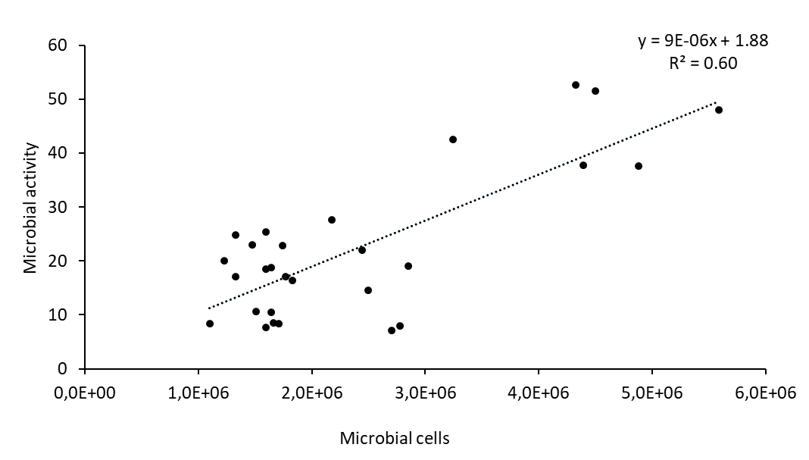

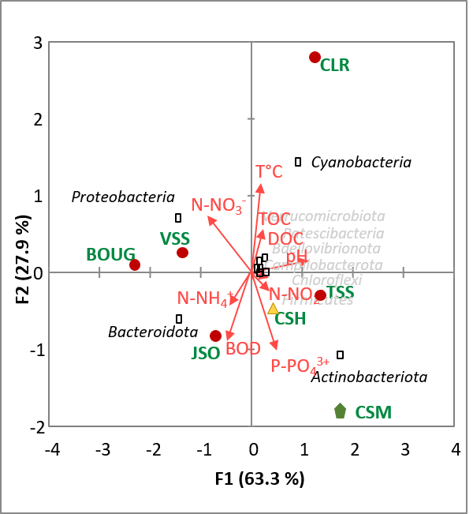
Figure S3. Analysis of bacterial community redundancy at phylum level in Seine River and environmental factors from different sampling sites (A), different rivers (B) and different seasons according to the year 2020 and 2021 (C)
(A)
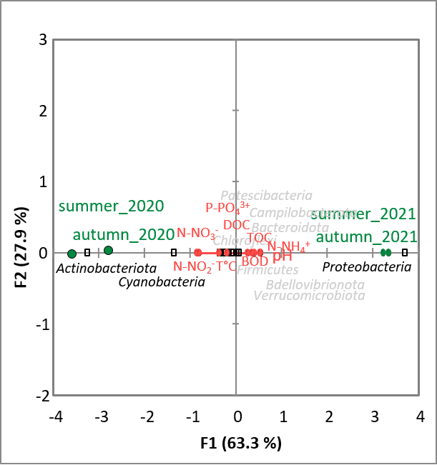
(B)

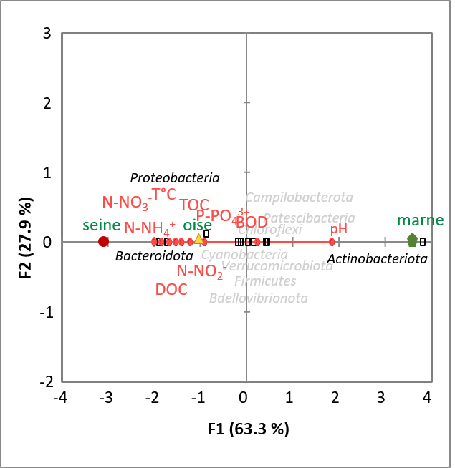
(C)
Table S1 : Physico-chemical properties of the Seine River samples
Total organic carbon, TOC; biological oxygen demand, BOD; chemical oxygen demand, COD; T°C, water temperature; NH₄⁺, ammonium; NO²⁻, nitrite; NO³⁻, nitrate; PO₄³⁻, orthophosphates.
Sampling sites | Season | Year | pH | NO₂⁻ | NO₃⁻ | NH₄⁺ | PO₄³⁻ | TOC | BOD | COD | T°C
 |  |  |  | mg/L | mg/L | mg/L | mg/L | mg/L | mg/L | mg/L
Juvisy-sur-Orge | summer | 2020 | 7.84 | 0.45 | 26.6 | 0.09 | 0.11 | 3.1 | 1.7 | 10.2 | 20.1
 | autumn | 2020 | 8.09 | 0.07 | 24.2 | 0.08 | 0.04 | 2.6 | 1.3 | 8.0 | 10.8
 | summer | 2021 | 8.27 | 0.03 | 22.6 | 0.03 | <0.02 | 2.1 | 1.1 | 7.5 | 20.8
 | autumn | 2021 | 8.12 | 0.04 | 16.1 | 0.06 | 0.17 | 2.6 | 1.4 | 7.9 | 8.1
Choisy-le-Roi | summer | 2020 | 8.02 | 0.06 | 23.5 | 0.06 | 0.04 | 4.5 | 1.3 | 7.8 | 21.6
 | autumn | 2020 | 8.10 | 0.07 | 24.2 | 0.08 | 0.04 | 2.5 | 1.0 | 7.3 | 11.1
 | summer | 2021 | 8.26 | 0.04 | 27.4 | 0.03 | 0.02 | 2.4 | 1.5 | 7.8 | 21.0
 | autumn | 2021 | 8.14 | 0.04 | 19.4 | 0.03 | 0.17 | 2.5 | <0.5 | 8.1 | 8.0
Vitry-sur-Seine | summer | 2020 | 7.87 | 0.06 | 26.2 | 0.06 | 0.09 | 2.5 | 0.8 | 6.4 | 20.2
 | autumn | 2020 | 7.94 | 0.08 | 27.1 | 0.17 | 0.10 | 3.0 | 2.0 | 8.1 | 10.7
 | summer | 2021 | 8.02 | 0.08 | 29.3 | 0.14 | 0.26 | 2.5 | 1.3 | 7.9 | 20.7
 | autumn | 2021 | 8.06 | 0.04 | 20.7 | 0.05 | 0.19 | 2.7 | 0.9 | 7.5 | 8.4
Champigny-sur-Marne | summer | 2020 | 8.02 | 0.07 | 17.4 | 0.07 | 0.05 | 2.2 | 1.1 | 5.8 | 20.0
 | autumn | 2020 | 8.19 | 0.10 | 16.9 | 0.08 | 0.05 | 2.2 | 1.7 | 6.9 | 11.0
 | summer | 2021 | 8.08 | 0.08 | 22.5 | 0.04 | 0.02 | 3.4 | 1.5 | 6.0 | 21.1
 | autumn | 2021 | 8.05 | 0.11 | 18.5 | 0.11 | 0.27 | 2.7 | 1.1 | 7.4 | 7.1
Bougival | summer | 2020 | 7.94 | 0.09 | 25.2 | 0.08 | 0.11 | 2.7 | 1.0 | 7.1 | 19.9
 | autumn | 2020 | 8.05 | 0.10 | 24.4 | 0.11 | 0.10 | 2.7 | 0.8 | 7.4 | 11.5
 | summer | 2021 | 8.15 | 0.11 | 26.3 | 0.10 | 0.07 | 2.5 | 1.3 | 7.2 | 21.0
 | autumn | 2021 | 7.96 | 0.12 | 20.7 | 0.14 | 0.31 | 2.7 | 1.4 | 8.3 | 9.0
Conflans-Sainte-Honorine | summer | 2020 | 8.04 | 0.08 | 19.3 | 0.09 | 0.07 | 3.2 | 0.8 | 8.1 | 21.9
 | autumn | 2020 | 8.08 | 0.11 | 19.8 | 0.10 | 0.07 | 3.5 | 1.0 | 8.4 | 11.1
 | summer | 2021 | 7.96 | 0.07 | 22.5 | 0.10 | 0.08 | 2.1 | 1.3 | 9.3 | 20.9
 | autumn | 2021 | 8.07 | 0.05 | 18.5 | 0.07 | 0.28 | 4.0 | 0.8 | 11.6 | 8.2
Triel-sur-Seine | summer | 2020 | 8.04 | 0.50 | 27.1 | 0.27 | 0.12 | 3.2 | 1.2 | 8.4 | 20.0
 | autumn | 2020 | 8.00 | 0.84 | 26.3 | 0.16 | 0.14 | 3.3 | 1.1 | 9.1 | 11.4
 | summer | 2021 | 7.72 | 0.25 | 25.0 | 0.11 | 0.13 | 5.1 | 5.1 | 15.1 | 20.9
 | autumn | 2021 | 7.94 | 0.24 | 20.0 | 0.26 | 0.39 | 3.8 | 1.1 | 12.4 | 9.6

