Spatial variation and individual specialization of stickleback diet
in relation to trophic morphology
Snorradóttir et al.
Supplementary materials

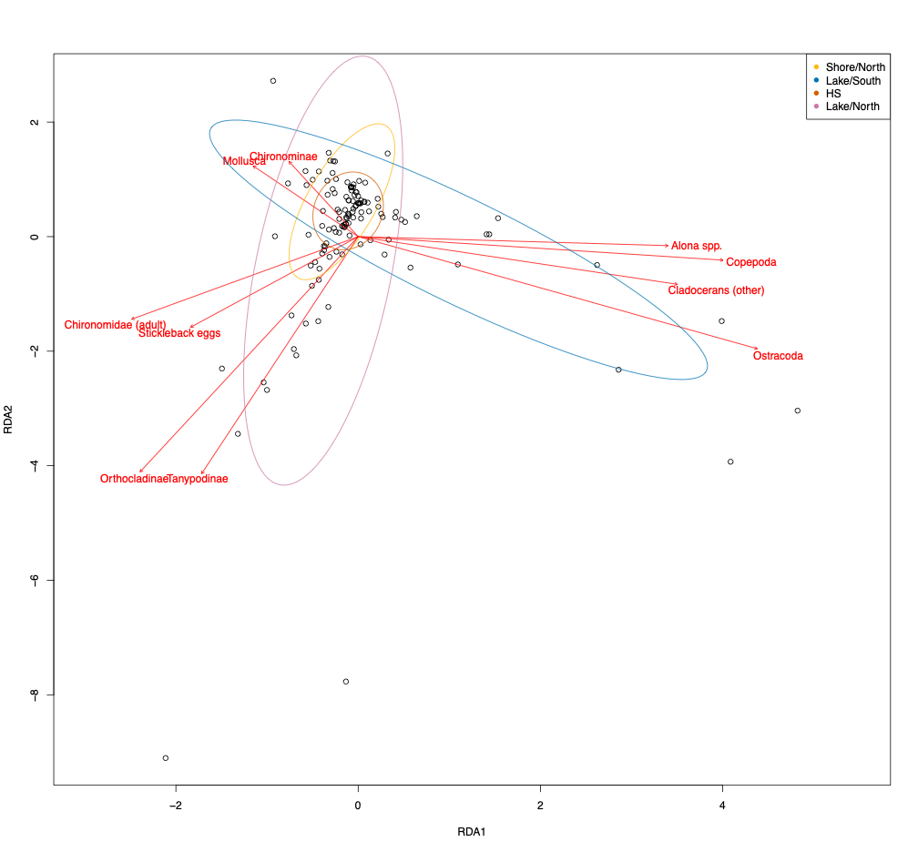

Figure S1. First two axes of RDA ordination describing covariance in diet items fed on by individual stickleback with ellipses grouping individuals from the same site.

Table S1. Prevalence (proportion of fish where taxon was present) and mean abundance for each taxon across all samples. Some taxa were grouped together for analysis to ensure reasonable representation across samples.
Taxon (finest resolution) | Revised taxon for analysis (if modified) | Prevalence | Mean abundance (standard deviation)
Adult chironomid |  | 0.44 | 2.74 (5.75)
Orthocladiinae |  | 0.29 | 2.40 (9.38)
Chironomini | Chironominae | 0.28 | 1.18 (2.87)
Unknown Alona spp. | Alona spp. | 0.22 | 3.81 (20.2)
Adult copepod | Copepod | 0.21 | 6.47 (29.4)
Tanypodinae |  | 0.12 | 0.41 (1.87)
Alona affinis or  Alona quadrangularis | Alona spp. | 0.11 | 0.89 (4.47)
Stickleback eggs |  | 0.10 | 0.86 (4.02)
Alona rectangula | Alona spp. | 0.08 | 0.41 (2.43)
Gastropod | Mollusk | 0.07 | 0.16 (0.74)
Ostracod |  | 0.05 | 0.31 (1.71)
Alonella nana | Cladoceran | 0.05 | 0.59 (5.00)
Bivalve | Mollusk | 0.03 | 0.05 (0.35)
Juvenile copepod | Copepod | 0.03 | 0.05 (0.31)
Unknown chironomid larvae | (Omitted) | 0.02 | 0.03 (0.20)
Acroperus harpae | Cladoceran | 0.02 | 0.05 (0.37)
Macrothrix hirsuticornix | Cladoceran | 0.01 | 0.02 (0.17)
Daphnia longispina | Cladoceran | 0.01 | 0.07 (0.85)
Cladoceran resting egg | (Omitted) | 0.01 | 0.02 (0.29)
Tanytarsini | Chironominae | 0.01 | 0.01 (0.10)

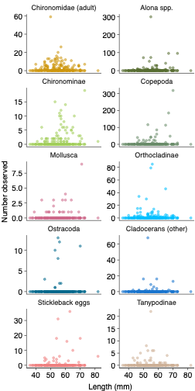

Figure S2. Scatter plot of number of the observed diet items for each taxon as a function of body length.

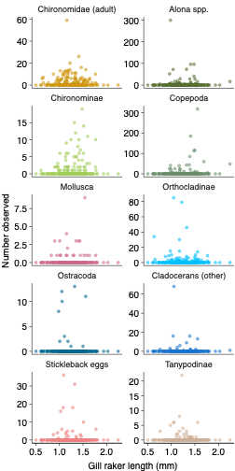

Figure S3. Scatter plot of number of the observed diet items for each taxon as a function of gill raker length.

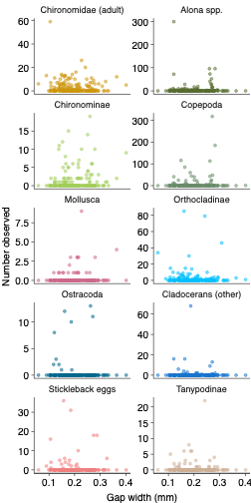
Figure S4. Scatter plot of number of the observed diet items for each taxon as a function of gap width.

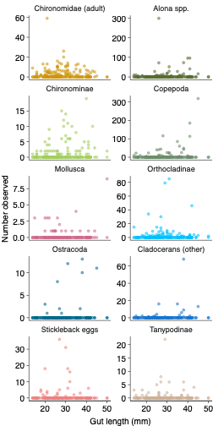
Figure S5. Scatter plot of number of the observed diet items for each taxon as a function of gut length.

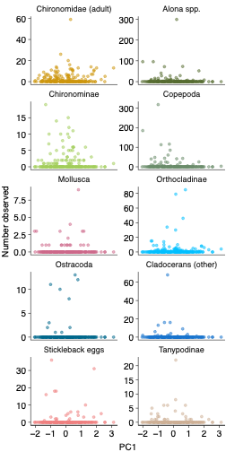

Figure S6. Scatter plot of number of the observed diet items for each taxon as a function of PC1.

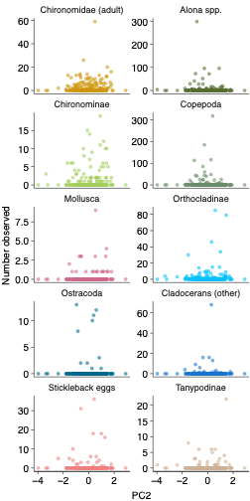
Figure S7. Scatter plot of number of the observed diet items for each taxon as a function of PC2.

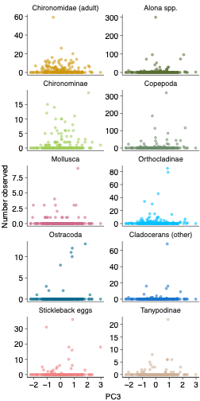
Figure S8. Scatter plot of number of the observed diet items for each taxon as a function of PC3.

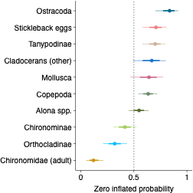

Figure S9. Variation in the zero-inflated probability for each taxon estimated with a multivariate GLMM. Points indicate posterior medians of the estimated relative trait value with the error bars depicting 68% and 95% posterior uncertainty intervals (based on quantiles; 68% intervals match the coverage of standard errors).

