SUPPLEMENTARY MATERIAL

Supplementary Table S1. Description of the predictor variables used in the study, including local environmental descriptors measured according to the adapted physical habitat assessment protocol by Peck et al. and modified by Callisto (2002), and land use and land cover (LULC) variables derived from MapBiomas. Environmental variables refer to morphometric features of the stream channel, substrate composition, canopy cover, and habitat complexity. LULC variables, on the other hand, represent landscape-level characteristics within the drainage areas of each stream.
Group | Variable | Description
Channel morphology | Mean water depth | Mean of five measurements taken across channel cross-sections, spanning from one bank to the other at each sampling site."
Channel morphology | Mean thalweg depth | Mean depth measured at the central point (thalweg) of each channel cross-section, calculated per sampling site.
Channel morphology | Seasonal channel width | Mean width of seasonally flooded areas estimated across different channel cross-sections, calculated per sampling site.
Substrate | Percentage of sand substrate | "Visual estimate of the proportion of sand in the substrate within each channel cross-section, considering different microhabitats; values were averaged for each sampling site.
Substrate | Percentage of leaf litter | Visual estimate of the percentage of leaf-litter banks accumulated in the substrate within each channel cross-section, considering different microhabitats; values were averaged for each sampling site.
Substrate | Percentage of organic matter | Visual estimate of the proportion of organic matter (leaf litter, plant debris, and other organic residues) in the substrate along the channel cross-sections, with the mean calculated for each sampling site.
Substrate | Mean substrate size | Visual classification of the predominant substrate size in the streambed, based on categories such as clay, silt, sand, gravel, pebbles, and boulders, according to the dominant type observed across the channel cross-sections.
Riparian zone | Mean total canopy cover | Mean canopy cover values obtained using a spherical densiometer, based on measurements taken at the center of five equally spaced cross-sections along the stream channel. Values were expressed as percentages and averaged for each sampling site.
Riparian zone | Mean canopy cover over the stream channel | Mean values of canopy cover directly over the stream channel, obtained using a spherical densiometer at five equally spaced cross-sections. At each section, a single reading was taken at the channel centerline, reflecting the vegetation cover directly shading the water surface.
Fish shelter | Mean macrophyte shelter availability | Estimation of aquatic macrophyte presence as a form of shelter, recorded along longitudinal sections of the stream channel. In each section, a score from 0 (absent or low shelter availability) to 4 (abundant or high shelter availability) was assigned, and the mean score was calculated for each sampling site.
Fish shelter | Mean total instream shelter availability | Estimation of the total availability of shelter structures (logs, branches, roots, macrophytes, etc.) for fish along longitudinal sections of the stream channel. In each section, a score from 0 (low shelter availability) to 4 (high shelter availability) was assigned, and the mean score was calculated for each sampling site.
Water quality | Temperature | Measurement taken at three equidistant segments—at the beginning, middle, and end—of the 150-meter sampled reach, followed by calculation of the average value.
Water quality | pH
Water quality | Condutivity
Water quality | Dissolved oxygen
Water quality | Salinity
Distance | Fluvial distance between sampled sites | Fluvial distance between sites (km) was calculated as the linear distance along the stream channel connecting each pair of sampling points. This variable represents spatial separation through the aquatic network and was used to assess spatial patterns in species composition.
Distance | Fluvial distance to shoreline | Linear distance along the stream channel between the sampling point and the island's coastline, measured following the fluvial course and representing a gradient of tidal influence.
Land Use and Land Cover (LULC) | Forest | Covers areas dominated by arboreal vegetation taller than 5 meters, including Ombrophilous Forests, Seasonal Forests, Mixed Forests, Forested Savannas, Forested Campinaranas, Mangroves, and Buriti Palm Stands.
Land Use and Land Cover (LULC) | Grassland | For areas located within the Amazon ecotone, the grassland formation corresponds to landscapes dominated by a herbaceous stratum, characterizing open environments with sparse tree cover.
Land Use and Land Cover (LULC) | Pasture | Refers to areas designated for the cultivation of grasses or other forage plants for animal feed, including both natural and planted pastures.

Supplementary Table S2. The abundance of individuals by taxonomic group was recorded across all sampling sites. Values represent the total number of individuals per species, along with the corresponding voucher number and the specimens deposited in the Zoological Museum of the Universidade Federal do Pará (MZUFPA), and were used to describe patterns of community structure and to support ecological analyses.
Taxon/Authority | N | Voucher
Beloniformes
Belonidae
Potamorrhaphis guianensis (Jardine, 1843) | 2 | MZUFPA0867
Characiformes
Acestrorhamphidae
Astyanax bimaculatus (Linnaeus, 1758) | 37 | MZUFPA0868
Hemigrammus ora Zarske, Le Bail & Géry 2006 | 327 | MZUFPA0869
Holopristis ocellifera (Steindachner, 1882) | 669 | MZUFPA0870
Hyphessobrycon heterorhabdus (Ulrey, 1894) | 13 | MZUFPA0871
Moenkhausia dichroura (Kner, 1858) | 14 | MZUFPA0872
Moenkhausia mikia Marinho & Langeani, 2010 | 507 | MZUFPA0873
Petitella rhodostoma (Ahl, 1924) | 34 | MZUFPA0874
Pristella maxillaris (Ulrey, 1894) | 964 | MZUFPA0875
Ramirezella pyrophthalma Costa, 1994 | 19 | MZUFPA0876
Characidae
Microschemobrycon sp. 1 | 3 | MZUFPA0877
Crenuchidae
Crenuchus spilurus Günther, 1863 | 637 | MZUFPA0878
Microcharacidium sp. 1 | 57 | MZUFPA0879
Curimatidae
Curimatopsis cryptica Vari, 1982 | 208 | MZUFPA0880
Erythrinidae
Hoplerythrinus unitaeniatus (Spix & Agassiz, 1829) | 1 | MZUFPA0881
Hoplias curupira Oyakawa & Mattox, 2009 | 1 | MZUFPA0882
Hoplias misionera Rosso, 2016 | 6 | MZUFPA0883
Hoplias malabaricus (Bloch, 1794) | 20 | MZUFPA0884
Gasteropelecidae
Carnegiella strigata (Günther, 1864) | 33 | MZUFPA0885
Iguanodectidae
Bryconops hexalepis Guedes, Oliveira, & Lucinda, 2019 | 5 | MZUFPA0886
Bryconops tocantinensis Guedes, Oliveira & Lucinda, 2016 | 68 | MZUFPA0887
Lebiasinidae
Copella arnoldi (Regan, 1912) | 552 | MZUFPA0888
Nannostomus eques Steindachner, 1876 | 32 | MZUFPA0889
Nannostomus nitidus Weitzman, 1978 | 569 | MZUFPA0890
Pyrrhulina capim Vieira & Netto-Ferreira, 2019 | 529 | MZUFPA0891
Serrasalmidae
Serrasalmus sp. 1 | 2 | MZUFPA0892
Stevardiidae
Knodus sp. 1 | 115 | MZUFPA0893
Cichliformes
Cichlidae
Acaronia nassa (Heckel, 1840) | 119 | MZUFPA0894
Aequidens tetramerus (Heckel, 1840) | 29 | MZUFPA0895
Apistogramma regani Kullander, 1980 | 1167 | MZUFPA0896
Geophagus brasiliensis (Quoy & Gaimard, 1824) | 1 | MZUFPA0897
Heros efasciatus Heckel, 1840 | 23 | MZUFPA0898
Lugubria johanna (Heckel 1840) | 68 | MZUFPA0899
Lugubria sp. 1 | 2 | MZUFPA0900
Saxatilia saxatilis (Linnaeus, 1758) | 77 | MZUFPA0901
Cyprinodontiformes
Fluviphylacidae
Fluviphylax sp. 1 | 48 | MZUFPA0902
Poeciliidae
Micropoecilia branneri (Eigenmann, 1894) | 12 | MZUFPA0903
Poecilia parae Eigenmann, 1894 | 121 | MZUFPA0904
Rivulidae
Anablepsoides urophthalmus (Günther, 1866) | 26 | MZUFPA0905
Melanorivulus sp. 1 | 197 | MZUFPA0906
Gobiiformes
Eleotridae
Dormitator maculatus (Bloch, 1792) | 20 | MZUFPA0907
Eleotris amblyopsis (Cope, 1871) | 69 | MZUFPA0908
Oxudercidae
Evorthodus lyricus (Girard, 1858) | 1 | MZUFPA0909
Gymnotiformes
Gymnotidae
Gymnotus carapo Linnaeus, 1758 | 1 | MZUFPA0910
Hypopomidae
Brachyhypopomus brevirostris (Steindachner, 1868) | 12 | MZUFPA0911
Hypopomus sp. 1 | 11 | MZUFPA0912
Rhamphichthyidae
Hypopygus lepturus Hoedeman, 1962 | 340 | MZUFPA0913
Ovalentaria
Polycentridae
Polycentrus schomburgkii Müller & Troschel, 1849 | 18 | MZUFPA0914
Siluriformes
Auchenipteridae
Trachelyopterus galeatus (Linnaeus, 1766) | 7 | MZUFPA0915
Callichthyidae
Callichthys callichthys (Linnaeus, 1758) | 1 | MZUFPA0916
Megalechis thoracata (Valenciennes, 1840) | 3 | MZUFPA0917
Loricariidae
Ancistrus sp. 1 | 2 | MZUFPA0918
Trichomycteridae
Potamoglanis sp. 1 | 8 | MZUFPA0919
Synbranchiformes
Synbranchidae
Synbranchus lampreia Favorito, Zanata & Assumpção, 2005 | 6 | MZUFPA0920
TOTAL | 7813

Supplementary Table S3. Descriptive statistics (mean, standard deviation, minimum, and maximum values) for all predictor variables used in the ecological analyses. This summary provides an overview of the range and variability of environmental and landscape metrics across the sampling sites.
VARIABLE | MEAN | STANDARD DEVIATION | MAXIMUM | MINIMUM
Water depth (cm) | 37.91 | 25.92 | 111.43 | 36.44
Thalweg depth (cm) | 56.50 | 30.10 | 153.12 | 45.20
Seasonal channel width (cm) | 51.30 | 21.52 | 106.3 | 30.54
Percentage of sand substrate (%) | 13.12 | 6.21 | 21.4 | 0
Percentage of leaf litter (%) | 34.4 | 21.5 | 51.3 | 0
Percentage of organic matter (%) | 59.4 | 23.44 | 71.32 | 41.21
Substrate size (mm) | 0.02 | 0.01 | 0.4 | 0.01
Total canopy cover | 40.61 | 62.56 | 205.4 | 0
Canopy cover over the stream channel | 68.32 | 28.94 | 91.84 | 0
Macrophyte shelter availability | 20.30 | 21.42 | 58.63 | 0
Total instream shelter availability | 165.65 | 96.51 | 407.5 | 21.36
Temperature (ºC) | 33.52 | 6.36 | 36.4 | 24.9
pH | 5.47 | 1 | 8.73 | 4.25
Condutivity (µS/cm) | 12.70 | 6.23 | 24.56 | 2.38
Dissolved oxygen (mg/L) | 2.76 | 1.73 | 6.1 | 0.7
Salinity (PSU) | 0.02 | 0.01 | 0.04 | 0
Fluvial distance to shoreline (KM) | 17.01 | 10.54 | 32.23 | 0.33
Forest (%) | 47 | 28 | 93 | 0
Grassland (%) | 26 | 30 | 97 | 0
Pasture (%) | 19 | 11 | 40 | 0

Supplementary Table S4. Results of Redundancy Analysis (RDA)
Component / Axis | df | Eigenvalue | Inertia | % Total | % Explained | F | p-value
Model (variables) | 3 | – | 0.1043 | 21.3 | – | 1.63 | 0.009
Residual | 18 | – | 0.3844 | 78.7 | – | – | –
Total | 21 | – | 0.4886 | 100 | – | – | –
RDA1 | – | 0.04488 | – | 9.2 | 43.0 | – | –
RDA2 | – | 0.03923 | – | 8.0 | 37.6 | – | –
RDA3 | – | 0.02016 | – | 4.1 | 19.3 | – | –
VIF (Total Shelter) | – | – | – | – | – | – | 1.03
VIF (Salinity) | – | – | – | – | – | – | 1.02
VIF (Grassland) | – | – | – | – | – | – | 1.05

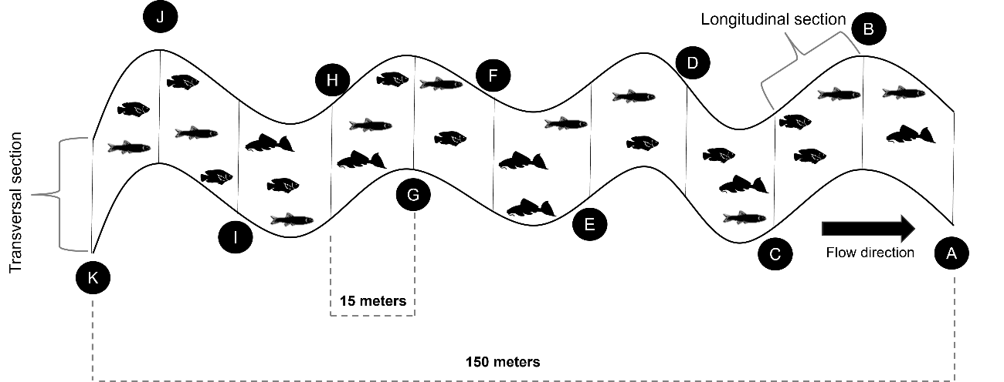Supplementary Figure S1 – Schematic representation of the division of streams into transversal and longitudinal sections for the application of the habitat description protocol, aiming to obtain local environmental variables and collect biological data.

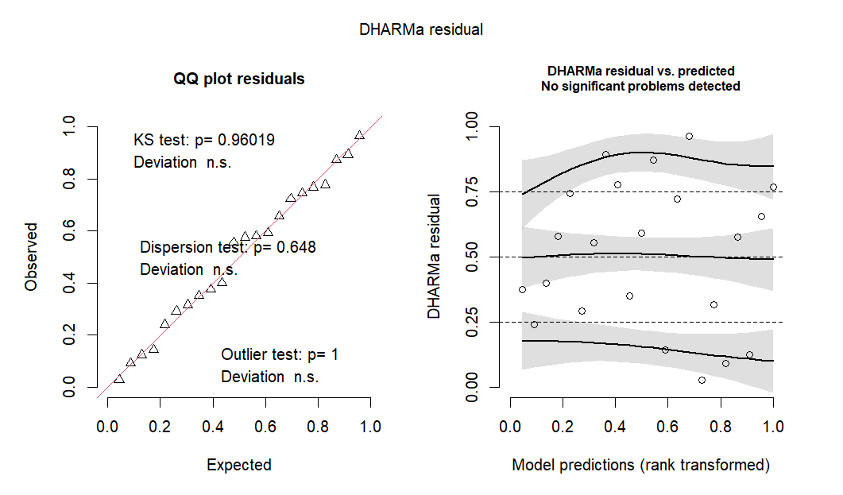
Supplementary Figure S2 – Residual diagnostics plot generated using the DHARMa package for the species richness model fitted with a Poisson distribution. The simulation-based residuals allow the assessment of model fit and the detection of potential violations of distributional assumptions.

