Electronic supplementary materials

ESM1 Head capsule length (µm) of the second, third and fourth larval instar of Chironomus riparius under varying temperatures (A) and food sources (B). The data include both male and female specimens, which are undifferentiated in this analysis, across all treatments. Boxplots illustrate the relationship between head capsule length and larval instar, confirming Dyar’s rule by showing distinct, predictable differences between the second, third, and fourth instars.

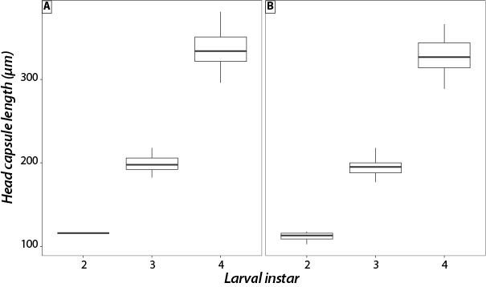
ESM2 Temporal dynamics of sex-based adult emergence across temperatures at low larval density at (A) 20°C, (B) 22°C, and (C) 24°C. The emergence patterns of male and female individuals were observed across three temperature treatments, with a distinct trend of later emergence for females at all temperatures, as anticipated. At lower temperatures (20°C), both sexes emerged more slowly, while at higher temperatures (22°C and 24°C), the timing of emergence accelerated. The pronounced delay in female emergence relative to males was consistent across all conditions, indicating temperature-dependent regulation of sex-specific developmental timing. In each panel, males are represented by blue bars, while females are represented by red bars.

