Supplementary Information
Synergistic effects of predation and parasitism on competition between edible and inedible phytoplankton
Minoru Kasada^{1,2*}, Patch Thongthaisong^{2,6}, Sabine Wollrab^{2,4*}, Silke Van den Wyngaert⁵, Christine Kiel², Stella A. Berger^{2,4}, and Hans-Peter Grossart^{2,3,4*}
¹ Field Science Center for Northern Biosphere, Uryu experimental forest, Hokkaido University, Horokanai, 074-0741, Japan
² Department of Plankton and Microbial Ecology, Leibniz Institute of Freshwater Ecology and Inland Fisheries, Zur alten Fischerhuette 2, 16775, Stechlin, Germany
³ Institute of Biochemistry and Biology, Potsdam University, Maulbeerallee 2, 14469 Potsdam, Germany
⁴ Berlin-Brandenburg Institute of Advanced Biodiversity Research (BBIB), Altensteinstraße 34, 14195 Berlin, Germany
⁵ Department of Biology, University of Turku, Vesilinnantie 5, 20014 Turku, Finland
⁶ European Institute for Marine Studies (IUEM), University of Western Brittany (UBO), Plouzané, France

Table S1. Recipe of modified CHU10 (mCHU10) medium. Note: pH of the final medium was adjusted to 6.4 for diatoms and green algae.

Stock solution mL/L mg/L
Na₂SiO₃(5H₂O) 10.824 g/250 mL 2.5 43.296
Ca(NO₃)₂(4H₂O) 2.878 g/50 mL 1 57.56
K₂HPO₄(3H₂O) 0.6551 g/50 mL 1 13.1
MgSO₄(7H₂O) 1.25 g/50 mL 1 25
Na₂CO₃ 1 g/50 mL 1 20
Fe-EDTA 1.85 g/50 mL 1 37
Vitamin B12 1 mg/1 mL, 50 μL/50 mL 1 1 μg/L
Biotin 1 mg/1 mL, 50 μL/50 mL 1 1 μg/L
Thiamine HCl 10 mg/50 mL 1 0.2

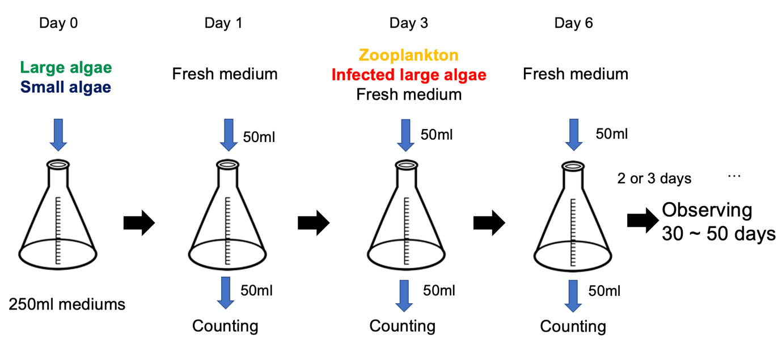
Figure S1. Experimental design of the semi-batch culture system. At the beginning of the experiment, large and small phytoplankton are added to the medium. After three days, zooplankton and infected large algae are added. Sampling and adding fresh medium are conducted every two or three days.

Calculating phytoplankton biovolume
For Staurastrum sp., we approximated the biovolume per cell using two triangular pyramids mimicking the shape of Staurastrum sp. cells. It was assumed that the bottom shape was an equilateral triangle. The volume was calculated as follows:
$$\frac{1}{2}a_{s}×\frac{a_{s}\sqrt{3}}{2}×\frac{1}{3}×b_{s}=\frac{{a_{s}}^{2}b_{s}\sqrt{3}}{12},$$
where a_{s} is the length of the side of the bottom triangle and b_{s} is the total height of the two triangular pyramids (Fig. S2b). Length data were obtained using the mean values of 10 Staurastrum sp. individuals measured under a microscope (Nikon ECLIPSE Ti2, Nikon, Japan). Here a_{s} and b_{s} were 30.18 μm (SD 2.78) and 23.65 μm (SD 1.71), respectively. The volume of Staurastrum sp. was calculated to be 3,140.08 μm³ (SD 709.53). For Cryptomonas sp., the volume was approximated using an ellipsoid based on the cell shape of Cryptomonas sp., and was calculated as follows:
$$4×π×\frac{a_{c}}{2}×\frac{a_{c}}{2}×\frac{b_{c}}{2}×\frac{1}{3}=\frac{{πa_{c}}^{2}b_{c}}{6},$$
where a_{c} is the shortest axis of the ellipsoid and b_{c} is the longest axis of the ellipsoid (see Fig. S2d). Length data were obtained using the mean values of 10 Cryptomonas sp. individuals. Here a_{c} and b_{c} were 5.80 μm (SD 1.13) and 11.49 μm (SD 1.33), respectively. The Cryptomonas sp. volume was calculated to be 208.80 μm³ (SD 84.41). Thus, the Staurastrum sp. volume was 15.04 times (3140.08/208.80) higher than that of Cryptomonas sp.

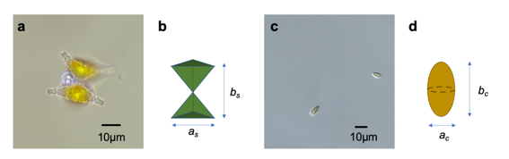
Figure S2. Images of phytoplankton and measured lengths used to calculate their volume. (a) Staurastrum sp. and (b) the geometric shape used to estimate its volume; (c) Cryptomonas sp. and (d) the geometric shape used to estimate its volume.

